**Day2**

1)      Alter Table:

* Add a new column linkedin_profile to employees table to store LinkedIn URLs as varchar.
* Change the linkedin_profile column data type from VARCHAR to TEXT.
* Add unique, not null constraint to linkedin_profile
* Drop column linkedin_profile

**SELECT * FROM employees**

**ALTER TABLE employees**

**ADD linkedin_profile varchar;**

**ALTER TABLE employees**

**ALTER COLUMN linkedin_profile TYPE text;**

**ALTER TABLE employees**

**ADD UNIQUE (linkedin_profile);**

**UPDATE employees**

**SET linkedin_profile = 'linkedin.com/'||employee_name**

**WHERE linkedin_profile IS NULL;**

**ALTER TABLE employees**

**ALTER COLUMN linkedin_profile SET NOT NULL**

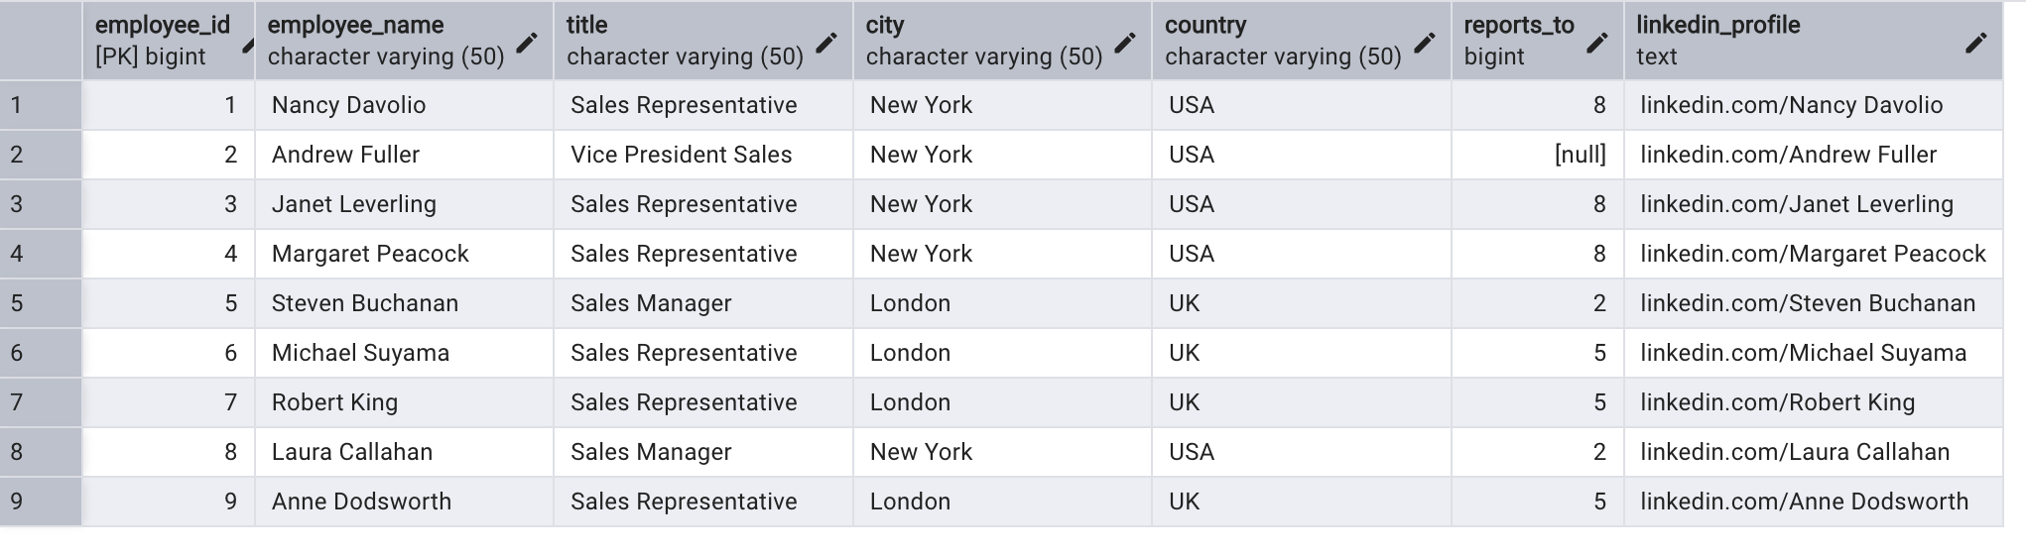

2)      Querying (Select)

* Retrieve the employee name and title of all employees

**SELECT employee_name,title FROM employees**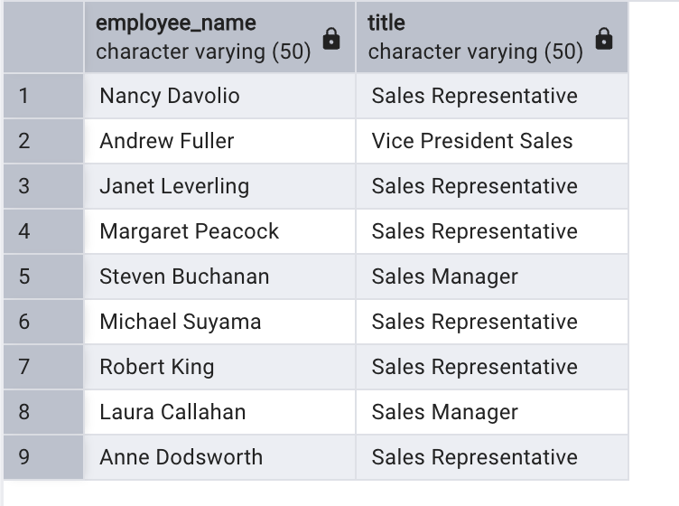

* + - Findall unique unit prices of products

**SELECT DISTINCT unit_price FROM products**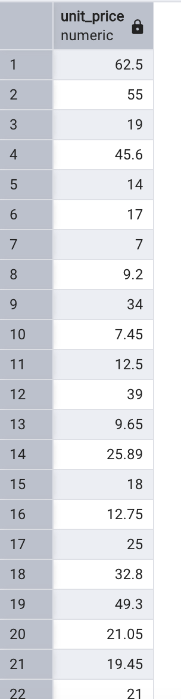

* List all customers sorted by company name in ascending order

**SELECT customer_id,company_name FROM customers**

**GROUP BY customer_id,company_name**

**ORDER BY company_name ASC**

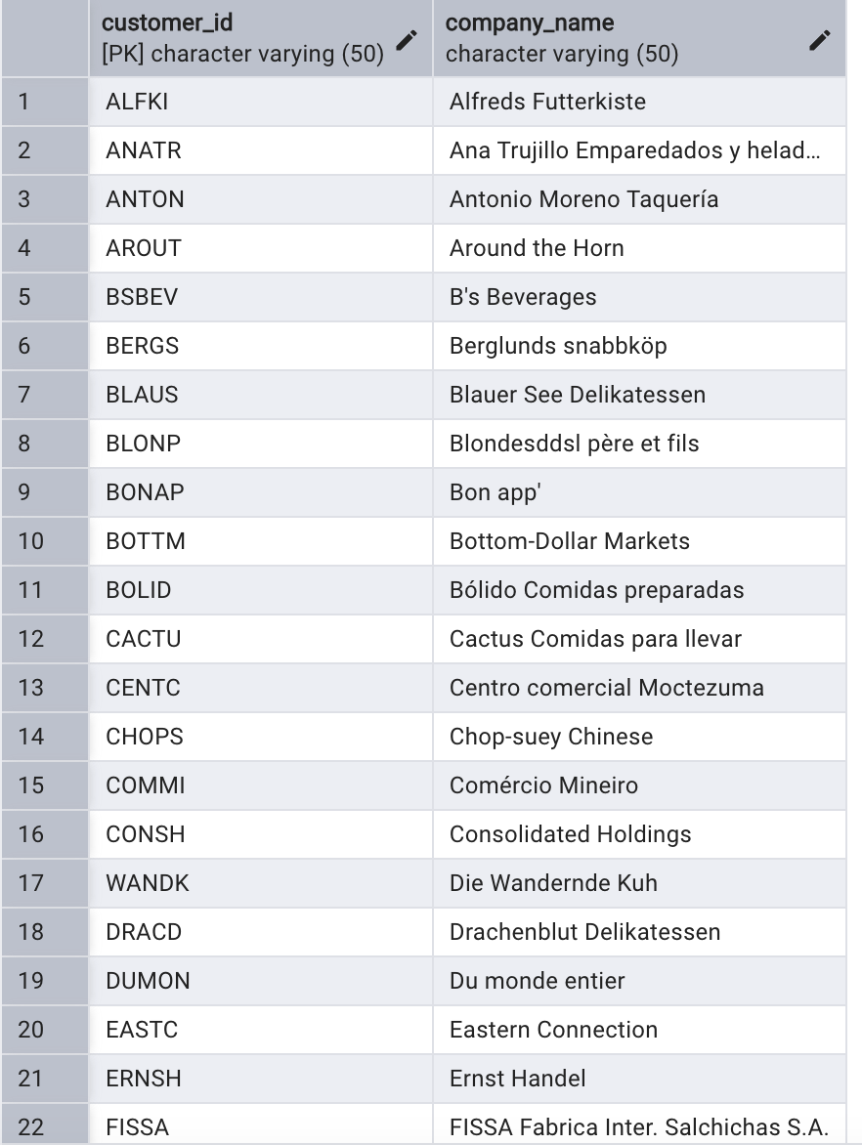

* Display product name and unit price, but rename the unit_price column as price_in_usd

**SELECT product_name,unit_price AS price_in_usd**

**FROM products**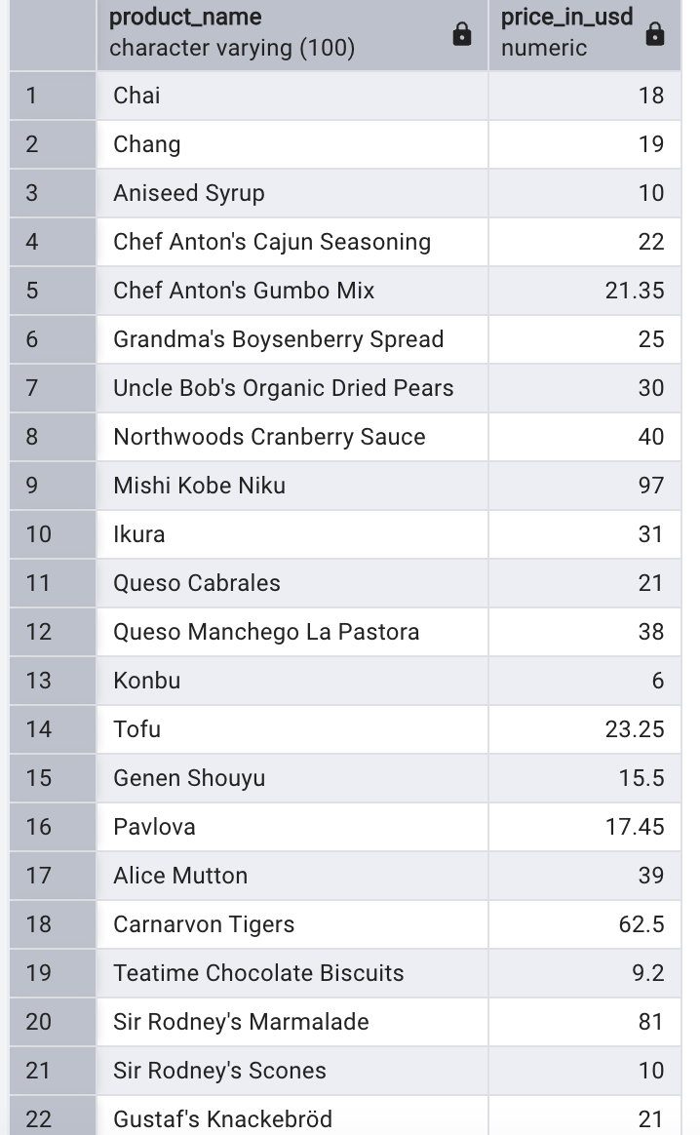

3)      Filtering

* Get all customers from Germany.

**SELECT customer_id,country FROM customers**

**WHERE country =‘Germany’**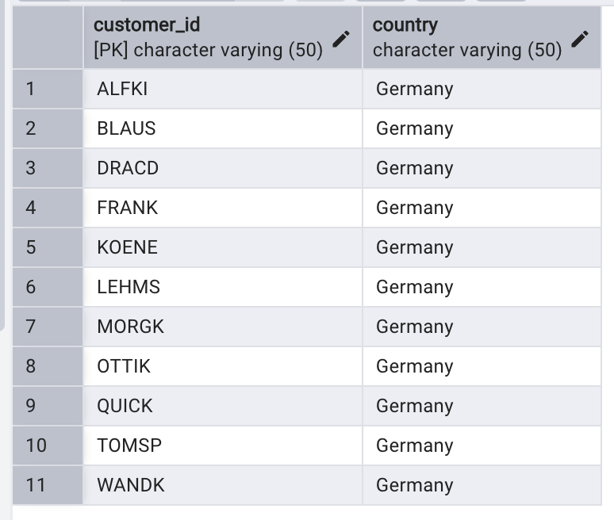

* Find all customers from France or Spain

**SELECT customer_id,country FROM customers**

**WHERE country ='France' OR country =‘Spain'**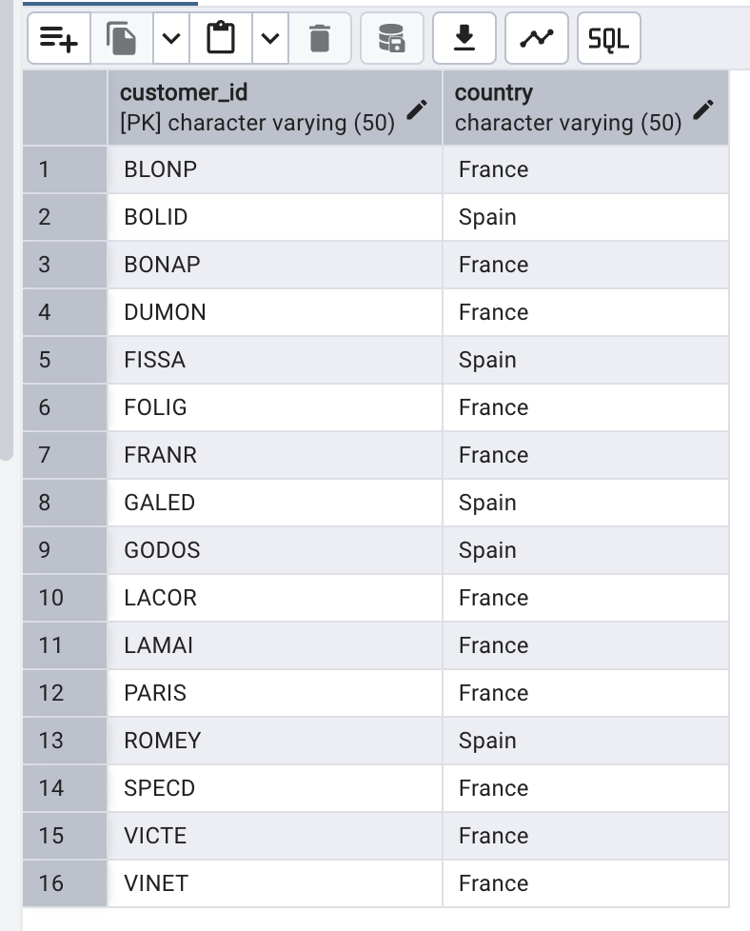

* Retrieve all orders placed in 2014(based on order_date), and either have freight greater than 50 or the shipped date available (i.e., non-NULL)  (Hint: EXTRACT(YEAR FROM order_date))

**SELECT * FROM (select EXTRACT(YEAR FROM(order_date)) AS order_year,order_id,customer_id,freight FROM orders**

**WHERE freight>50 OR shipped_date IS NOT NULL) WHERE order_year=2014**

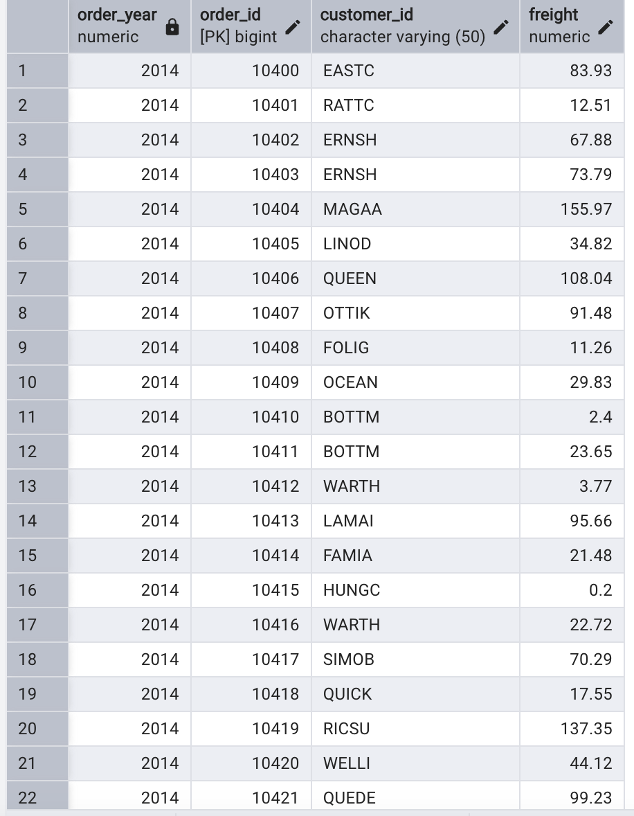

4)      Filtering

* Retrieve the product_id, product_name, and unit_price of products where the unit_price is greater than 15.

**SELECT Product_id,product_name,unit_price FROM products**

**WHERE unit_price>15**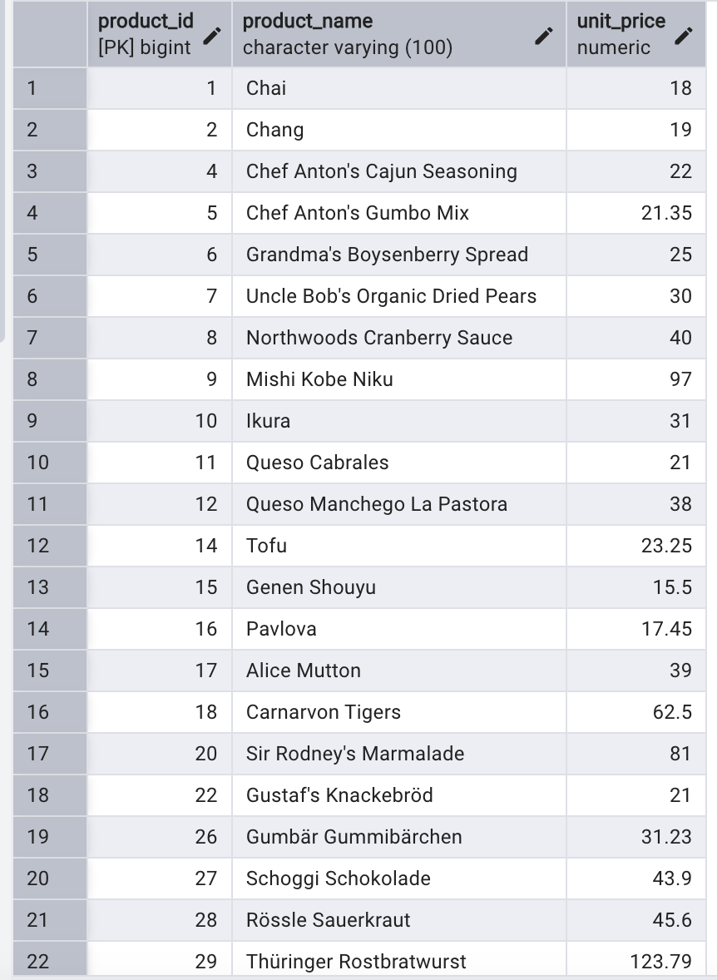

* List all employees who are located in the USA and have the title "Sales Representative”.

**SELECT employee_id,employee_name,title,country FROM employees**

**WHERE title ='Sales Representative' AND country = ‘USA'**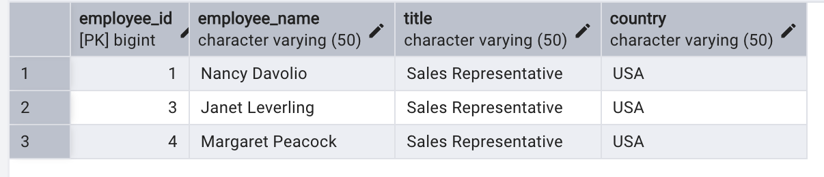

* Retrieve all products that are not discontinued and priced greater than 30.

**SELECT product_id,product_name,unit_price,discontinued FROM products**

**WHERE unit_price>30 AND discontinued=0**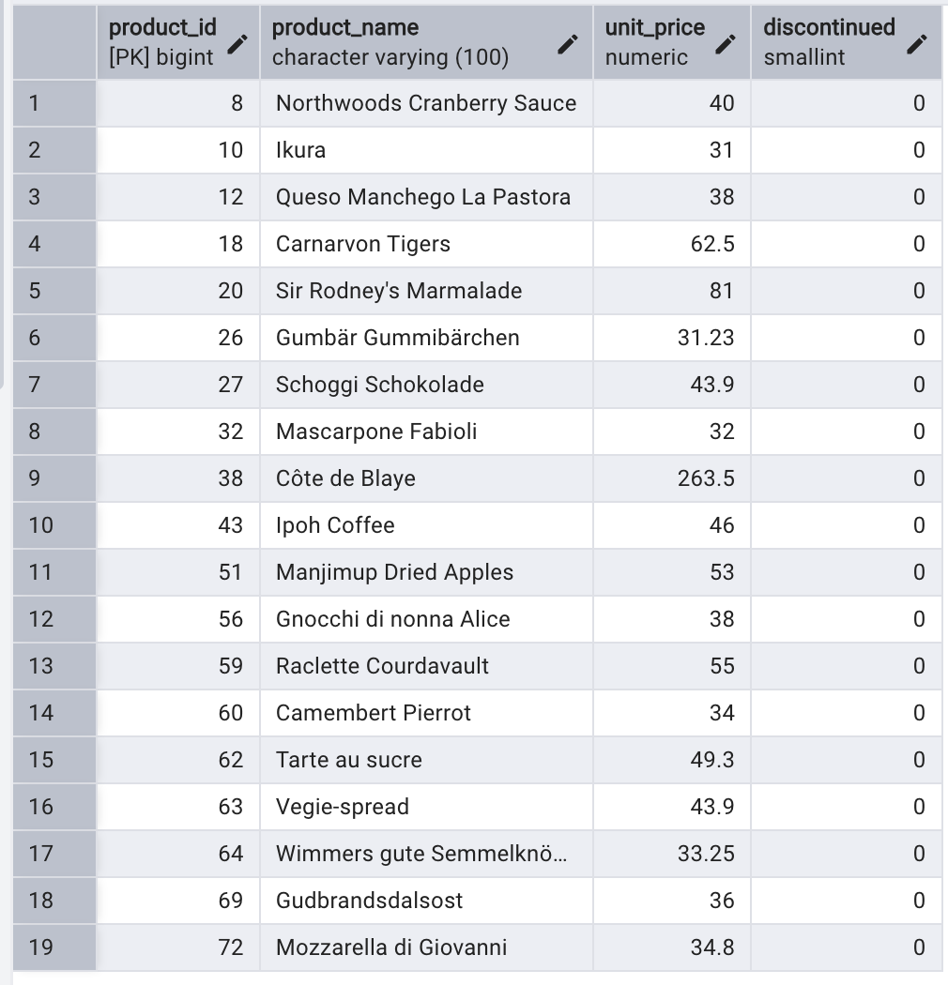

5)      LIMIT/FETCH

* Retrieve the first 10 orders from the orders table.

**SELECT order_id,customer_id,order_date FROM orders**

**GROUP BY order_id**

**ORDER BY order_date ASC LIMIT 10**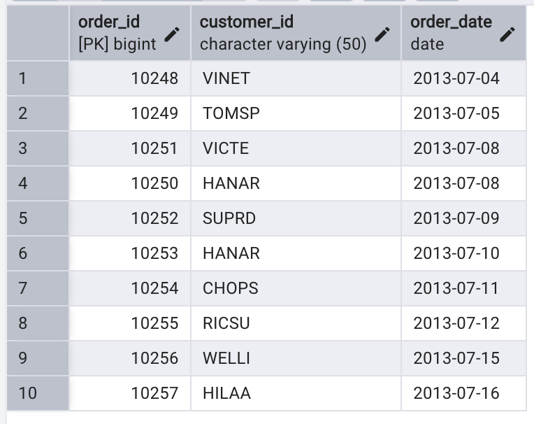

* Retrieve orders starting from the 11th order, fetching 10 rows (i.e., fetch rows 11-20).

**SELECT * FROM orders**

**ORDER BY order_id ASC**

**LIMIT 10**

**OFFSET 10;**

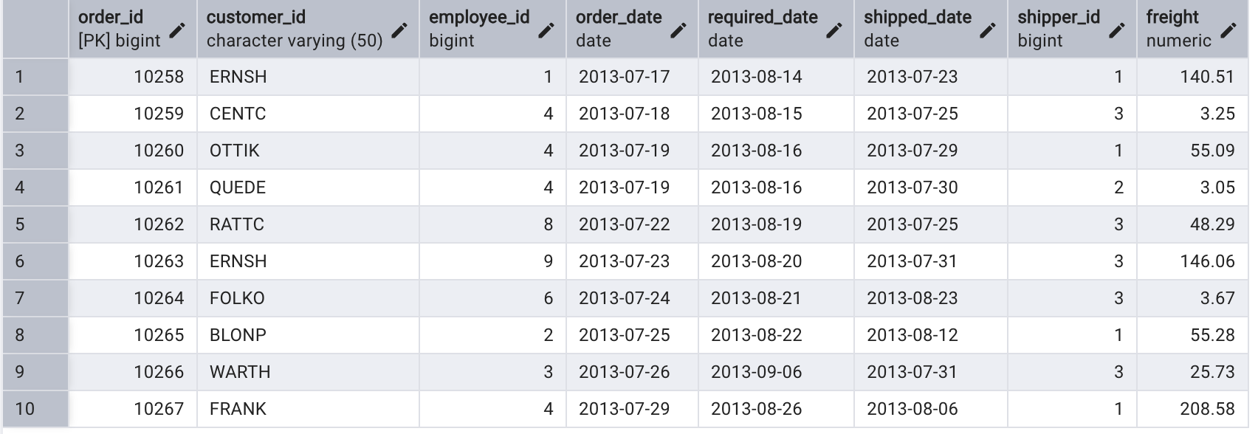

6)      Filtering (IN, BETWEEN)

* List all customers who are either Sales Representative, Owner

**SELECT * FROM customers**

**WHERE contact_title = 'Sales Representative' OR contact_title ='Owner';**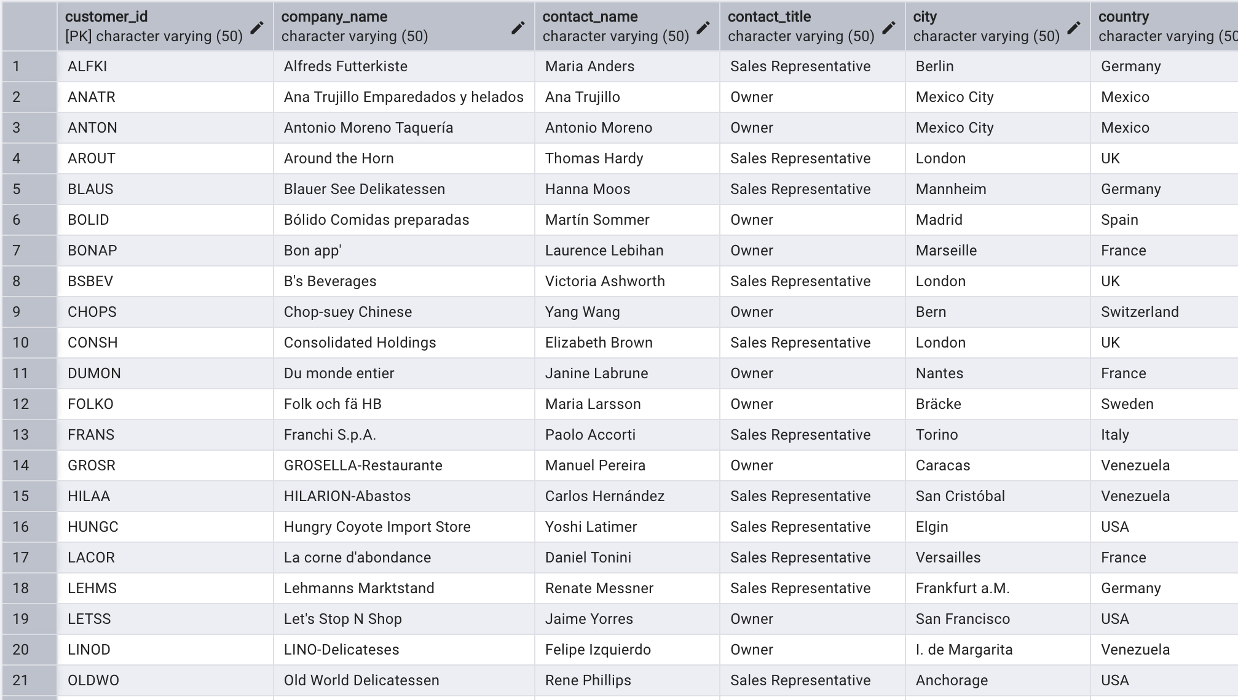

* Retrieve orders placed between January 1, 2013, and December 31, 2013.

**SELECT * FROM orders**

**WHERE order_date BETWEEN '2013-01-01' AND '2013-12-31';**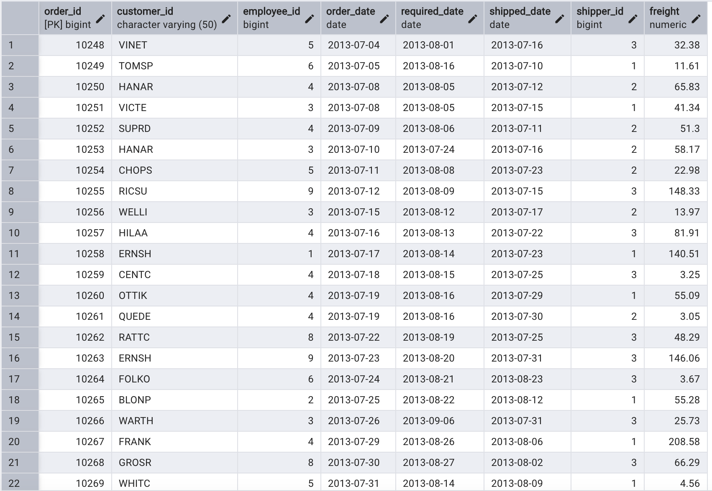

7)      Filtering

* List all products whose category_id is not 1, 2, or 3.

**SELECT * FROM products**

**WHERE category_id NOT IN (1,2,3);**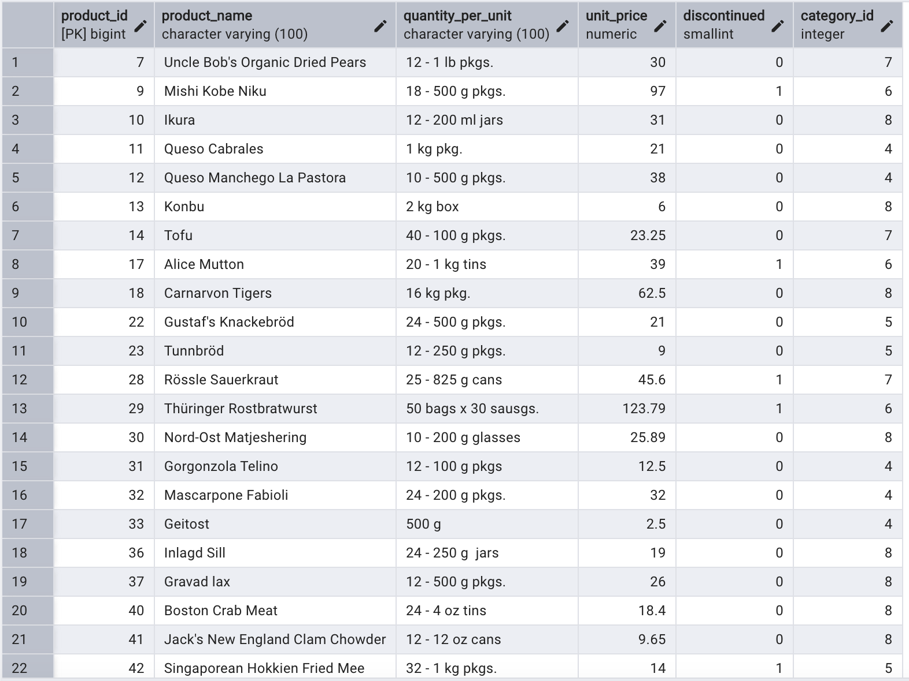

* Find customers whose company name starts with "A".

**SELECT * FROM customers**

**WHERE company_name LIKE’A%';**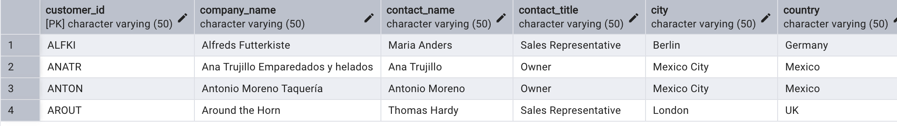

8)       INSERT into orders table:

**INSERT INTO orders (order_id,customer_id,employee_id,order_date,required_date,shipped_date,shipper_id,freight)**

**VALUES(‘11078','ALFKI','5','2025-04-23','2025-04-30','2025-04-25','2','45.50')**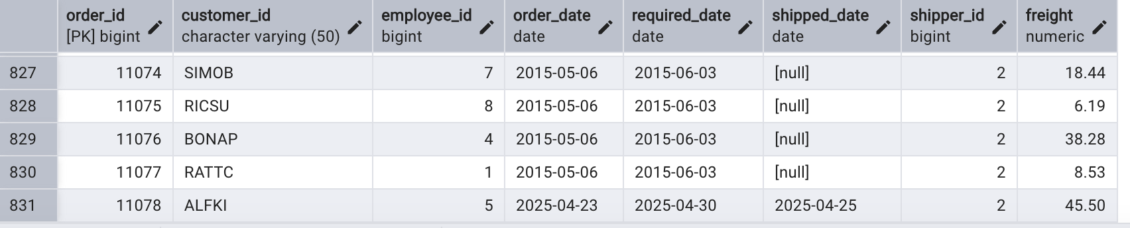

9)      Increase(Update)  the unit price of all products in category_id =2 by 10%.

**UPDATE products**

**SET unit_price = unit_price*1.10**

**WHERE category_id = 2;**

**SELECT * FROM products**

**WHERE category_id = 2;**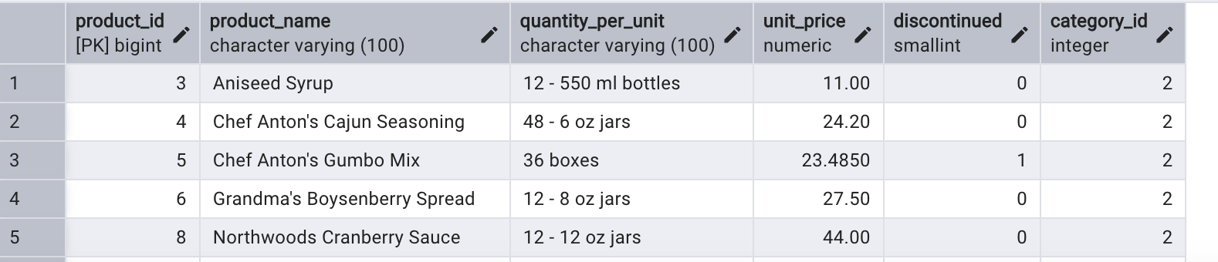

10) Sample Northwind database-Download.