**Day2**

1) Alter Table:

* Add a new column linkedin_profile to employees table to store LinkedIn URLs as varchar.
* Change the linkedin_profile column data type from VARCHAR to TEXT.
* Add unique, not null constraint to linkedin_profile
* Drop column linkedin_profile

**Query:**

--Add a new column linkedin_profile to employees table to store LinkedIn URLs as varchar.

ALTER TABLE employees

ADD COLUMN linkedin_profile VARCHAR GENERATED ALWAYS AS ('http://linkedin.com/user' || employeeid::text) STORED;

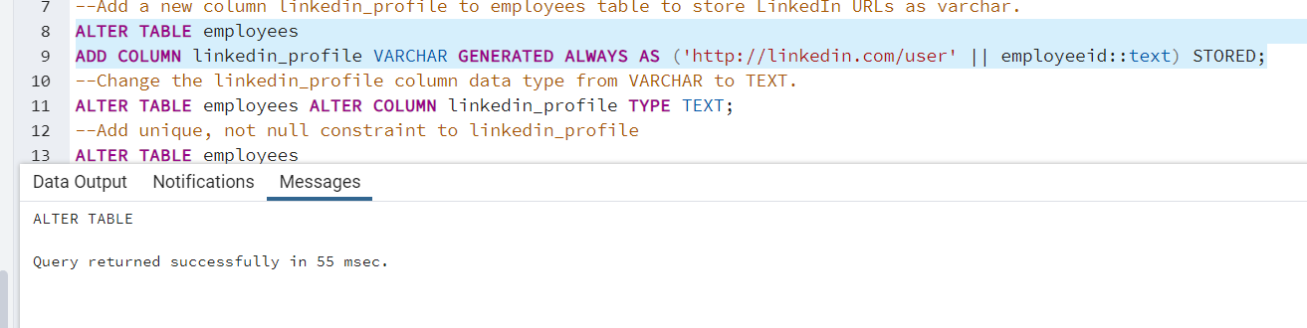

--Change the linkedin_profile column data type from VARCHAR to TEXT.

ALTER TABLE employees ALTER COLUMN linkedin_profile TYPE TEXT;

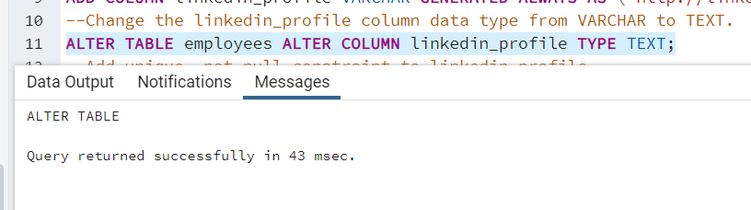

--Add unique, not null constraint to linkedin_profile

ALTER TABLE employees

ADD CONSTRAINT UNIQUE_EMAIL UNIQUE(linkedin_profile),

ALTER COLUMN linkedin_profile SET NOT NULL;

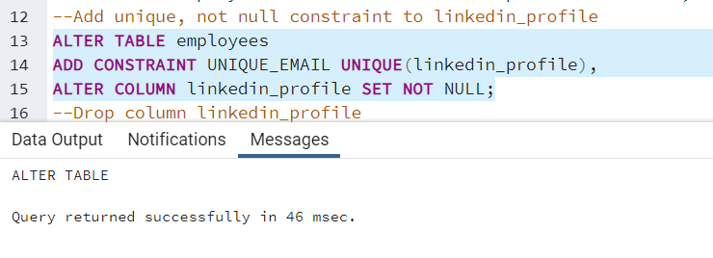

--Drop column linkedin_profile

ALTER TABLE employees DROP COLUMN linkedin_profile;

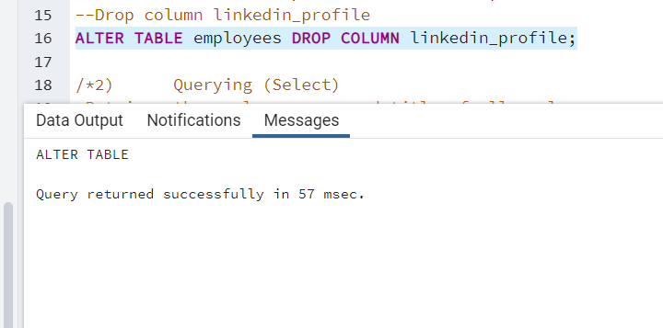

2) Querying (Select)

* Retrieve the first name, last name, and title of all employees
* Find all unique unit prices of products
* List all customers sorted by company name in ascending order
* Display product name and unit price, but rename the unit_price column as price_in_usd

**Query:**

--Retrieve the employee name and title of all employees

SELECT employeename,title FROM public.employees;

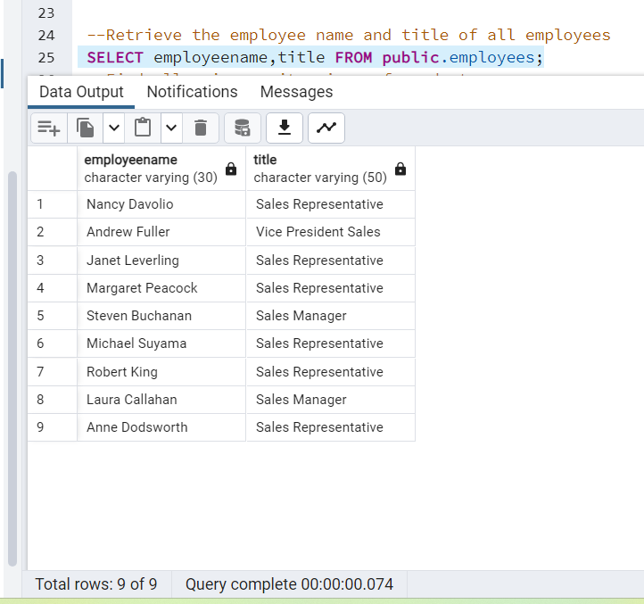

--Find all unique unit prices of products

SELECT DISTINCT unitprice FROM public.products;

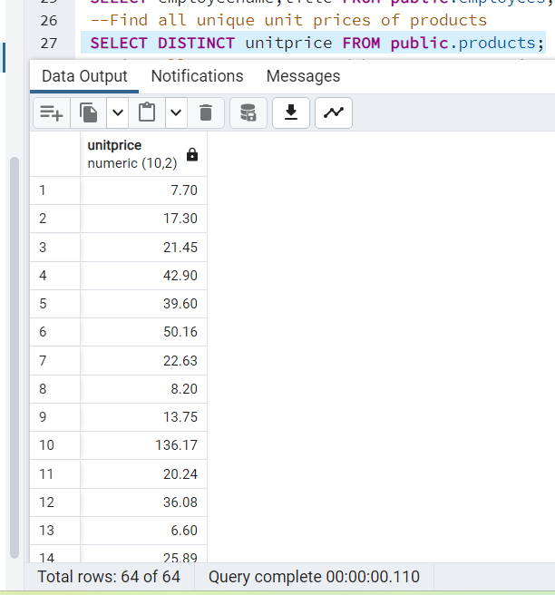

--List all customers sorted by company name in ascending order

SELECT * FROM public.customers ORDER BY companyname ;

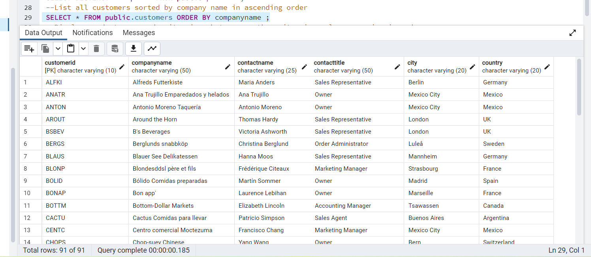

--Display product name and unit price, but rename the unit_price column as price_in_usd

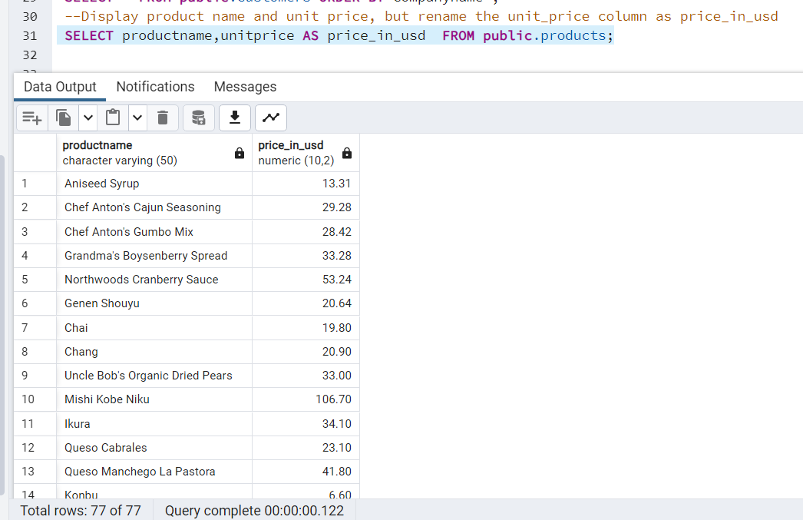

SELECT productname,unitprice AS price_in_usd FROM public.products;

3) Filtering

* Get all customers from Germany.
* Find all customers from France or Spain
* Retrieve all orders placed in 1997 (based on order_date), and either have freight greater than 50 or the shipped date available (i.e., non-NULL) (Hint: EXTRACT(YEAR FROM order_date))

**Query:**

--Get all customers from Germany

SELECT * FROM public.customers WHERE country='Germany';

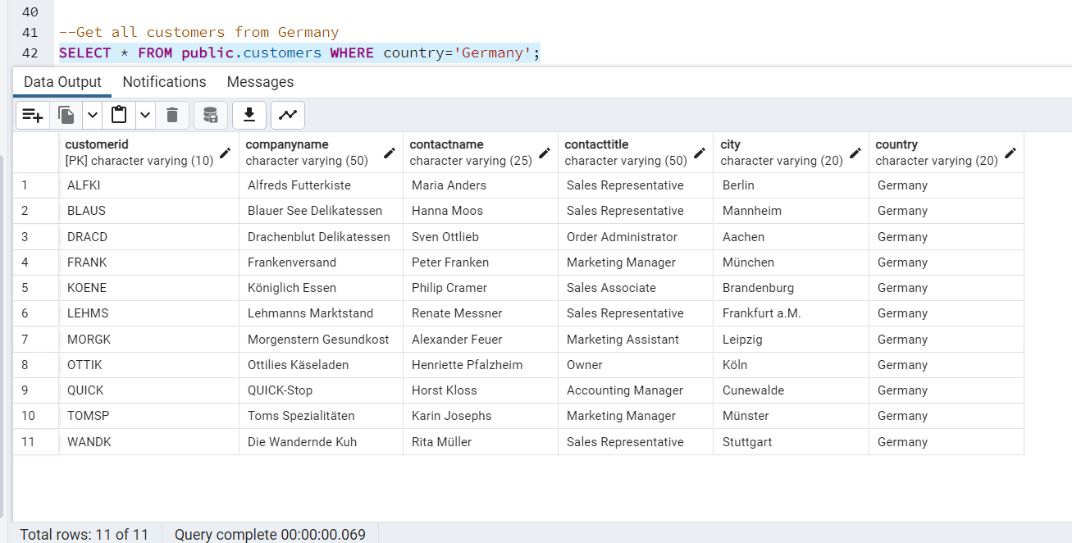

--Find all customers from France or Spain

SELECT * FROM public.customers WHERE country='France' OR country='Spain';

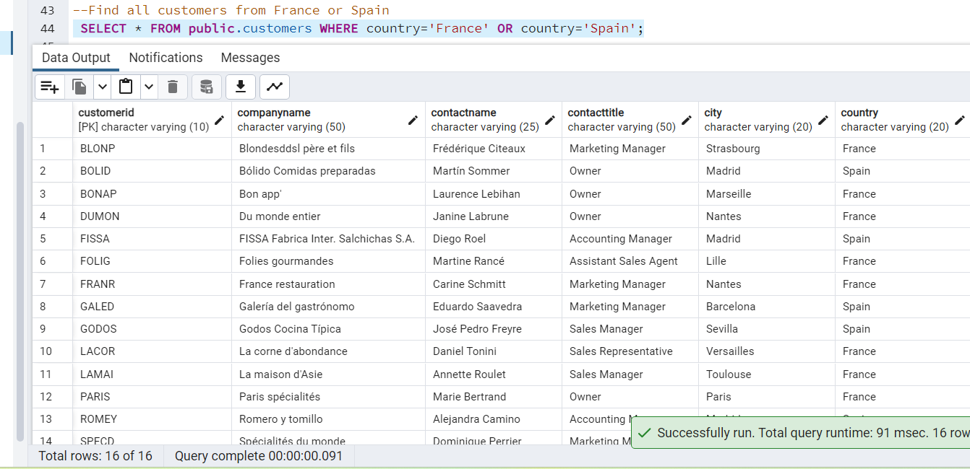

-- Retrieve all orders placed in 1997 (based on order_date), and either have freight greater than 50 or the shipped date available (i.e., non-NULL) (Hint: EXTRACT(YEAR FROM order_date))

SELECT * FROM public.orders WHERE EXTRACT(YEAR FROM orderdate)=2014 AND (freight>50 OR shippeddate IS NOT NULL);

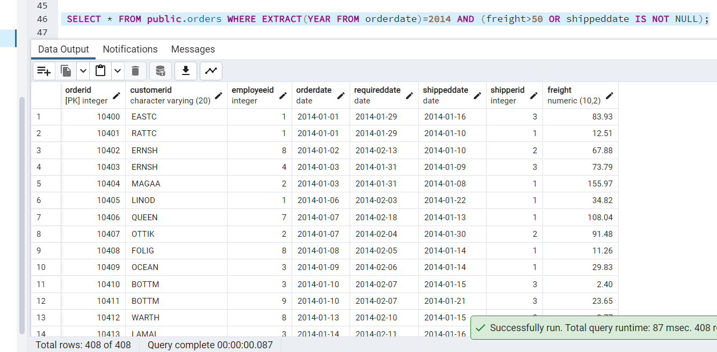

4) Filtering

* Retrieve the product_id, product_name, and unit_price of products where the unit_price is greater than 15.
* List all employees who are located in the USA and have the title "Sales Representative".
* Retrieve all products that are not discontinued and priced greater than 30.

**Query:**

--Retrieve the product_id, product_name, and unit_price of products where the unit_price is greater than 15.

SELECT productid,productname,unitprice FROM public.products WHERE unitprice>15;

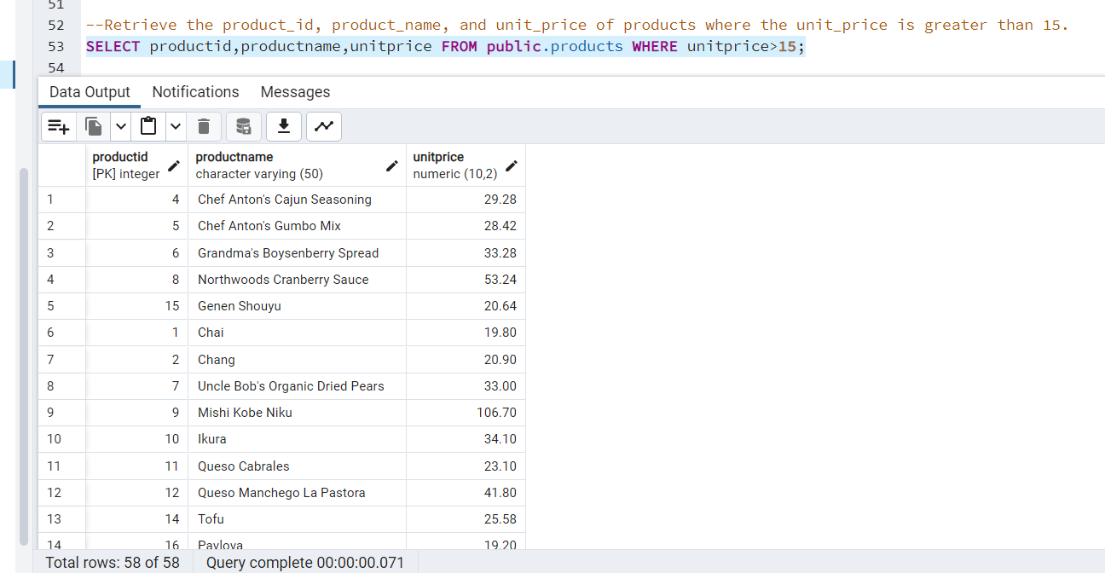

--List all employees who are located in the USA and have the title "Sales Representative".

SELECT * FROM public.employees WHERE country='USA' AND title='Sales Representative';

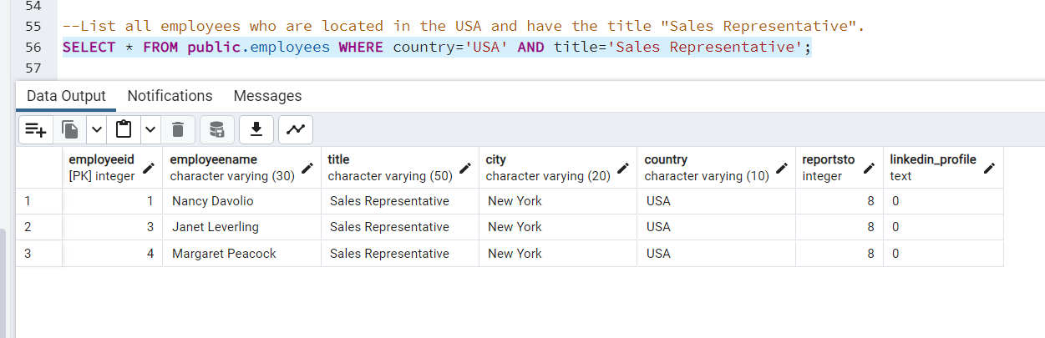

--Retrieve all products that are not discontinued and priced greater than 30

SELECT * FROM public.products WHERE discontinued=0 AND unitprice>30

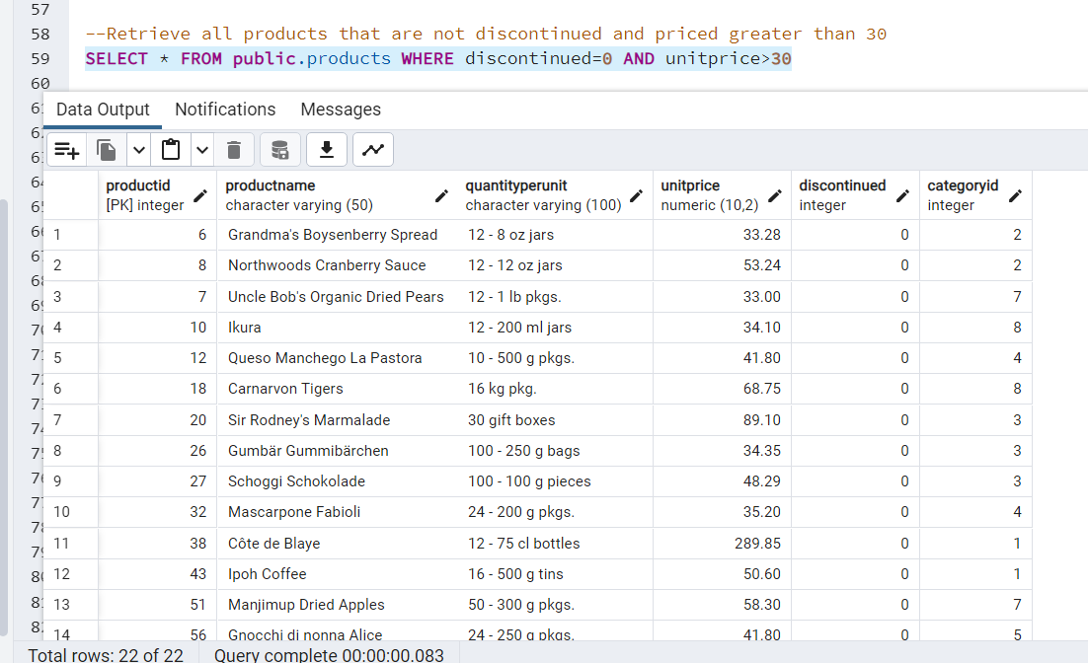

5) LIMIT/FETCH

* Retrieve the first 10 orders from the orders table.
* Retrieve orders starting from the 11th order, fetching 10 rows (i.e., fetch rows 11-20).

**Query:**

--Retrieve the first 10 orders from the orders table

SELECT * FROM public.orders ORDER BY orderid LIMIT 10

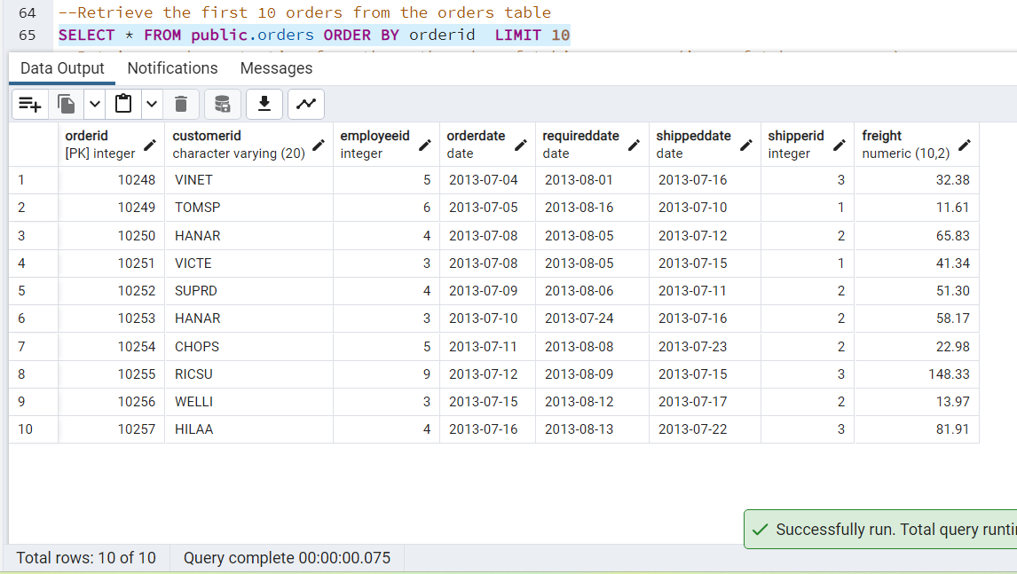

--Retrieve orders starting from the 11th order, fetching 10 rows (i.e., fetch rows 11-20).

SELECT * FROM public.orders ORDER BY orderid OFFSET 10 ROWS

FETCH FIRST 10 ROW ONLY;

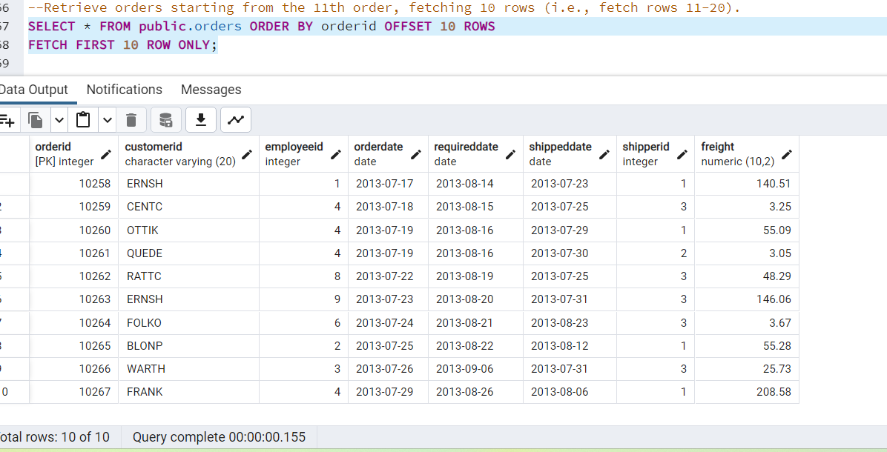

6) Filtering (IN, BETWEEN)

* List all customers who are either Sales Representative, Owner
* Retrieve orders placed between January 1, 2013, and December 31, 2013.

**Query:**

--List all customers who are either Sales Representative, Owner

SELECT * FROM public.customers WHERE contacttitle IN ('Sales Representative','Owner')

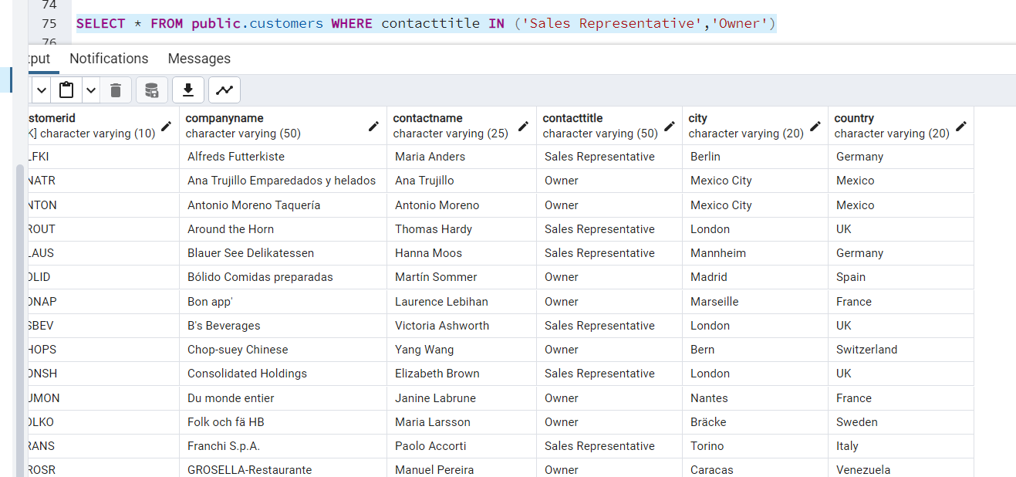

---Retrieve orders placed between January 1, 2013, and December 31, 2013.

SELECT * from public.orders where orderdate between '2013-01-01' AND '2013-12-31';

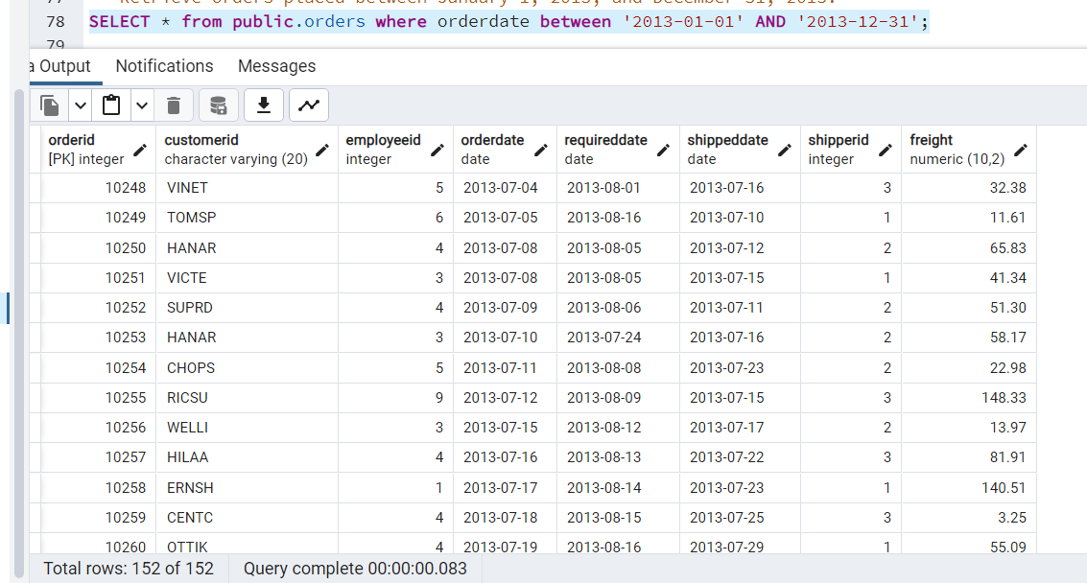

7) Filtering

* List all products whose category_id is not 1, 2, or 3.
* Find customers whose company name starts with "A".

**Query:**

--List all products whose category_id is not 1, 2, or 3.

SELECT * FROM public.products WHERE categoryid NOT IN (1,2,3)

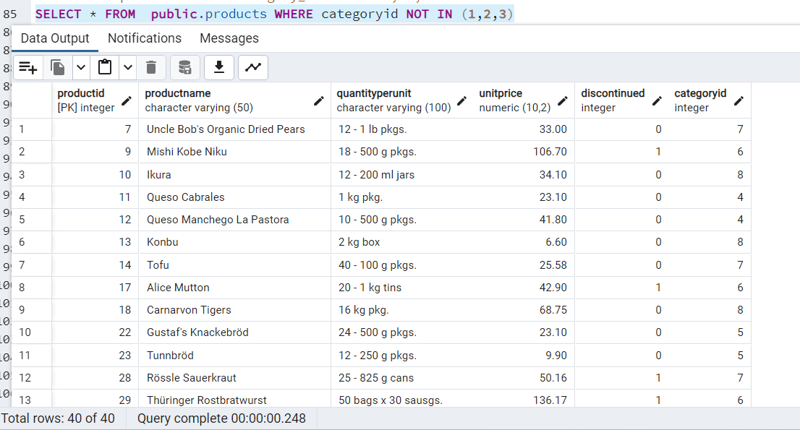

--Find customers whose company name starts with "A".

SELECT * FROM public.customers WHERE companyname LIKE 'A%'

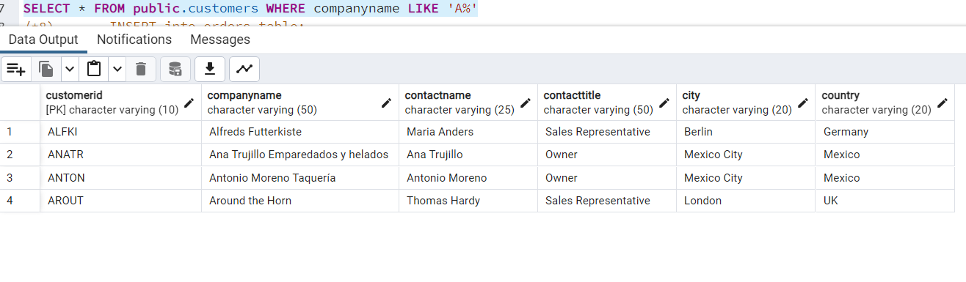

8) INSERT into orders table:

Task: Add a new order to the orders table with the following details:

Order ID: 11078

Customer ID: ALFKI

Employee ID: 5

Order Date: 2025-04-23

Required Date: 2025-04-30

Shipped Date: 2025-04-25

shipperID:2

Freight: 45.50

**Query:**

INSERT INTO public.orders (orderid,customerid,employeeid,orderdate,requireddate,shippeddate,shipperid,freight)

VALUES(11078,'ALFKI',5,'2025-04-23','2025-04-30','2025-04-25',2,45.50)

9) Increase(Update) the unit price of all products in category_id =2 by 10%.

(HINT: unit_price =unit_price * 1.10)

**Query:**

UPDATE productS

SET unitprice = unitprice*1.10

WHERE categoryid=2

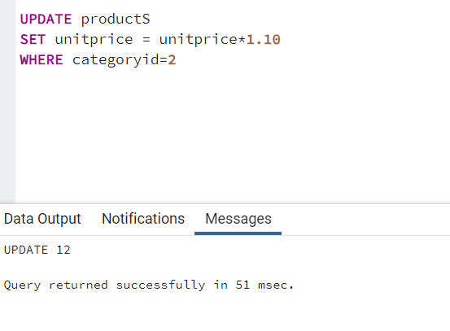

10) Sample Northwind database:

Download

1. Download northwind.sql from below link into your local. Sign in to Git first <https://github.com/pthom/northwind_psql>
2. Manually Create the database using pgAdmin:
   1. Right-click on "Databases" → Create → Database
   2. Give name as ‘northwind’ (all small letters)
   3. Click ‘Save’

Import database:

1. Open pgAdmin and connect to your server
2. Select the database ‘northwind’
3. Right Click-> Query tool.
4. Click the folder icon to open your northwind.sql file
5. Press F5 or click the Execute button.
6. You will see total 14 tables loaded
7. Databases → your database → Schemas → public → Tables

