**Day 3**

**USE Northwind from Kaggle:**

1)      Update the categoryName From “Beverages” to "Drinks" in the categories table.

**UPDATE categories**

**SET category_name = REPLACE(category_name,’Beverages','Drinks');**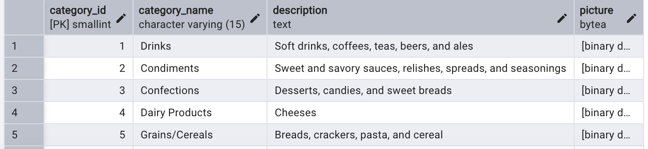

2)      Insert into shipper new record (give any values) Delete that new record from shippers table.

**INSERT INTO shippers(shipper_id,company_name,phone)**

**VALUES('7','Full Express’,’840-951-0002’);**

**DELETE FROM shippers**

**WHERE shipper_id = 7;**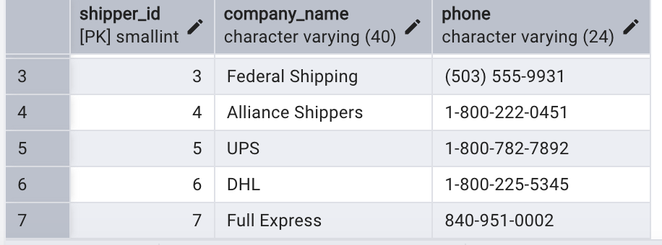

3)      Update categoryID=1 to categoryID=1001. Make sure related products update their categoryID too. Display the both category and products table to show the cascade.

 Delete the categoryID= “3”  from categories. Verify that the corresponding records are deleted automatically from products.

 (HINT: Alter the foreign key on products(categoryID) to add ON UPDATE CASCADE, ON DELETE CASCADE, add ON DELETE CASCADE for order_details(productid) )

**ALTER TABLE products**

**ADD FOREIGN KEY (category_id) REFERENCES categories(category_id) ON UPDATE CASCADE;**

**ALTER TABLE products**

**ADD FOREIGN KEY (category_id) REFERENCES categories(category_id) ON DELETE CASCADE;**

**UPDATE categories**

**SET category_id = 1001 WHERE category_id=1;**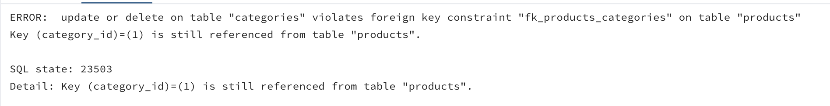

4)      Delete the customer = “VINET”  from customers. Corresponding customers in orders table should be set to null (HINT: Alter the foreign key on orders(customerID) to use ON DELETE SET NULL)

**ALTER TABLE orders**

**ADD FOREIGN KEY (customer_id) REFERENCES customers(customer_id) ON DELETE SET NULL;**

**DELETE FROM customers**

**WHERE customer_id='VINET'**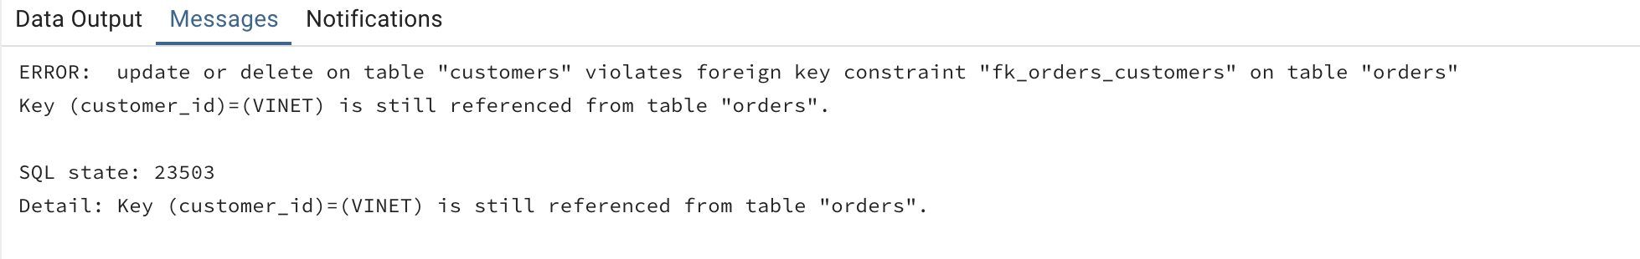

5)      Insert the following data to Products using UPSERT:

product_id = 100, product_name = Wheat bread, quantityperunit=1,unitprice = 13, discontinued = 0, categoryID=5

product_id = 101, product_name = White bread, quantityperunit=5 boxes,unitprice = 13, discontinued = 0, categoryID=5

product_id = 100, product_name = Wheat bread, quantityperunit=10 boxes,unitprice = 13, discontinued = 0, categoryID=5

(this should update the quantityperunit for product_id = 100)

**INSERT INTO products(product_id,product_name,quantity_per_unit,unit_price,discontinued,category_id)**

**VALUES(100,'Wheat bread','1',13,0,5),**

**(101,'White bread','5 boxes’,13,0,5)**

**INSERT INTO products(product_id,product_name,quantity_per_unit,unit_price,discontinued,category_id)**

**VALUES(100,'Wheat Bread','10 boxes',13,0,5)**

**ON CONFLICT(product_id)**

**DO UPDATE SET**

**quantity_per_unit = EXCLUDED.quantity_per_unit;**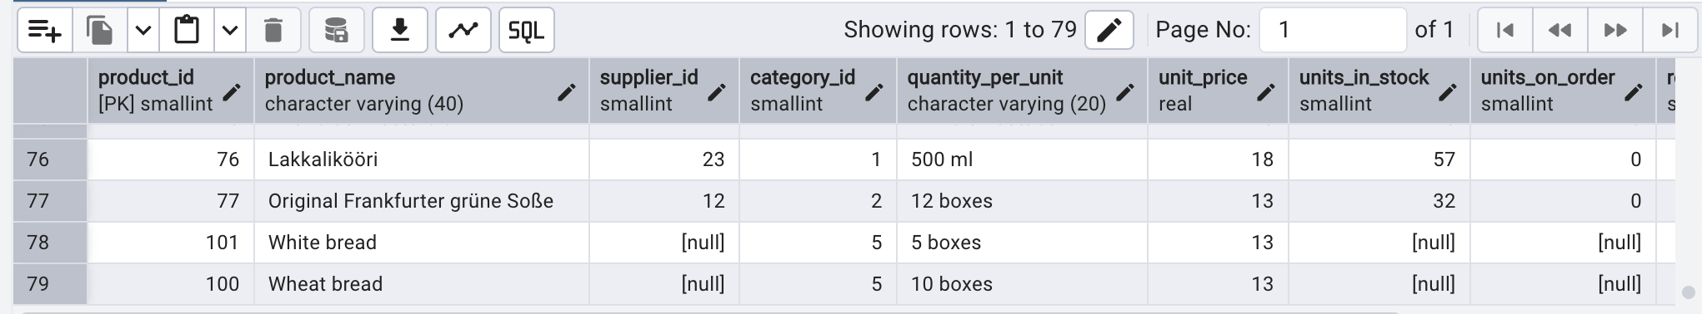

6)      Write a **MERGE query**:

Create **temp table with name:**  ‘updated_products’ and insert values as below:

|  |  |  |  |  |  |
| --- | --- | --- | --- | --- | --- |
| productID | productName | quantityPerUnit | unitPrice | discontinued | categoryID |
| 100 | Wheat bread | 10 | 20 | 1 | 5 |
| 101 | White bread | 5 boxes | 19.99 | 0 | 5 |
| 102 | Midnight Mango Fizz | 24 - 12 oz bottles | 19 | 0 | 1 |
| 103 | Savory Fire Sauce | 12 - 550 ml bottles | 10 | 0 | 2 |

* Update the price and discontinued status for from below table ‘updated_products’ only if there are matching products and updated_products .discontinued =0
* If there are matching products and updated_products .discontinued =1 then delete

* Insert any new products from updated_products that don’t exist in products only if updated_products .discontinued =0.

**CREATE TEMP TABLE updated_products**

**(productid integer,**

**productname character varying(50) ,**

**quantityperunit character varying(100) ,**

**unitprice numeric(10,2),**

**discontinued integer,**

**categoryid integer);**

**INSERT INTO updated_products(productid,productname,quantityperunit,unitprice,discontinued,categoryid) VALUES**

**(100,'Wheat bread','10',20,1,3),**

**(101,'White bread','5 boxes',19.99,0,3),**

**(102,'Midnight Mango Fizz','24 - 12 oz bottles',19,0,1),**

**(103,'Savory Fire Sauce','12 - 550 ml bottles',10,0,2)**

**SELECT * FROM products**

**MERGE INTO products p**

**USING updated_products u ON p.product_id = u.productid**

**WHEN MATCHED AND u.discontinued = 1 THEN DELETE**

**WHEN MATCHED AND u.discontinued = 0 THEN**

**UPDATE**

**SET unit_price = u.unitprice,**

**discontinued = u.discontinued**

**WHEN NOT MATCHED AND u.discontinued = 0 THEN**

**INSERT(product_id,product_name,quantity_per_unit,unit_price,discontinued,category_id)**

**VALUES(u.productid,u.productname,u.quantityperunit,u.unitprice,u.discontinued,u.categoryid)**

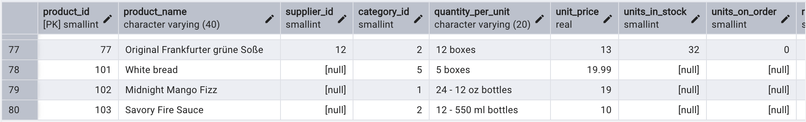

**USE NEW Northwind DB:**

7)      List all orders with employee full names. (Inner join)

**SELECT e.first_name,e.last_name,o.order_id**

**FROM employees e**

**INNER JOIN orders o ON e.employee_id = o.employee_id**

**ORDER BY order_id**

