**DAY 4**

1.     List all customers and the products they ordered with the order date. (Inner join)

**Tables used:** customers, orders, order_details, products

**Output should have below columns:**

    companyname AS customer,

    orderid,

    productname,

    quantity,

    orderdate

**SELECT * FROM customers**

**SELECT * FROM products**

**SELECT * FROM orders**

**SELECT * FROM order_details**

**SELECT c.company_name AS customer,o.order_id,p.product_name,od.quantity,o.order_date FROM customers c**

**INNER JOIN orders o ON c.customer_id = o.customer_id**

**INNER JOIN order_details od ON o.order_id = od.order_id**

**INNER JOIN products p ON od.product_id = p.product_id**

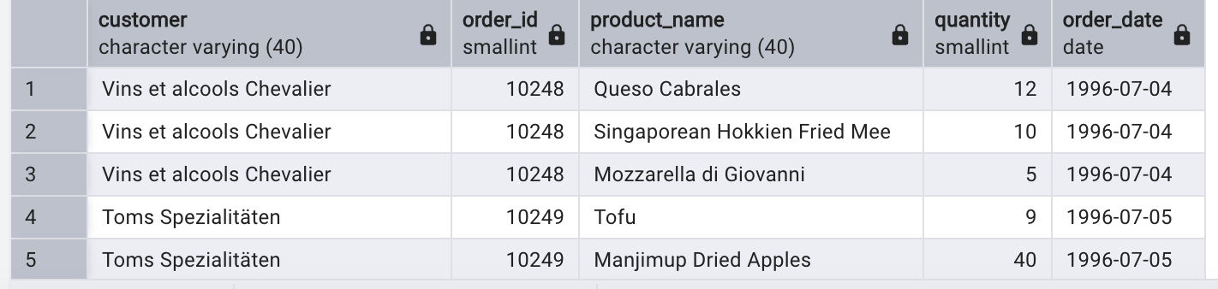

2.     Show each order with customer, employee, shipper, and product info — even if some parts are missing. (Left Join)

**Tables used: orders, customers, employees, shippers, order_details, products**

**SELECT o.order_id,c.customer_id,e.employee_id,s.shipper_id,p.product_id,p.product_name FROM orders o**

**LEFT JOIN customers c ON o.customer_id = c.customer_id**

**LEFT JOIN employees e ON o.employee_id = e.employee_id**

**LEFT JOIN order_details od ON o.order_id = od.order_id**

**LEFT JOIN products p ON od.product_id = p.product_id**

**LEFT JOIN shippers s ON o.ship_via = s.shipper_id**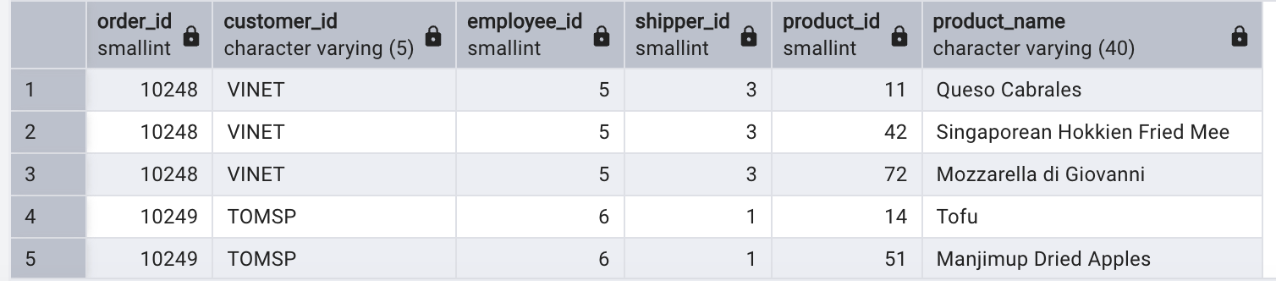

3.     Show all order details and products (include all products even if they were never ordered). (Right Join)

**Tables used: order_details, products**

**Output should have below columns:**

    orderid,

    productid,

    quantity,

    productname

**SELECT o.order_id,p.product_id,p.product_name,o.quantity**

**FROM order_details o**

**RIGHT JOIN products p ON o.product_id = p.product_id**

**ORDER BY product_id**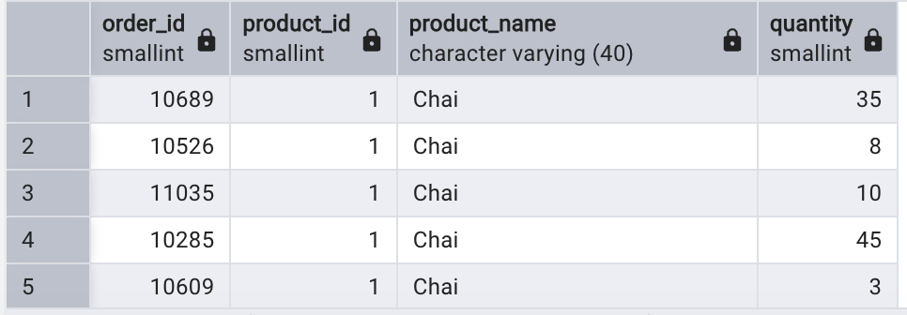

4. List all product categories and their products — including categories that have no products, and products that are not assigned to any category.(Outer Join)

**Tables used: categories, products**

**SELECT c.category_id,c.category_name,p.product_id,p.product_name**

**FROM categories c**

**FULL OUTER JOIN products p ON c.category_id = p.category_id**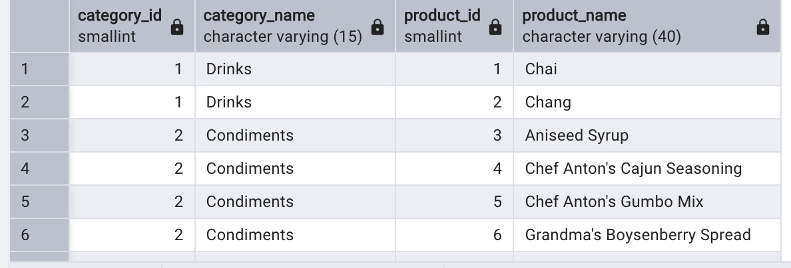

5. Show all possible product and category combinations (Cross join).

**SELECT p.product_id,p.product_name,c.category_id,c.category_name**

**FROM products p**

**CROSS JOIN categories c**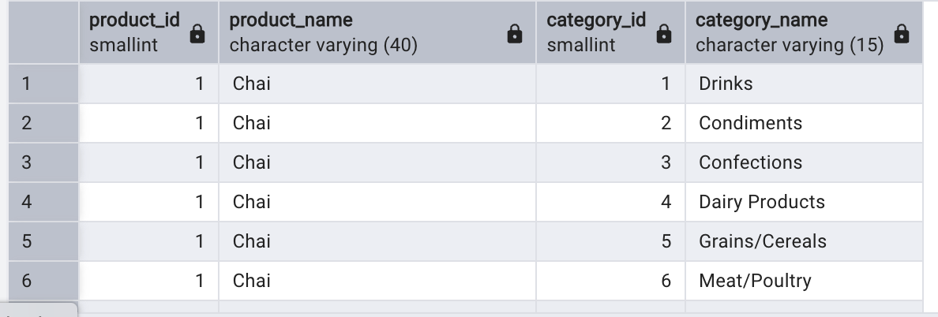

6. Show all employees and their manager(Self join(left join))

**SELECT e.employee_id,**

**e.first_name||' '||e.last_name AS employee_name,**

**m.first_name||' '||m.last_name AS manager_name**

**FROM employees e**

**LEFT JOIN employees m ON e.reports_to = m.employee_id**

**ORDER BY e.employee_id**

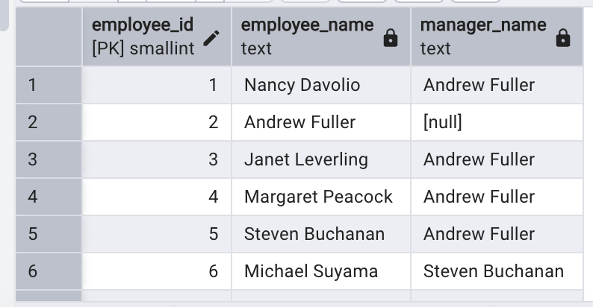

7. List all customers who have not selected a shipping method.

**Tables used:** customers, orders

**(Left Join, WHERE o.shipvia IS NULL)**

**SELECT c.customer_id,c.company_name,o.ship_via**

**FROM customers c**

**LEFT JOIN orders o ON c.customer_id = o.customer_id**

**WHERE o.ship_via IS NULL**

