**Day 5**

1.      GROUP BY with WHERE - Orders by Year and Quarter

Display, order year, quarter, order count, avg freight cost only for those orders where freight cost > 100

**SELECT EXTRACT(YEAR FROM order_date) AS Order_year,**

**EXTRACT(QUARTER FROM order_date) AS order_quarter,COUNT(order_id) AS order_count,AVG(freight) AS Average_freight**

**FROM orders**

**WHERE freight>100**

**GROUP BY**

**EXTRACT(YEAR FROM order_date),**

**EXTRACT(QUARTER FROM order_date)**

**ORDER BY**

**order_year,**

**order_quarter**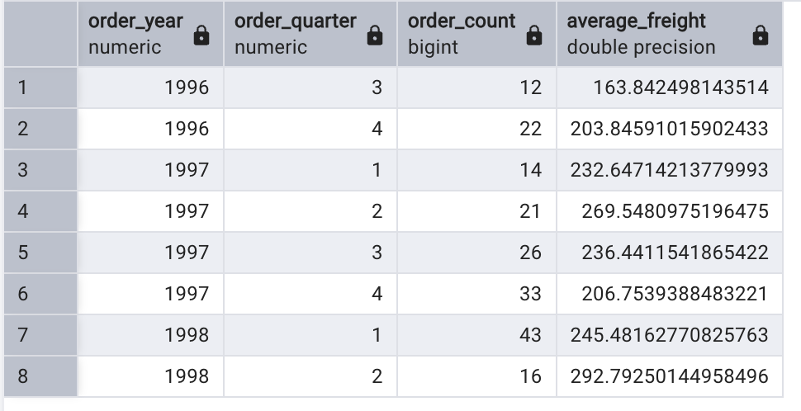

2.      GROUP BY with HAVING - High Volume Ship Regions

Display, ship region, no of orders in each region, min and max freight cost  
 Filter regions where no of orders >= 5

**SELECT * FROM orders**

**SELECT ship_region,COUNT(order_id) AS order_count,MIN(freight) AS Freight_min, MAX(freight) AS Freight_max**

**FROM orders**

**GROUP BY ship_region**

**HAVING COUNT(order_id)>=5**

**ORDER BY ship_region**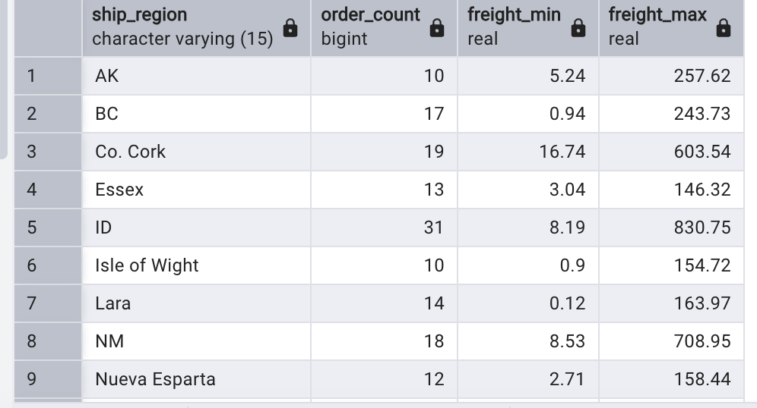

3.      Get all title designations across employees and customers ( Try UNION & UNION ALL)

**SELECT contact_title AS designation FROM customers**

**UNION**

**SELECT title AS designation FROM employees;**

**SELECT contact_title AS designation FROM customers**

**UNION ALL**

**SELECT title AS designation FROM employees;**

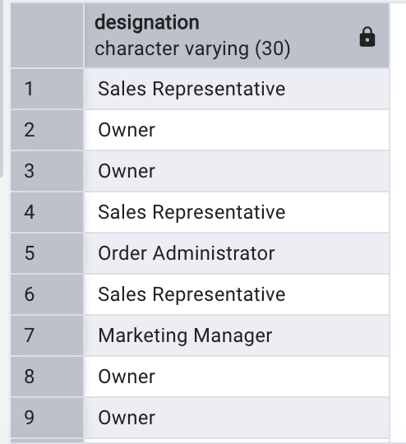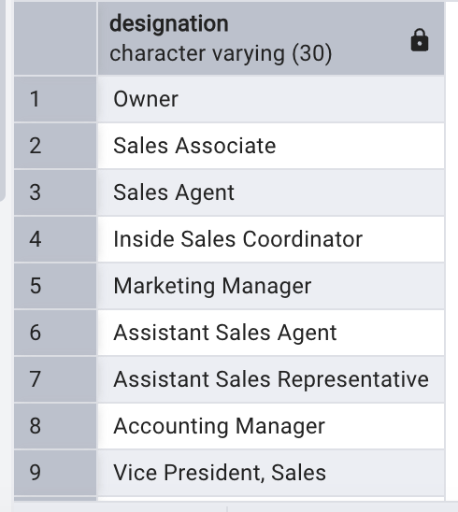

4.      Find categories that have both discontinued and in-stock products

(Display category_id, instock means units_in_stock > 0, Intersect)

**SELECT category_id FROM products**

**WHERE discontinued = 1**

**INTERSECT**

**SELECT category_id FROM products**

**WHERE units_in_stock>0**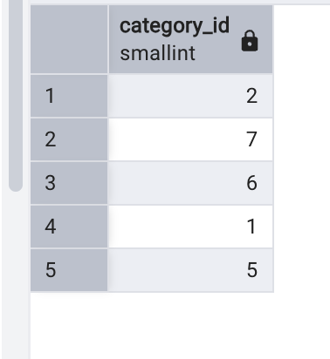

5.      Find orders that have no discounted items (Display the  order_id, EXCEPT)

**SELECT * FROM order_details**

**SELECT order_id FROM order_details**

**EXCEPT**

**SELECT DISTINCT order_id FROM order_details**

**WHERE discount>0**