**Day 6**

1.      Categorize products by stock status

(Display product_name, a new column stock_status whose values are based on below condition

 units_in_stock = 0  is 'Out of Stock'

       units_in_stock < 20  is 'Low Stock’)

**SELECT product_id,product_name,**

**CASE**

**WHEN units_in_stock=0 THEN 'Out Of Stock'**

**WHEN units_in_stock<20 THEN 'Low Stock'**

**ELSE**

**'High Stock'**

**END AS stock_status**

**FROM products**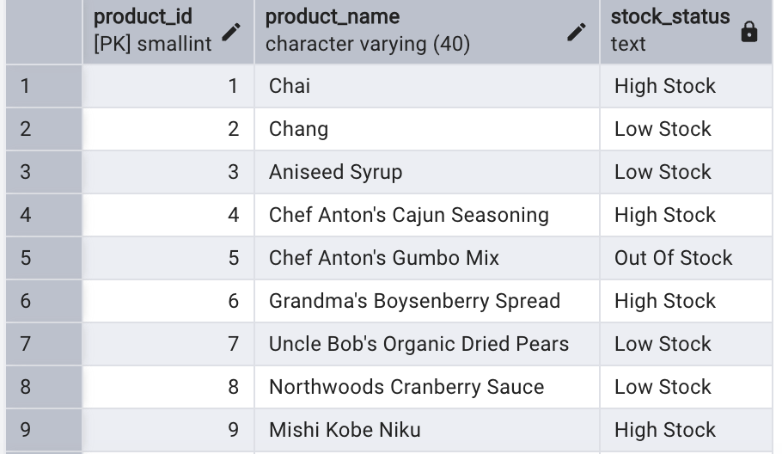

2.      Find All Products in Beverages Category

(Subquery, Display product_name,unitprice)

**SELECT product_name,unit_price FROM products**

**WHERE category_id =(**

**SELECT category_id**

**FROM categories**

**WHERE category_name = ‘Drinks’)**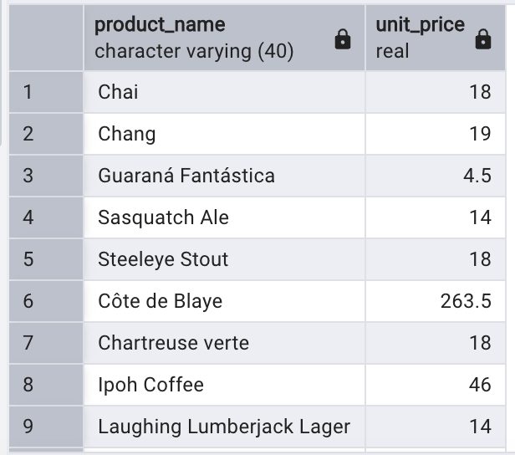

3.      Find Orders by Employee with Most Sales

(Display order_id,   order_date,  freight, employee_id.

Employee with Most Sales=Get the total no.of of orders for each employee then order by DESC and limit 1. Use Subquery)

**SELECT order_id,order_date,freight,employee_id**

**FROM orders**

**WHERE**

**employee_id=(**

**SELECT employee_id FROM orders**

**GROUP BY employee_id**

**ORDER BY COUNT(*) DESC LIMIT 1)**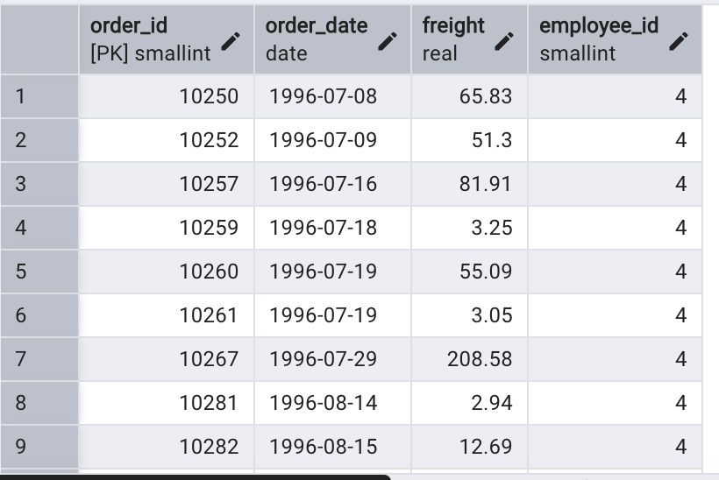

4.      Find orders  where for country!= ‘USA’ with freight costs higher than any order from USA. (Subquery, Try with ANY, ALL operators)

**SELECT order_id,freight,ship_country**

**FROM orders**

**WHERE**

**ship_country != 'USA'**

**AND freight > ANY (**

**SELECT freight**

**FROM orders**

**WHERE ship_country = ‘USA')**