**Day 7**

1.     Rank employees by their total sales

(Total sales = Total no of orders handled, JOIN employees and orders table)

**SELECT o.employee_id,e.first_name||' '||e.last_name AS employee_name,COUNT(o.order_id) AS total_sales,**

**RANK() OVER(**

**ORDER BY COUNT(o.order_id) DESC**

**) AS employee_rank**

**FROM orders o**

**INNER JOIN employees e ON o.employee_id = e.employee_id**

**GROUP BY o.employee_id,e.first_name,e.last_name**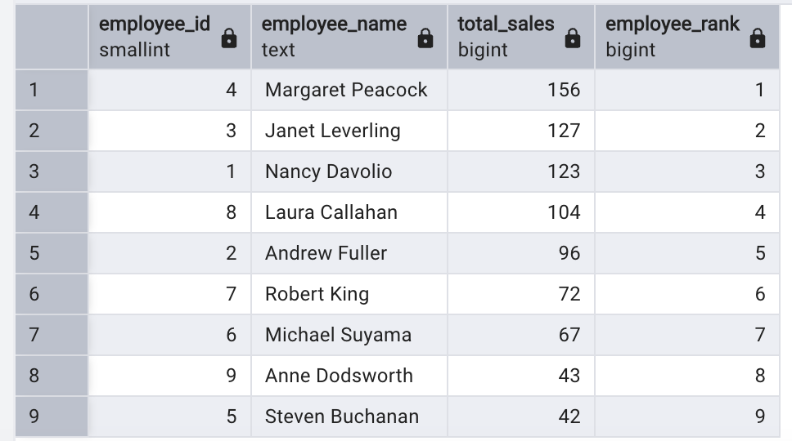

2.      Compare current order's freight with previous and next order for each customer.

(Display order_id,  customer_id,  order_date,  freight,

Use lead(freight) and lag(freight).

**SELECT**

**order_id,customer_id,order_date,freight,**

**lag(freight) over(partition by customer_id order by freight) AS previous_freight,**

**freight - lag(freight) over(partition by customer_id order by freight) AS lag_freight**

**FROM orders;**

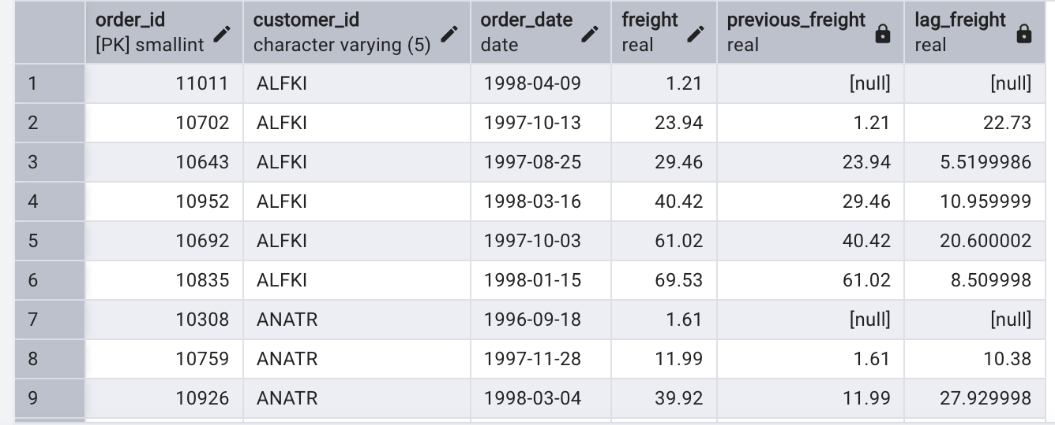

**SELECT**

**order_id,customer_id,order_date,freight,**

**lead(freight) over(partition by customer_id order by freight) AS next_freight,**

**freight - lead(freight) over(partition by customer_id order by freight) AS lead_freight**

**FROM orders**

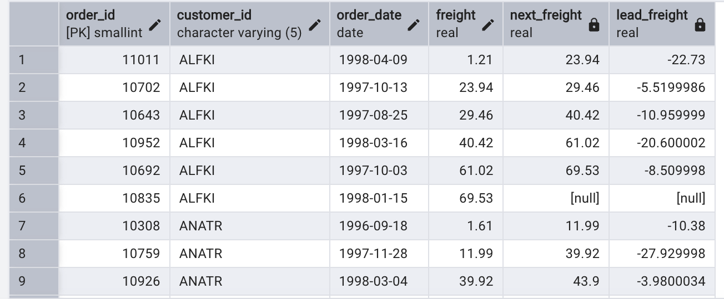

3.     Show products and their price categories, product count in each category, avg price:

         (HINT:

·  Create a CTE which should have price_category definition:

         WHEN unit_price < 20 THEN 'Low Price'

            WHEN unit_price < 50 THEN 'Medium Price'

            ELSE 'High Price'

·  In the main query display: price_category,  product_count in each price_category,  ROUND(AVG(unit_price)::numeric, 2) as avg_price)

**SELECT * FROM categories**

**SELECT * FROM products**

**WITH price_cat AS**

**(SELECT**

**product_id,product_name,unit_price,**

**CASE**

**WHEN unit_price<20 THEN 'Low Price'**

**WHEN unit_price<50 THEN 'Medium Price'**

**ELSE 'High Price'**

**END AS price_category**

**FROM products)**

**SELECT price_category, COUNT(*) AS product_count, ROUND(AVG(unit_price)::numeric,2) AS Avg_price**

**FROM price_cat**

**GROUP BY price_category**

**ORDER BY price_category;**

