**Day 8**

**1.     Create view vw_updatable_products (use same query whatever I used in the training)**

**Try updating view with below query and see if the product table also gets updated.**

**Update query:**

**UPDATE updatable_products SET unit_price = unit_price * 1.1 WHERE units_in_stock < 10;**

SELECT * FROM products WHERE units_in_stock<10

CREATE VIEW vw_updatable_products AS

SELECT

product_id,

product_name,

unit_price,

units_in_stock,

discontinued

FROM products

WHERE discontinued=0

WITH CHECK OPTION;

UPDATE INTO vw_updatable_products

SET unit_price = unit_price *1.1

WHERE units_in_stock<10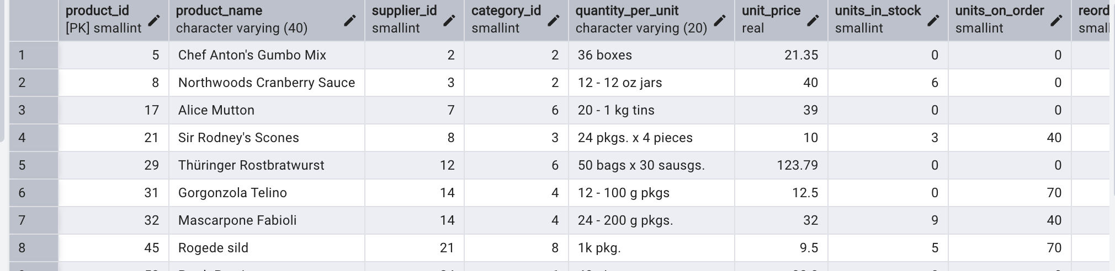

Note: After update, unit_price gets updated for units_in_stock<10 and discontinued=0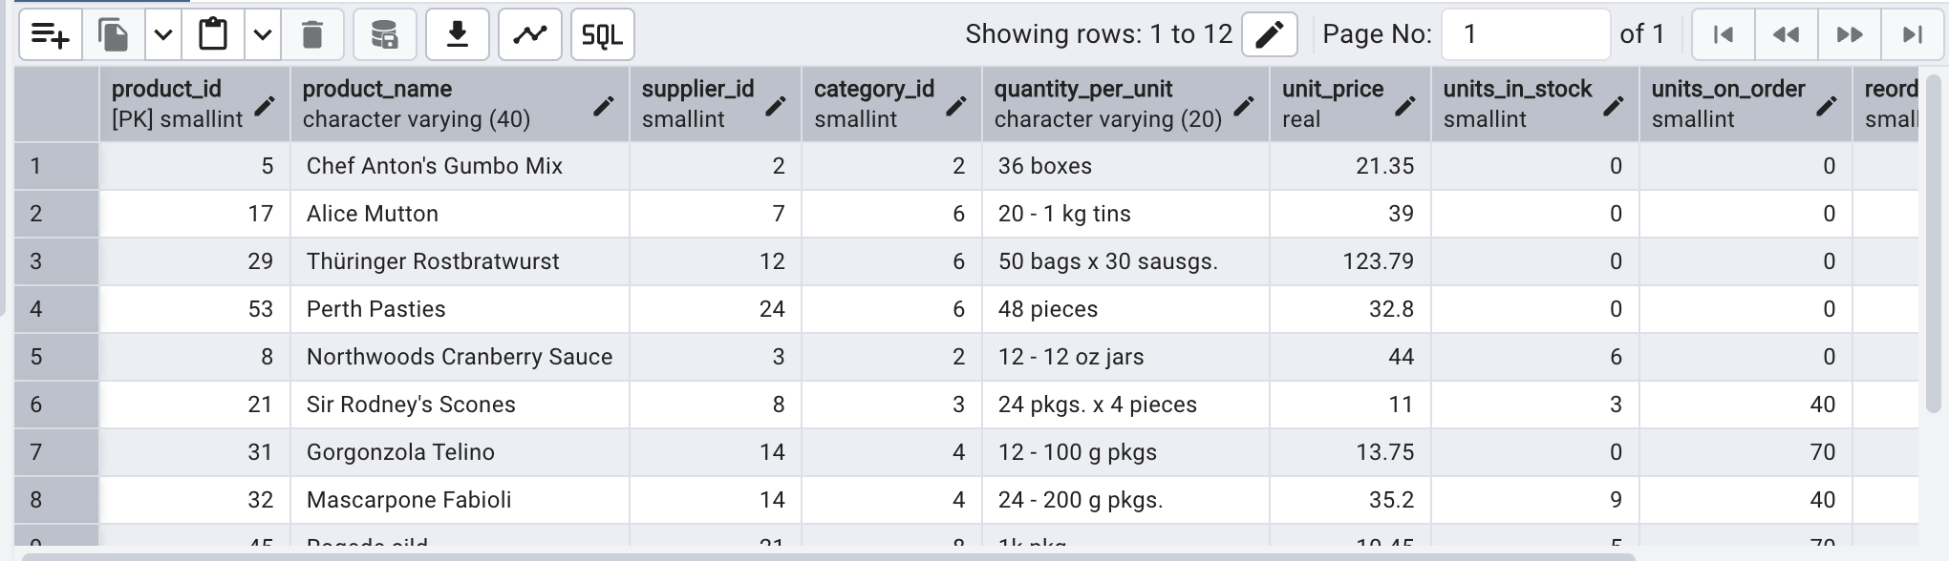

**2.     Transaction:**

**Update the product price for products by 10% in category id=1**

**Try COMMIT and ROLLBACK and observe what happens.**

 BEGIN;

UPDATE products

SET unit_price = unit_price * 1.10

WHERE category_id =1

DO$$

BEGIN

IF EXISTS(

SELECT 1

FROM products

WHERE category_id = 1 AND unit_price>50

) THEN

RAISE EXCEPTION 'some prices exceed $50';

ELSE

RAISE NOTICE 'price update successful';

END IF;

END $$;

COMMIT;

ROLLBACK;

SELECT * FROM products WHERE category_id =1 AND

unit_price>50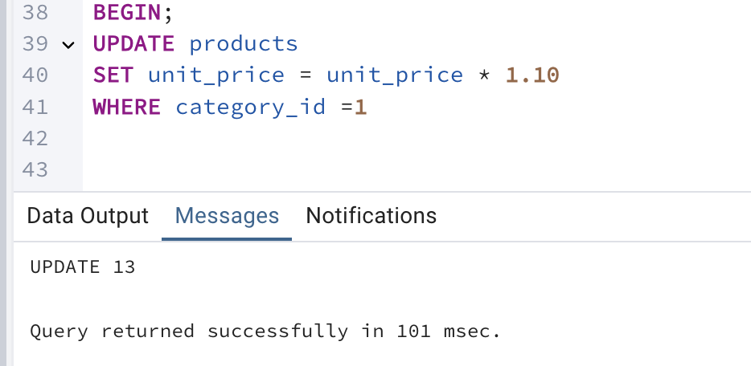

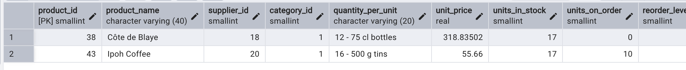

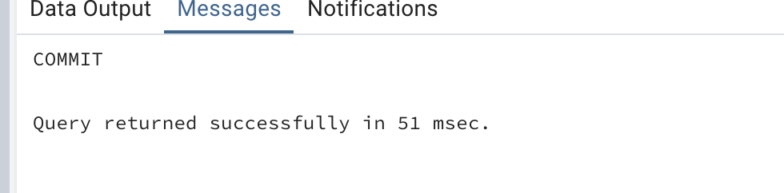

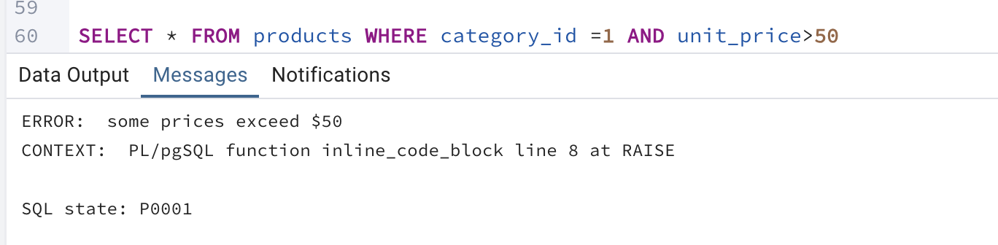

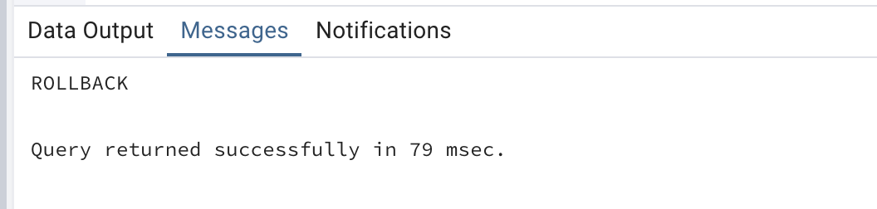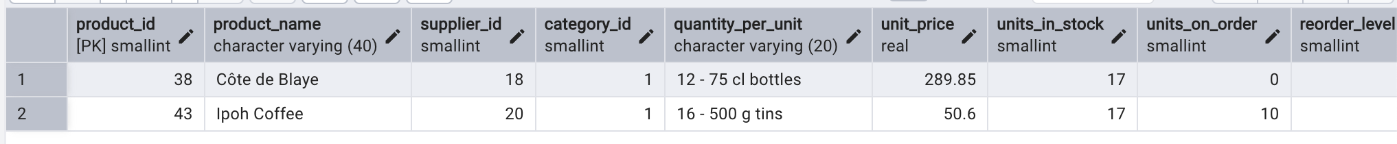

**3.     Create a regular view which will have below details** (Need to do joins):

**Employee_id,**

**Employee_full_name,**

**Title,**

**Territory_id,**

**territory_description,**

**region_description**

 CREATE VIEW vw_employee_details AS

SELECT

e.employee_id,e.first_name||' '||e.last_name AS full_name,e.title,

t.territory_id, t.territory_description,r.region_description

FROM employees e

JOIN employee_territories et

ON e.employee_id = et.employee_id

JOIN territories t

ON et.territory_id = t.territory_id

JOIN region r

ON t.region_id = r.region_id

GROUP BY e.employee_id,t.territory_id, t.territory_description,r.region_description

SELECT * FROM vw_employee_details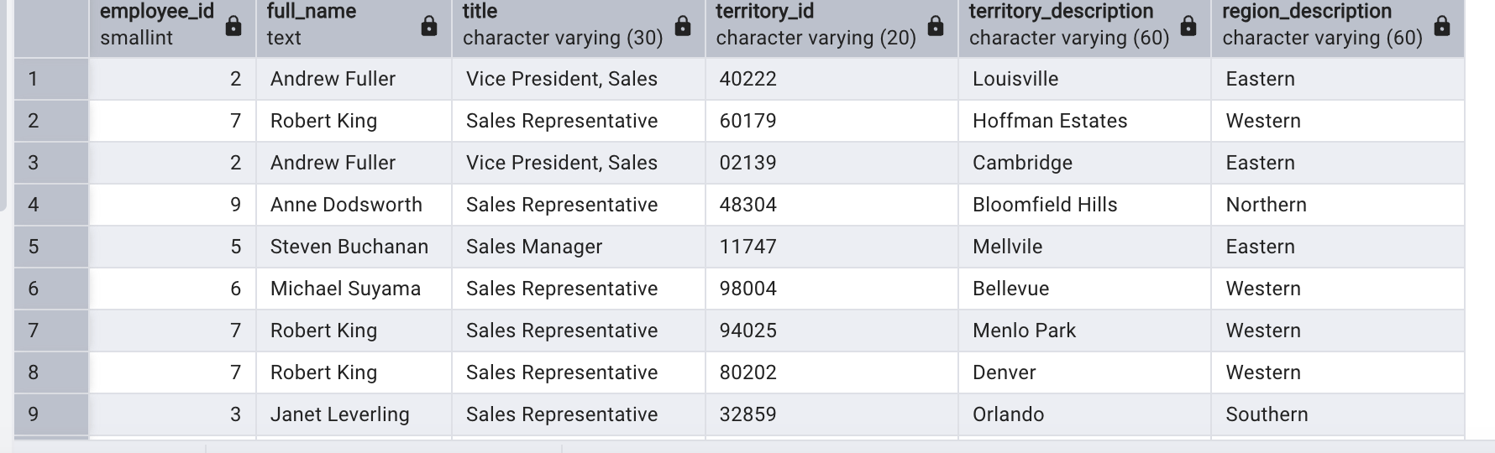

**4.     Create a recursive CTE based on Employee Hierarchy**

WITH RECURSIVE cte_employeehierarchy AS (

SELECT

employee_id,

first_name,

last_name,

reports_to,

0 AS LEVEL

FROM

employees e

WHERE

reports_to IS NULL

UNION ALL

SELECT

e.employee_id,

e.first_name,

e.last_name,

e.reports_to,

eh.level+1

FROM

employees e

JOIN

cte_employeehierarchy eh

ON

eh.employee_id = e.reports_to

)

SELECT level,employee_id,first_name||' '||last_name AS full_name

FROM

cte_employeehierarchy

ORDER BY level,employee_id;