1**.      Create AFTER UPDATE trigger to track product price changes**

**Create a row level trigger for below event:**

**AFTER UPDATE OF unit_price ON products**

**Test the trigger by updating the product price by 10% to any one product_id.**

SELECT * FROM products

CREATE TABLE product_price_audit(

audit_id SERIAL PRIMARY KEY,

product_id INT,

product_name VARCHAR(40),

old_price DECIMAL(10,2),

new_price DECIMAL(10,2),

change_date TIMESTAMP DEFAULT current_timestamp,

user_name VARCHAR(50) DEFAULT current_user

)

CREATE OR REPLACE FUNCTION log_price_change()

RETURNS TRIGGER

AS

$$

BEGIN

INSERT INTO product_price_audit(product_id,product_name,old_price,new_price)

VALUES(OLD.product_id,OLD.product_name,OLD.unit_price,NEW.unit_price);

RETURN NEW;

END;

$$ LANGUAGE plpgsql;

CREATE TRIGGER after_update_price_trigger1

AFTER UPDATE OF unit_price ON products

FOR EACH ROW

EXECUTE FUNCTION log_price_change();

UPDATE products

SET unit_price = unit_price * 1.10

WHERE product_id = 10;

SELECT * FROM product_price_audit;

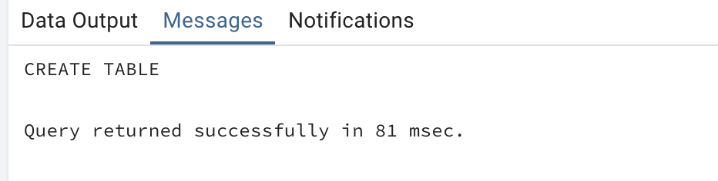

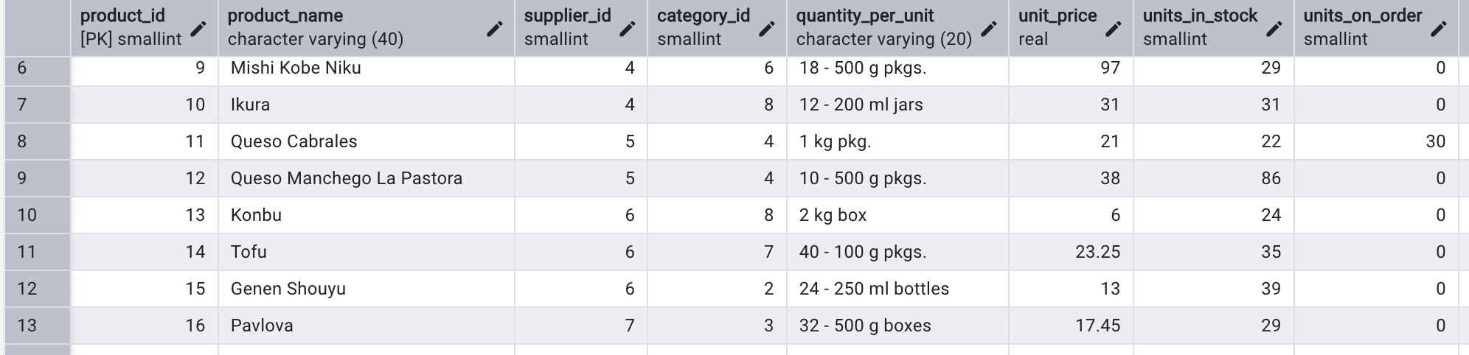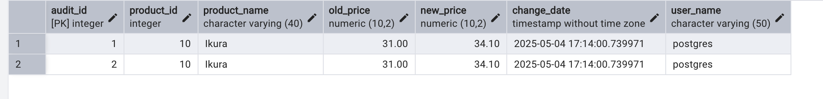

**2.      Create stored procedure  using IN and INOUT parameters to assign tasks to employees.**

**After creating stored procedure test by calling  it:**

**CALL assign_task(1, 'Review Reports')**

**You should see the entry in employee_tasks table.**

SELECT * FROM employees

CREATE OR REPLACE PROCEDURE assign_task(

IN p_employee_id INT,

IN p_task_name VARCHAR(50),

INOUT p_task_count INT DEFAULT 0

)

LANGUAGE plpgsql

AS $$

BEGIN

CREATE TABLE IF NOT EXISTS employee_tasks(

task_id SERIAL PRIMARY KEY,

employee_id INT,

task_name VARCHAR(50),

assigned_date DATE DEFAULT CURRENT_DATE

);

INSERT INTO employee_tasks(employee_id,task_name)

VALUES(p_employee_id,p_task_name);

SELECT COUNT(*) INTO p_task_count

FROM employee_tasks

WHERE employee_id = p_employee_id;

RAISE NOTICE 'Task "%" assigned to employee %. Total tasks: %',p_task_name,p_employee_id,p_task_count;

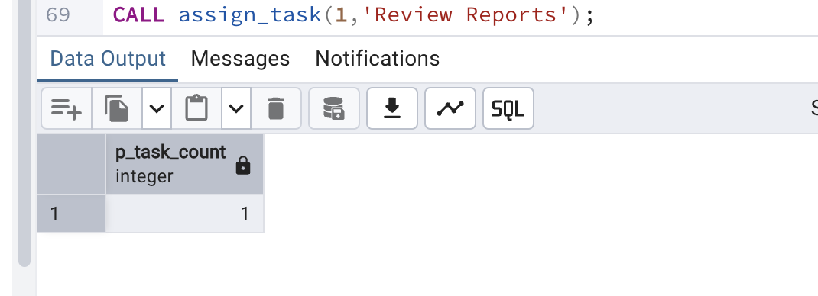

END;

$$;