DAY2_ASSIGNMENT

-- 1) Alter Table:

-- Add a new column linkedin_profile to employees table to store LinkedIn URLs as varchar.

ALTER TABLE EMPLOYEES

ADD COLUMN LINKEDIN_PROFILE VARCHAR(255);

### OUTPUT



SELECT

LINKEDIN_PROFILE

FROM

EMPLOYEES

### OUTPUT

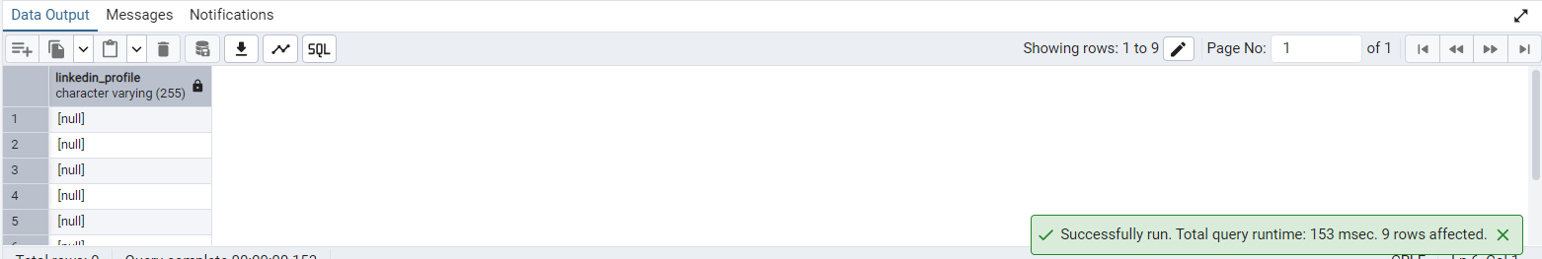

-- Change the linkedin_profile column data type from VARCHAR to TEXT.

ALTER TABLE EMPLOYEES

ALTER COLUMN LINKEDIN_PROFILE

SET DATA TYPE TEXT;

### OUTPUT



-- Update nulls

UPDATE EMPLOYEES

SET

LINKEDIN_PROFILE = 'https://www.linkedin.com/in/unknown-' || EMPLOYEEID

WHERE

LINKEDIN_PROFILE IS NULL;

### OUTPUT



SELECT

LINKEDIN_PROFILE

FROM

EMPLOYEES

### OUTPUT

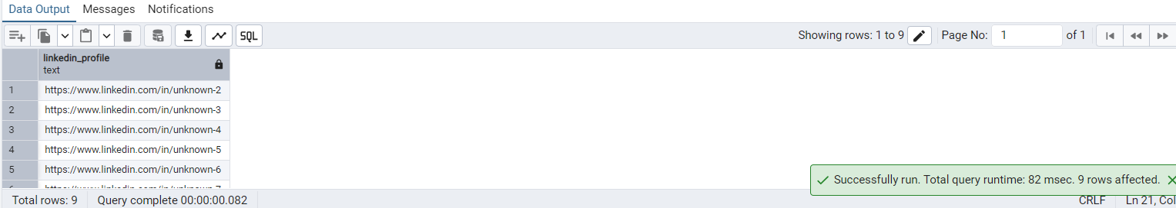

-- Add unique, not null constraint to linkedin_profile

-- Add NOT NULL constraint

ALTER TABLE EMPLOYEES

ALTER COLUMN LINKEDIN_PROFILE

SET NOT NULL;

### OUTPUT

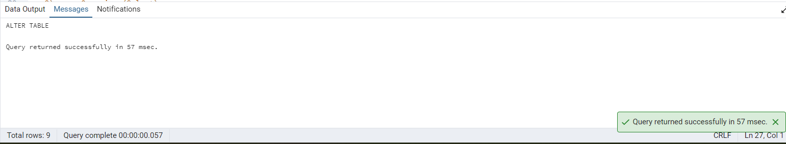

--Add Unique

ALTER TABLE EMPLOYEES

ADD CONSTRAINT UNIQUE_LINKEDIN_PROFILE UNIQUE (LINKEDIN_PROFILE);

### OUTPUT

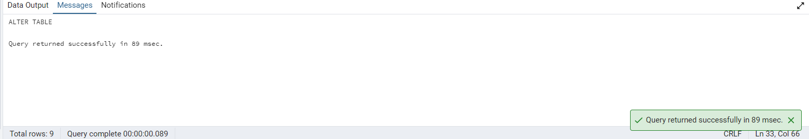

-- Drop column linkedin_profile

ALTER TABLE EMPLOYEES

DROP COLUMN LINKEDIN_PROFILE;

### OUTPUT

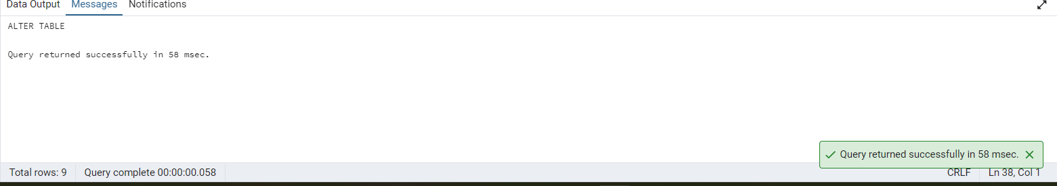

-- 2) Querying (Select)

-- Retrieve the first name, last name, and title of all employees

SELECT

*

FROM

PRODUCTS

SELECT

EMPLOYEENAME,

SPLIT_PART(EMPLOYEENAME, ' ', 1) AS FIRST_NAME,

SPLIT_PART(EMPLOYEENAME, ' ', 2) AS LAST_NAME,

TITLE

FROM

EMPLOYEES;

### OUTPUT

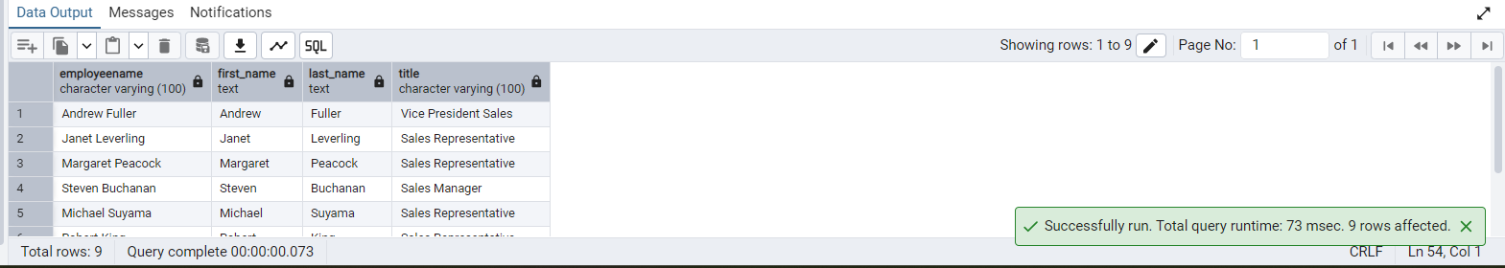

-- Find all unique unit prices of products

SELECT DISTINCT

UNITPRICE

FROM

PRODUCTS;

### OUTPUT

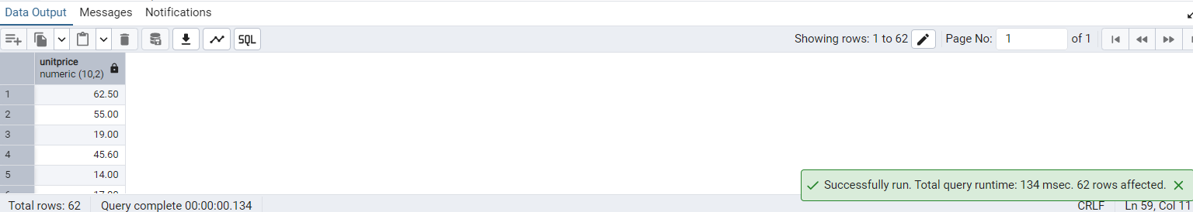

-- List all customers sorted by company name in ascending order

SELECT

CUSTOMER_ID,

COMPANY_NAME

FROM

CUSTOMERS

ORDER BY

COMPANY_NAME ASC;

### OUTPUT

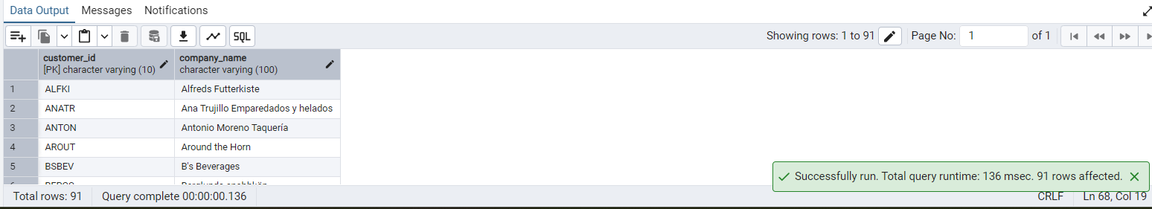

-- Display product name and unit price, but rename the unit_price column as price_in_usd

SELECT

PRODUCTNAME,

UNITPRICE AS PRICE_IN_USD

FROM

PRODUCTS

### OUTPUT

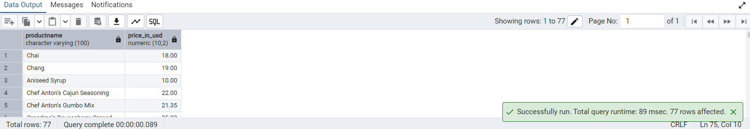

-- 3) Filtering

-- Get all customers from Germany.

SELECT

CUSTOMER_ID,

CONTACT_NAME

FROM

CUSTOMERS

WHERE

COUNTRY = 'Germany';

### OUTPUT

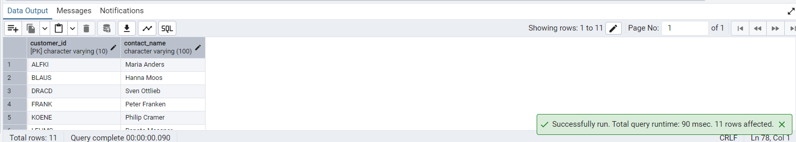

-- Find all customers from France or Spain

SELECT

CUSTOMER_ID,

CONTACT_NAME,

COUNTRY

FROM

CUSTOMERS

WHERE

COUNTRY = 'Germany'

OR COUNTRY = 'Spain';

### OUTPUT

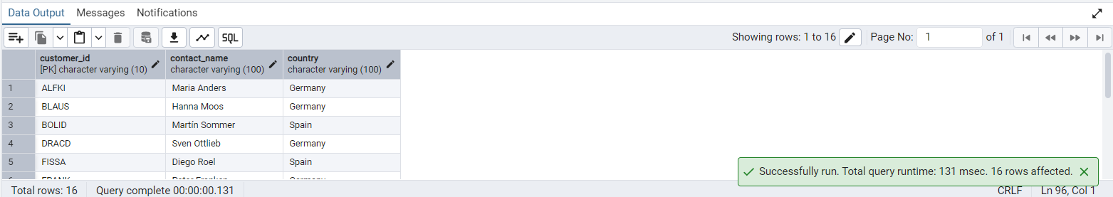

-- Retrieve all orders placed in 1997 (based on order_date), and either have freight greater than 50 or the shipped date available (i.e., non-NULL) (Hint: EXTRACT(YEAR FROM order_date))

SELECT

*

FROM

ORDERS

WHERE

EXTRACT(

YEAR

FROM

ORDERDATE

) = 1997

AND (

FREIGHT > 50

OR SHIPPEDDATE IS NOT NULL

);

### OUTPUT

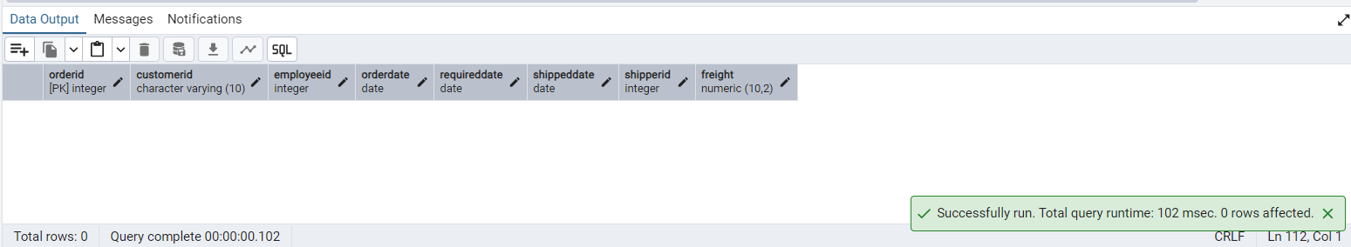

-- 4) Filtering

-- Retrieve the product_id, product_name, and unit_price of products where the unit_price is greater than 15.

SELECT

PRODUCTID,

PRODUCTNAME,

UNITPRICE

FROM

PRODUCTS

WHERE

UNITPRICE > 15

### OUTPUT

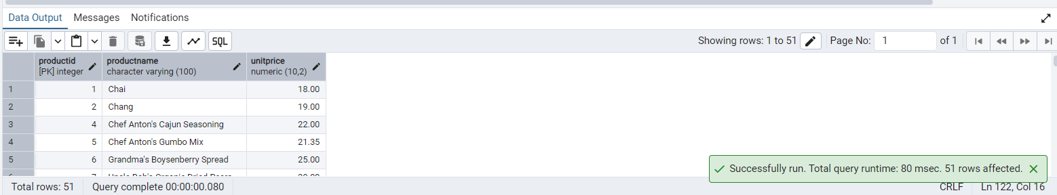

-- List all employees who are located in the USA and have the title "Sales Representative".

SELECT

*

FROM

EMPLOYEES

WHERE

COUNTRY = 'USA'

AND TITLE = 'Sales Representative'

### OUTPUT

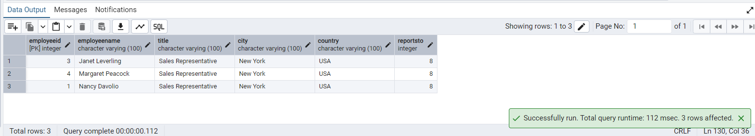

-- Retrieve all products that are not discontinued and priced greater than 30.

SELECT

*

FROM

PRODUCTS

WHERE

DISCONTINUED = FALSE

AND UNITPRICE > 30;

### OUTPUT

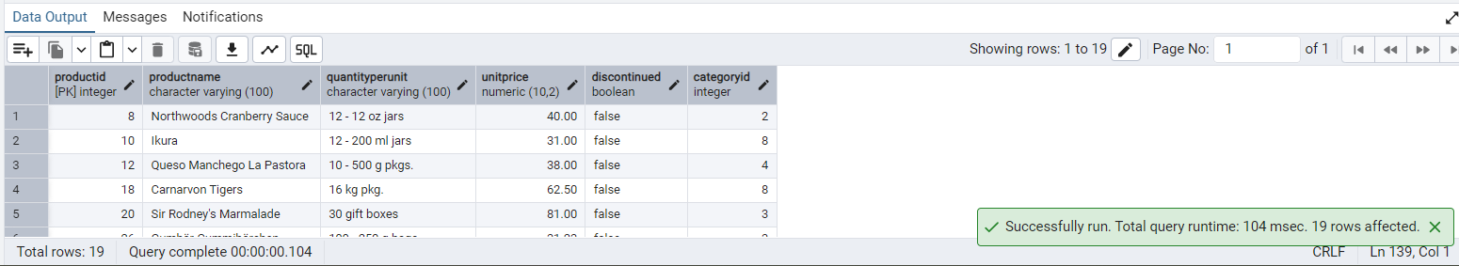

-- 5) LIMIT/FETCH

-- Retrieve the first 10 orders from the orders table.

SELECT

*

FROM

ORDERS

LIMIT

10;

--OR--

SELECT

*

FROM

ORDERS

ORDER BY

ORDERDATE

LIMIT

10;

### OUTPUT

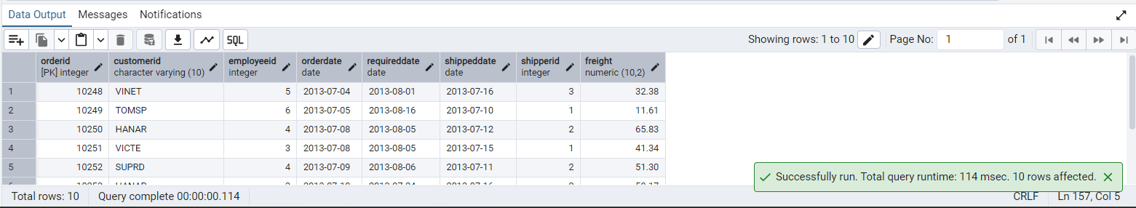

-- Retrieve orders starting from the 11th order, fetching 10 rows (i.e., fetch rows 11-20).

SELECT

*

FROM

ORDERS

OFFSET

10

LIMIT

10;

### OUTPUT

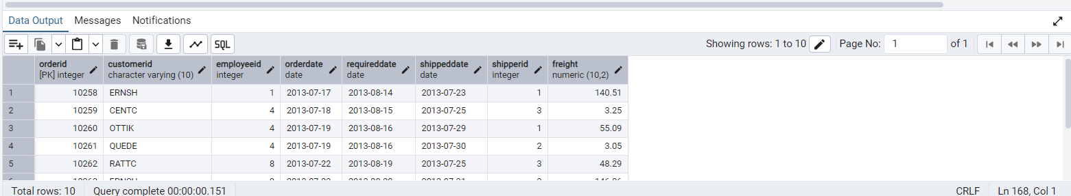

-- 6) Filtering (IN, BETWEEN)

-- List all customers who are either Sales Representative, Owner

SELECT

*

FROM

CUSTOMERS

WHERE

CONTACT_TITLE IN ('Sales Representative', 'Owner');

### OUTPUT

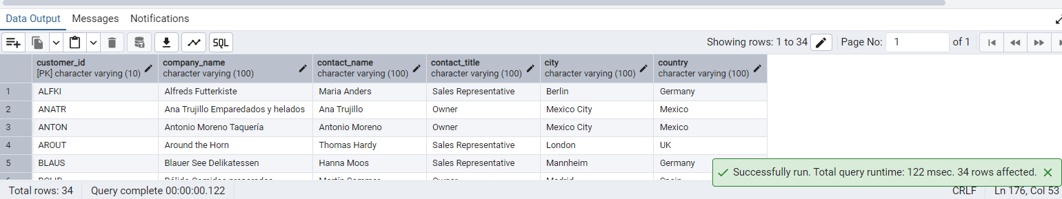

-- Retrieve orders placed between January 1, 2013, and December 31, 2013.

SELECT

*

FROM

ORDERS

WHERE

ORDERDATE BETWEEN '2013-01-01' AND '2013-12-31';

### OUTPUT

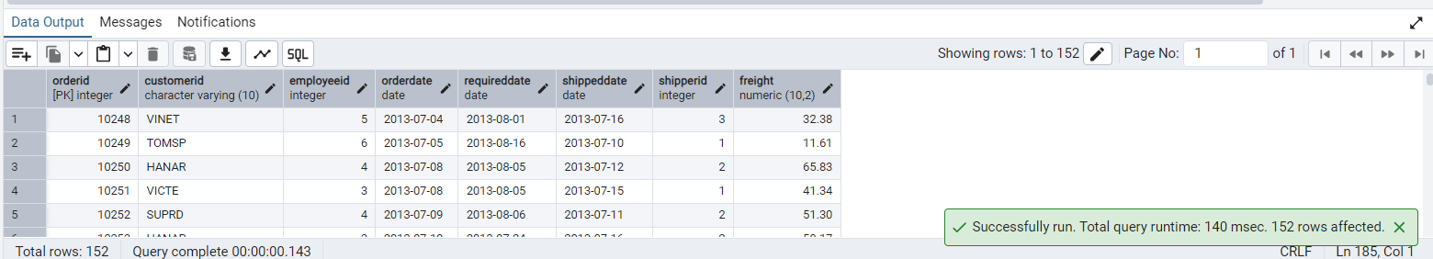

-- 7) Filtering

-- List all products whose category_id is not 1, 2, or 3.

SELECT

*

FROM

PRODUCTS

WHERE

CATEGORYID NOT IN (1, 2, 3);

### OUTPUT

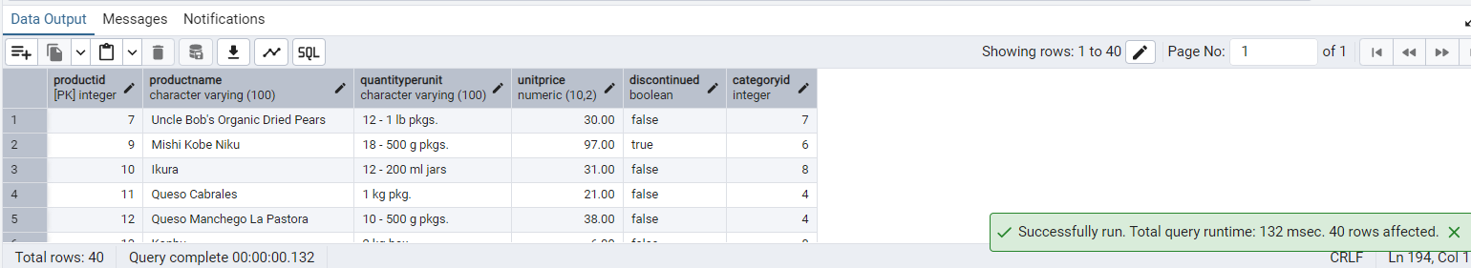

-- Find customers whose company name starts with "A".

SELECT

*

FROM

CUSTOMERS

WHERE

COMPANY_NAME LIKE 'A%';

### OUTPUT

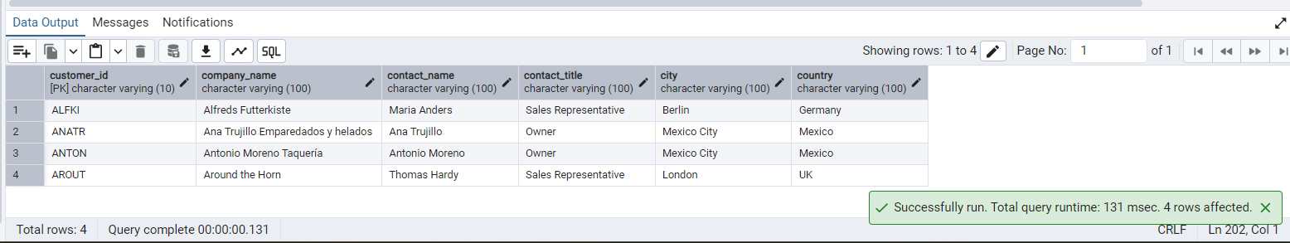

-- 8) INSERT into orders table:

-- Task: Add a new order to the orders table with the following details:

-- Order ID: 11078

-- Customer ID: ALFKI

-- Employee ID: 5

-- Order Date: 2025-04-23

-- Required Date: 2025-04-30

-- Shipped Date: 2025-04-25

-- shipperID:2

-- Freight: 45.50

INSERT INTO

ORDERS (

ORDERID,

CUSTOMERID,

EMPLOYEEID,

ORDERDATE,

REQUIREDDATE,

SHIPPEDDATE,

SHIPPERID,

FREIGHT

)

VALUES

(

11078,

'ALFKI',

5,

'2025-04-23',

'2025-04-30',

'2025-04-25',

2,

45.50

);

### OUTPUT

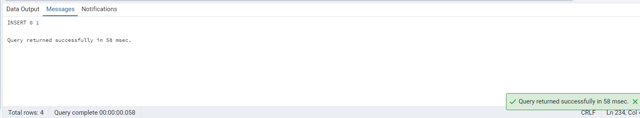

SELECT

*

FROM

ORDERS

WHERE

ORDERID = 11078

### OUTPUT

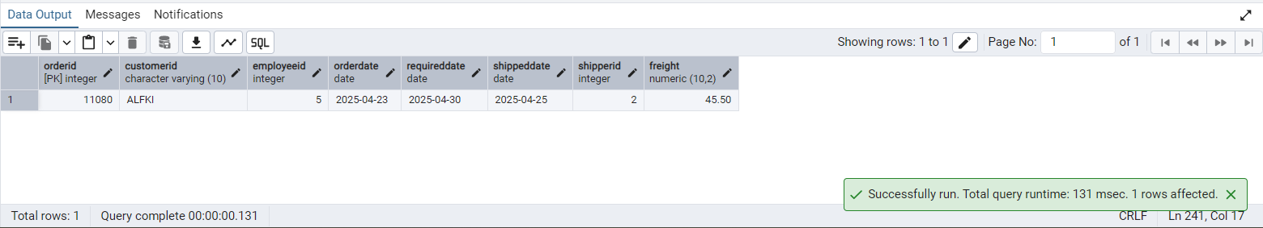

-- 9) Increase(Update) the unit price of all products in category_id =2 by 10%.

-- (HINT: unit_price =unit_price * 1.10)

UPDATE PRODUCTS

SET

UNITPRICE = UNITPRICE * 1.10

WHERE

CATEGORYID = 2;

### OUTPUT

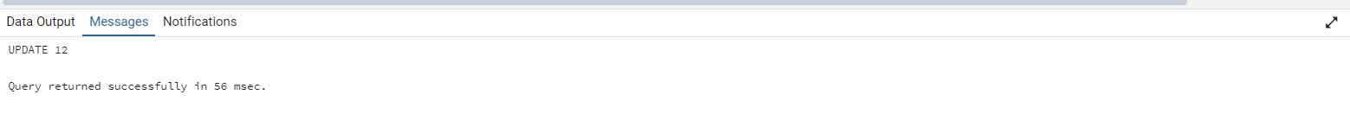

SELECT

UNITPRICE

FROM

PRODUCTS

WHERE

CATEGORYID =2

### OUTPUT

