**Day 2 Assignment Output**

1. **Alter_Table**

* Add a new column linkedin_profile to employees table to store LinkedIn URLs as varchar

**ALTER TABLE employees ADD COLUMN linkedin_profile VARCHAR(500);**

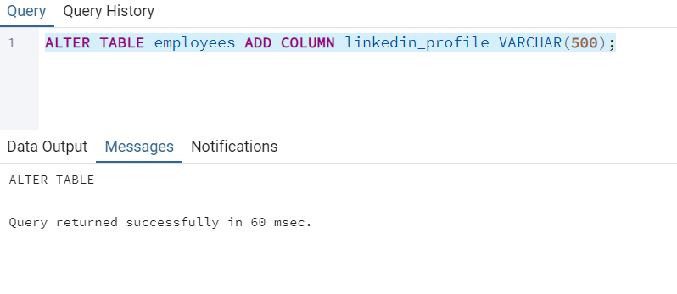

* Change the linkedin_profile column data type from VARCHAR to TEXT

**ALTER TABLE employees ALTER COLUMN linkedin_profile SET DATA TYPE TEXT;**

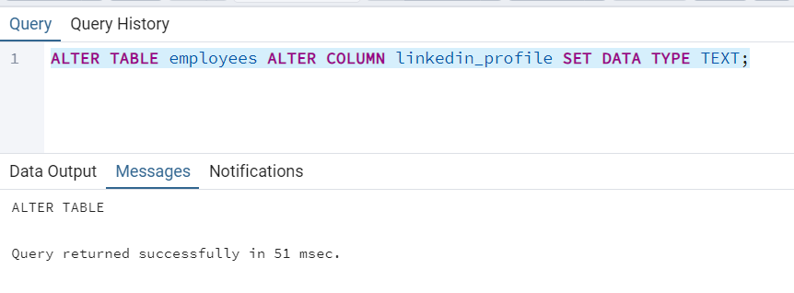

* Add unique, not null constraint to linkedin_profile

**UPDATE employees SET linkedin_profile = 'NOT_FOUND';**

**ALTER TABLE employees ALTER COLUMN linkedin_profile**

**SET NOT NULL;**

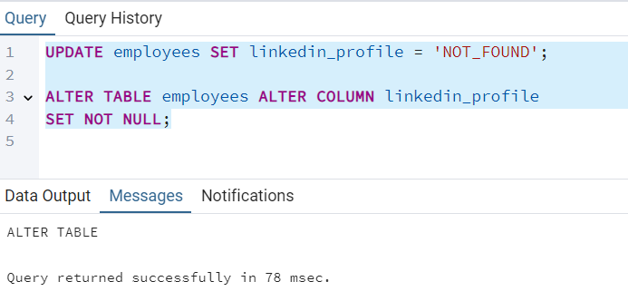

* Drop column linkedin_profile

**ALTER TABLE employees**

**DROP COLUMN linkedin_profile**

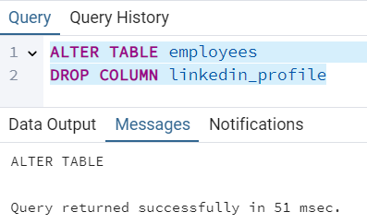

1. **Querying (Select)**
   * Retrieve the employee name and title of all employees

**Select employee_name, title from employees**

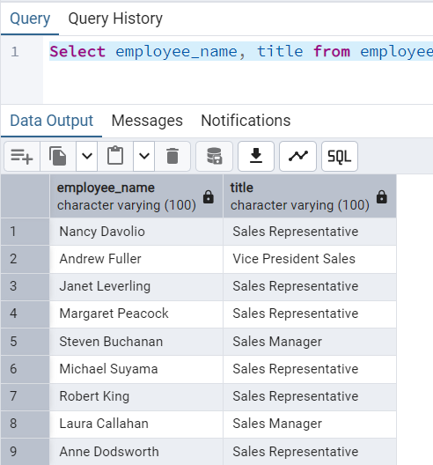

* Find all unique unit prices of products

**SELECT DISTINCT unit_price FROM products**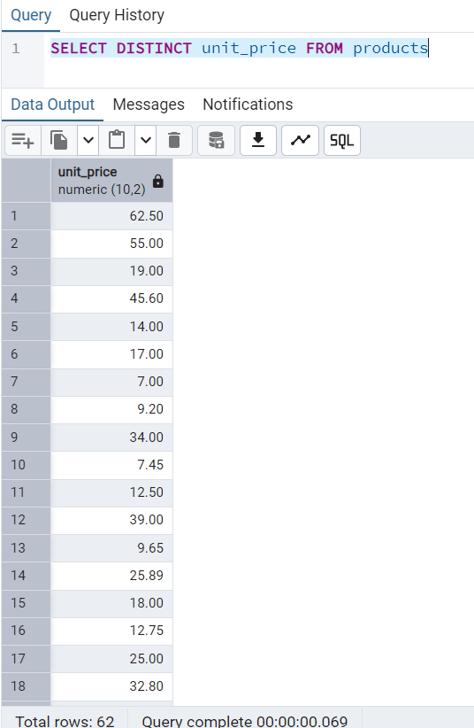

* List all customers sorted by company name in ascending order

**SELECT * FROM customers ORDER BY company_name**

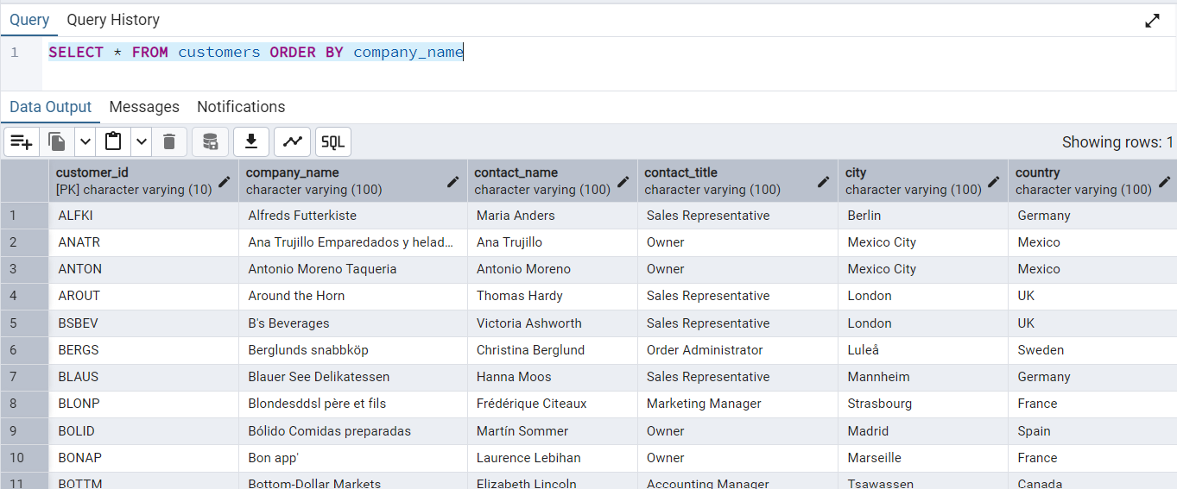

* Display product name and unit price, but rename the unit_price column as price_in_usd

**SELECT product_name, unit_price AS price_in_usd from products**

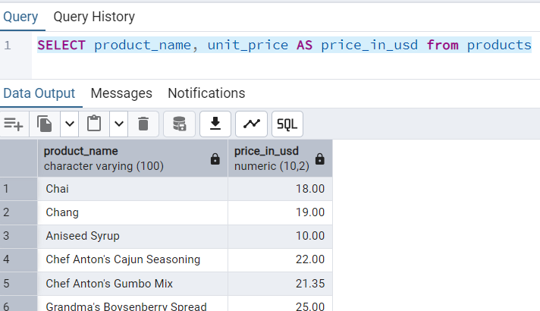

**3. Filtering**

* Get all customers from Germany

**SELECT * FROM customers where country = 'Germany'**

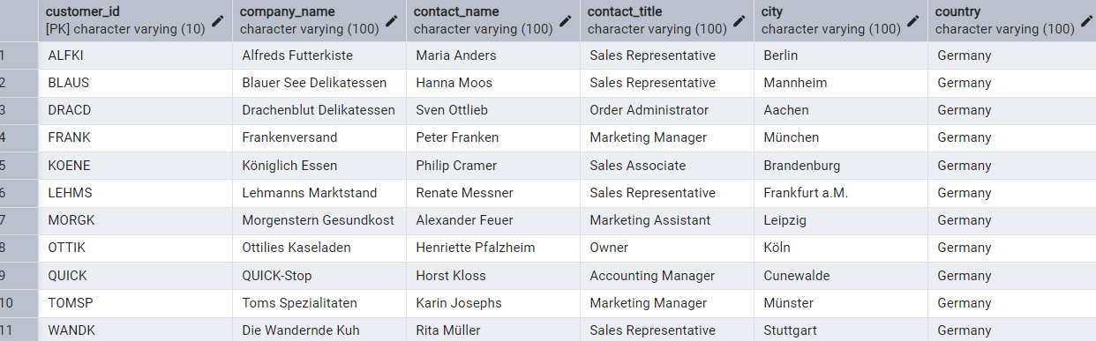

* Find all customers from France or Spain

**SELECT * FROM customers where country IN ('France', 'Spain')**

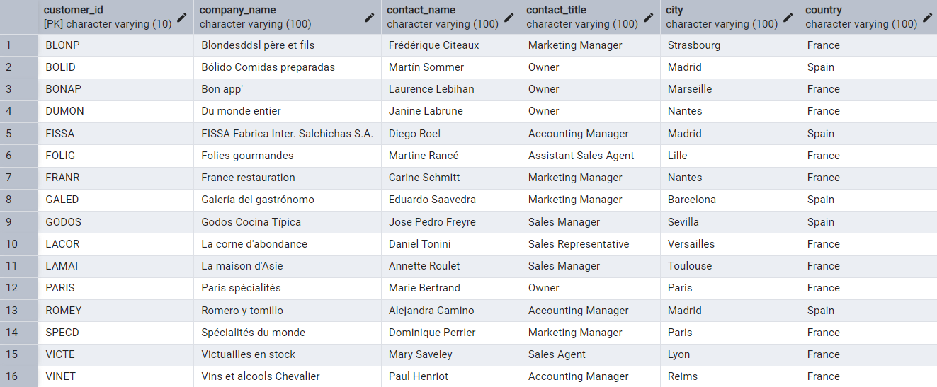

* Retrieve all orders placed in 2014(based on order_date), and either have freight greater than 50 or the shipped date available (i.e., non-NULL) (Hint: EXTRACT(YEAR FROM order_date))

**SELECT * FROM orders WHERE EXTRACT(YEAR FROM order_date) = 2014 AND (freight > 50 OR shipped_date IS NOT NULL)**

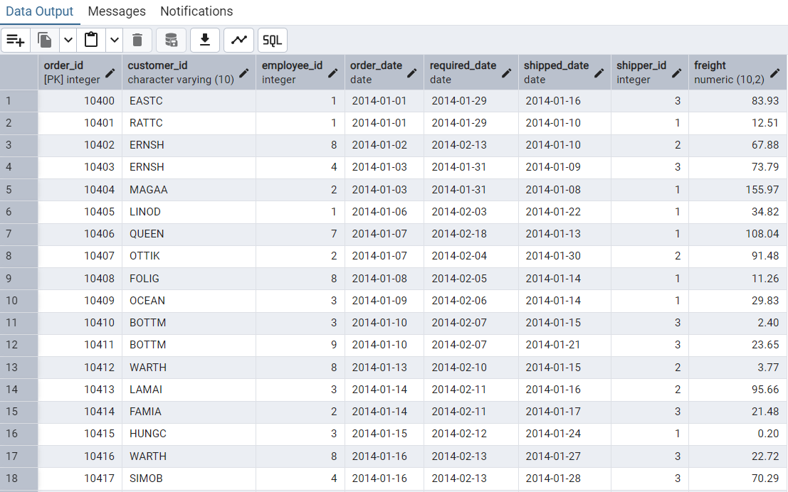

**4. Filtering**

* Retrieve the product_id, product_name, and unit_price of products where the unit_price is greater than 15

**SELECT product_id, product_name, unit_price FROM products WHERE unit_price > 15**

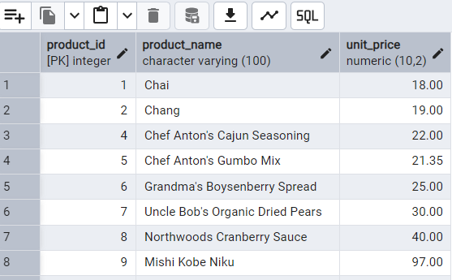

* List all employees who are located in the USA and have the title "Sales Representative”

**SELECT * FROM employees WHERE COUNTRY = 'USA' AND title = 'Sales Representative'**

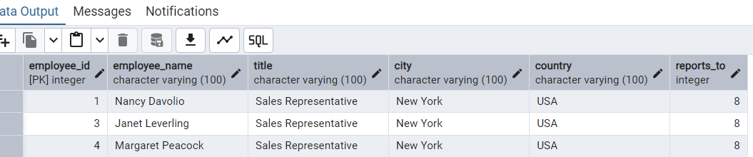

* Retrieve all products that are not discontinued and priced greater than 30

**SELECT * FROM products WHERE unit_price > 30 and discontinued <> TRUE**

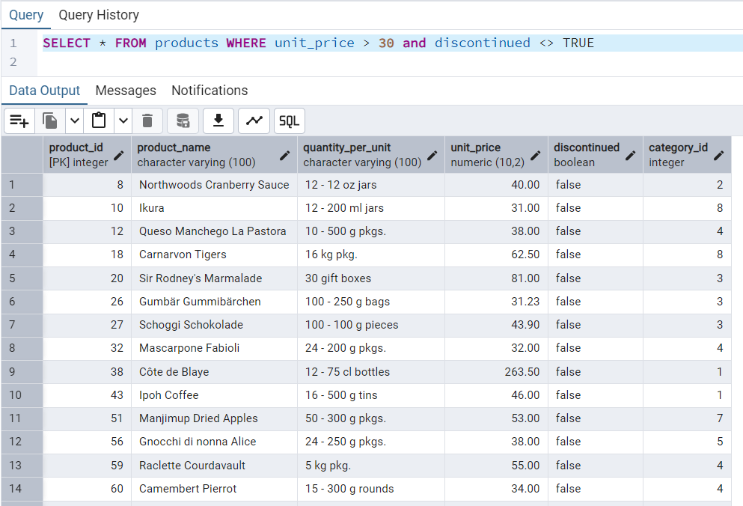

**5. LIMIT/FETCH**

* Retrieve the first 10 orders from the orders table.

**SELECT * FROM orders FETCH FIRST 10 ROWS ONLY**

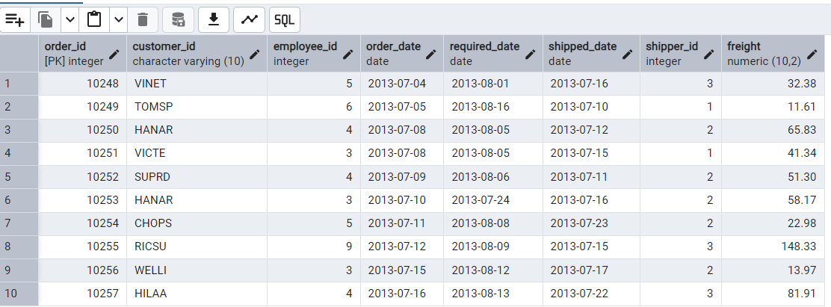

* Retrieve orders starting from the 11th order, fetching 10 rows (i.e., fetch rows 11-20).

**SELECT * FROM orders OFFSET 10 ROWS FETCH NEXT 10 ROWS ONLY**

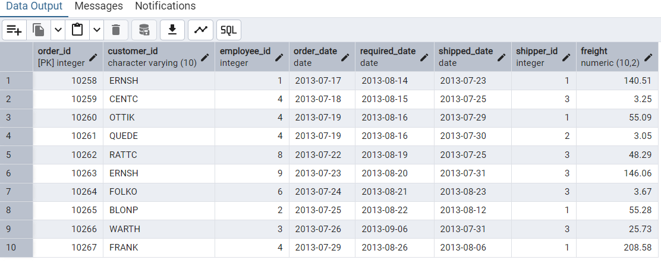

**6. Filtering (IN, BETWEEN)**

* List all customers who are either Sales Representative, Owner

**SELECT * FROM customers WHERE contact_title IN ('Sales Representative', 'Owner')**

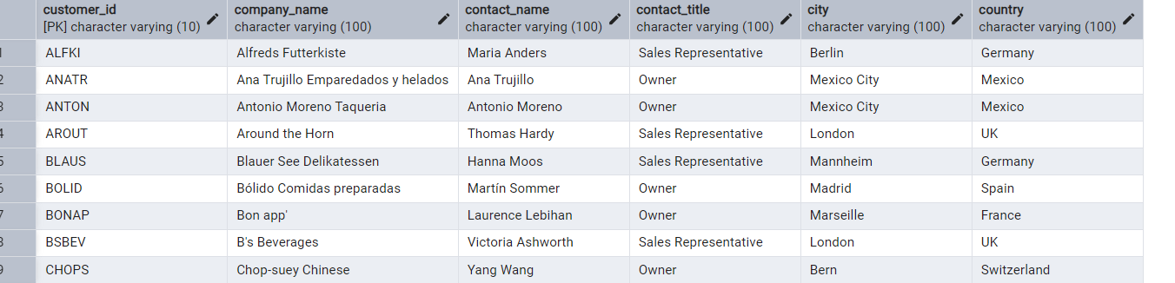

* Retrieve orders placed between January 1, 2013, and December 31, 2013.

**SELECT * FROM orders WHERE order_date BETWEEN '2013-01-01' AND '2013-12-31'**

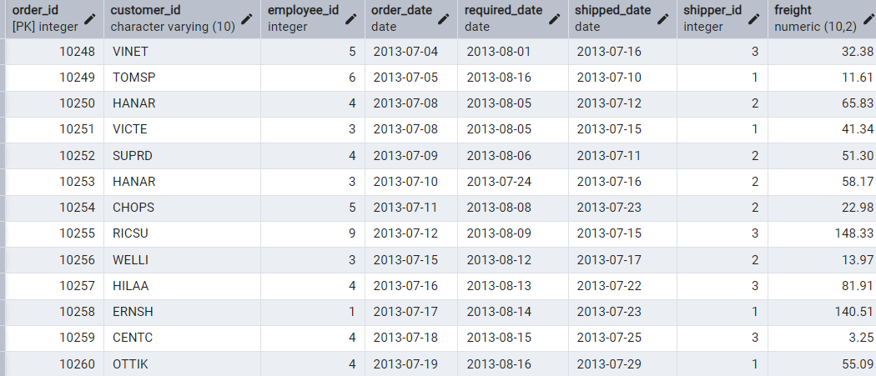

**7. Filtering**

* List all products whose category_id is not 1, 2, or 3

**SELECT * FROM products WHERE category_id NOT IN (1, 2, 3)**

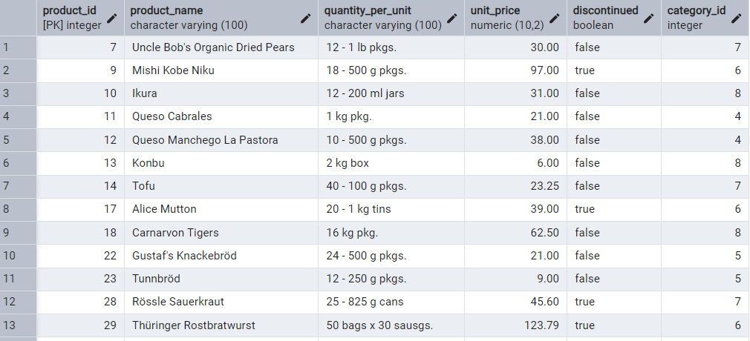

* Find customers whose company name starts with "A"

**SELECT * FROM customers WHERE company_name LIKE 'A%'**

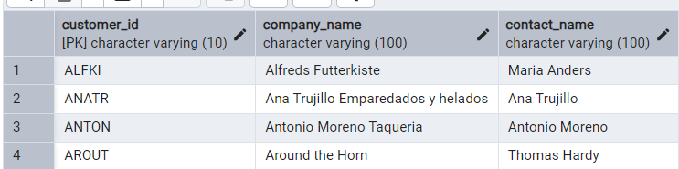

**8. INSERT into orders table**

* Add a new order to the orders table with the following details

**INSERT INTO orders(order_id, customer_id, employee_id, order_date, required_date, shipped_date, shipper_id, freight)**

**VALUES (11078, 'ALFKI', 5, '2025-04-23', '2025-04-30', '2025-04-25', 2, 45.50)**

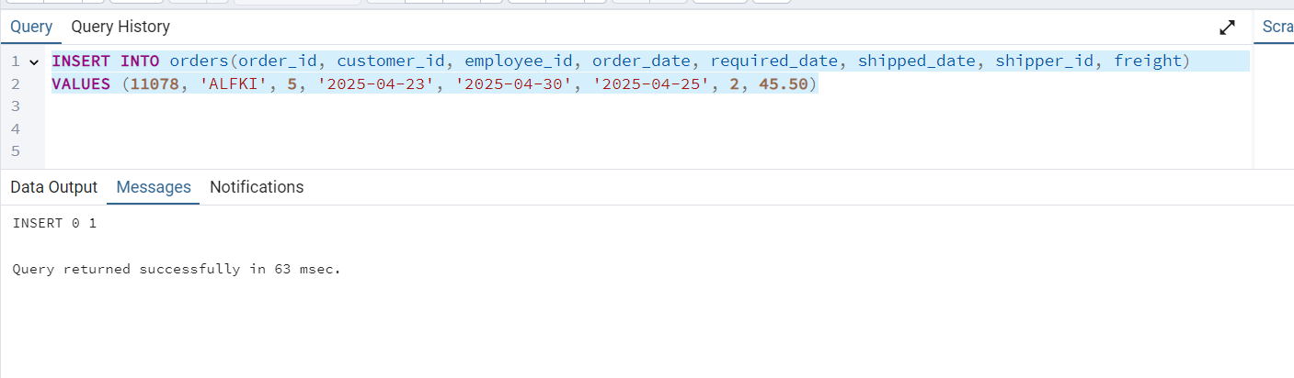

**9. Increase(Update) the unit price of all products in category_id =2 by 10%**

* **UPDATE products SET unit_price = unit_price * 1.10 WHERE category_id = 2**

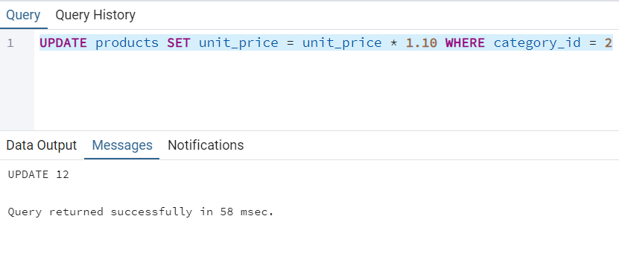

**10. Create northwind database and import northwind.sql**

