1) ALTER TABLE employees

ADD COLUMN linkedin_profile VARCHAR;

ALTER TABLE employees

ALTER COLUMN linkedin_profile TYPE TEXT;

ALTER TABLE employees

ALTER COLUMN linkedin_profile SET NOT NULL;

ALTER TABLE employees

ADD CONSTRAINT unique_linkedin_profile UNIQUE (linkedin_profile);

ALTER TABLE employees

DROP COLUMN linkedin_profile;

2) SELECT employeename, title

FROM employees;

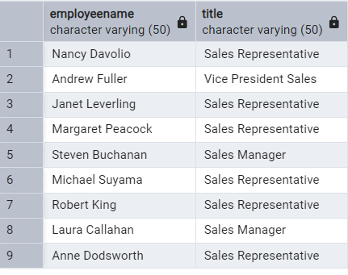

SELECT DISTINCT unitprice

FROM products;

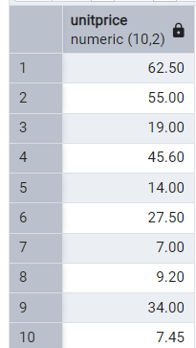

SELECT *

FROM customers

ORDER BY companyname ASC;

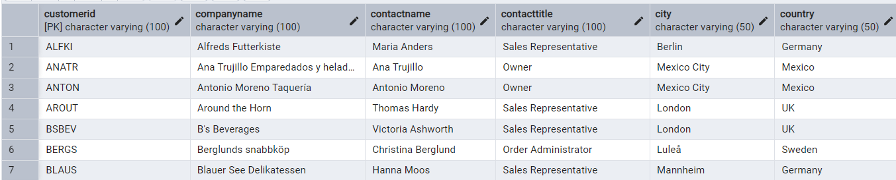

SELECT productname, unitprice AS price_in_usd

FROM products;

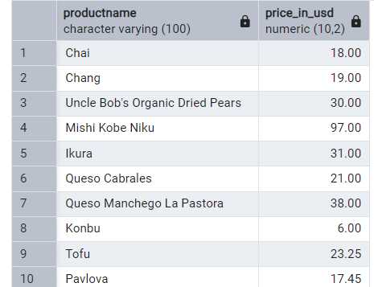

3) SELECT *

FROM customers

WHERE country = 'Germany';

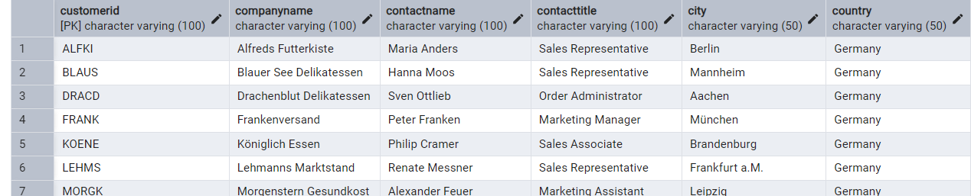

SELECT *

FROM customers

WHERE country IN ('France', 'Spain');

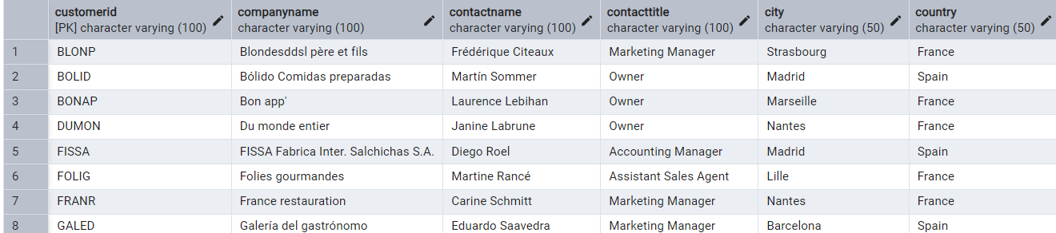

SELECT *

FROM orders

WHERE EXTRACT(YEAR FROM orderdate) = 1997

AND (freight > 50 OR shippeddate IS NOT NULL);

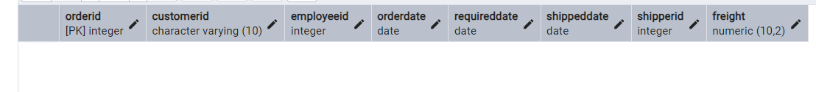

4)

SELECT productid, productname, unitprice

FROM products

WHERE unitprice > 15;

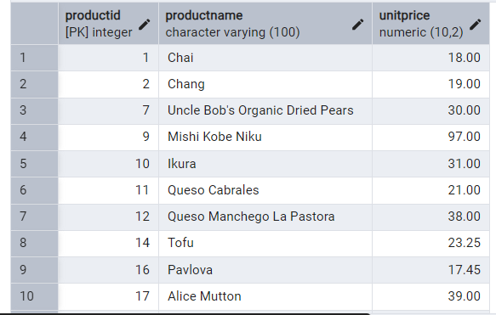

SELECT *

FROM employees

WHERE country = 'USA'

AND title = 'Sales Representative';

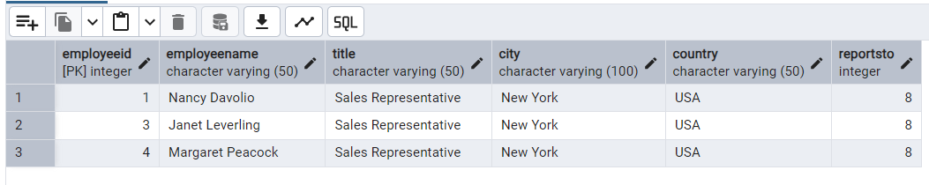

SELECT *

FROM products

WHERE discontinued = FALSE

AND unitprice > 30;

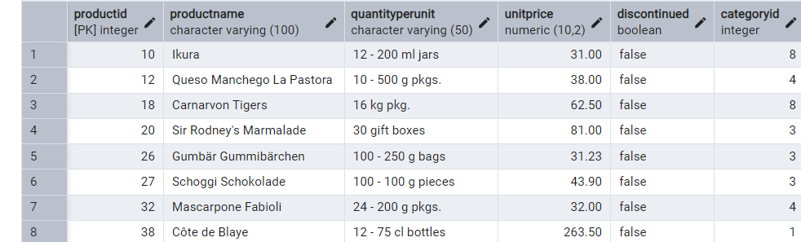

5) SELECT *

FROM orders

ORDER BY orderid

LIMIT 10;

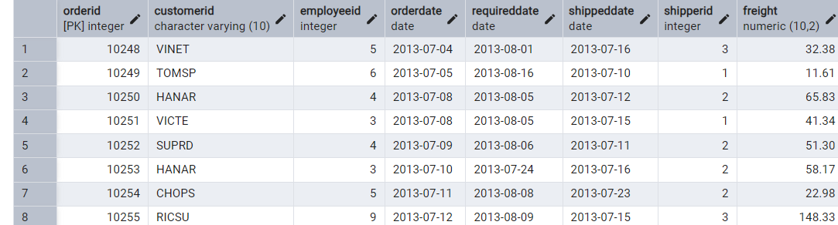

SELECT *

FROM orders

ORDER BY orderid

OFFSET 10

LIMIT 10;

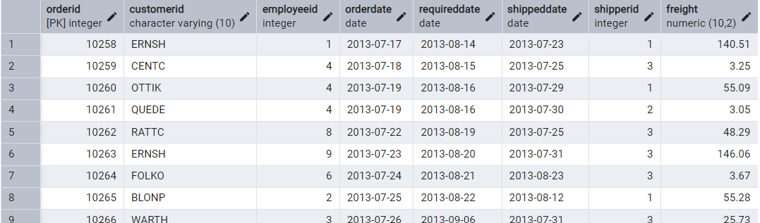

6) SELECT *

FROM customers

WHERE contacttitle IN ('Sales Representative', 'Owner');

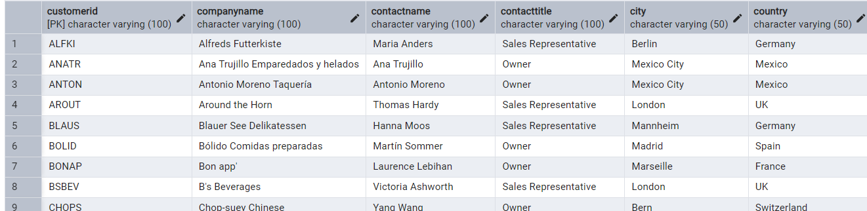

SELECT *

FROM orders

WHERE orderdate BETWEEN '2013-01-01' AND '2013-12-31';

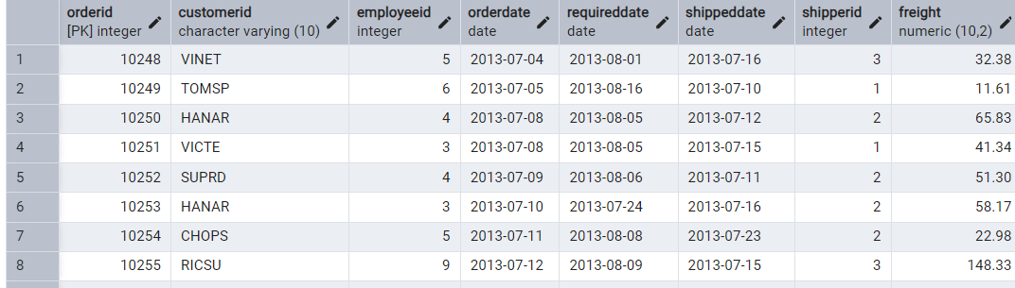

7) SELECT *

FROM products

WHERE categoryid NOT IN (1, 2, 3);

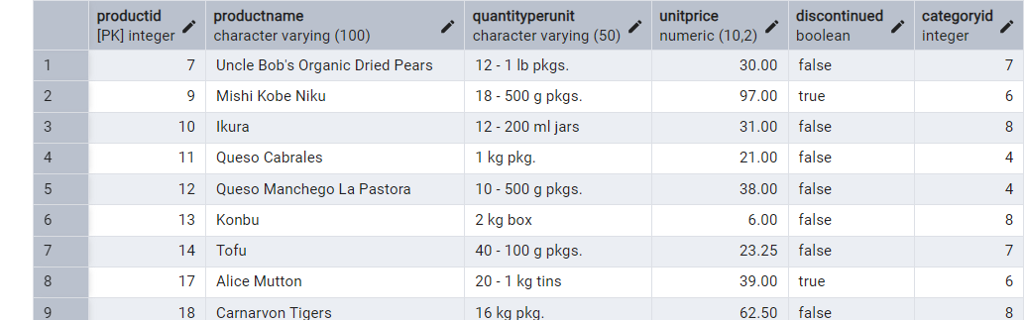

SELECT *

FROM customers

WHERE companyname LIKE 'A%';

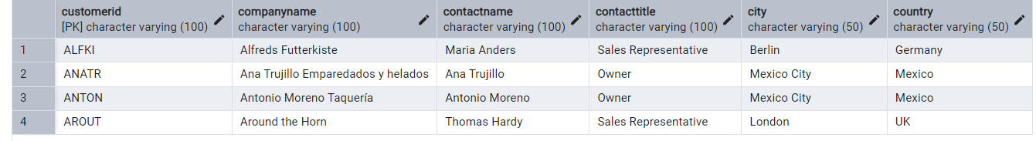

8)INSERT INTO orders (

orderid,

customerid,

employeeid,

orderdate,

requireddate,

shippeddate,

shipperid,

freight

)

VALUES (

11078,

'ALFKI',

5,

'2025-04-23',

'2025-04-30',

'2025-04-25',

2,

45.50

);

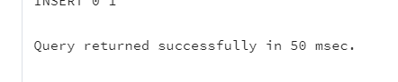

9) UPDATE products

SET unitprice = unitprice * 1.10

WHERE categoryid = 2;

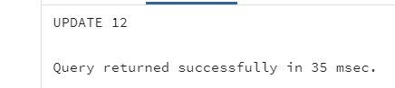

10)Imported northwind database

