/*--1)Alter Table:

Add a new column linkedin_profile to employees table to store LinkedIn URLs as varchar.

Change the linkedin_profile column data type from VARCHAR to TEXT.

Add unique, not null constraint to linkedin_profile

Drop column linkedin_profile --*/

-- Add a new column linkedin_profile to employees table to store LinkedIn URLs as varchar.

ALTER TABLE employees

ADD COLUMN linkedin_profile VARCHAR;

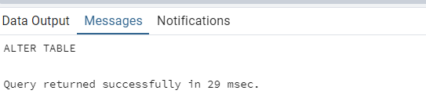

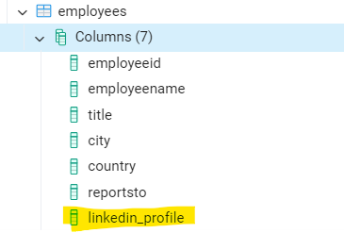

--Change the linkedin_profile column data type from VARCHAR to TEXT.

ALTER TABLE employees

ALTER COLUMN linkedin_profile TYPE TEXT;

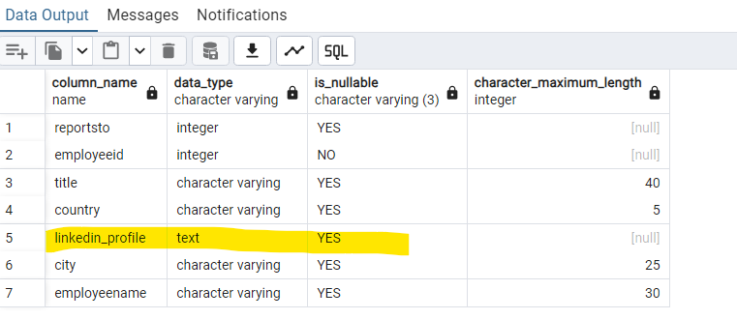

-- Add unique, not null constraint to linkedin_profile

ALTER TABLE employees

ADD CONSTRAINT unique_linkedin_profile UNIQUE (linkedin_profile);

ALTER TABLE employees

ALTER COLUMN linkedin_profile SET NOT NULL;

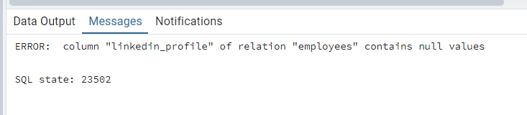

Command failed because linkedin_profile is blank, values not inserted yet.

--Drop column linkedin_profile

ALTER TABLE employees

DROP COLUMN linkedin_profile;

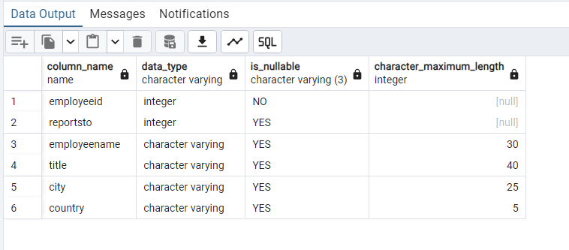

/*--2) Querying (Select)

Retrieve the employee name and title of all employees

Find all unique unit prices of products

List all customers sorted by company name in ascending order

Display product name and unit price, but rename the unit_price column as price_in_usd --*/

--Retrieve the employee name and title of all employees

SELECT employeename, title FROM employees;

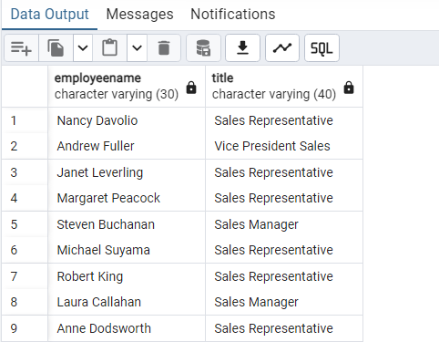

-- Find all unique unit prices of products

SELECT DISTINCT unitprice FROM products;

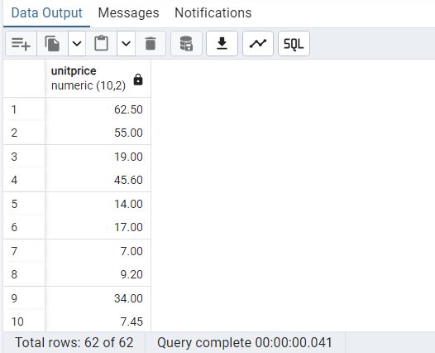

--List all customers sorted by company name in ascending order

SELECT * FROM customers ORDER BY companyname ASC;

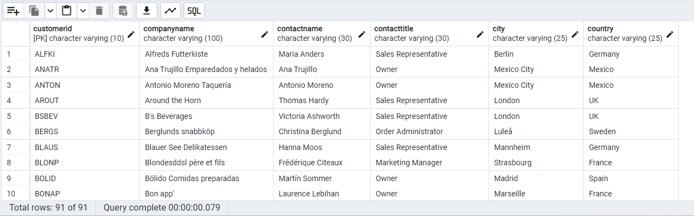

--Display product name and unit price, but rename the unit_price column as price_in_usd

SELECT productname, unitprice AS price_in_usd FROM products;

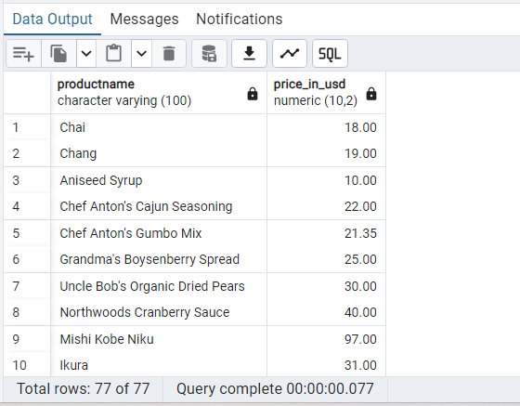

/*--3) Filtering

Get all customers from Germany.

Find all customers from France or Spain

Retrieve all orders placed in 2014 (based on order_date), and either have freight greater than 50 or the shipped date available (i.e., non-NULL)

(Hint: EXTRACT(YEAR FROM order_date)) --*/

--Get all customers from Germany.

SELECT * FROM customers

WHERE country = 'Germany';

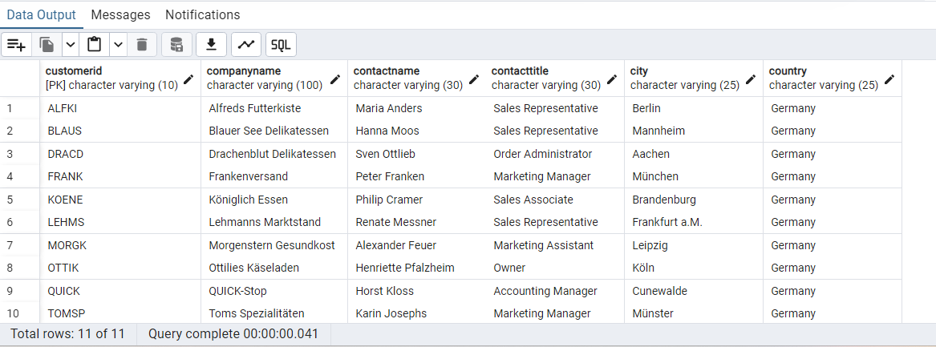

--Find all customers from France or Spain

SELECT * FROM customers

WHERE country IN ('France', 'Spain');

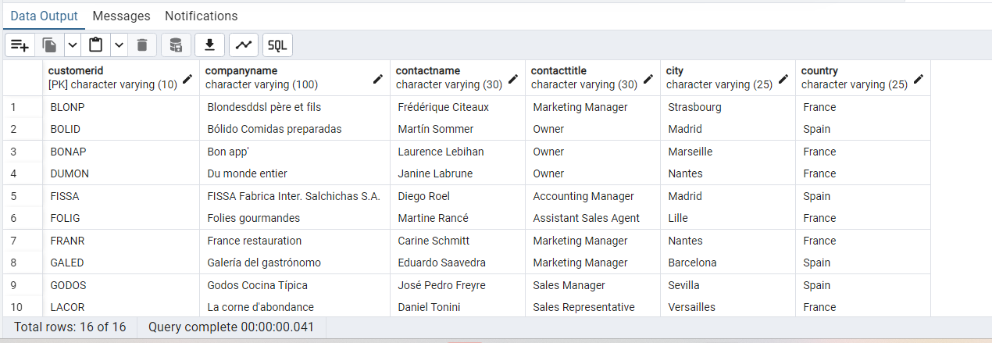

--Retrieve all orders placed in 2014 (based on order_date), and either have freight greater than 50 or the shipped date available (i.e., non-NULL)

SELECT * FROM orders

WHERE EXTRACT(YEAR FROM orderdate) = 2014

AND (freight > 50 OR shippeddate IS NOT NULL);

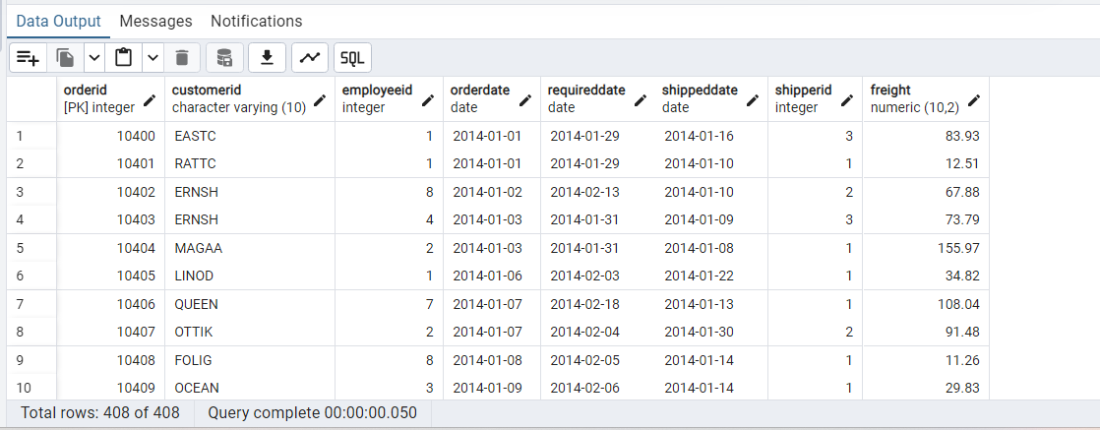

/*--4) Filtering

Retrieve the product_id, product_name, and unit_price of products where the unit_price is greater than 15.

List all employees who are located in the USA and have the title "Sales Representative".

Retrieve all products that are not discontinued and priced greater than 30. **/

-- Retrieve the product_id, product_name, and unit_price of products where the unit_price is greater than 15.

SELECT productid, productname, unitprice

FROM products

WHERE unitprice > 15;

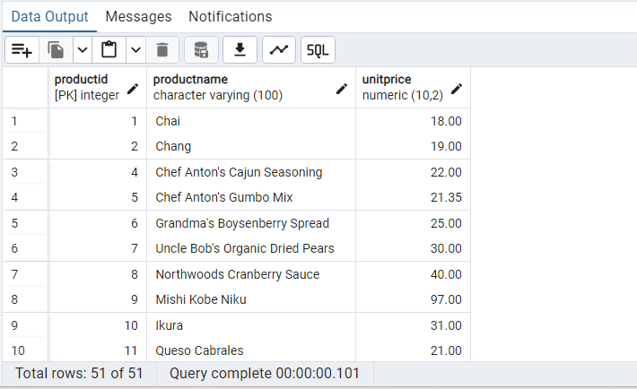

--List all employees who are located in the USA and have the title "Sales Representative".

SELECT * FROM employees

WHERE country = 'USA' AND title = 'Sales Representative';

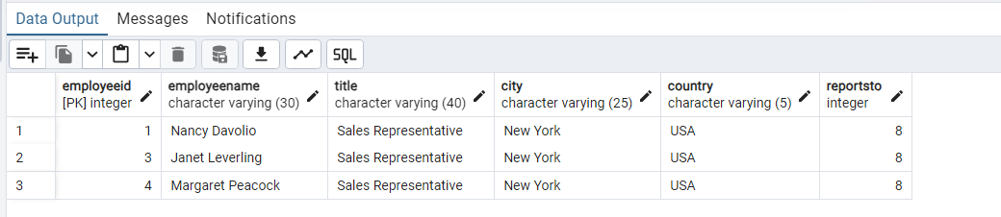

/*-- 5) LIMIT/FETCH

Retrieve the first 10 orders from the orders table.

Retrieve orders starting from the 11th order, fetching 10 rows (i.e., fetch rows 11-20). --*/

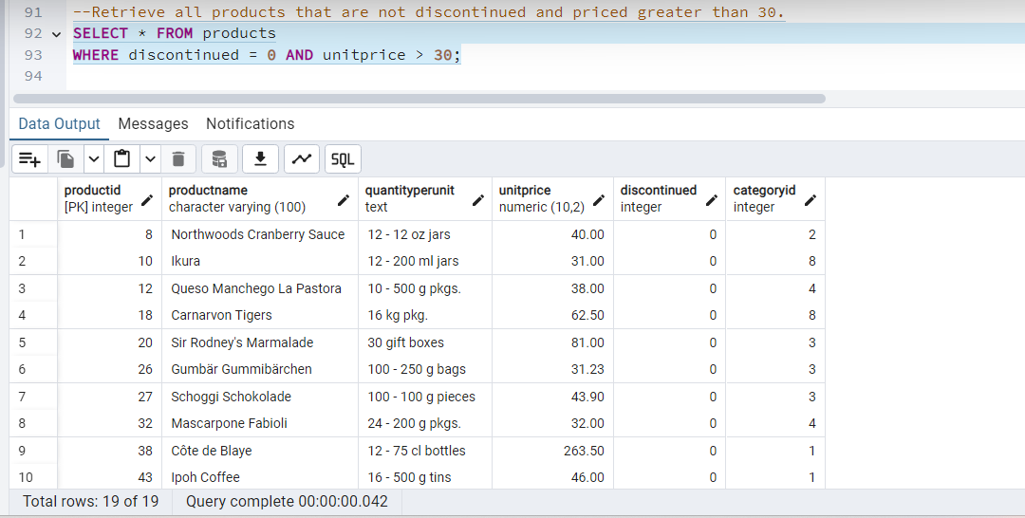

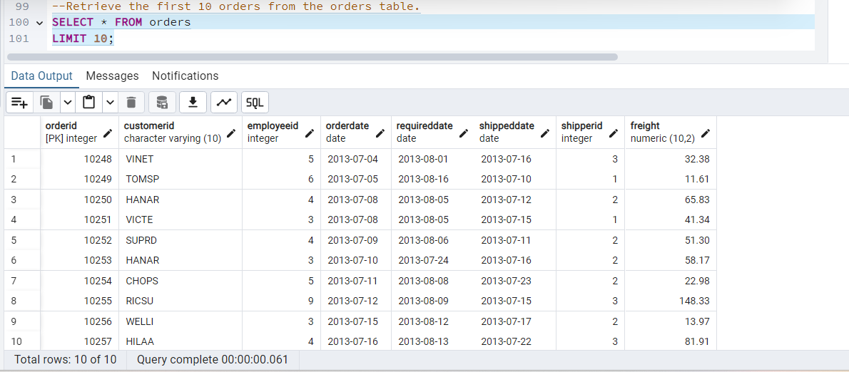

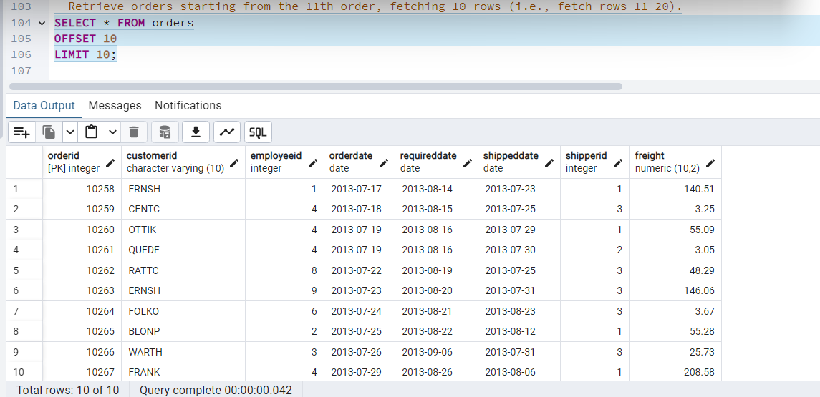

/*-- 6) Filtering (IN, BETWEEN)

List all customers who are either Sales Representative, Owner

Retrieve orders placed between January 1, 2013, and December 31, 2013. --*/

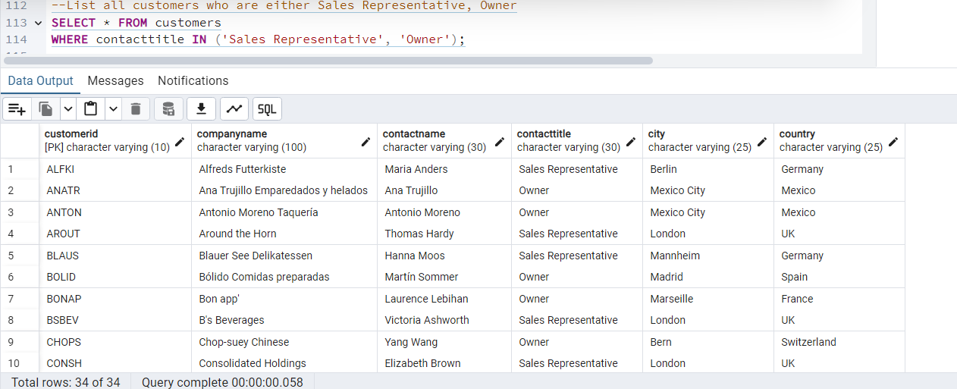

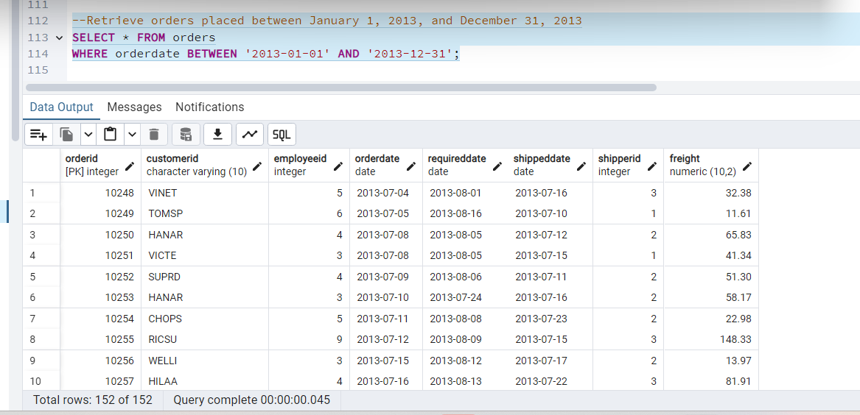

/*-- 7) Filtering

List all products whose category_id is not 1, 2, or 3.

Find customers whose company name starts with "A". --*/

--List all products whose category_id is not 1, 2, or 3.

SELECT * FROM products

WHERE categoryid NOT IN (1, 2, 3);

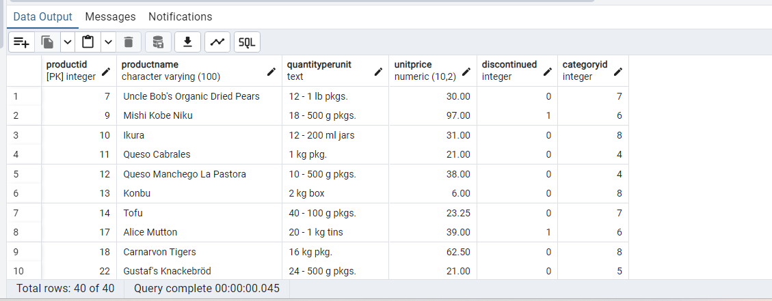

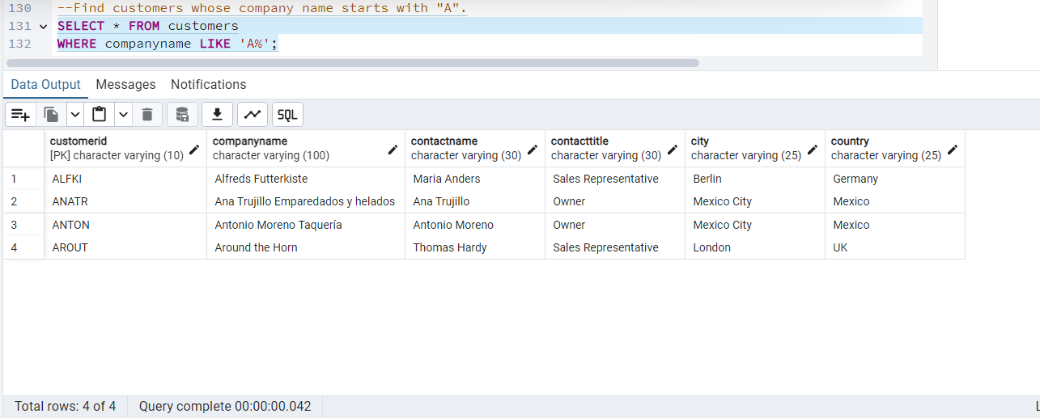

/** 8) INSERT into orders table:

Task: Add a new order to the orders table with the following details:

Order ID: 11078

Customer ID: ALFKI

Employee ID: 5

Order Date: 2025-04-23

Required Date: 2025-04-30

Shipped Date: 2025-04-25

shipperID:2

Freight: 45.50 **/

INSERT INTO orders (

orderid, customerid, employeeid, orderdate,

requireddate, shippeddate, shipperid, freight

)

VALUES (

11078, 'ALFKI', 5, '2025-04-23','2025-04-30', '2025-04-25', 2, 45.50);

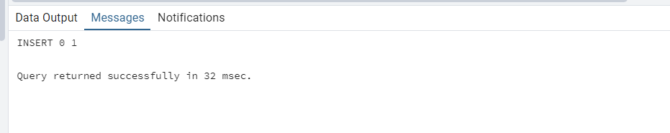

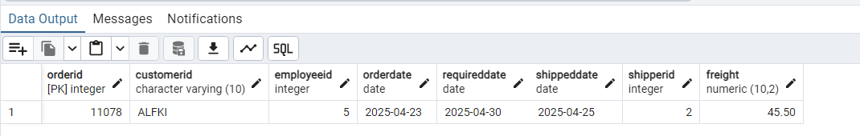

/**9) Increase(Update) the unit price of all products in category_id =2 by 10%.

(HINT: unit_price =unit_price * 1.10)**/

UPDATE products

SET unitprice = unitprice * 1.10

WHERE categoryid = 2;

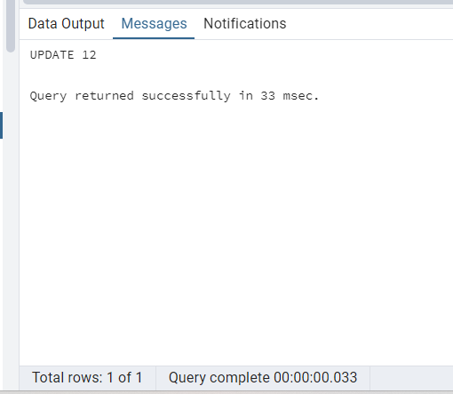

/**10) Sample Northwind database:

Download

Download northwind.sql from below link into your local. Sign in to Git first https://github.com/pthom/northwind_psql

Manually Create the database using pgAdmin:

Right-click on "Databases" → Create → Database

Give name as ‘northwind’ (all small letters)

Click ‘Save’

Import database:

Open pgAdmin and connect to your server

Select the database ‘northwind’

Right Click-> Query tool.

Click the folder icon to open your northwind.sql file

Press F5 or click the Execute button.

You will see total 14 tables loaded

Databases → your database → Schemas → public → Tables **/

