**Day3 Assignment**

1. Update the categoryName From “Beverages” to "Drinks" in the categories table.

**UPDATE categories set category_name = 'Drinks' WHERE category_name = 'Beverages'**

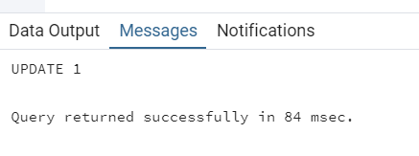

1. Insert into shipper new record (give any values) Delete that new record from shippers table

**INSERT INTO shippers (shipper_id, company_name) VALUES (4, 'USPS')**

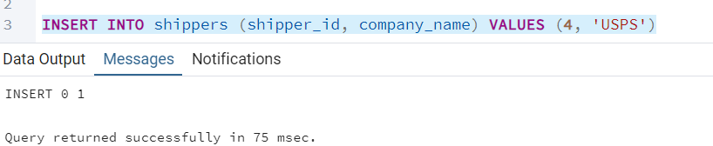

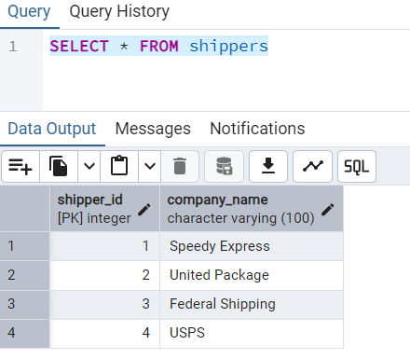

**DELETE FROM shippers where shipper_id = 4**

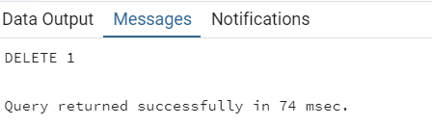

1. Update categoryID=1 to categoryID=1001. Make sure related products update their categoryID too. Display the both category and products table to show the cascade

**ALTER TABLE products**

**DROP CONSTRAINT category_id_fk,**

**ADD CONSTRAINT category_id_fk FOREIGN KEY (category_id)**

**REFERENCES categories (category_id) ON UPDATE CASCADE ON DELETE CASCADE**

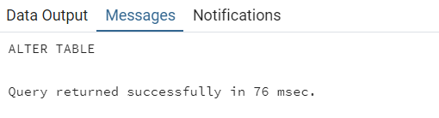

**UPDATE categories set category_id = 1001 where category_id = 1**

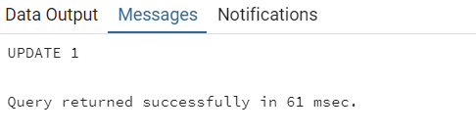

**SELECT * from products where category_id = 1001**

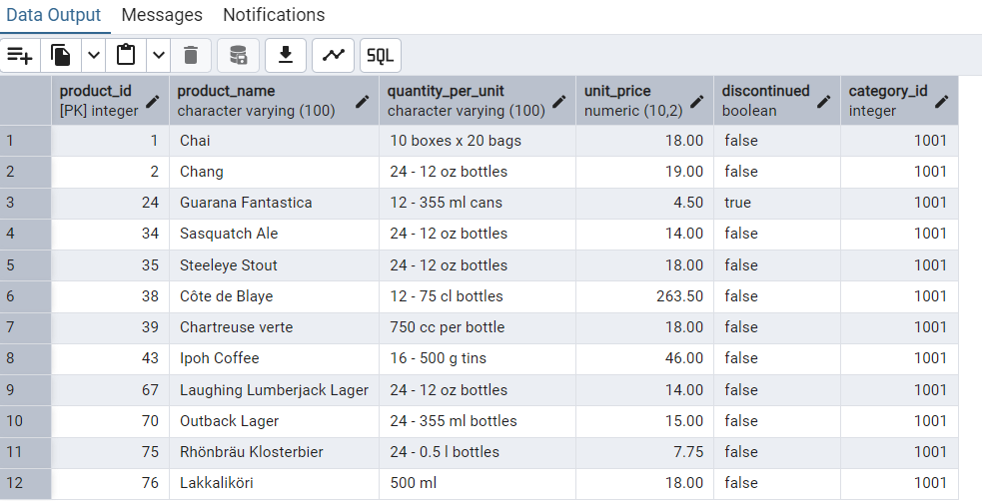

**SELECT * from categories where category_id = 1001**

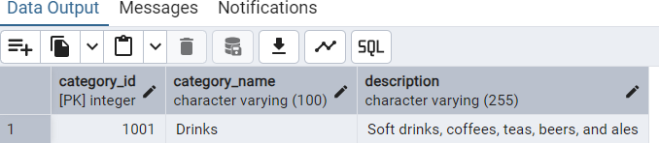

1. Delete the customer = “VINET” from customers. Corresponding customers in orders table should be set to null (HINT: Alter the foreign key on orders(customerID) to use ON DELETE SET NULL)

**ALTER TABLE orders**

**DROP CONSTRAINT customer_id_fk,**

**ADD CONSTRAINT customer_id_fk FOREIGN KEY (customer_id)**

**REFERENCES customers (customer_id) ON UPDATE CASCADE ON DELETE SET NULL**

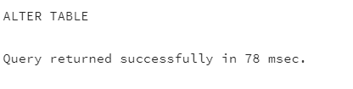

**DELETE FROM customers where customer_id = 'VINET'**

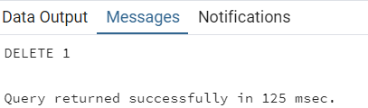

**SELECT * FROM orders WHERE customer_id IS NULL**

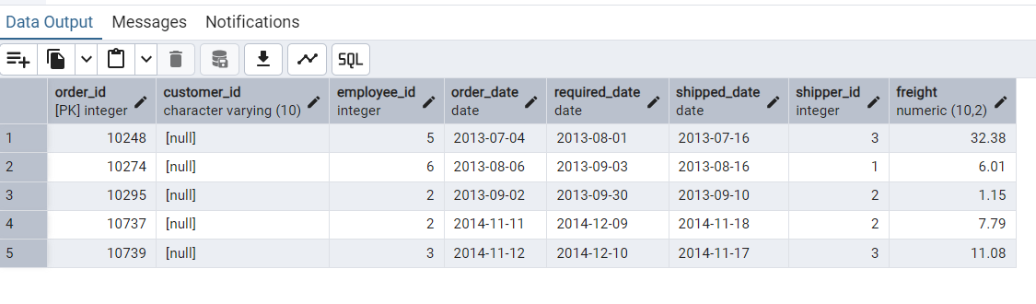

1. Insert the following data to Products using UPSERT

**INSERT INTO products (product_id, product_name, quantity_per_unit, unit_price, discontinued, category_id)**

**VALUES (100, 'Wheat bread', '1', 13, FALSE, 5),**

**(101, 'White bread', '5 boxes', 13, FALSE, 5)**

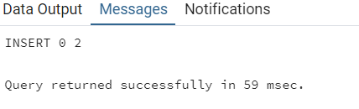

**INSERT INTO products (product_id, product_name, quantity_per_unit, unit_price, discontinued, category_id)**

**VALUES (100, 'White bread', '10 boxes', 13, FALSE, 5)**

**ON CONFLICT(product_id)**

**DO UPDATE SET**

**quantity_per_unit = EXCLUDED.quantity_per_unit**

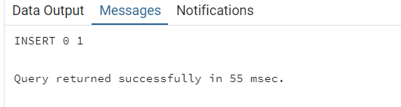

**SELECT * FROM products WHERE product_id = 100**

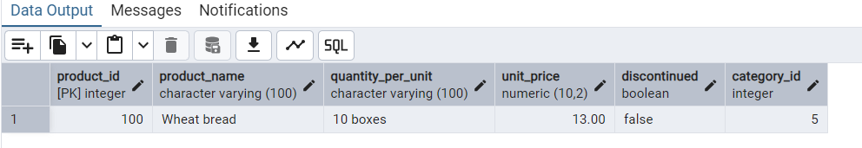

1. **Merge Query**

Create temp table with name: ‘updated_products’ and insert values as below

**CREATE TEMP TABLE updated_products(**

**product_id INTEGER,**

**product_name VARCHAR(100),**

**quantity_per_unit VARCHAR(100),**

**unit_price NUMERIC(10,2),**

**discontinued BOOLEAN,**

**category_id INTEGER);**

**INSERT INTO updated_products(product_id, product_name, quantity_per_unit, unit_price, discontinued, category_id)**

**VALUES (100, 'Wheat bread', '10', 20, TRUE, 5),**

**(101, 'White bread', '5 boxes', 19.99, FALSE, 5),**

**(102, 'Midnight Mango Fizz', '24 - 12 oz bottles', 19, FALSE, 1),**

**(103, 'Savory Fire Sauce', '12 - 550 ml bottles', 10, FALSE, 2)**

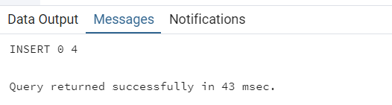

**MERGE INTO products USING updated_products ON products.product_id = updated_products.product_id**

**WHEN MATCHED AND updated_products.discontinued = FALSE THEN**

**UPDATE SET unit_price = updated_products.unit_price, discontinued = updated_products.discontinued**

**WHEN MATCHED AND updated_products.discontinued = TRUE THEN DELETE**

**WHEN NOT MATCHED AND updated_products.discontinued = FALSE THEN**

**INSERT (product_id, product_name, quantity_per_unit, unit_price, discontinued, category_id)**

**VALUES(updated_products.product_id, updated_products.product_name, updated_products.quantity_per_unit,**

**updated_products.unit_price, updated_products.discontinued, updated_products.category_id)**

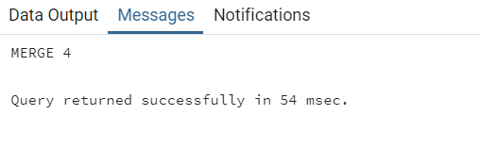

**select * from products where product_id IN (101, 102, 103, 100)**

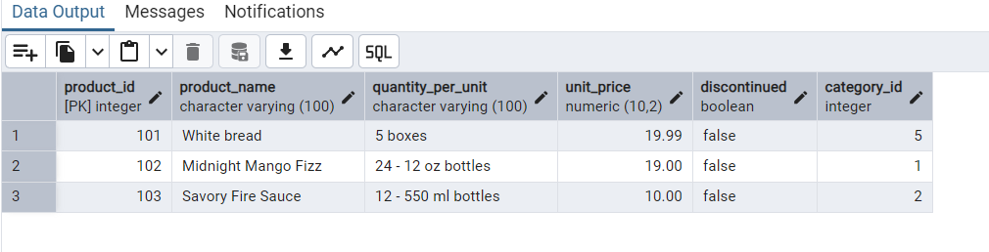

1. List all orders with employee full names. (Inner join)

**select CONCAT(e.first_name, ' ', e.last_name) AS employee_name, o.* from orders o INNER JOIN employees e**

**ON e.employee_id = o.employee_id**

