1) UPDATE categories

SET categoryname = 'Drinks'

WHERE categoryname = 'Beverages';

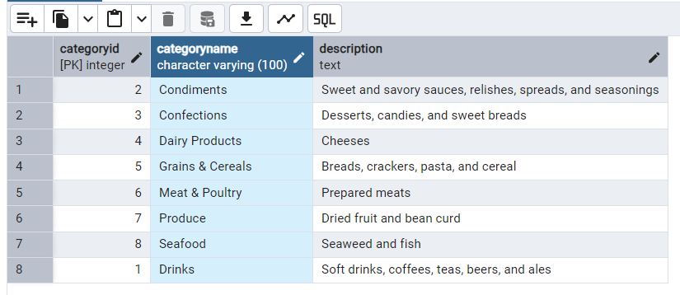

2) select * from shippers;

INSERT INTO shippers (companyname)

VALUES ('Speedy Shippers');

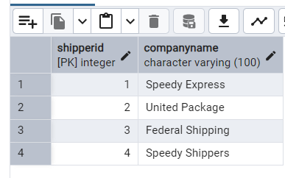

DELETE FROM shippers

WHERE companyname = 'Speedy Shippers';

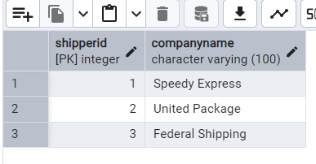

3) 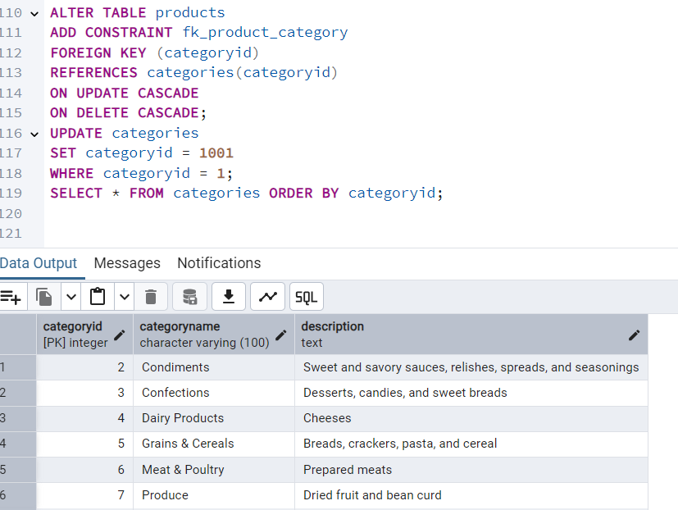

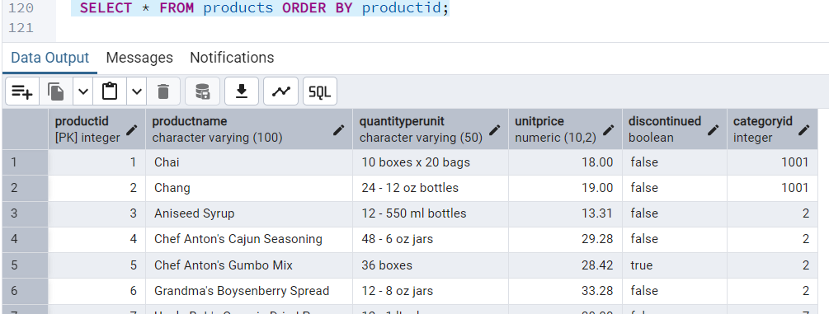

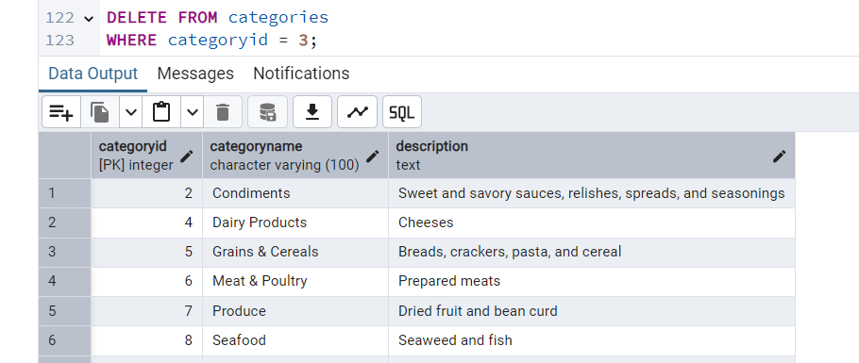

4) ALTER TABLE orders

DROP CONSTRAINT IF EXISTS fk_order_customer;

ALTER TABLE orders

ADD CONSTRAINT fk_order_customer

FOREIGN KEY (customerid)

REFERENCES customers(customerid)

ON DELETE SET NULL

ON UPDATE CASCADE;

DELETE FROM customers

WHERE customerid = 'VINET';

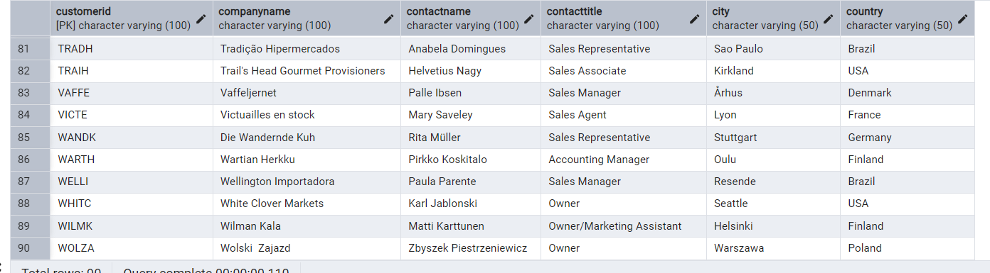

5) 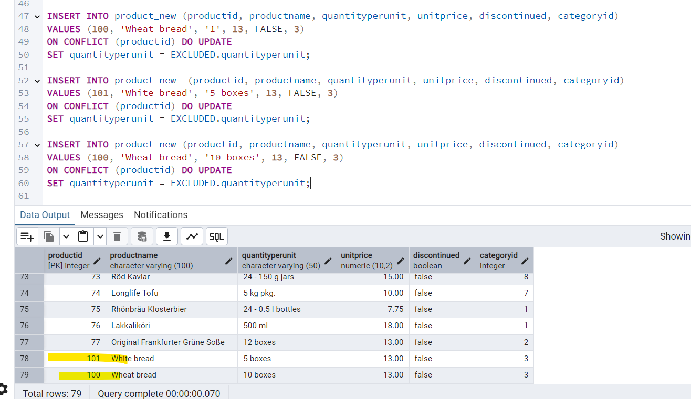

6) MERGE INTO product_new AS p

USING updated_products AS u

ON p.productid = u.productid

WHEN MATCHED THEN

UPDATE SET

productname = u.productname,

quantityperunit = u.quantityperunit,

unitprice = u.unitprice,

discontinued = u.discontinued,

categoryid = u.categoryid

WHEN NOT MATCHED THEN

INSERT (productid, productname, quantityperunit, unitprice, discontinued, categoryid)

VALUES (u.productid, u.productname, u.quantityperunit, u.unitprice, u.discontinued, u.categoryid);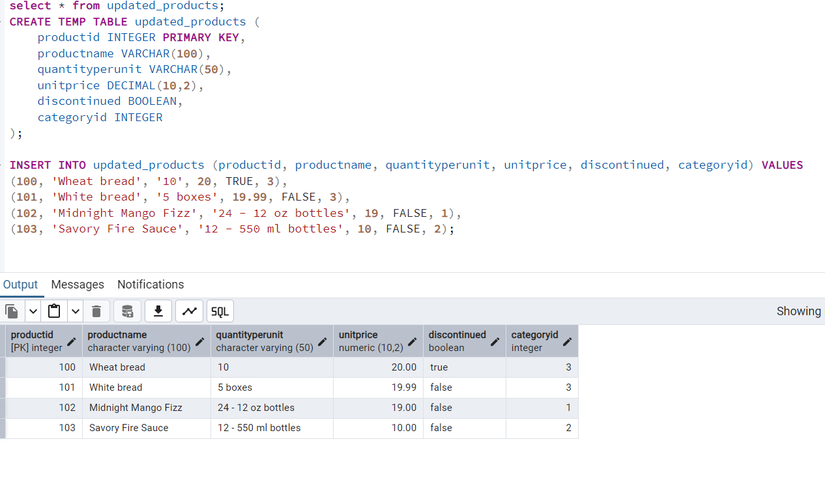

UPDATE product_new p

SET

unitprice = u.unitprice,

discontinued = u.discontinued

FROM updated_products u

WHERE p.productid = u.productid

AND u.discontinued = FALSE;

DELETE FROM product_new p

USING updated_products u

WHERE p.productid = u.productid

AND u.discontinued = TRUE;

INSERT INTO product_new (productid, productname, quantityperunit, unitprice, discontinued, categoryid)

SELECT u.productid, u.productname, u.quantityperunit, u.unitprice, u.discontinued, u.categoryid

FROM updated_products u

LEFT JOIN products p ON u.productid = p.productid

WHERE p.productid IS NULL

AND u.discontinued = FALSE;

7)

