Day4_Assignment

-- 1. List all customers and the products they ordered with the order date. (Inner join)

-- Tables used: customers, orders, order_details, products

-- Output should have below columns:

-- companyname AS customer,

-- orderid,

-- productname,

-- quantity,

-- orderdate

SELECT

C.COMPANY_NAME AS CUSTOMER,

O.ORDER_ID,

P.PRODUCT_NAME,

OD.QUANTITY,

O.ORDER_DATE

FROM

CUSTOMERS C

INNER JOIN ORDERS O ON C.CUSTOMER_ID = O.CUSTOMER_ID

INNER JOIN ORDER_DETAILS OD ON O.ORDER_ID = OD.ORDER_ID

INNER JOIN PRODUCTS P ON OD.PRODUCT_ID = P.PRODUCT_ID;

### OUTPUT

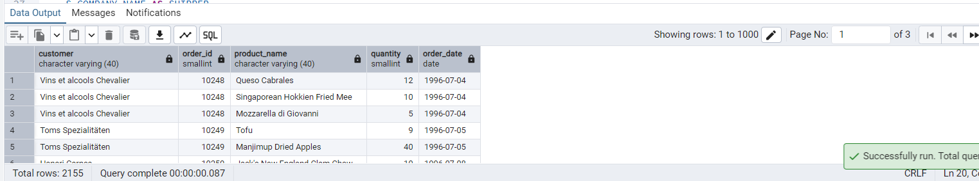

-- 2. Show each order with customer, employee, shipper, and product info — even if some parts are missing. (Left Join)

-- Tables used: orders, customers, employees, shippers, order_details, products

SELECT

O.ORDER_ID,

C.CONTACT_NAME AS CUSTOMER,

E.FIRST_NAME || ' ' || E.LAST_NAME AS EMPLOYEE,

S.COMPANY_NAME AS SHIPPER,

P.PRODUCT_NAME,

OD.QUANTITY,

O.ORDER_DATE

FROM

ORDERS O

LEFT JOIN CUSTOMERS C ON O.CUSTOMER_ID = C.CUSTOMER_ID

LEFT JOIN EMPLOYEES E ON O.EMPLOYEE_ID = E.EMPLOYEE_ID

LEFT JOIN SHIPPERS S ON O.SHIP_VIA = S.SHIPPER_ID

LEFT JOIN ORDER_DETAILS OD ON O.ORDER_ID = OD.ORDER_ID

LEFT JOIN PRODUCTS P ON OD.PRODUCT_ID = P.PRODUCT_ID;

### OUTPUT

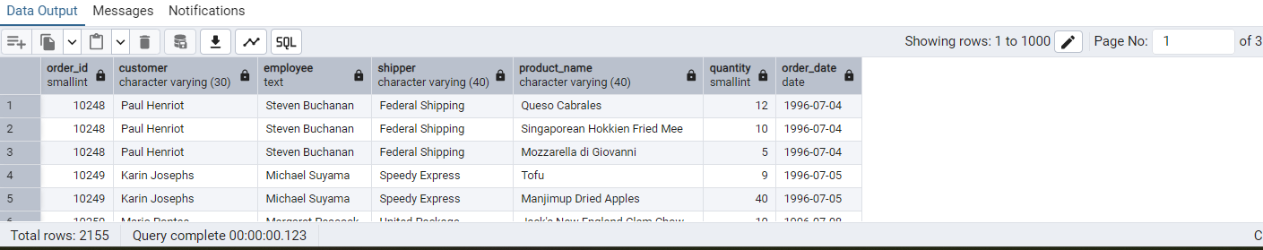

-- 3. Show all order details and products (include all products even if they were never ordered). (Right Join)

-- Tables used: order_details, products

-- Output should have below columns:

-- orderid,

-- productid,

-- quantity,

-- productname

SELECT

OD.ORDER_ID,

P.PRODUCT_ID,

OD.QUANTITY,

P.PRODUCT_NAME

FROM

ORDER_DETAILS OD

RIGHT JOIN PRODUCTS P ON OD.PRODUCT_ID = P.PRODUCT_ID;

### OUTPUT

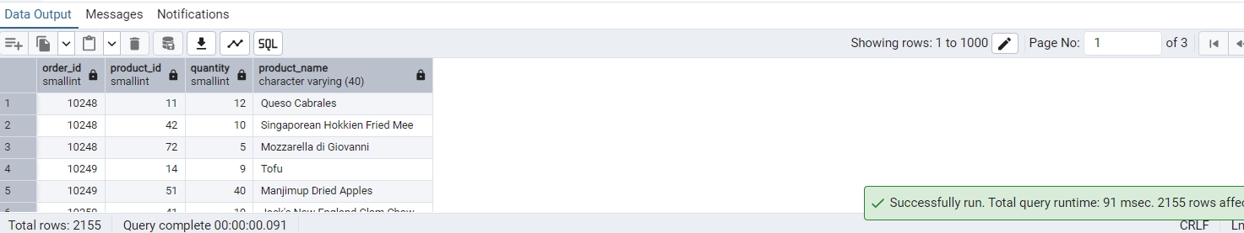

-- 4. List all product categories and their products — including categories that have no products, and products that are not assigned to any category.(Outer Join)

-- Tables used: categories, products

SELECT

C.CATEGORY_ID,

C.CATEGORY_NAME,

P.PRODUCT_ID,

P.PRODUCT_NAME

FROM

CATEGORIES C

FULL OUTER JOIN PRODUCTS P ON C.CATEGORY_ID = P.CATEGORY_ID;

### OUTPUT

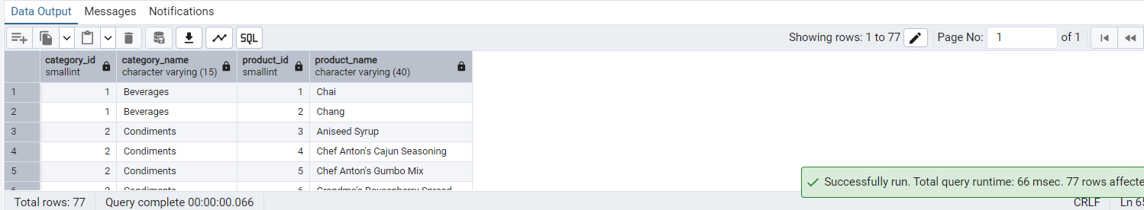

-- 5. Show all possible product and category combinations (Cross join).

SELECT

P.PRODUCT_ID,

P.PRODUCT_NAME,

P.SUPPLIER_ID,

P.CATEGORY_ID,

P.QUANTITY_PER_UNIT,

P.UNIT_PRICE,

P.UNITS_IN_STOCK,

P.UNITS_ON_ORDER,

P.REORDER_LEVEL,

P.DISCONTINUED,

C.CATEGORY_ID,

C.CATEGORY_NAME,

C.DESCRIPTION,

C.PICTURE

FROM

PRODUCTS P

CROSS JOIN CATEGORIES C;

### OUTPUT

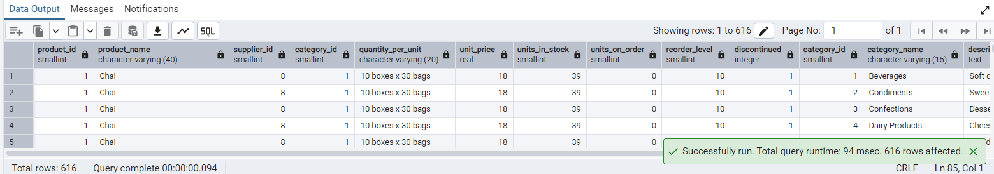

-- 6. Show all employees who have the same manager(Self join)

SELECT

E1.EMPLOYEE_ID AS EMPLOYEEID,

E1.FIRST_NAME || ' ' || E1.LAST_NAME AS EMPLOYEE_NAME,

E2.EMPLOYEE_ID AS MANAGER_ID,

E2.FIRST_NAME || ' ' || E2.LAST_NAME AS MANAGER_NAME

FROM

EMPLOYEES E1

JOIN EMPLOYEES E2 ON E1.REPORTS_TO = E2.EMPLOYEE_ID

ORDER BY

E2.EMPLOYEE_ID,

E1.EMPLOYEE_ID;

### OUTPUT

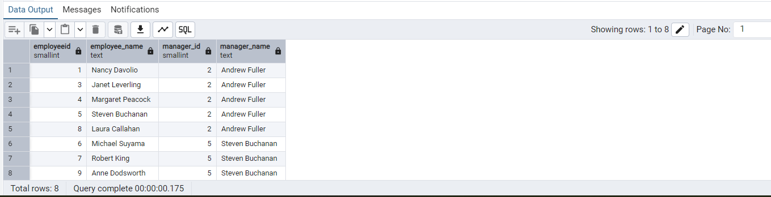

-- 7. List all customers who have not selected a shipping method.

-- Tables used: customers, orders

-- (Left Join, WHERE o.shipvia IS NULL)

SELECT

C.CUSTOMER_ID,

C.COMPANY_NAME

FROM

CUSTOMERS C

LEFT JOIN ORDERS O ON C.CUSTOMER_ID = O.CUSTOMER_ID

WHERE

O.SHIP_VIA IS NULL;

### OUTPUT

