---DAY 4---

/*1.List all customers and the products they ordered with the order date. (Inner join)

Tables used: customers, orders, order_details, products

Output should have below columns:

companyname AS customer,

orderid,

productname,

quantity,

orderdate*/

SELECT

c.company_name AS customer,

o.order_id,

p.product_name,

od.quantity,

o.order_date

FROM

customers c

INNER JOIN

orders o ON c.customer_id = o.customer_id

INNER JOIN

order_details od ON o.order_id = od.order_id

INNER JOIN

products p ON od.product_id = p.product_id

ORDER BY

c.company_name, o.order_id;

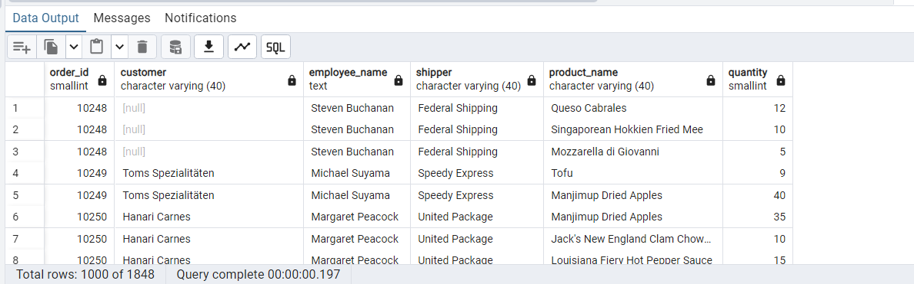

/*2.Show each order with customer, employee, shipper, and product info — even if some parts are missing. (Left Join)

Tables used: orders, customers, employees, shippers, order_details, products*/

SELECT

o.order_id,

c.company_name AS customer,

e.first_name || ' ' || e.last_name AS employee_name,

s.company_name AS shipper,

p.product_name,

od.quantity

FROM

orders o

LEFT JOIN

customers c ON o.customer_id = c.customer_id

LEFT JOIN

employees e ON o.employee_id = e.employee_id

LEFT JOIN

shippers s ON o.ship_via = s.shipper_id

LEFT JOIN

order_details od ON o.order_id = od.order_id

LEFT JOIN

products p ON od.product_id = p.product_id

ORDER BY

o.order_id;



/*3.Show all order details and products (include all products even if they were never ordered). (Right Join)

Tables used: order_details, products

Output should have below columns:

orderid,

productid,

quantity,

productname*/

SELECT

od.order_id,

p.product_id,

od.quantity,

p.product_name

FROM

order_details od

RIGHT JOIN

products p ON od.product_id = p.product_id

ORDER BY

p.product_id;

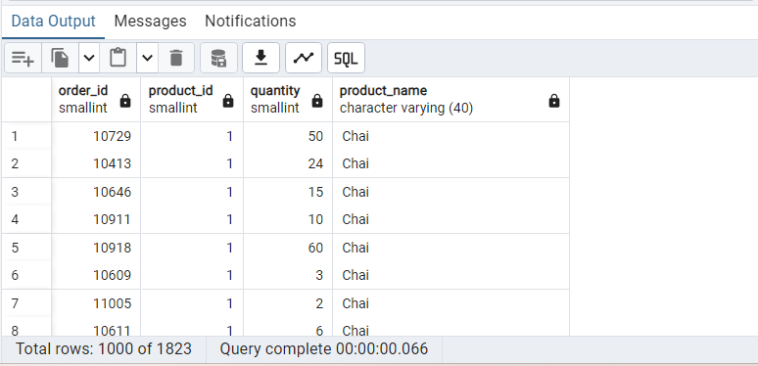

/*4. List all product categories and their products — including categories that have no products, and products that are not assigned to any category.(Outer Join)

Tables used: categories, products*/

SELECT

c.category_id,

c.category_name,

p.product_id,

p.product_name

FROM

categories c

FULL OUTER JOIN

products p ON c.category_id = p.category_id

ORDER BY

c.category_name,

p.product_name;

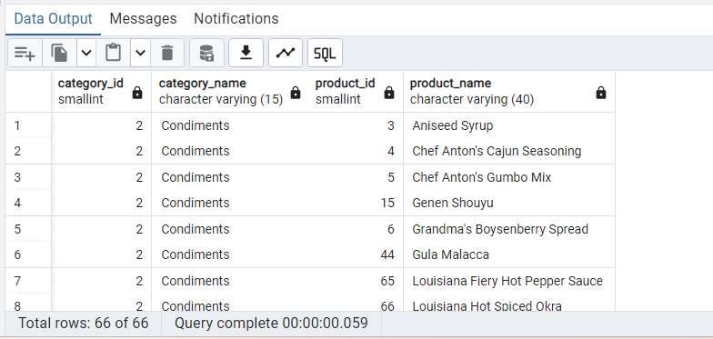

/*5. Show all possible product and category combinations (Cross join).*/

SELECT

p.product_id,

p.product_name,

c.category_id,

c.category_name

FROM

products p

CROSS JOIN

categories c

ORDER BY

p.product_id,

c.category_id;

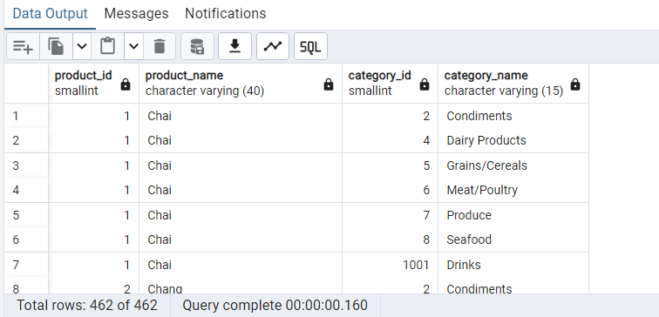

/*6. Show all employees and their manager(Self join(left join))*/

SELECT

e.employee_id,

e.first_name || ' ' || e.last_name AS employee_name,

m.employee_id AS manager_id,

m.first_name || ' ' || m.last_name AS manager_name

FROM

employees e

LEFT JOIN

employees m ON e.reports_to = m.employee_id

ORDER BY

e.employee_id

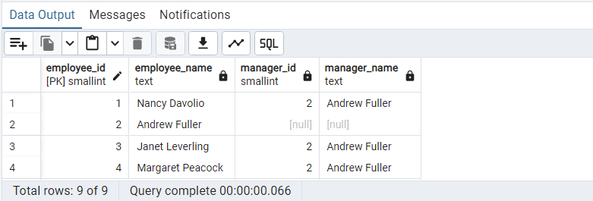

/*7. List all customers who have not selected a shipping method.

Tables used: customers, orders

(Left Join, WHERE o.shipvia IS NULL)*/

SELECT

c.customer_id,

c.company_name AS customer_name

FROM

customers c

LEFT JOIN

orders o ON c.customer_id = o.customer_id

WHERE

o.ship_via IS NULL

ORDER BY

c.company_name;

