Day5_Assignment

-- 1.Group by with WHERE on orders by year and quarter.

-- Display the year, quarter, order count, and average freight cost, but only for those orders where the freight cost is greater than 100!

SELECT

EXTRACT(

YEAR

FROM

ORDER_DATE

) AS YEAR,

CEIL(

EXTRACT(

MONTH

FROM

ORDER_DATE

) / 3

) AS QUARTER,

COUNT(*) AS ORDER_COUNT,

AVG(FREIGHT) AS AVG_FREIGHT

FROM

ORDERS

WHERE

FREIGHT > 100

GROUP BY

EXTRACT(

YEAR

FROM

ORDER_DATE

),

CEIL(

EXTRACT(

MONTH

FROM

ORDER_DATE

) / 3

)

ORDER BY

YEAR,

QUARTER;

### OUTPUT

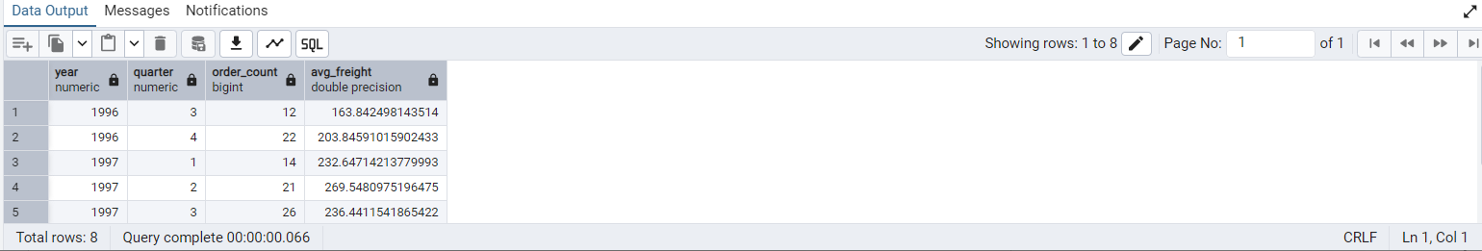

-- Group by with HAVING on high-volume ship regions.

-- Display the ship region, number of orders in each region, and the minimum and maximum freight costs.

-- Filter to show only regions where the number of orders is greater than or equal to 5!

SELECT

SHIP_REGION,

COUNT(*) AS ORDER_COUNT,

MIN(FREIGHT) AS MIN_FREIGHT,

MAX(FREIGHT) AS MAX_FREIGHT

FROM

ORDERS

WHERE

SHIP_REGION IS NOT NULL

GROUP BY

SHIP_REGION

HAVING

COUNT(*) >= 5

ORDER BY

ORDER_COUNT DESC;

### OUTPUT

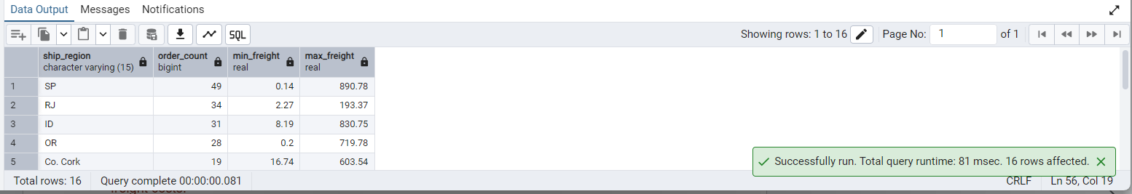

-- Get all title designations across employees and customers.

-- Try using UNION and UNION ALL!

SELECT

TITLE

FROM

EMPLOYEES

UNION

SELECT

CONTACT_TITLE

FROM

CUSTOMERS

ORDER BY

TITLE;

### OUTPUT

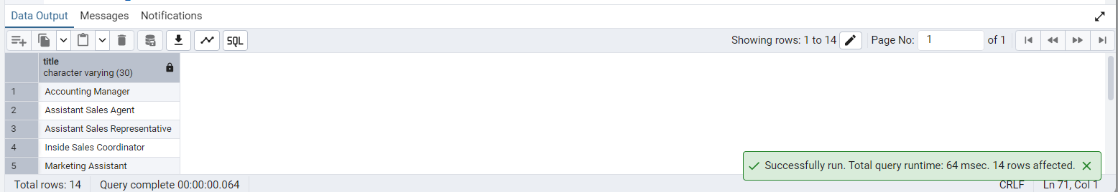

-- Find categories that have both discontinued and in-stock products.

-- Display the category ID (in-stock means units in stock > 0) using INTERSECT.

-- Categories with discontinued products

SELECT

CATEGORY_ID

FROM

PRODUCTS

WHERE

DISCONTINUED = 1

INTERSECT

-- Categories with in-stock products

SELECT

CATEGORY_ID

FROM

PRODUCTS

WHERE

UNITS_IN_STOCK > 0

ORDER BY

CATEGORY_ID;

### OUTPUT

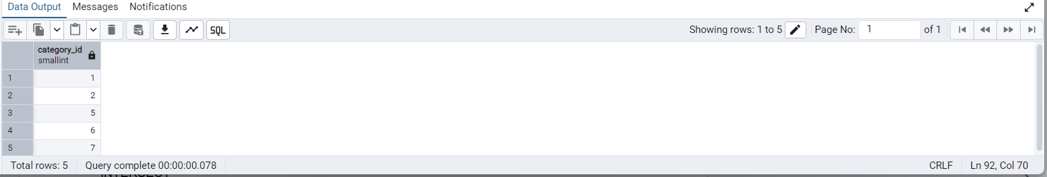

-- 5. Find orders that have no discounted items (Display the order_id, EXCEPT)

SELECT

ORDER_ID

FROM

ORDER_DETAILS

EXCEPT

SELECT DISTINCT

ORDER_ID

FROM

ORDER_DETAILS

WHERE

DISCOUNT > 0

ORDER BY

ORDER_ID;

### OUTPUT

