Day 5

/*1. GROUP BY with WHERE - Orders by Year and Quarter

Display, order year, quarter, order count, avg freight cost only for those orders where freight cost > 100*/

SELECT

EXTRACT(YEAR FROM Order_date) AS OrderYear,

EXTRACT(QUARTER FROM Order_date) AS OrderQuarter,

COUNT(*) AS OrderCount,

AVG(freight) AS AvgFreightCost

FROM

Orders

WHERE

freight > 100

GROUP BY

EXTRACT(YEAR FROM Order_date),

EXTRACT(QUARTER FROM Order_date)

ORDER BY

OrderYear,

OrderQuarter;

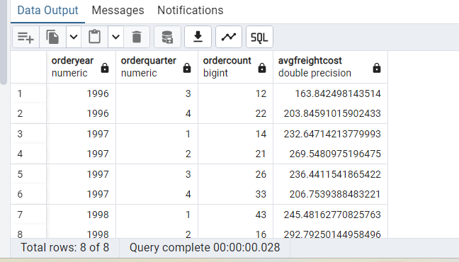

2. GROUP BY with HAVING - High Volume Ship Regions

Display, ship region, no of orders in each region, min and max freight cost

Filter regions where no of orders >= 5

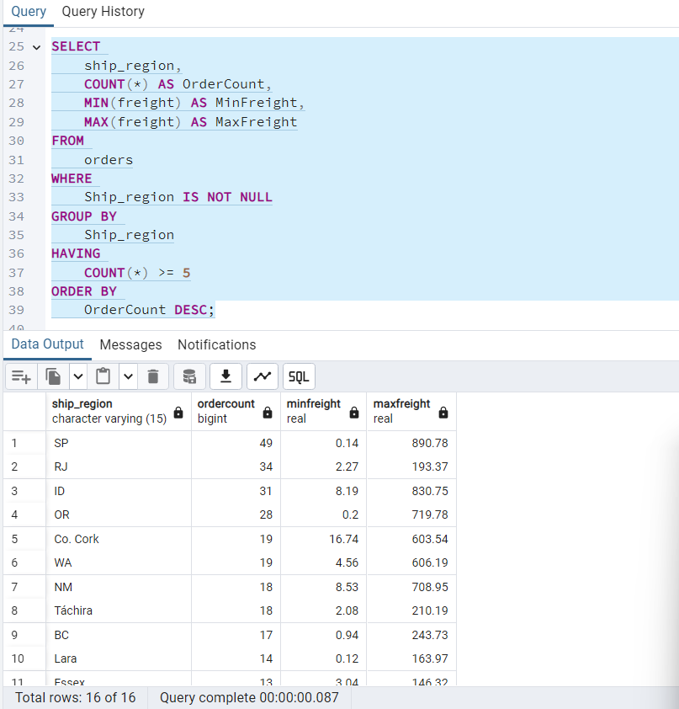

3. Get all title designations across employees and customers ( Try UNION & UNION ALL)

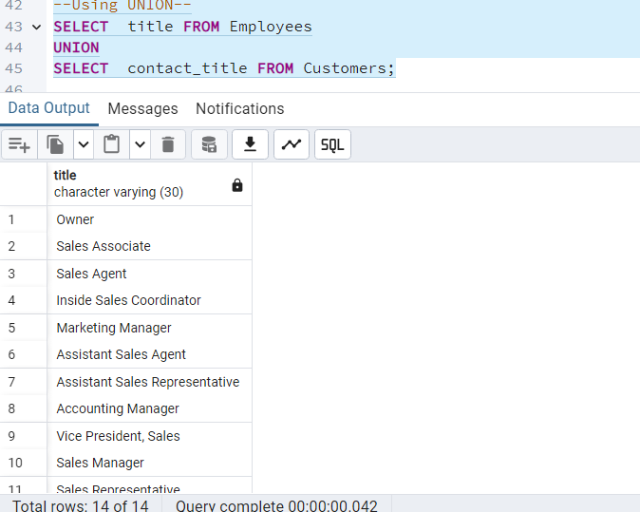

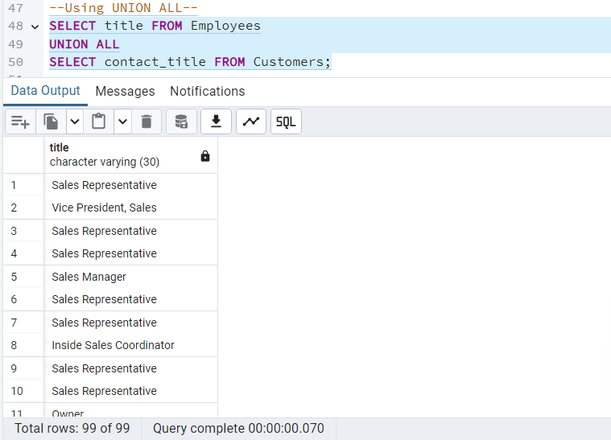

4. Find categories that have both discontinued and in-stock products

(Display category_id, instock means units_in_stock > 0, Intersect)

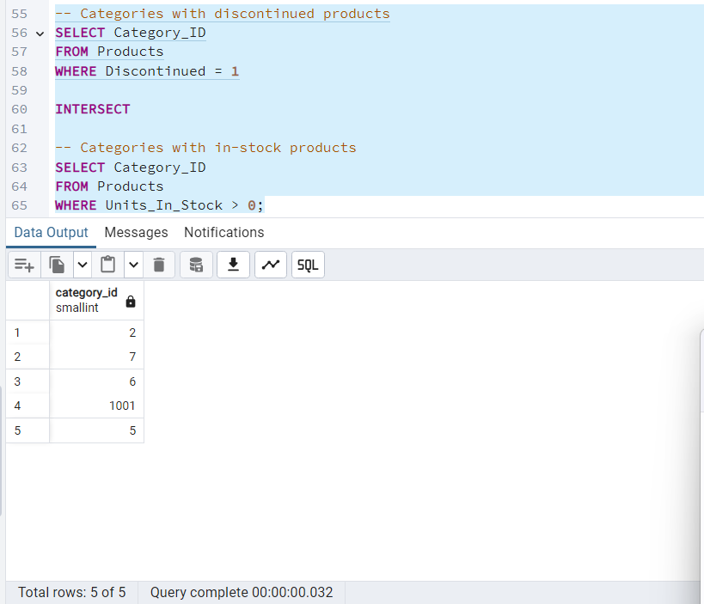

5. Find orders that have no discounted items (Display the order_id, EXCEPT)

