Day6_PavithraMani_SDET177

-- 1. Categorize products by stock status

-- (Display product_name, a new column stock_status whose values are based on below condition

-- units_in_stock = 0 is 'Out of Stock'

-- units_in_stock < 20 is 'Low Stock')

SELECT

product_name,

CASE

WHEN units_in_stock = 0 THEN 'Out of Stock'

WHEN units_in_stock < 20 THEN 'Low Stock'

ELSE 'In Stock'

END AS stock_status

FROM

Products;

### OUTPUT

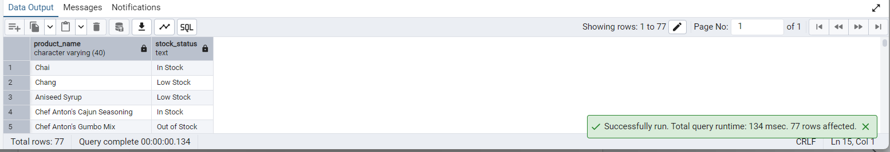

-- 2. Find All Products in Beverages Category

-- (Subquery, Display product_name,unitprice)

SELECT

product_name,

unit_price

FROM

products

WHERE

category_id = (

SELECT category_id

FROM categories

WHERE category_name = 'Beverages'

);

### OUTPUT

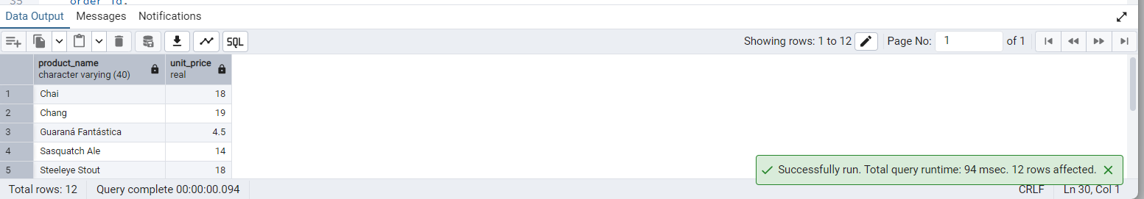

-- 3. Find Orders by Employee with Most Sales

-- (Display order_id, order_date, freight, employee_id.

-- Employee with Most Sales=Get the total no.of of orders for each employee then order by DESC and limit 1. Use Subquery)

SELECT

order_id,

order_date,

freight,

employee_id

FROM

orders

WHERE

employee_id = (

SELECT employee_id

FROM orders

GROUP BY employee_id

ORDER BY COUNT(order_id) DESC

LIMIT 1

);

### OUTPUT

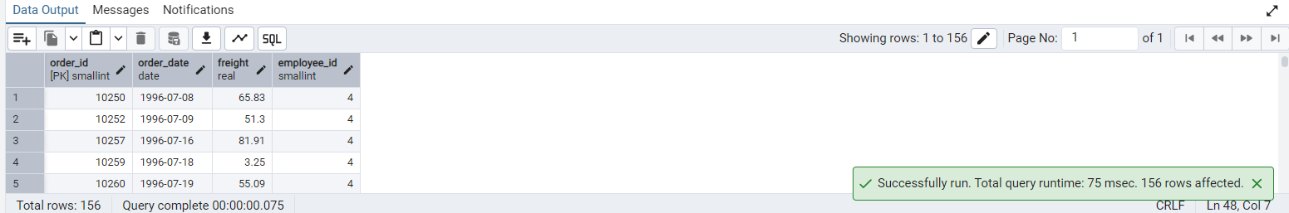

-- 4. Find orders where for country!= ‘USA’ with freight costs higher than any order from USA. (Subquery, Try with ANY, ALL operators)

SELECT

order_id,

order_date,

freight,

ship_country,

CASE

WHEN freight > ALL (

SELECT freight FROM orders WHERE ship_country = 'USA'

) THEN 'Higher than ALL USA orders'

WHEN freight > ANY (

SELECT freight FROM orders WHERE ship_country = 'USA'

) THEN 'Higher than SOME USA orders'

ELSE 'Not higher'

END AS freight_comparison

FROM

orders

WHERE

ship_country != 'USA'

AND freight > (

SELECT MIN(freight) FROM orders WHERE ship_country = 'USA'

);

### OUTPUT

