Day 7

--1. Rank employees by their total sales

--(Total sales = Total no of orders handled, JOIN employees and orders table)

SELECT

e.employee_id,

e.first_name || ' ' || e.last_name AS employee_name,

COUNT(o.order_id) AS total_sales,

RANK() OVER (ORDER BY COUNT(o.order_id) DESC) AS sales_rank

FROM

employees e

JOIN

orders o ON e.employee_id = o.employee_id

GROUP BY

e.employee_id

ORDER BY

sales_rank;

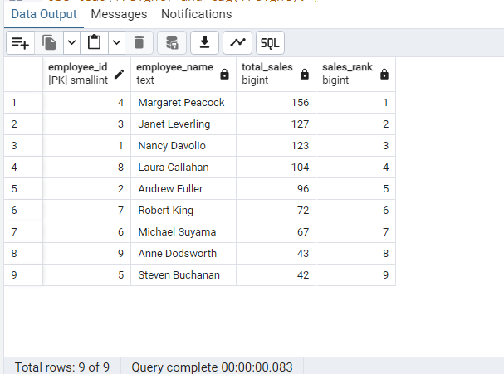

/*2. Compare current order's freight with previous and next order for each customer.

(Display order_id, customer_id, order_date, freight,

Use lead(freight) and lag(freight).*/

SELECT

order_id,

customer_id,

order_date,

freight,

LAG(freight) OVER (PARTITION BY customer_id ORDER BY order_date) AS prev_freight,

LEAD(freight) OVER (PARTITION BY customer_id ORDER BY order_date) AS next_freight,

ROUND((freight - LAG(freight) OVER (PARTITION BY customer_id ORDER BY order_date))::numeric,2) AS compare_from_prev,

ROUND((LEAD(freight) OVER (PARTITION BY customer_id ORDER BY order_date) - freight)::numeric,2) AS compare_to_next

FROM

orders

ORDER BY

customer_id, order_date;

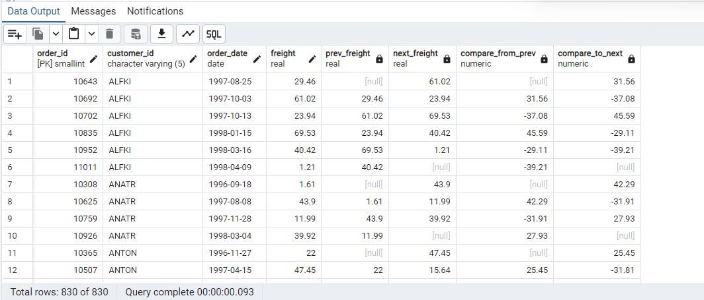

/*3.Show products and their price categories, product count in each category, avg price:

(HINT:

· Create a CTE which should have price_category definition:

WHEN unit_price < 20 THEN 'Low Price'

WHEN unit_price < 50 THEN 'Medium Price'

ELSE 'High Price'

· In the main query display: price_category, product_count in each price_category,

ROUND(AVG(unit_price)::numeric, 2) as avg_price) */

WITH PriceCategories AS (

SELECT

product_id,

CASE

WHEN unit_price < 20 THEN 'Low Price'

WHEN unit_price < 50 THEN 'Medium Price'

ELSE 'High Price'

END AS price_category, unit_price

FROM products

)

SELECT

price_category,

COUNT(product_id) AS product_count,

ROUND(AVG(unit_price)::numeric, 2) AS avg_price

FROM PriceCategories

GROUP BY price_category;

