Day7_PavithraMani_SDET177

-- 1. Rank employees by their total sales

-- (Total sales = Total no of orders handled, JOIN employees and orders table)

SELECT

E.EMPLOYEE_ID,

E.FIRST_NAME,

E.LAST_NAME,

COUNT(O.ORDER_ID) AS TOTAL_SALES,

RANK() OVER (

ORDER BY

COUNT(O.ORDER_ID) DESC

) AS SALES_RANK

FROM

EMPLOYEES E

JOIN ORDERS O ON E.EMPLOYEE_ID = O.EMPLOYEE_ID

GROUP BY

E.EMPLOYEE_ID,

E.FIRST_NAME,

E.LAST_NAME

ORDER BY

TOTAL_SALES DESC;

### OUTPUT

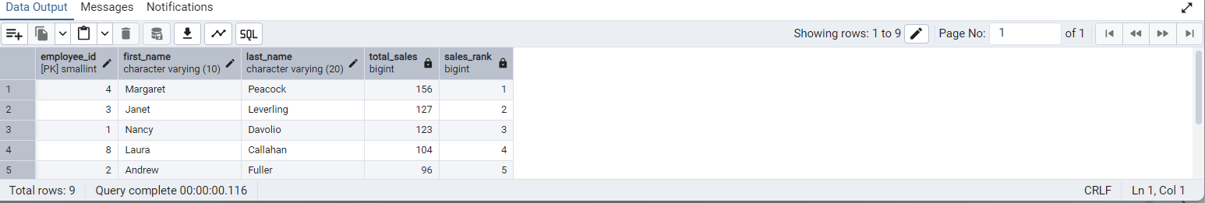

-- 2. Compare current order's freight with previous and next order for each customer.

-- (Display order_id, customer_id, order_date, freight,

-- Use lead(freight) and lag(freight).

SELECT

ORDER_ID,

CUSTOMER_ID,

ORDER_DATE,

FREIGHT,

LAG(FREIGHT) OVER (

PARTITION BY

CUSTOMER_ID

ORDER BY

ORDER_DATE

) AS PREVIOUS_FREIGHT,

LEAD(FREIGHT) OVER (

PARTITION BY

CUSTOMER_ID

ORDER BY

ORDER_DATE

) AS NEXT_FREIGHT

FROM

ORDERS

ORDER BY

CUSTOMER_ID,

ORDER_DATE;

### OUTPUT

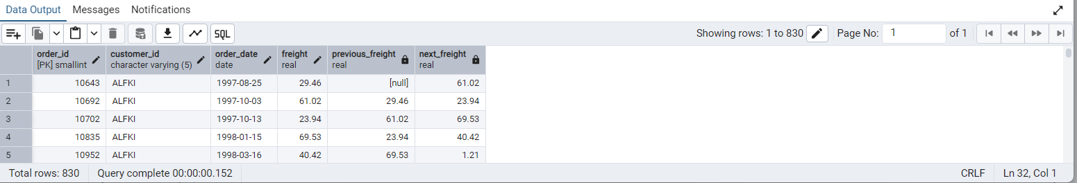

-- 3. Show products and their price categories, product count in each category, avg price:

-- (HINT:

-- · Create a CTE which should have price_category definition:

-- WHEN unit_price < 20 THEN 'Low Price'

-- WHEN unit_price < 50 THEN 'Medium Price'

-- ELSE 'High Price'

-- · In the main query display: price_category, product_count in each price_category,

- – ROUND(AVG(unit_price)::numeric, 2) as avg_price)

WITH

PRICE_CTE AS (

SELECT

PRODUCT_ID,

PRODUCT_NAME,

UNIT_PRICE,

CASE

WHEN UNIT_PRICE < 20 THEN 'Low Price'

WHEN UNIT_PRICE < 50 THEN 'Medium Price'

ELSE 'High Price'

END AS PRICE_CATEGORY

FROM

PRODUCTS

)

SELECT

PRICE_CATEGORY,

COUNT(*) AS PRODUCT_COUNT,

ROUND(AVG(UNIT_PRICE)::NUMERIC, 2) AS AVG_PRICE

FROM

PRICE_CTE

GROUP BY

PRICE_CATEGORY

ORDER BY

PRICE_CATEGORY;

### OUTPUT

