1)

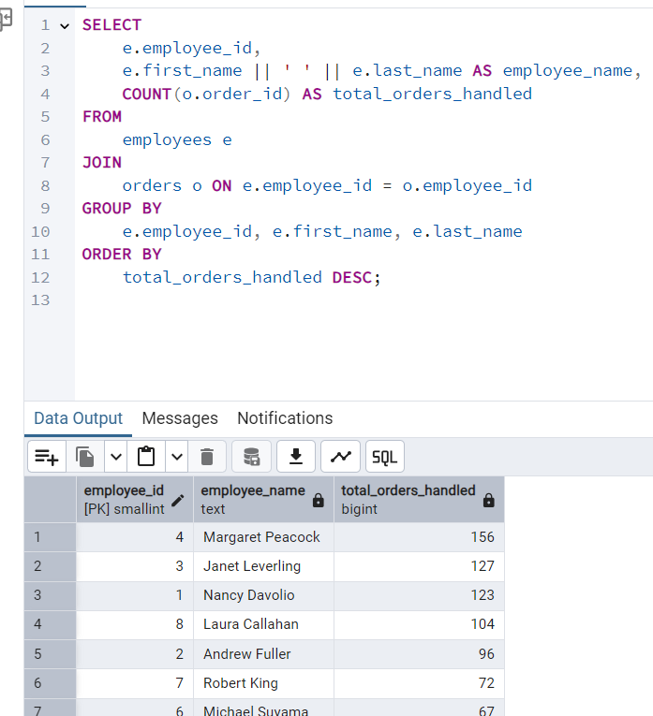

2) 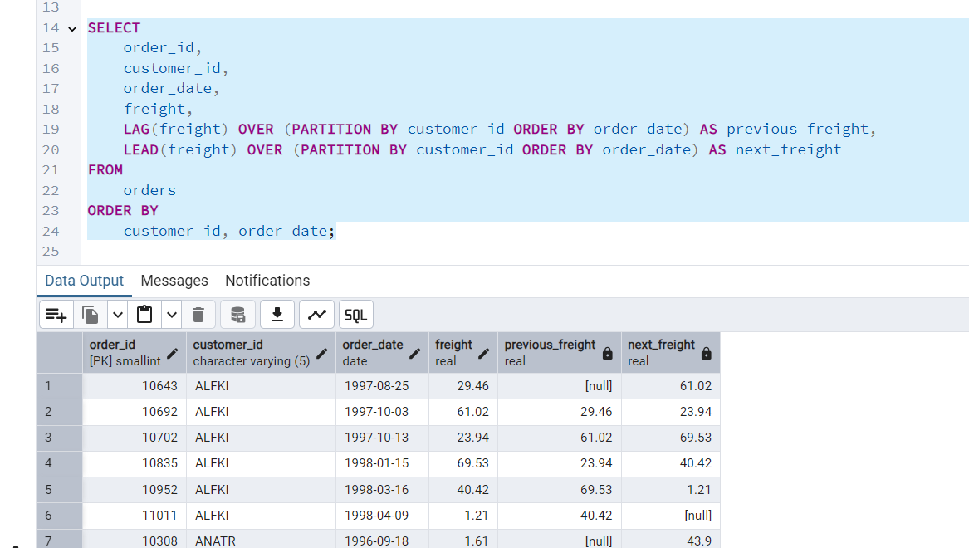

3) WITH price_cte AS (

SELECT

product_name,

unit_price,

CASE

WHEN unit_price < 20 THEN 'Low Price'

WHEN unit_price < 50 THEN 'Medium Price'

ELSE 'High Price'

END AS price_category

FROM

products

)

SELECT

price_category,

COUNT(*) AS product_count,

ROUND(AVG(unit_price)::numeric, 2) AS avg_price

FROM

price_cte

GROUP BY

price_category

ORDER BY

price_category;

