Day8_PavithraMani_SDET177

-- 1. Create view vw_updatable_products (use same query whatever I used in the training)

-- Try updating view with below query and see if the product table also gets updated.

-- Update query:

-- UPDATE updatable_products SET unit_price = unit_price * 1.1 WHERE units_in_stock < 10;

--create view

CREATE OR REPLACE VIEW VW_UPDATABLE_PRODUCTS AS

SELECT

PRODUCT_ID,

PRODUCT_NAME,

UNIT_PRICE,

UNITS_IN_STOCK

FROM

PRODUCTS

WHERE

DISCONTINUED = 0;

--update

UPDATE VW_UPDATABLE_PRODUCTS

SET

UNIT_PRICE = UNIT_PRICE * 1.1

WHERE

UNITS_IN_STOCK < 10;

--verify

SELECT

PRODUCT_ID,

PRODUCT_NAME,

UNIT_PRICE,

UNITS_IN_STOCK

FROM

PRODUCTS

WHERE

UNITS_IN_STOCK < 10

AND DISCONTINUED = 0;

### 

### OUTPUT

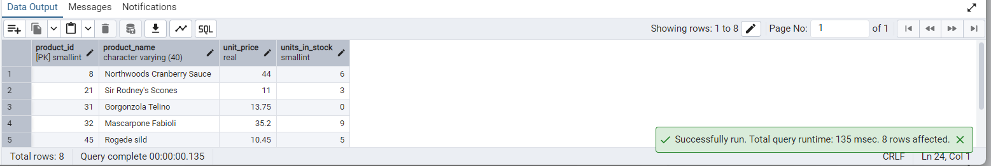

-- 2. Transaction:

-- Update the product price for products by 10% in category id=1

-- Try COMMIT and ROLLBACK and observe what happens.

-- Transaction 1: COMMIT

BEGIN;

-- Update prices by 10% where category_id = 1

UPDATE PRODUCTS

SET

UNIT_PRICE = UNIT_PRICE * 1.1

WHERE

CATEGORY_ID = 1;

-- View changes (this will show updated prices)

SELECT

PRODUCT_ID,

PRODUCT_NAME,

UNIT_PRICE

FROM

PRODUCTS

WHERE

CATEGORY_ID = 1;

-- Commit the changes

COMMIT;

-- Check again to confirm changes are saved

SELECT

PRODUCT_ID,

PRODUCT_NAME,

UNIT_PRICE

FROM

PRODUCTS

WHERE

CATEGORY_ID = 1;

This output is after updating and commiting

### OUTPUT

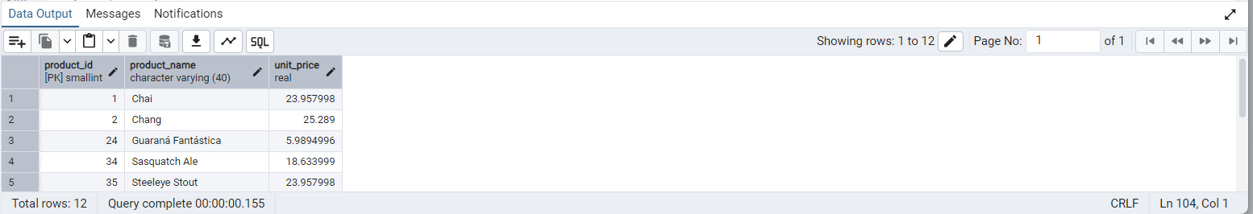

-- Transaction 2: ROLLBACK

BEGIN;

-- Update again by another 10%

UPDATE PRODUCTS

SET

UNIT_PRICE = UNIT_PRICE * 1.1

WHERE

CATEGORY_ID = 1;

-- View changes after second update

SELECT

PRODUCT_ID,

PRODUCT_NAME,

UNIT_PRICE

FROM

PRODUCTS

WHERE

CATEGORY_ID = 1;

-- Rollback the second update

ROLLBACK;

-- Final check: should show committed values only (first 10% increase)

SELECT

PRODUCT_ID,

PRODUCT_NAME,

UNIT_PRICE

FROM

PRODUCTS

WHERE

CATEGORY_ID = 1;

This output is after again updating and rollback

### OUTPUT

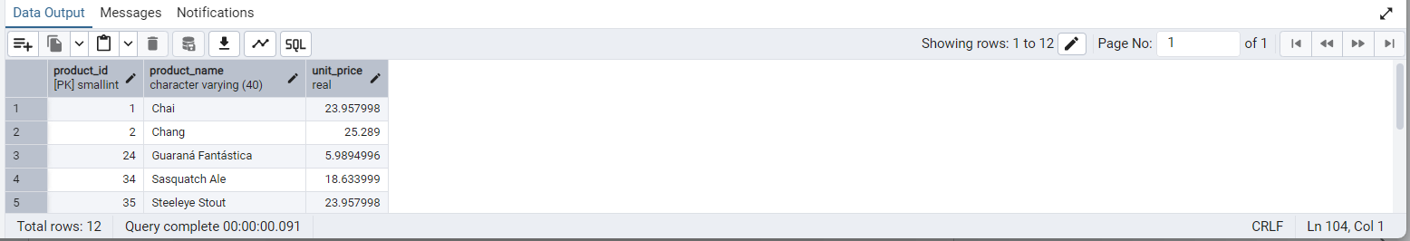

-- 3. Create a regular view which will have below details (Need to do joins):

-- Employee_id,

-- Employee_full_name,

-- Title,

-- Territory_id,

-- territory_description,

-- region_description

CREATE OR REPLACE VIEW VW_EMPLOYEE_TERRITORIES AS

SELECT

E.EMPLOYEE_ID,

E.FIRST_NAME || ' ' || E.LAST_NAME AS EMPLOYEE_FULL_NAME,

E.TITLE,

T.TERRITORY_ID,

T.TERRITORY_DESCRIPTION,

R.REGION_DESCRIPTION

FROM

EMPLOYEES E

JOIN EMPLOYEE_TERRITORIES ET ON E.EMPLOYEE_ID = ET.EMPLOYEE_ID

JOIN TERRITORIES T ON ET.TERRITORY_ID = T.TERRITORY_ID

JOIN REGION R ON T.REGION_ID = R.REGION_ID;

### 

### 

### 

### OUTPUT

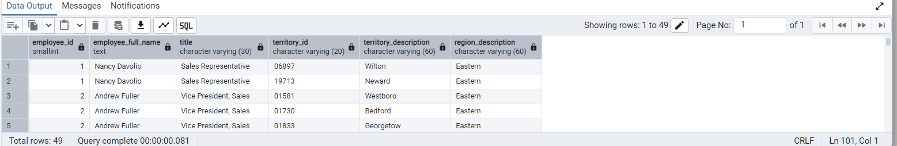

-- 4. Create a recursive CTE based on Employee Hierarchy

WITH RECURSIVE

EMPLOYEE_HIERARCHY AS (

-- Anchor: Top-level employee(s) with no manager

SELECT

EMPLOYEE_ID,

FIRST_NAME || ' ' || LAST_NAME AS FULL_NAME,

TITLE,

REPORTS_TO,

1 AS LEVEL

FROM

EMPLOYEES

WHERE

REPORTS_TO IS NULL

UNION ALL

-- Recursive: employees who report to others

SELECT

E.EMPLOYEE_ID,

E.FIRST_NAME || ' ' || E.LAST_NAME AS FULL_NAME,

E.TITLE,

E.REPORTS_TO,

EH.LEVEL + 1 AS LEVEL

FROM

EMPLOYEES E

INNER JOIN EMPLOYEE_HIERARCHY EH ON E.REPORTS_TO = EH.EMPLOYEE_ID

)

SELECT

*

FROM

EMPLOYEE_HIERARCHY

ORDER BY

LEVEL,

REPORTS_TO,

EMPLOYEE_ID;

### OUTPUT

