Day 8

/*1. Create view vw_updatable_products (use same query whatever I used in the training)

Try updating view with below query and see if the product table also gets updated.

Update query:

UPDATE updatable_products SET unit_price = unit_price * 1.1 WHERE units_in_stock < 10; */

-- CREATE VIEW

CREATE VIEW vw_updatable_products AS

SELECT

product_id,

product_name,

unit_price,

units_in_stock,

discontinued

FROM products

where discontinued = 0

WITH CHECK OPTION;

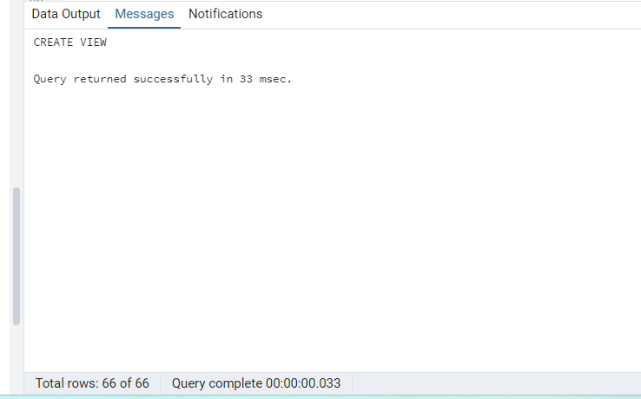

select * from vw_updatable_products;

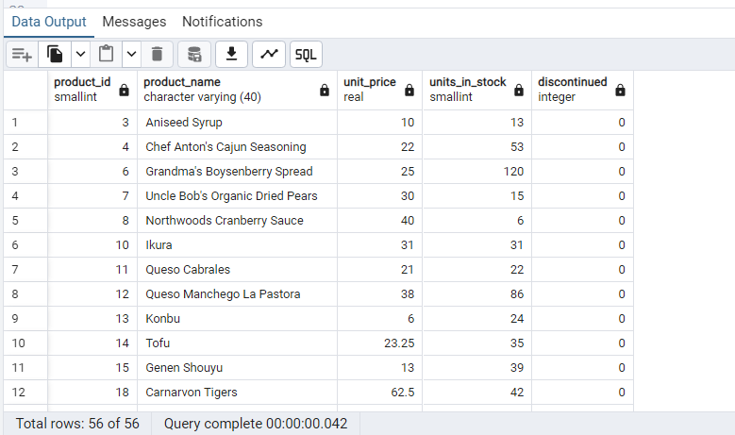

select * from products;

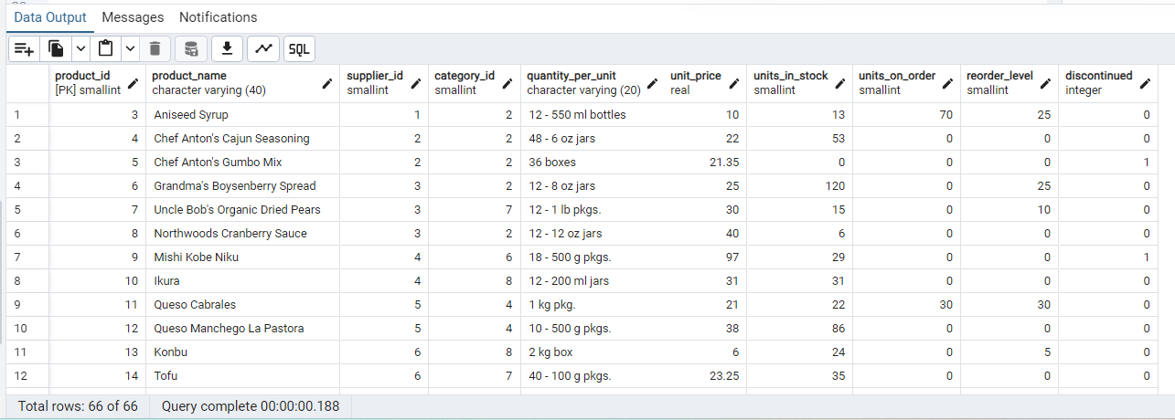

-- After the UPDATE product_id 8 unit_price will be increased by 10%

--UPDATE VIEW

UPDATE vw_updatable_products

SET unit_price = unit_price * 1.1

WHERE units_in_stock < 10;

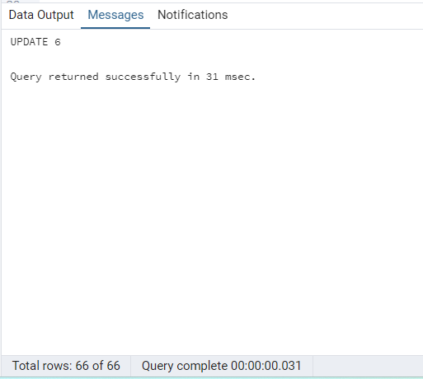

select * from products order by product_id;

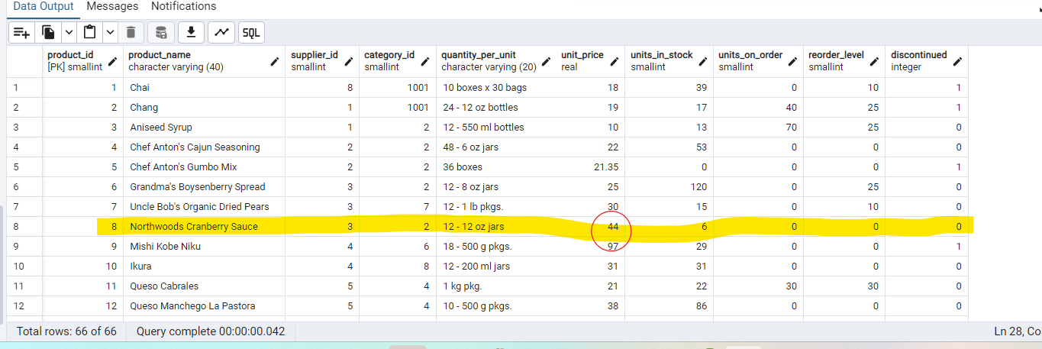

/*2. Transaction:

Update the product price for products by 10% in category id=1

Try COMMIT and ROLLBACK and observe what happens.*/

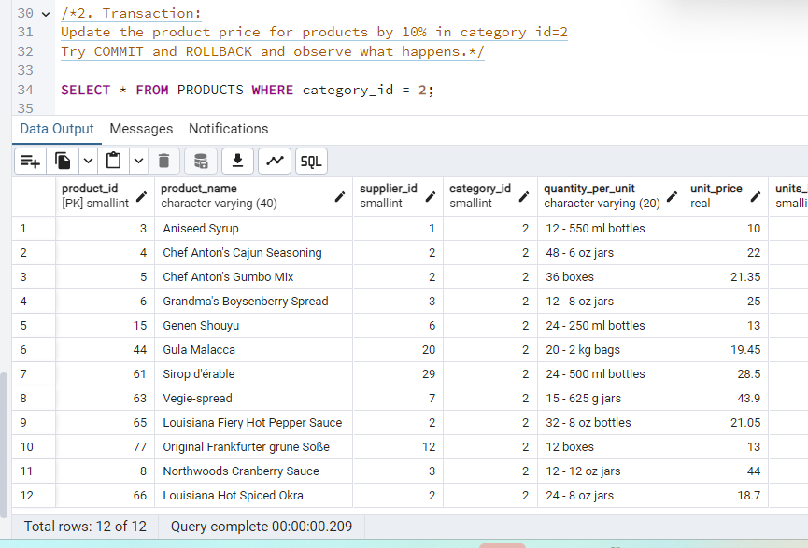

BEGIN;

UPDATE products

SET unit_price = unit_price * 1.10

WHERE category_id = 2;

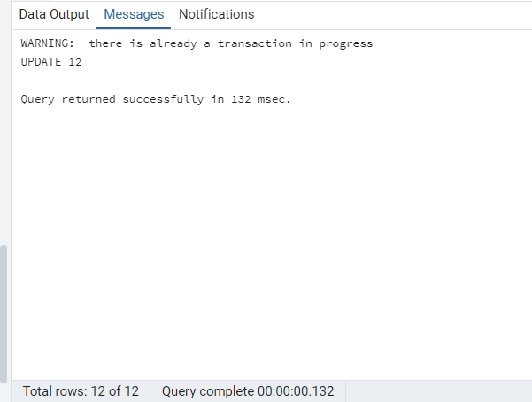

SELECT product_id, product_name, unit_price, category_id

FROM products

WHERE category_id = 2;

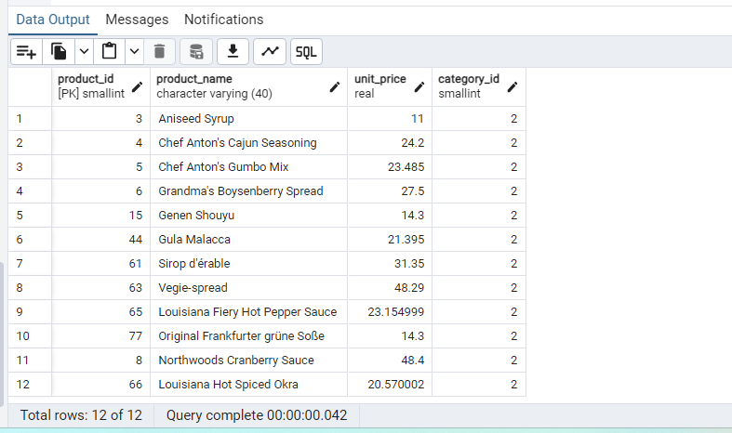

COMMIT;

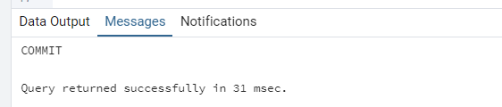

ROLLBACK;

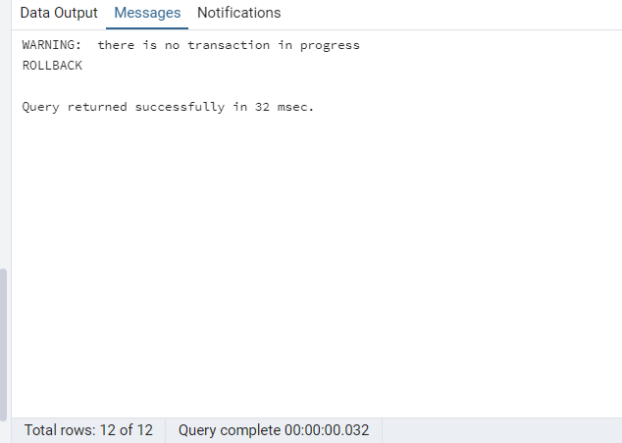

3. Create a regular view which will have below details (Need to do joins):

Employee_id,

Employee_full_name,

Title,

Territory_id,

territory_description,

region_description

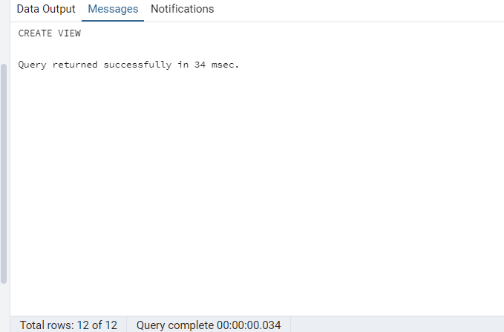

/*4. Create a recursive CTE based on Employee Hierarchy */

WITH RECURSIVE employee_hierarchy AS (

--Top-level managers

SELECT

employee_id,

first_name,

last_name,

title,

reports_to,

1 AS level,

CONCAT(first_name, ' ', last_name) AS hierarchy

FROM employees

WHERE reports_to IS NULL

UNION ALL

-- Recursive member: Employees reporting to others

SELECT

e.employee_id,

e.first_name,

e.last_name,

e.title,

e.reports_to,

eh.level + 1,

CONCAT(eh.hierarchy, ' > ', e.first_name, ' ', e.last_name)

FROM employees e

INNER JOIN employee_hierarchy eh ON e.reports_to = eh.employee_id

)

SELECT *

FROM employee_hierarchy

ORDER BY hierarchy;

