1) CREATE TABLE product_price_audit (

audit_id SERIAL PRIMARY KEY,

productid INT,

old_price DECIMAL(10, 2),

new_price DECIMAL(10, 2),

changed_at TIMESTAMP DEFAULT CURRENT_TIMESTAMP

);

CREATE OR REPLACE FUNCTION log_price_change()

RETURNS TRIGGER AS $$

BEGIN

-- Only log if the price actually changed

IF OLD.unitprice IS DISTINCT FROM NEW.unitprice THEN

INSERT INTO product_price_audit (productid, old_price, new_price)

VALUES (OLD.productid, OLD.unitprice, NEW.unitprice);

END IF;

RETURN NEW;

END;

$$ LANGUAGE plpgsql;

select * from products;

CREATE TRIGGER trg_price_change

AFTER UPDATE ON products

FOR EACH ROW

EXECUTE FUNCTION log_price_change();

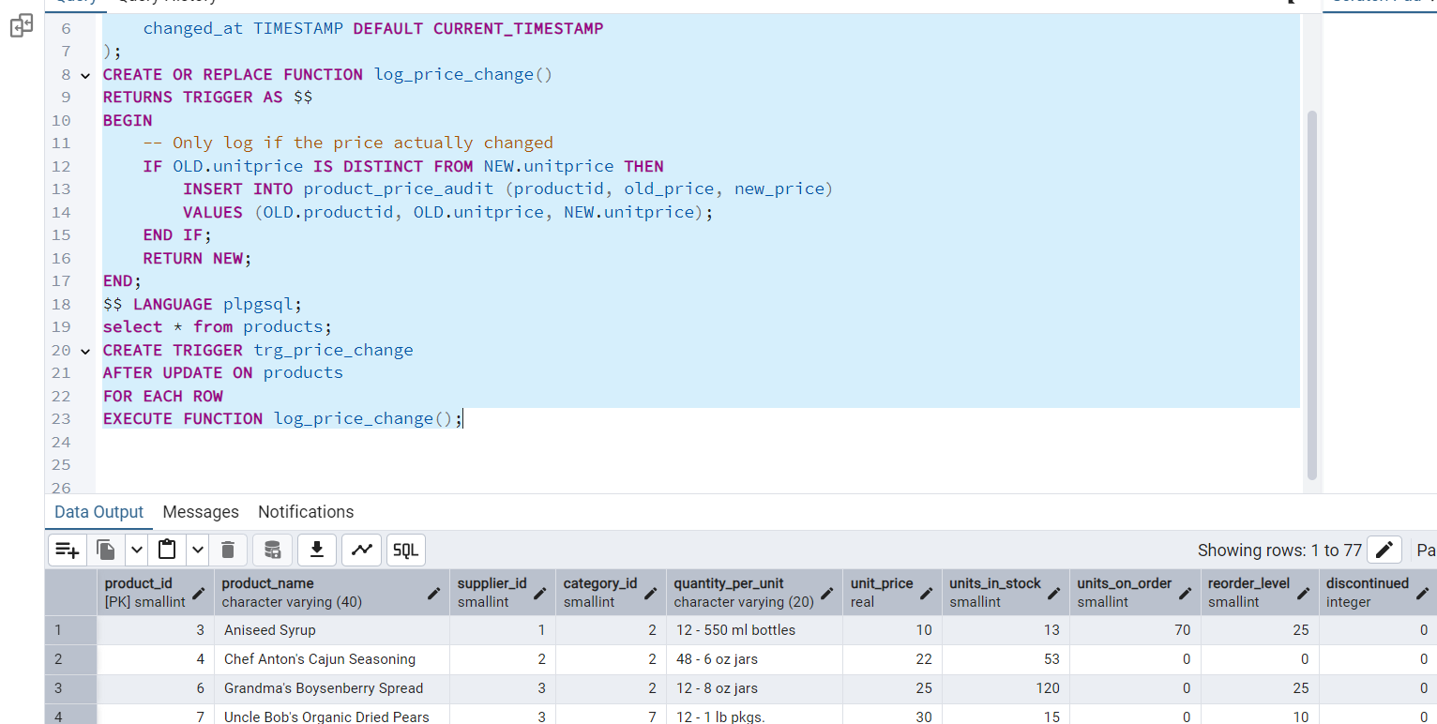

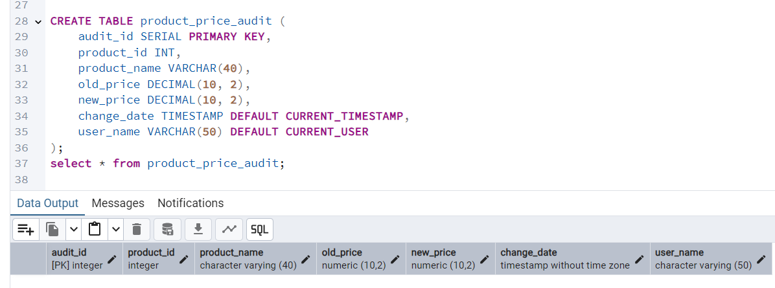

CREATE OR REPLACE FUNCTION log_product_price_change()

RETURNS TRIGGER AS $$

BEGIN

-- Only log if the price has actually changed

IF OLD.unit_price IS DISTINCT FROM NEW.unit_price THEN

INSERT INTO product_price_audit (

product_id,

product_name,

old_price,

new_price

)

VALUES (

OLD.product_id,

OLD.product_name,

OLD.unit_price,

NEW.unit_price

);

END IF;

RETURN NEW;

END;

$$ LANGUAGE plpgsql;

CREATE TRIGGER trg_log_unit_price_change

AFTER UPDATE OF unit_price ON products

FOR EACH ROW

EXECUTE FUNCTION log_product_price_change();

select * from products;

UPDATE products

SET unit_price = unit_price * 1.10

WHERE product_id = 3;

SELECT * FROM product_price_audit

ORDER BY change_date DESC

LIMIT 5;

2)

CREATE OR REPLACE PROCEDURE assign_task_to_employee(

IN p_employee_id INT,

IN p_task_name VARCHAR(50),

INOUT p_task_count INT DEFAULT 0

)

LANGUAGE plpgsql

AS $$

BEGIN

INSERT INTO employee_tasks (employee_id, task_name)

VALUES (p_employee_id, p_task_name);

SELECT COUNT(*)

INTO p_task_count

FROM employee_tasks

WHERE employee_id = p_employee_id;

RAISE NOTICE 'Task "%" assigned to employee %. Total tasks: %',

p_task_name, p_employee_id, p_task_count;

END;

$$;

SELECT * FROM information_schema.tables

WHERE table_name = 'employee_tasks';

CREATE TABLE employee_tasks (

task_id SERIAL PRIMARY KEY,

employee_id INT,

task_name VARCHAR(50),

assigned_date DATE DEFAULT CURRENT_DATE

);

DO $$

DECLARE

task_total INT := 0;

BEGIN

CALL assign_task_to_employee(101, 'Submit Status Report', task_total);

END;

$$;

select * from employee_tasks;