**VOYAGE VISTA : ILLUMINATING INSIGHTS FROM UBER EXPENDITIONARY ANALYSIS :**

**INTRODUCTION :**

*Uber offers rides under a dynamic pricing model for both drivers and passengers. Passengers needing a ride can use the app to hail a driver with an estimated price that is dependent on the destination as well as the demand at the time.*

**VISUALIZATION & GRAPH :**

* **EMPATHY MAP :**

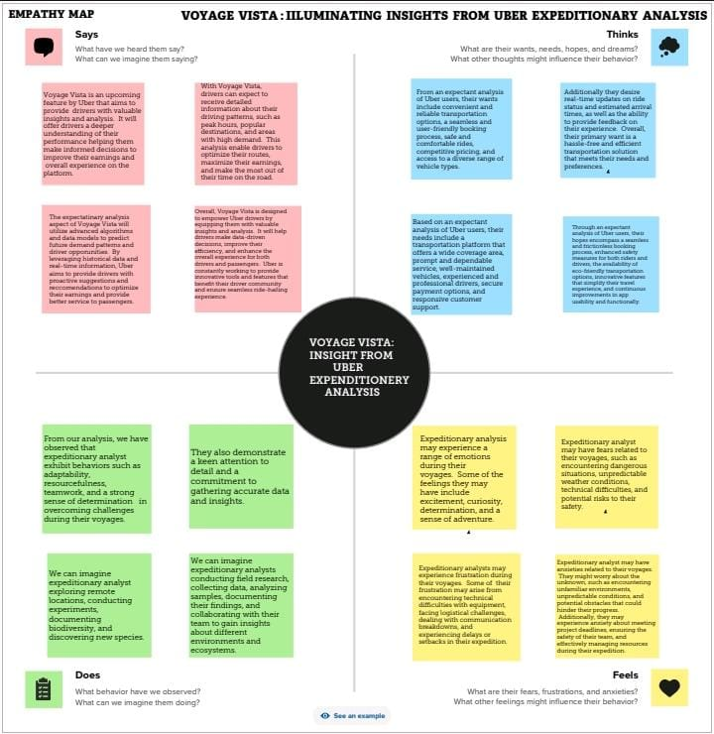

* **BRAIN STORM :**

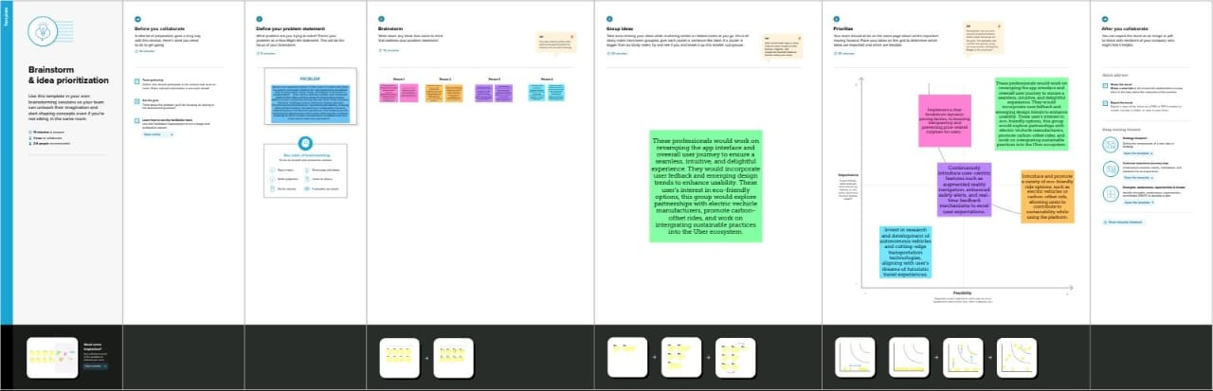

* **MILES COVERED PER CATEGORY AND PURPOSE ANALYSIS :**

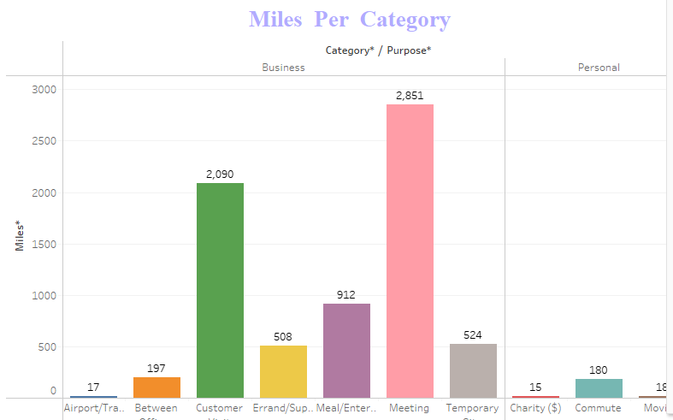

* **MILES COVERED IN CATEGORY ANALYSIS:**

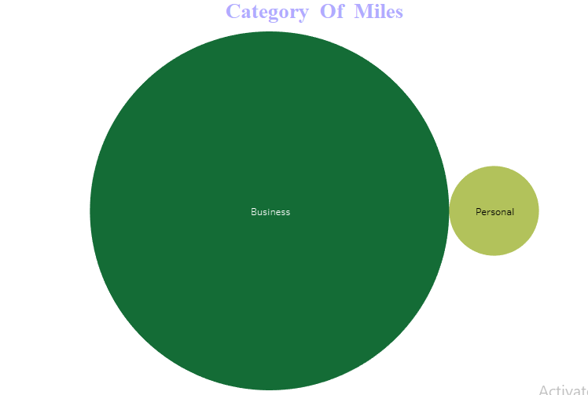

* **MONTH WISE UBER MILES ANALYSIS :**

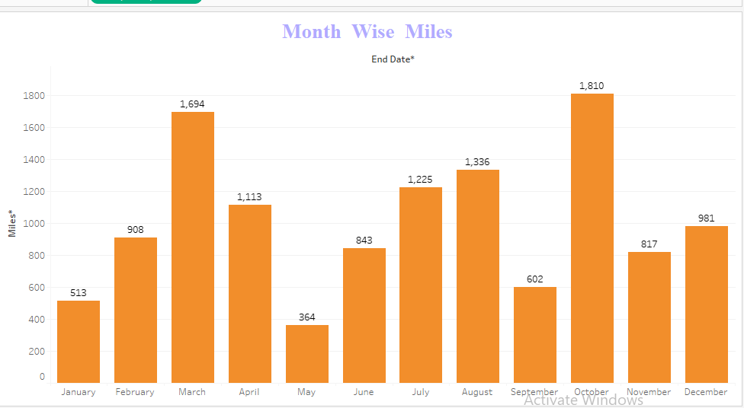

* **WEEK WISE UBER MILES ANALYSIS :**

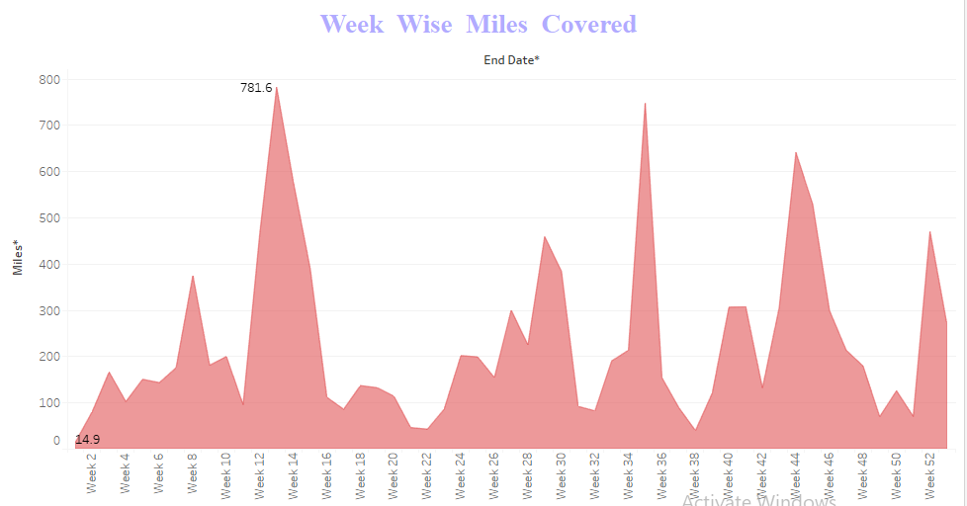

* **QUARTER WISE MILES :**

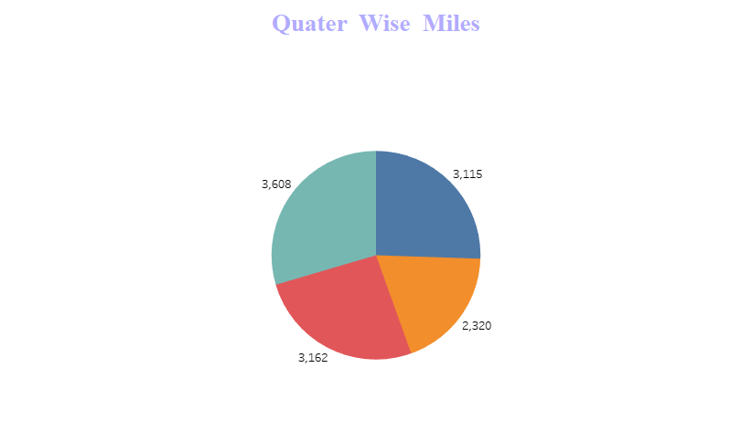

* **MONTH WISE UBER TRIPS ANALYSIS :**

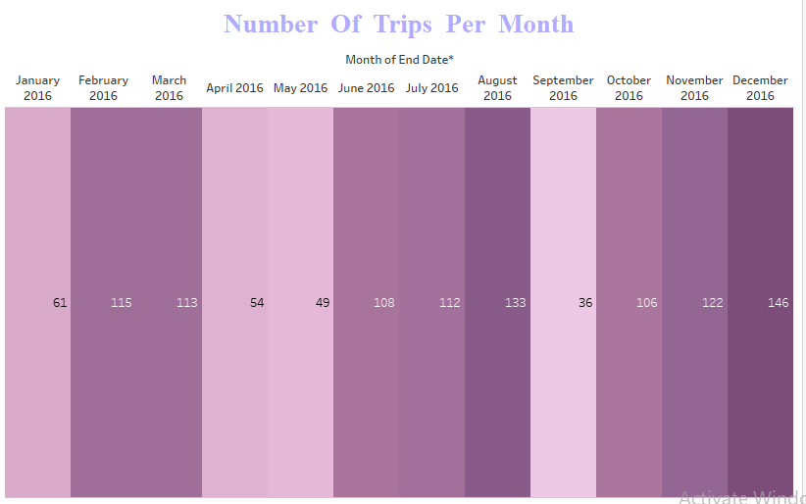

* **QUARTER WISE UBER TRIPS ANALYSIS :**

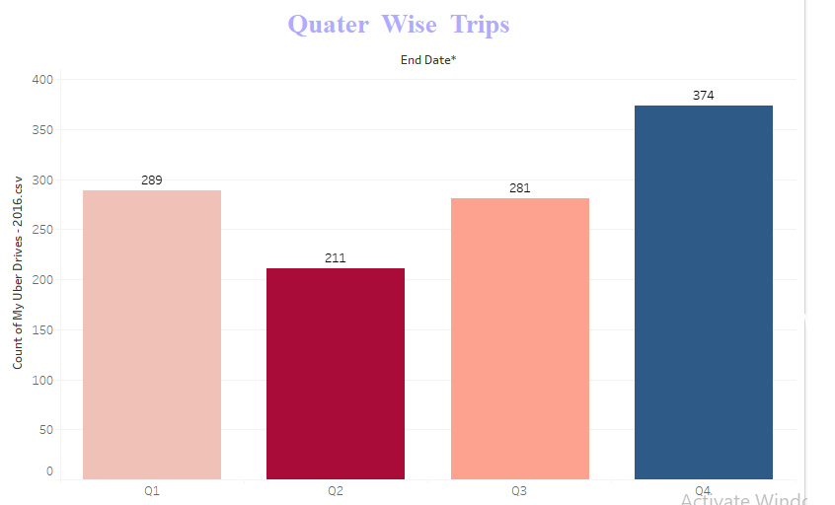

* **HOUR WISE UBER TRIPS ANALYSIS :**

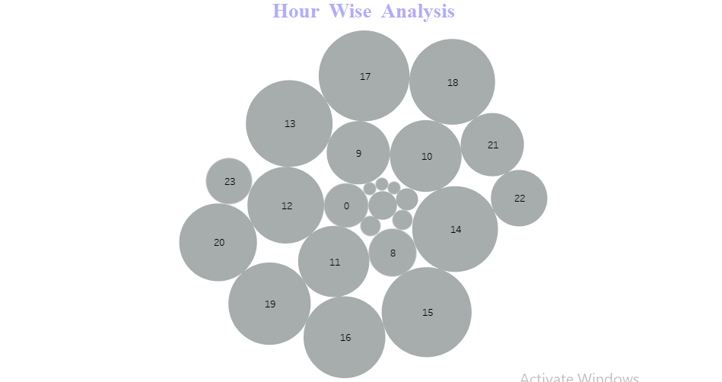

* **DASHBOARD – 1 :**

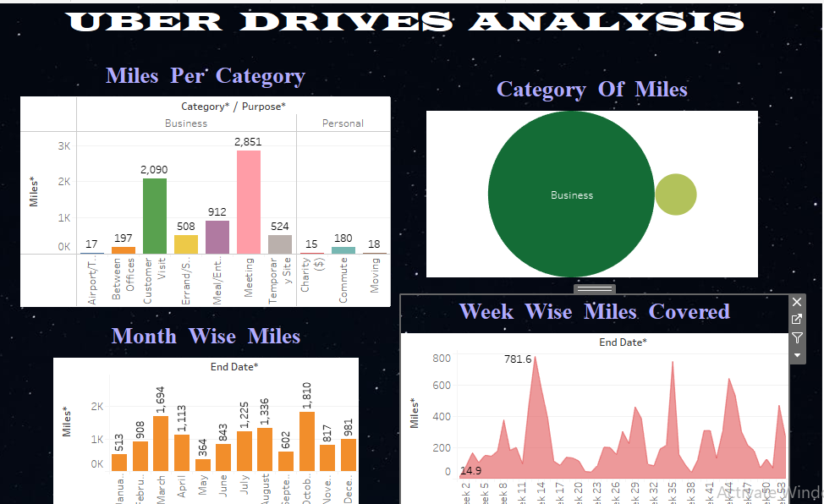

* **DASHBOARD – 2 :**

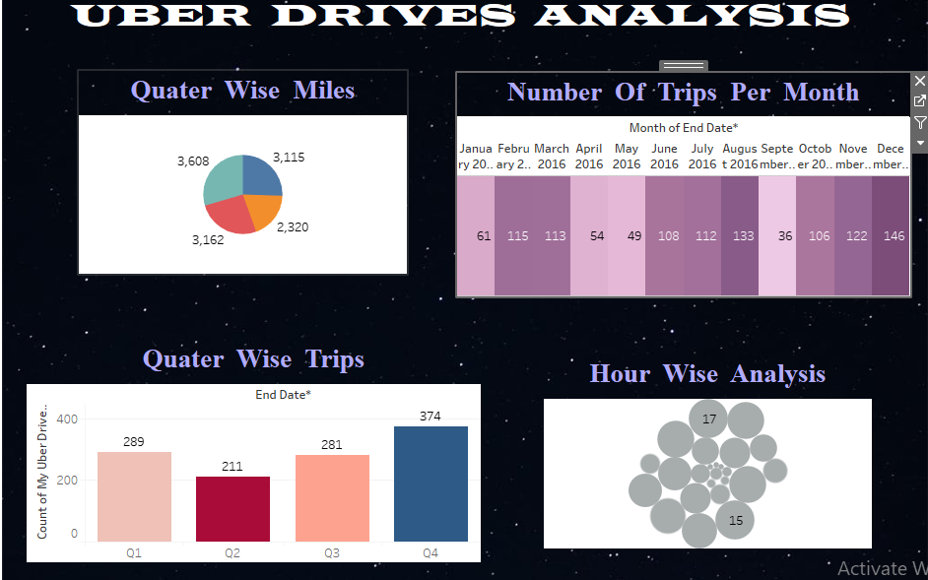

* **STORY – 1 :**

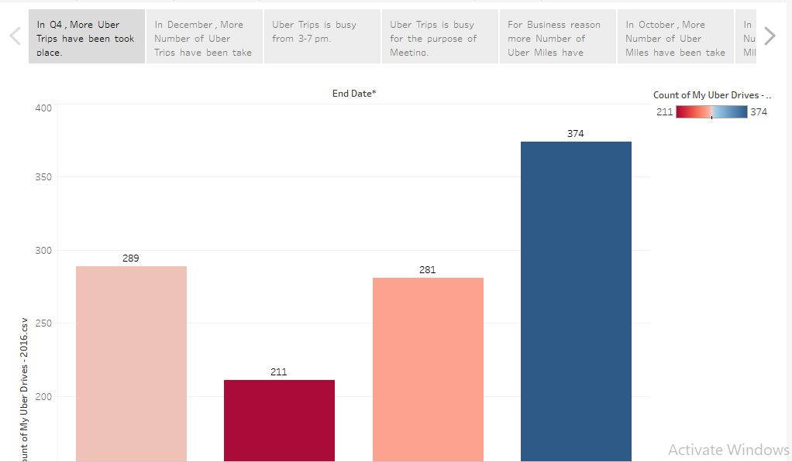

**STORY - 2 :**

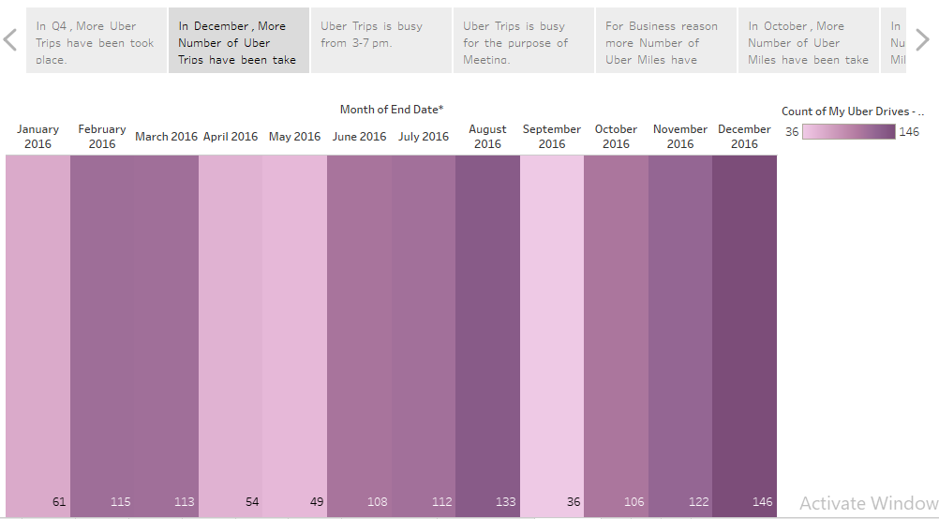

* **STORY - 3 :**



* **STORY – 4 :**

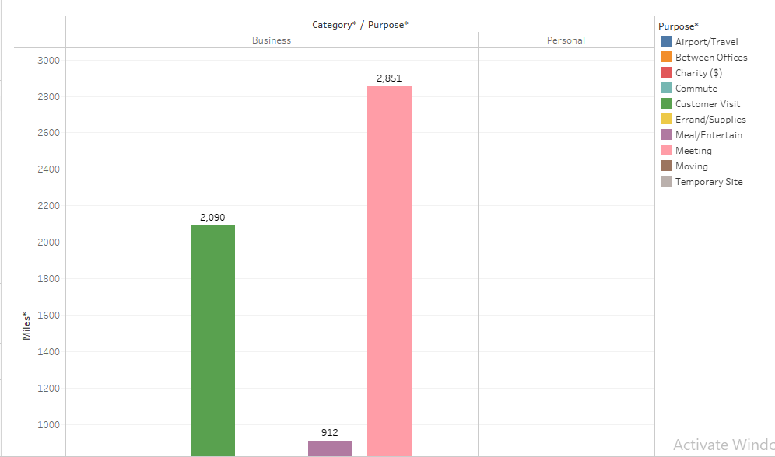

* **STORY - 5 :**

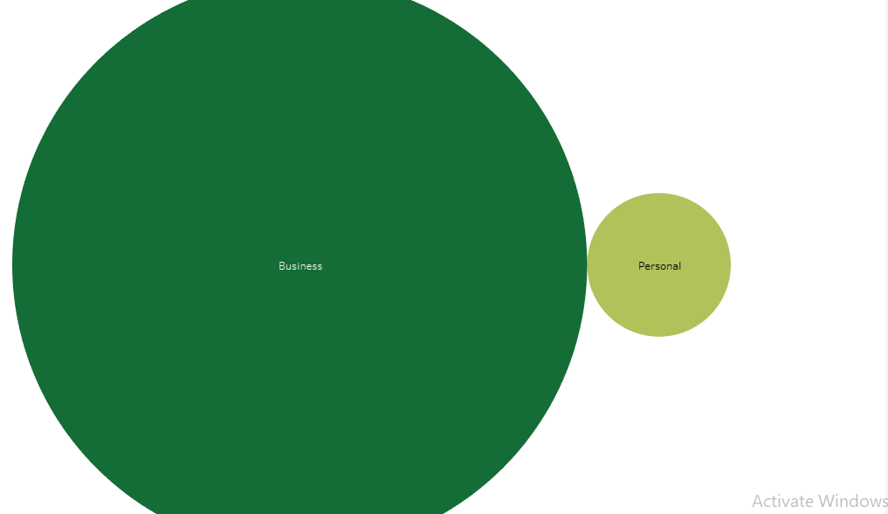

* **STORY - 6 :**

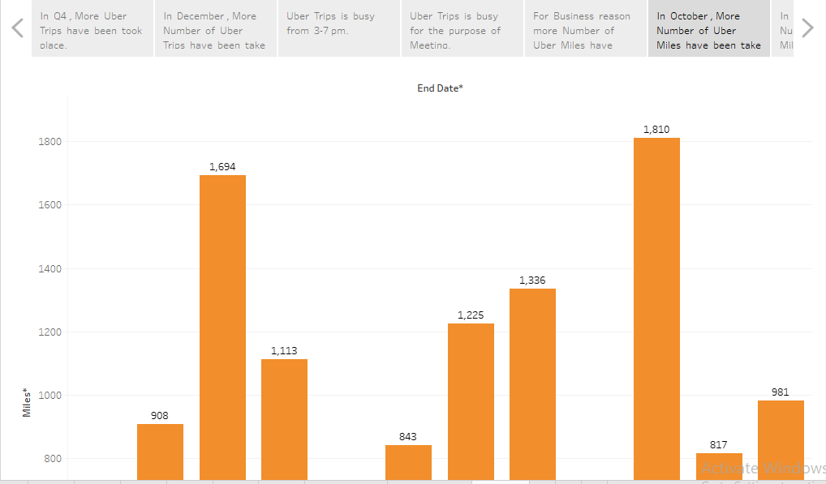

* **STORY - 7 :**

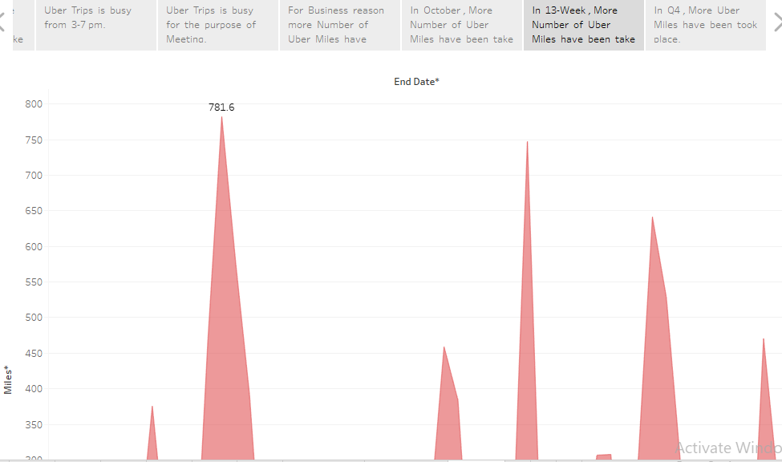

* **STORY - 8 :**

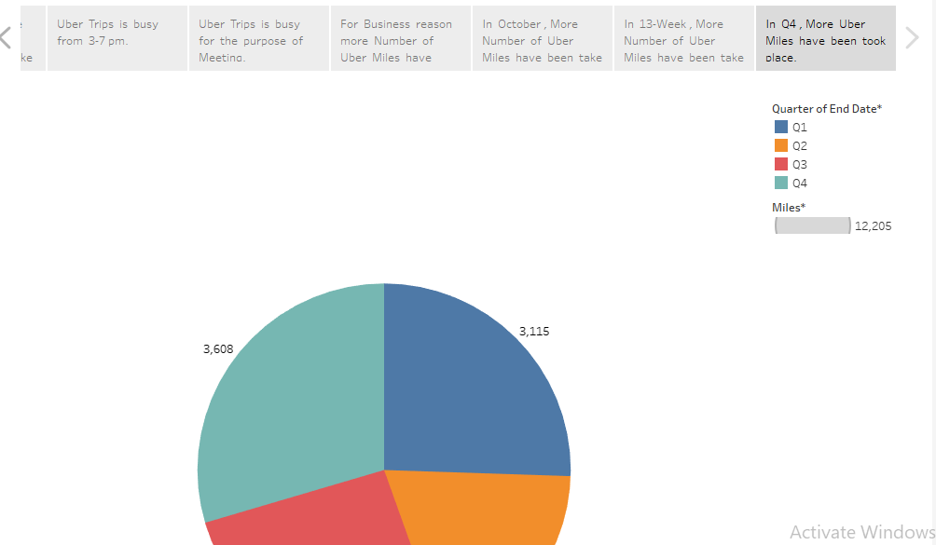

**CONCLUSION:**

*Uber is a popular ride-sharing that allows you to request a ride using your Smartphone . It’s convenient and often more affordable than traditional taxis.*