MANIPAL INSTITUTE OF TECHNOLOGY
ICT 4442 Deep Learning Mini Project

Customer Review Intelligence System
Comparative deep learning for sentiment classification and aspect-level evidence
FINAL REPORT
Member | Registration number
Pavit Agrawal | 230953406
Priyanshu Sharma | 230953520
Shivam Lahoty | 230953026
Aryan Sorout | 230953342

Team 14 | Semester VII | Academic Year 2026-2027
Repository: https://github.com/pavitagrawal/CRIS_DL

Abstract
This project compares four deep learning architectures for three-class sentiment classification of Amazon customer reviews and integrates the selected model into an explainable review-analysis application. MLP, TextCNN, BiLSTM, and a compact attention-based Transformer use one category-and-class stratified 70/15/15 split, a training-only tokenizer, a 20,000-token vocabulary limit, and a 200-token sequence limit. Validation macro F1 selects the architecture before final test evaluation.
BiLSTM achieved the strongest validation macro F1 at 0.6803. On the held-out 7,500-review test split it reached 67.71% accuracy and 0.6767 macro F1. Neutral reviews remained the main error source, with 55.36% recall. A later fine-tuned BiLSTM supports short product and restaurant reviews in the Streamlit application. The application adds clause-level aspect evidence, conservative explicit cues, human-review flags, editable corrections, and downloadable results.
The aspect component is intentionally separated from the overall sentiment model. Keyword profiles and phrase cues reached 59.64% recall and 89.59% mention precision on the inspected SemEval laptop test split, while a restaurant profile reached 61.73% recall and 94.09% mention precision on SemEval restaurant Phase B. These figures describe term coverage and covered-term polarity, not end-to-end ABSA accuracy. The final system is complete for the course scope and retains these limitations in the dashboard and documentation.

1 Project objectives
The system addresses two related tasks. First, it compares complementary neural architectures under a fair experimental protocol. Second, it turns the selected model into a usable review-intelligence workflow that preserves evidence and supports human correction.
- Compare MLP, TextCNN, BiLSTM, and Transformer architectures on one saved split.
- Select models using validation macro F1 and report held-out Accuracy, macro Precision, Recall, F1, training time, prediction time, and confusion matrices.
- Expose aspect mentions and their matched clauses without presenting heuristic aspect labels as a separately trained ABSA model.
- Support single-review and CSV analysis, review triage, human labels, and downloadable annotated results.
- Make data preparation, training, analysis, and verification reproducible from scripts.

2 Background and literature
Customer reviews can contain different opinions about quality, price, design, performance, battery, service, and other attributes. Document sentiment classification summarizes the review as a whole, while aspect-based sentiment analysis identifies a target and evaluates the sentiment expressed toward it. The final project treats these as separate layers because Amazon star ratings supervise document sentiment but do not provide aspect-level labels.
Kim's TextCNN motivates local phrase filters. Hochreiter and Schmidhuber's LSTM supports sequential context, while bidirectional processing and learned attention provide a sentence representation. Vaswani et al. motivate self-attention and direct token interactions. SemEval-2014 provides public laptop and restaurant aspect annotations used here to evaluate keyword coverage and covered-term polarity.

Architecture | Primary mechanism | Role in comparison
MLP | Mean-pooled token embeddings and feed-forward layers | Fast baseline
TextCNN | Parallel one-dimensional convolutions and global max pooling | Local phrase patterns
BiLSTM | Bidirectional recurrent layers with attention pooling | Long-range sequence context
Transformer | Multi-head self-attention with a learned CLS token | Global token interaction

Table 1. Roles of the four planned architectures

3 Dataset and preprocessing

3.1 Dataset construction
The reproducible benchmark samples 50,000 reviews from Amazon Reviews 2023 categories All Beauty, Books, Electronics, and Home and Kitchen. Each category contributes 12,500 reviews. Reservoir sampling operates within the first 200,000 source records per category, filters short text, removes case-insensitive exact duplicates across categories, and balances the three rating-derived sentiment classes.
Ratings 1-2 map to negative, rating 3 maps to neutral, and ratings 4-5 map to positive. These labels are consistent and scalable, but they remain proxies for the text's sentiment. A review can contain mixed language or wording that conflicts with its star rating.
Partition | Reviews | Share | Purpose
Training | 35,000 | 70% | Model parameter learning and tokenizer fitting
Validation | 7,500 | 15% | Epoch selection and architecture comparison
Test | 7,500 | 15% | Final held-out evaluation

Table 2. Fixed category-and-sentiment stratified split

3.2 Text processing
The shared pipeline lowercases text, removes HTML and URLs, filters non-alphabetic noise, optionally removes stopwords, builds a vocabulary from training text only, and converts reviews to fixed-length integer sequences. The final comparison limits the vocabulary to 20,000 tokens and pads or truncates each review to 200 tokens. Padding masks prevent padded tokens from affecting MLP pooling, BiLSTM attention pooling, and Transformer attention.

3.3 Reproducibility
The dataset builder records source URLs, scan limits, sampling seed 20261021, class quotas, deduplication, split policy, and output sizes. The model runner fixes Python, NumPy, and PyTorch seed 42. The full dataset remains excluded from version control because it is large and redistributable from the documented public source.

4 Model implementation

4.1 MLP
The baseline embeds tokens, computes a padding-aware mean representation, and applies two fully connected blocks with BatchNorm, ReLU, and dropout before the three-class output layer.

4.2 TextCNN
TextCNN applies convolutional kernels of widths 2, 3, and 4 to identify local n-gram-like patterns. ReLU activations and global max pooling produce a fixed-length feature vector for classification.

4.3 BiLSTM
The BiLSTM uses two bidirectional recurrent layers. A learned attention score combines non-padding hidden states, and the resulting context vector feeds the final classifier. Gradient clipping controls recurrent training. This architecture won the validation comparison.

4.4 Transformer
The compact Transformer uses learned token embeddings, sinusoidal positions, a learned CLS token, two encoder layers, four attention heads, and a feed-forward dimension of 256. Padding masks exclude padded positions. It trains from scratch and should not be interpreted as a pretrained BERT result.

5 Experimental protocol
All four architectures receive the same encoded training, validation, and test tensors. Each uses 128-dimensional embeddings and AdamW. MLP, TextCNN, and BiLSTM use a learning rate of 5e-4, while Transformer uses 1e-4. Training runs for at most five epochs. The script saves the epoch with the highest validation macro F1, then evaluates that state on the test split exactly once for reporting.
Control | Final setting
Vocabulary | 20,000 tokens fitted on training reviews only
Sequence length | 200 tokens with post padding and truncation
Batch size | 128
Selection metric | Validation macro F1
Test labels | Negative, neutral, positive rating proxies
Reported efficiency | Training seconds and full-test prediction seconds

Table 3. Shared experimental controls

6 Architecture comparison
Model | Epoch | Val F1 | Test accuracy | Test F1 | Train | Predict
MLP | 5 | 0.6062 | 61.13% | 0.6115 | 14.3 s | 0.07 s
TextCNN | 5 | 0.6065 | 62.01% | 0.6157 | 215.3 s | 3.22 s
BiLSTM | 5 | 0.6803 | 67.71% | 0.6767 | 1096.5 s | 14.12 s
Transformer | 4 | 0.3942 | 39.57% | 0.3907 | 1042.4 s | 8.20 s

Table 4. Final four-model comparison on the shared split
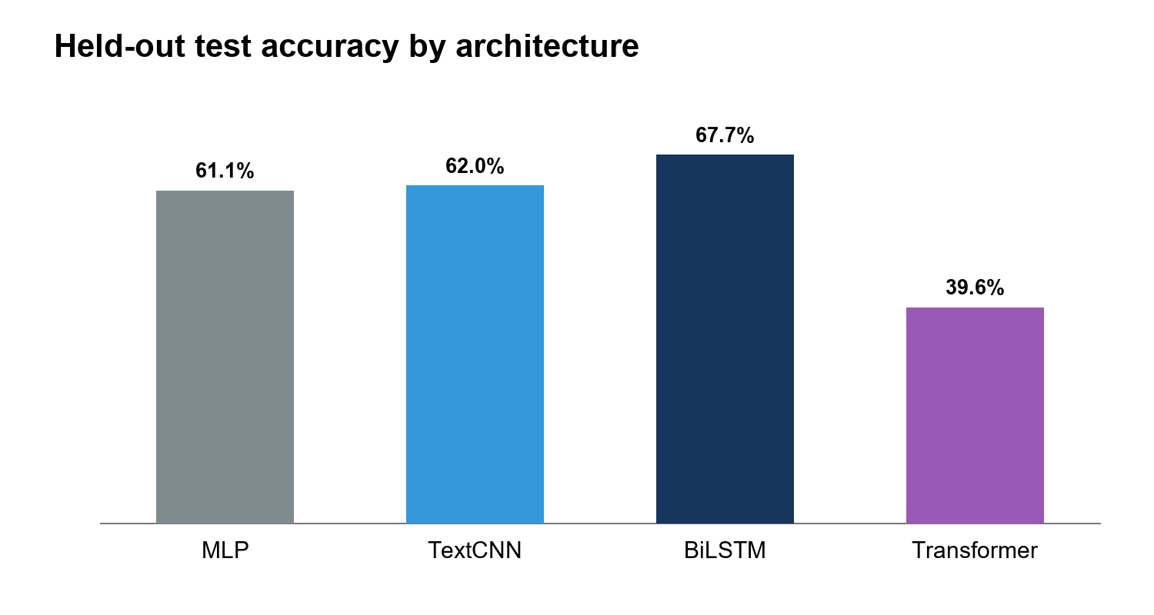
Figure 1. Held-out accuracy for the four planned architectures
BiLSTM achieved the highest validation macro F1 and therefore became the selected architecture. It also achieved the highest held-out test accuracy and macro F1. TextCNN modestly improved on MLP but required substantially more computation. The compact Transformer did not optimize successfully under the declared from-scratch configuration; its result documents this experiment rather than supporting a general claim about Transformer models.

7 Error analysis
Class | Support | Correct | Errors | Precision | Recall | F1
Negative | 2500 | 1794 | 706 | 0.6669 | 0.7176 | 0.6913
Neutral | 2500 | 1384 | 1116 | 0.5767 | 0.5536 | 0.5649
Positive | 2500 | 1900 | 600 | 0.7884 | 0.7600 | 0.7739

Table 5. BiLSTM class-level test performance
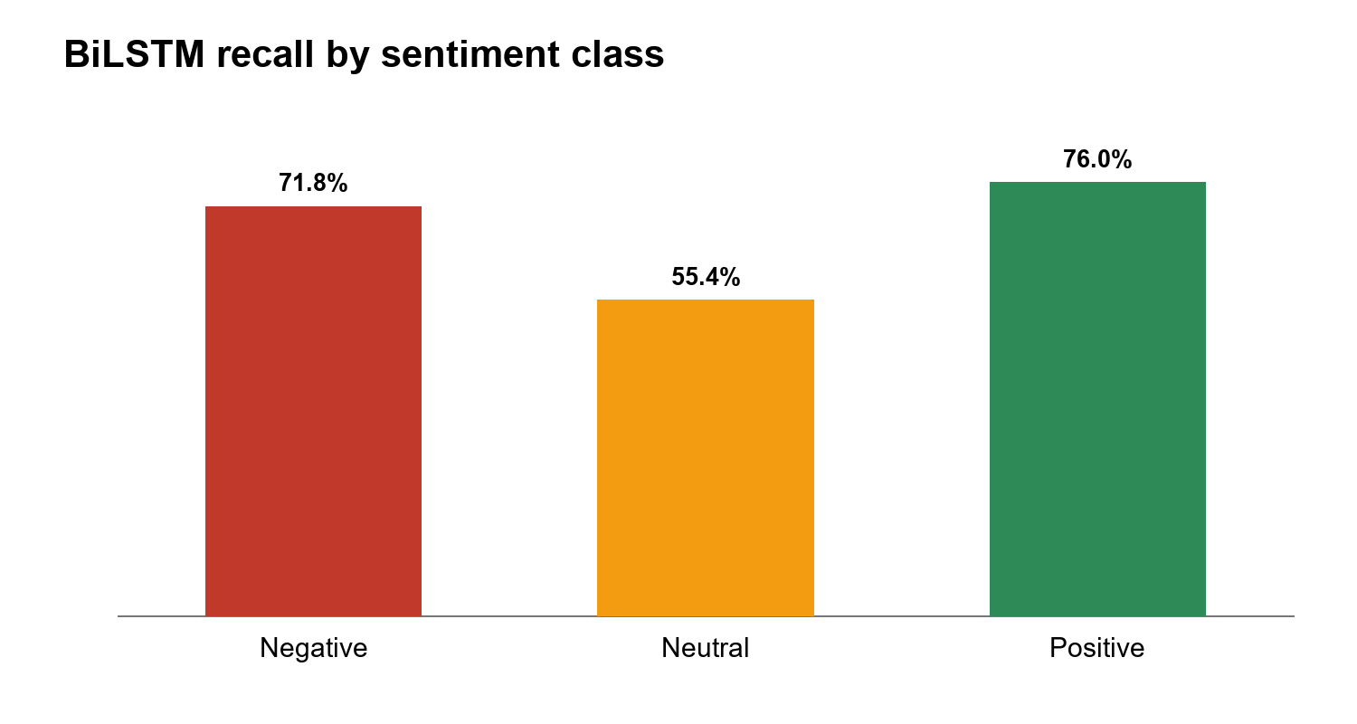
Figure 2. BiLSTM recall by sentiment class
Neutral reviews produced 1,116 of the model's 2,422 test errors. The largest individual confusion mapped 744 neutral reviews to negative. Other large confusions mapped 568 negative reviews to neutral and 448 positive reviews to neutral. This pattern explains why the application flags low-score predictions, mixed aspect evidence, and explicit complaints paired with neutral predictions for human review.
The softmax score shown by the application is uncalibrated. The review queue is a triage aid rather than a guarantee that every flagged prediction is wrong or every unflagged prediction is correct.

8 Aspect-level evidence

8.1 Method
The aspect layer segments a review into short clauses, matches category-specific keywords, and assigns each matched clause a sentiment label. Conservative phrase rules handle clear statements such as battery drains quickly or the keyboard is comfortable. Every result includes the matched clause and the method used. Aspect summaries remain separate from the overall model prediction.

8.2 Laptop evaluation
Measure | Result
Gold laptop terms | 332
Detected gold terms | 198
Mention precision | 89.59%
Gold-term recall | 59.64%
Mention F1 | 0.7161
Covered-term polarity accuracy | 62.12%
Correct detected polarity per gold term | 37.05%

Table 6. Expanded laptop aspect results on the inspected test split

8.3 Restaurant evaluation
The restaurant profile detected 700 of 1134 Phase B aspect terms, with 94.09% mention precision, 61.73% recall, and 0.7455 F1. Restaurant keywords were developed from restaurant training-term frequencies, so this comparison remains exploratory. The later Yelp fine-tuning improved held-out binary restaurant accuracy from 71.5% to 77.5%, while three-class neutral behavior remains weak because Yelp provides positive and negative labels only.
The system does not claim full end-to-end ABSA accuracy. Term-span overlap evaluates detection, category grouping remains heuristic, and polarity is scored only for covered terms with a located clause. These limits appear in the documentation and dashboard.

9 Application and human review
The Streamlit application serves the included fine-tuned PyTorch BiLSTM. Users can analyze one review or upload a UTF-8 CSV, select the review column, inspect overall sentiment and model score, view aspect evidence, compare sentiment distributions, and download annotated results. Empty rows are skipped and the upload signature prevents stale results from carrying across changed files or aspect profiles.
For uploaded datasets, the application provides a fixed random human-evaluation sample and a review queue. Users can enter three-class labels without seeing the model label in the evaluation editor, calculate accuracy and macro F1, inspect a confusion matrix, correct individual results, and export both model outputs and human corrections. No browser-session correction silently retrains the model.
Application function | Evidence and safeguard
Single review | Overall label, uncalibrated score, aspect clauses, cue disclosure
CSV analysis | Batch predictions, distributions, aspect counts, annotated download
Review queue | Low score, mixed aspects, disagreement, or explicit complaint checks
Human evaluation | Random sample, hidden model answer, accuracy, macro F1, confusion matrix
Human correction | Preserves original prediction and records final label source
Model comparison | Saved architecture and fine-tuning evidence with limitations

Table 7. Final application scope

10 Validation and limitations
The project includes unit tests for label mapping, macro metrics, aspect clauses, keyword boundaries, explicit cues, restaurant profiles, review-queue reasons, human corrections, and evaluation sampling. Dependency-light validation confirms the four expected architectures, validation-selected winner, runtime checkpoint, tokenizer, required documentation, and JSON integrity.
Limitation | Impact | Control in the final system
Rating-derived labels | Text sentiment can disagree with stars | Describe results as proxy-label agreement
Neutral weakness | Mixed and factual reviews are often misclassified | Macro metrics, class analysis, and review queue
Aspect heuristics | Unseen expressions and categories remain uncovered | Evidence clauses, profile selector, abstention, and measured coverage
Uncalibrated scores | Softmax values are not correctness probabilities | Dashboard disclosure and no probability claim
Dataset not stored in Git | Training requires regeneration or separate bundle | Deterministic builder and provenance
From-scratch Transformer | Weak result does not represent pretrained models | Explicit interpretation limit

Table 8. Final limitations and controls

11 Reproduction guide
On Windows, run scripts/bootstrap.ps1 to create a local virtual environment and install dependencies. Run scripts/reproduce_phase3.ps1 to download and sample the four categories, recreate the fixed split, train all four models, generate the comparison, and rebuild the class-level analysis. Run scripts/check.ps1 for bundle validation and the test suite. To demonstrate the included checkpoint without retraining, run python -m streamlit run app.py.
The repository keeps large downloaded datasets and non-runtime experiment checkpoints out of ordinary commits. The included runtime checkpoint and tokenizer remain eligible for version control so the final application can run from a fresh checkout.

12 Team contributions
Member | Primary project contribution
Pavit Agrawal | Project setup, preprocessing, dataset pipeline, MLP, training and evaluation
Priyanshu Sharma | TextCNN architecture, training, and experiment notebook
Shivam Lahoty | BiLSTM, Transformer, experiment notebooks, and comparative analysis
Aryan Sorout | Application integration, evaluation, visualization, and reporting support

Table 9. Contribution summary aligned with repository evidence

13 Conclusion
The project completes the Phase 3 roadmap. It implements and compares all four planned architectures under one reproducible protocol, selects BiLSTM by validation macro F1, documents class-level errors, evaluates aspect evidence on public annotations, and integrates the selected model into a usable review-analysis application. The strongest result is a transparent, reproducible system rather than an unsupported universal-accuracy claim. Neutral sentiment, proxy labels, and heuristic aspect coverage remain the main technical limits and are disclosed throughout the final deliverables.

References
[1] Y. Kim, Convolutional Neural Networks for Sentence Classification, EMNLP, 2014.
[2] S. Hochreiter and J. Schmidhuber, Long Short-Term Memory, Neural Computation, 1997.
[3] A. Vaswani et al., Attention Is All You Need, NeurIPS, 2017.
[4] J. Devlin et al., BERT: Pre-training of Deep Bidirectional Transformers for Language Understanding, NAACL-HLT, 2019.
[5] M. Pontiki et al., SemEval-2014 Task 4: Aspect Based Sentiment Analysis, SemEval, 2014.
[6] L. Zhang, S. Wang, and B. Liu, Deep Learning for Sentiment Analysis: A Survey, WIREs Data Mining and Knowledge Discovery, 2018.
[7] D. Tang, B. Qin, and T. Liu, Document Modeling with Gated Recurrent Neural Network for Sentiment Classification, EMNLP, 2015.
[8] Y. Wang et al., Attention-based LSTM for Aspect-level Sentiment Classification, EMNLP, 2016.
[9] D. Ma et al., Interactive Attention Networks for Aspect-Level Sentiment Classification, IJCAI, 2017.
[10] J. Ni et al., Justifying Recommendations using Distantly-Labeled Reviews and Fine-Grained Aspects, EMNLP-IJCNLP, 2019. Amazon Reviews 2023 project site: https://amazon-reviews-2023.github.io/.
[11] Project repository: https://github.com/pavitagrawal/CRIS_DL.

