*MODULE - 5COSC010C.2 CLIENT SERVER ARCHITECTURE*

GROUP COURSE WORK

**INFORMATICS INSTITUTE OF TECHNOLOGY**

(DEPARTMENT OF COMPUTER SCIENCE)

MODULE LEADER – MR. NALAKA R. DISSANAYAKE

DATE OF SUBMISSION 17/04/2017

|  |  |  |
| --- | --- | --- |
| **Name** | **UOW ID** | **IIT ID** |
| Thayanithi Kokulan | w1583044 | 2014287 |
| P.H. Menusha Prashan | w1582973 | 2015131 |
| S.G.V.P.B. Gunasekara | w1608462 | 2015238 |
| H.B.T.P. Gunarathna | w1583016 | 2015009 |
| P. Thevaki | w1608457 | 2015227 |

Contents

GUI SCREENSHOTS 6

Login screen 6

Create customer screen 6

Edit customer screen 7

Delete customer screen 7

Create employee screen 8

Delete employee screen 8

Edit Employee Screen 9

Employee list screen 9

Customer list screen 10

USE CASE DIAGRAM 11

SEQUENCE DIAGRAM 12

SEQUENCE DIAGRAM FOR LOGIN 12

SEQUENCE DIAGRAM FOR VIEW CUSTOMER DETAILS 13

SEQUENCE DIAGRAM FOR EDIT CUSTOMER DETAILS 14

SEQUENCE DIAGRAM FOR DELETE CUSTOMER DETAILS 15

SEQUENCE DIAGRAM FOR CREATE CUSTOMER ACCOUNT 16

SEQUENCE DIAGRAM FOR CUSTOMER LIST 17

SEQUENCE DIAGRAM FOR EMPLOYEE LIST 18

SEQUENCE DIAGRAM FOR CREATE EMPLOYEE 19

SEQUENCE DIAGRAM FOR DELETE EMPLOYEE 20

SEQUENCE DIAGRAM FOR EDIT EMPLOYEE 21

SEQUENCE DIAGRAM FOR VIEW EMPLOYEE 22

EMPLOYEE AND CUSTOMER DATA 22

Employee data 23

Customer data 23

WORK LOAD MATRIX 24

# GUI SCREENSHOTS

## Login screen

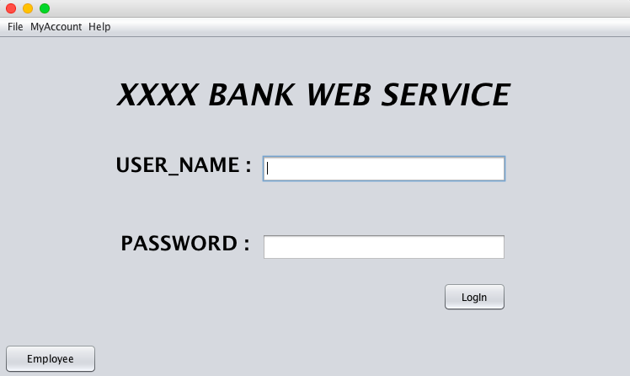

## Create customer screen

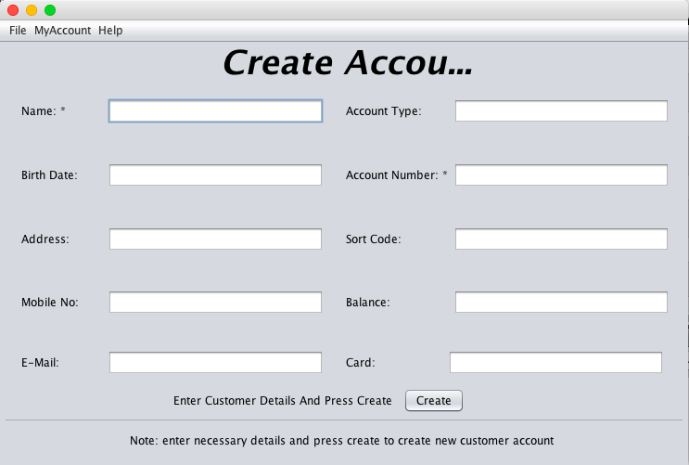

## Edit customer screen

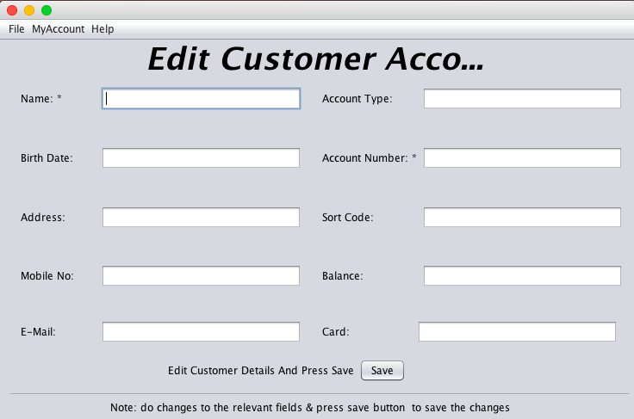

## Delete customer screen

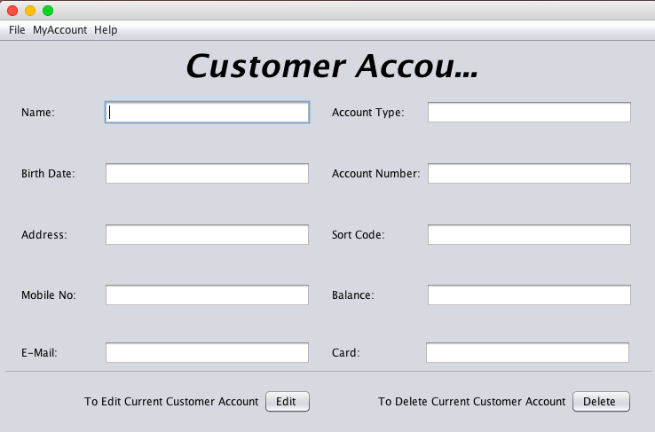

## Create employee screen

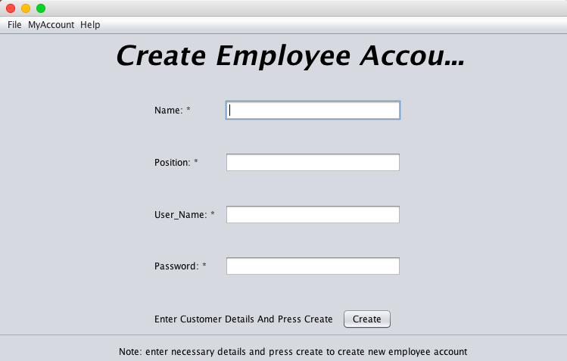

## Delete employee screen

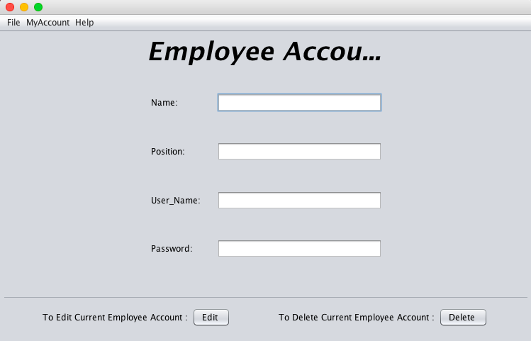

## Edit Employee Screen

## ../Desktop/Screen%20Shot%202017-04-15%20at%207.31.53%20AM.png

## Employee list screen

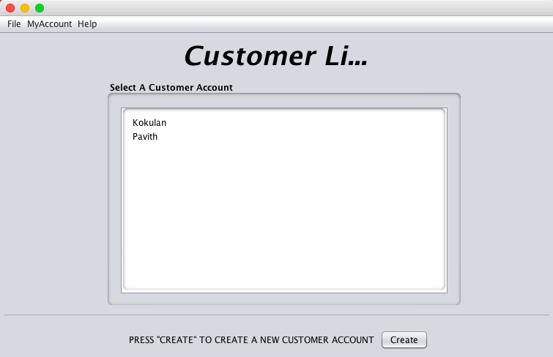

## Customer list screen

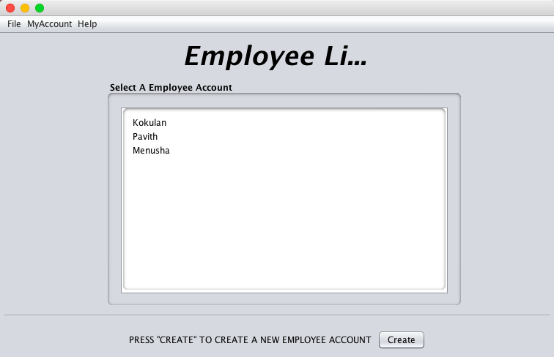

# USE CASE DIAGRAM

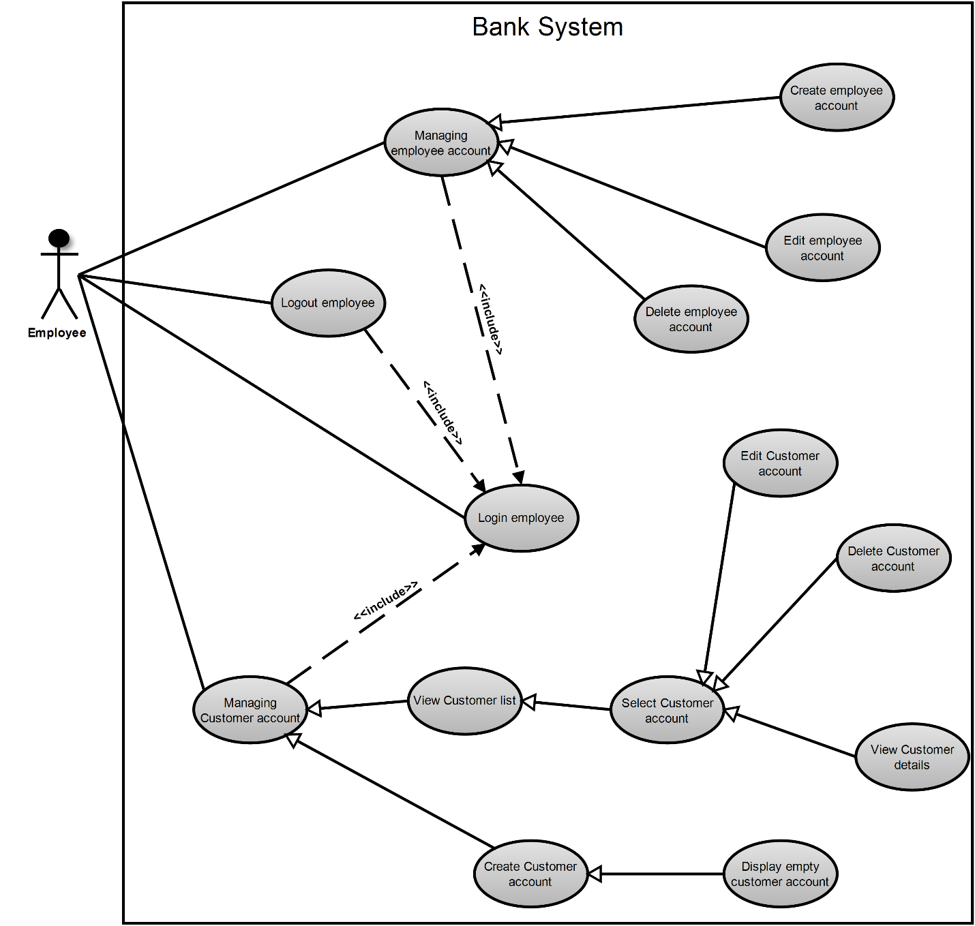

**SEQUENCE DIAGRAMS**

**LOGIN**

**DISPLAYING CUSTOMERS’ LIST**

**CREATE CUSTOMER ACCOUNT**

# SEQUENCE DIAGRAM

## SEQUENCE DIAGRAM FOR LOGIN

## ­ SEQUENCE DIAGRAM FOR VIEW CUSTOMER DETAILS

## SEQUENCE DIAGRAM FOR EDIT CUSTOMER DETAILS

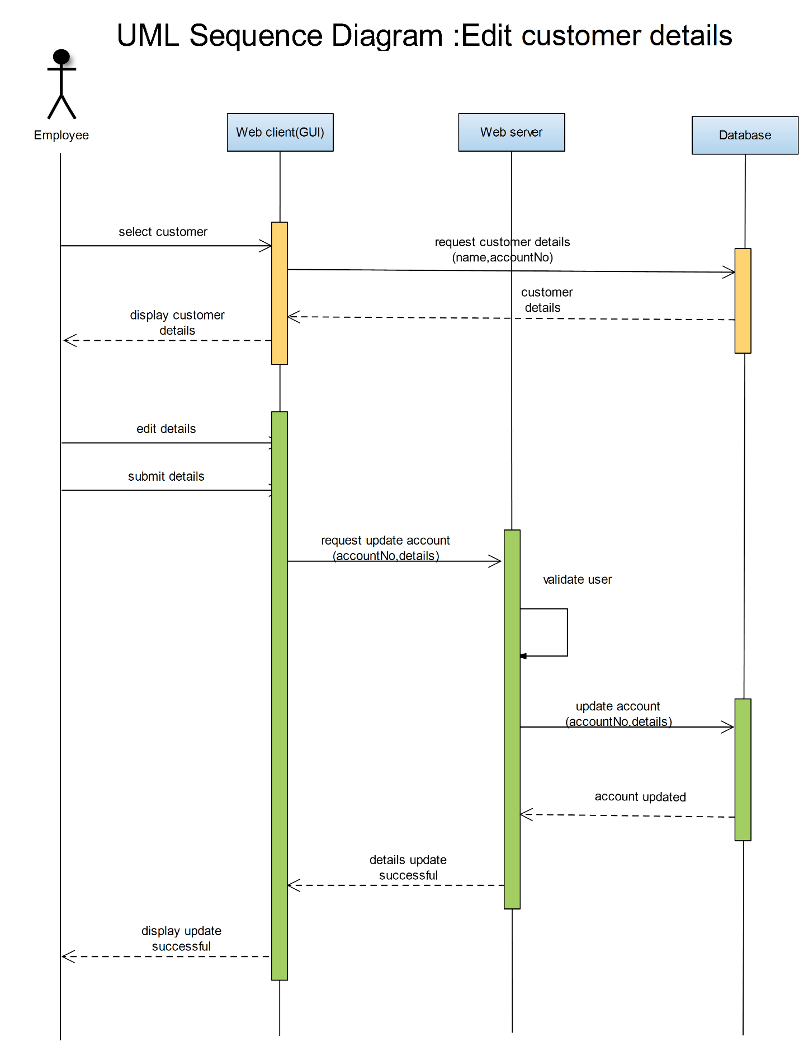

## SEQUENCE DIAGRAM FOR DELETE CUSTOMER DETAILS

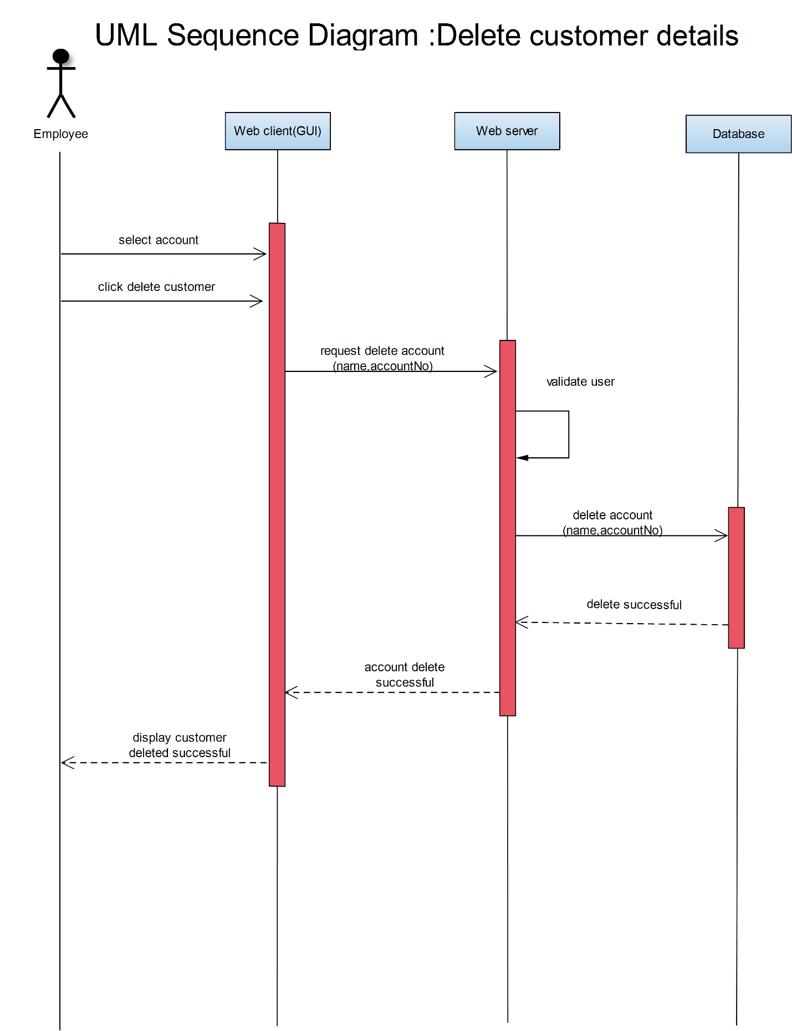

## SEQUENCE DIAGRAM FOR CREATE CUSTOMER ACCOUNT

## SEQUENCE DIAGRAM FOR CUSTOMER LIST

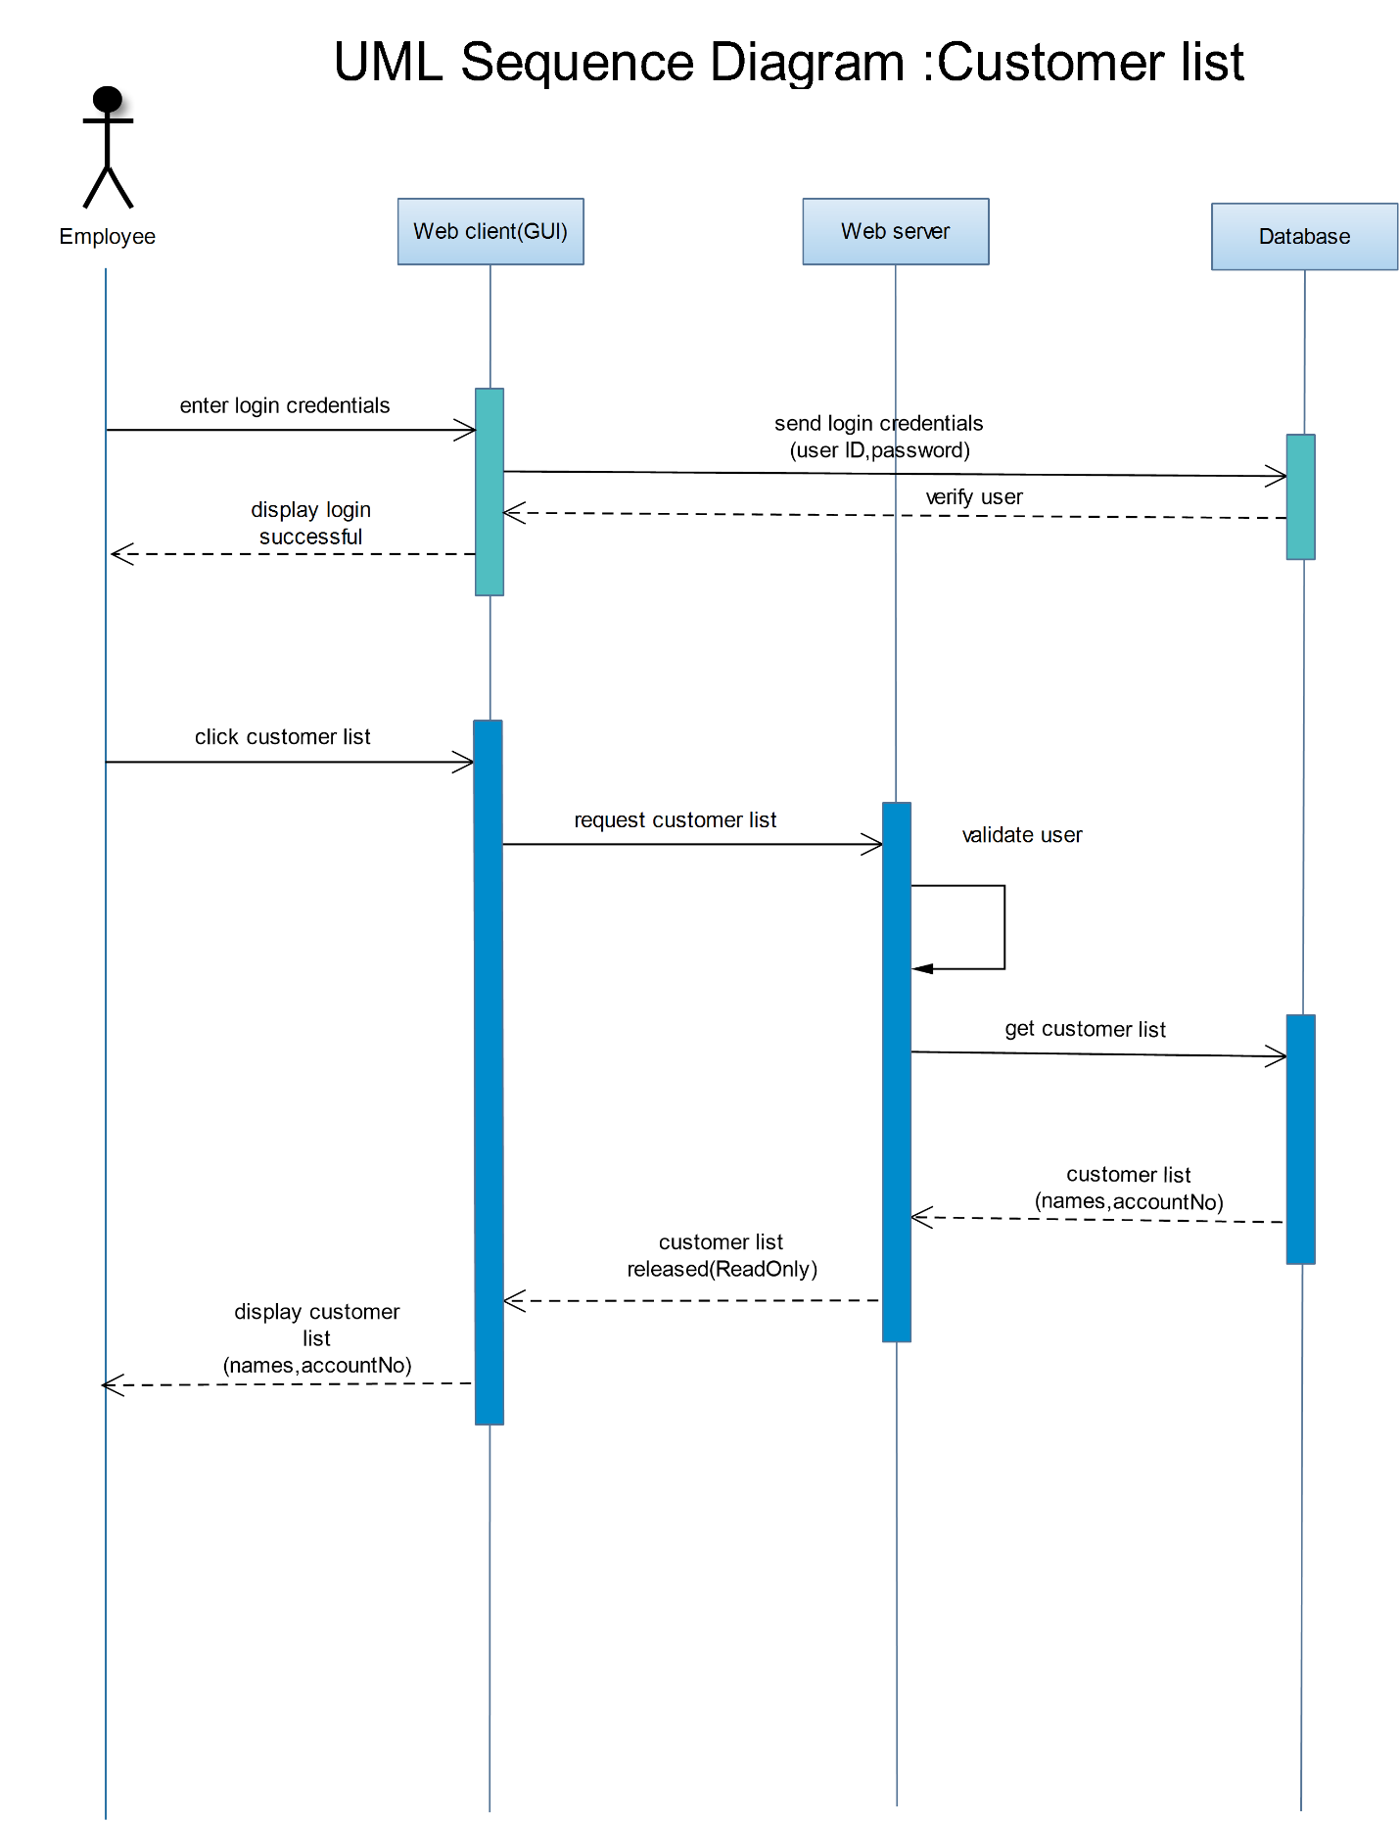

## SEQUENCE DIAGRAM FOR EMPLOYEE LIST

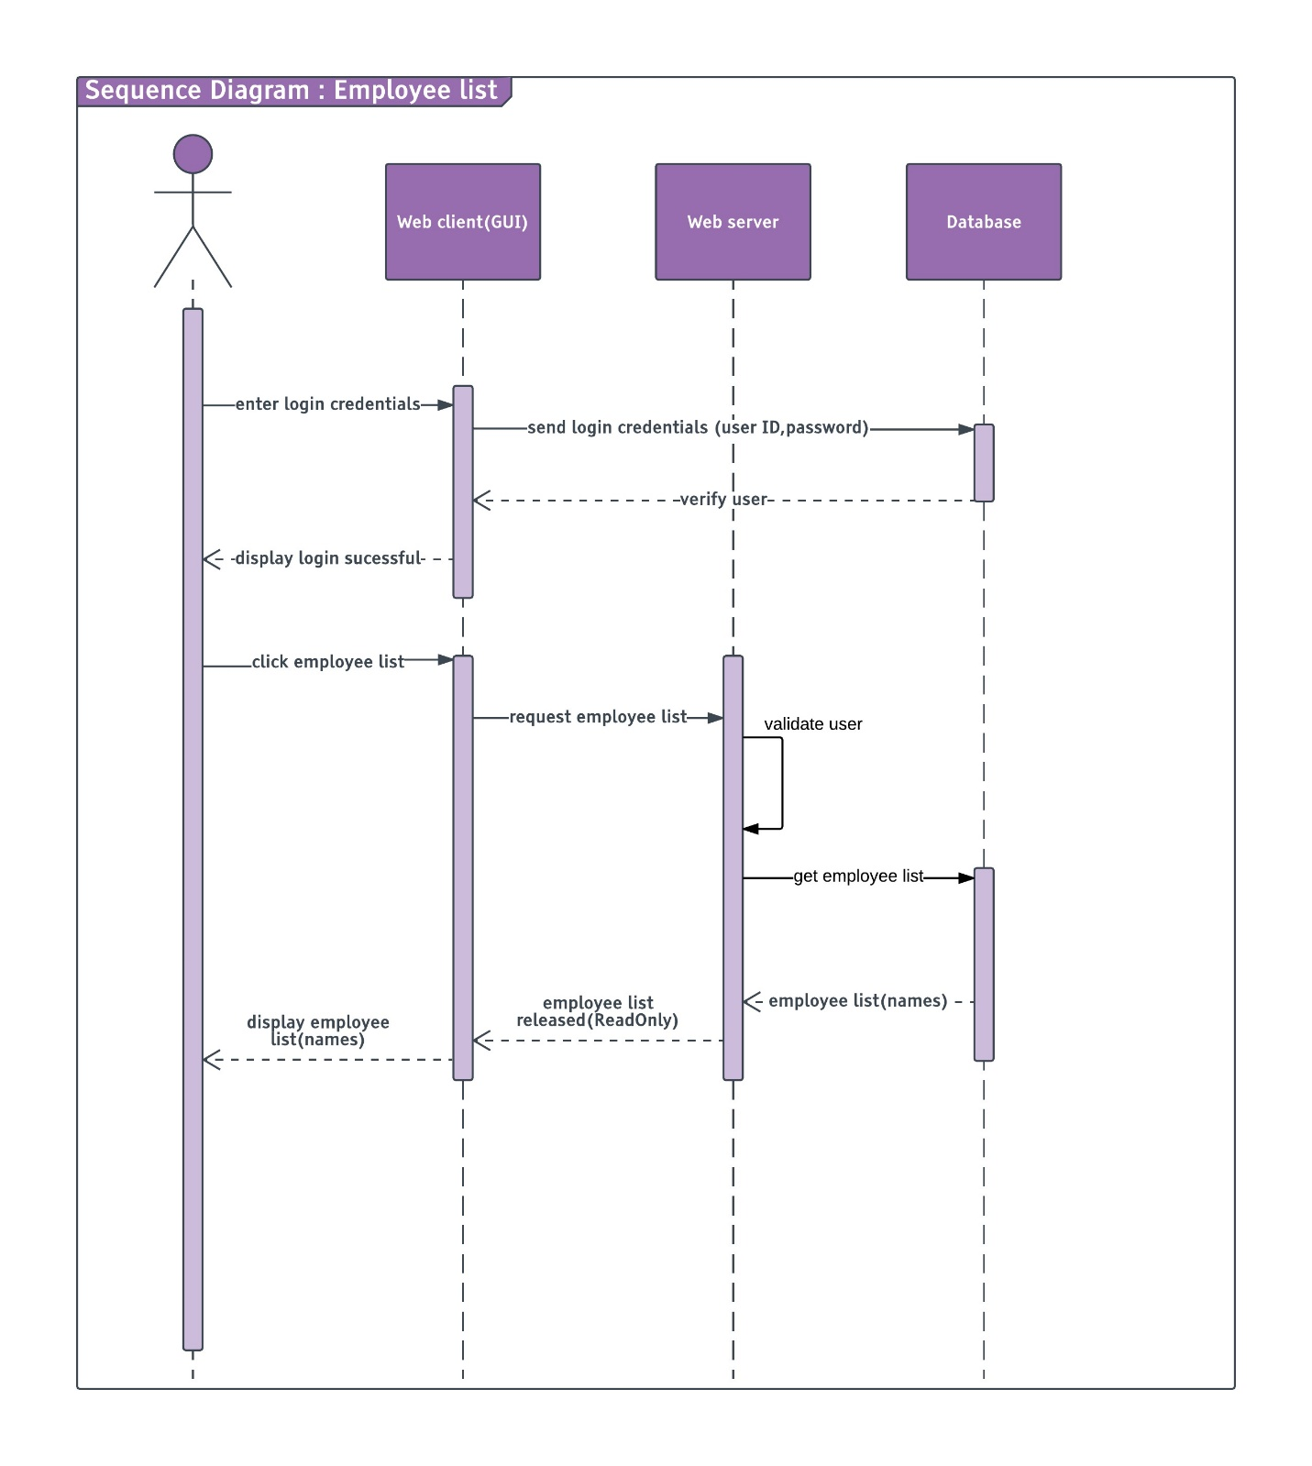

## SEQUENCE DIAGRAM FOR CREATE EMPLOYEE

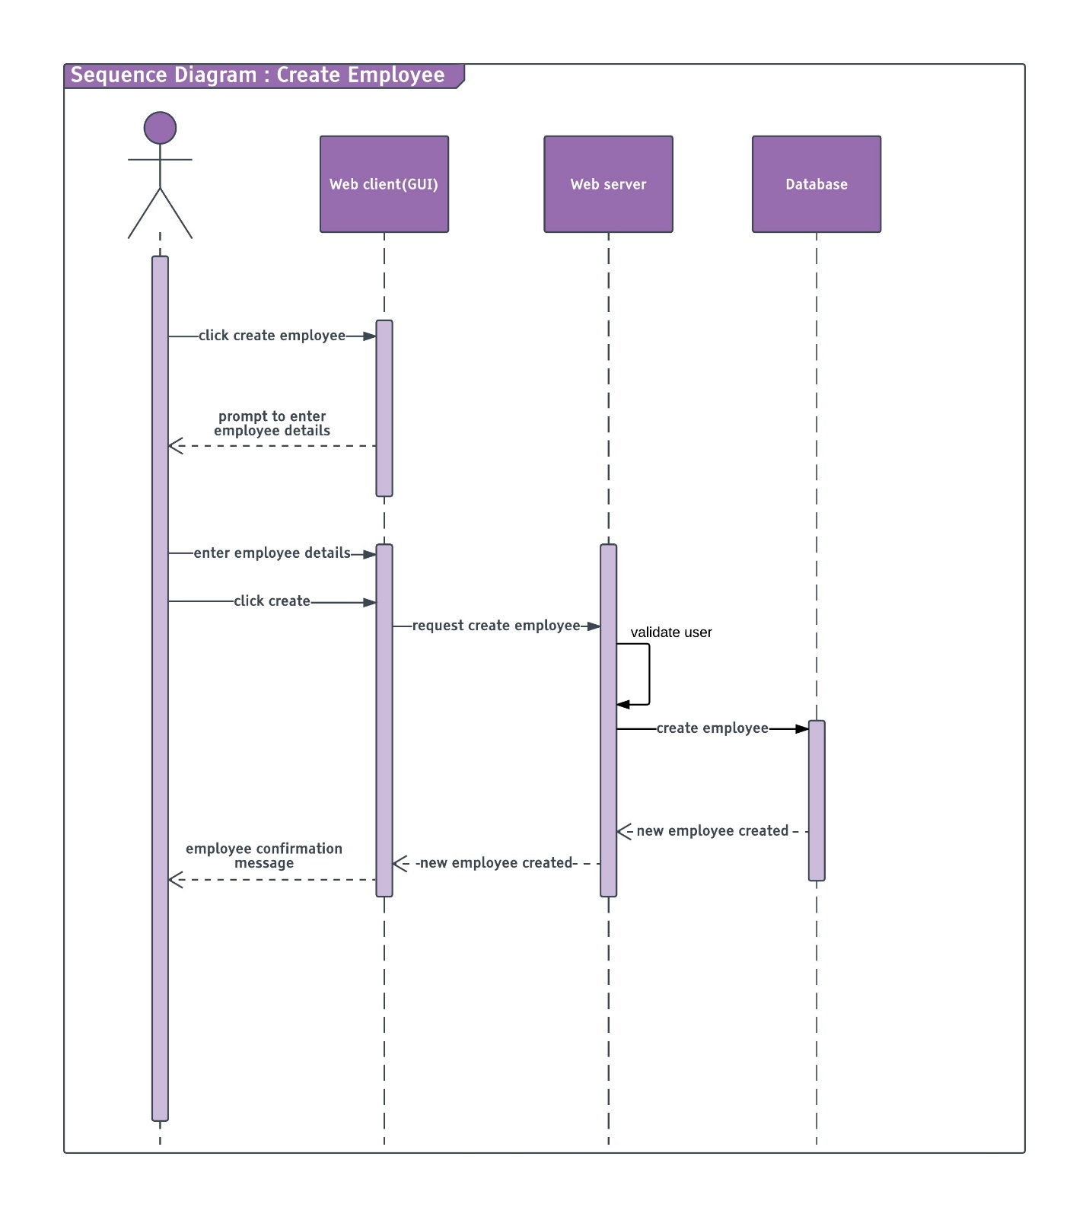

## SEQUENCE DIAGRAM FOR DELETE EMPLOYEE

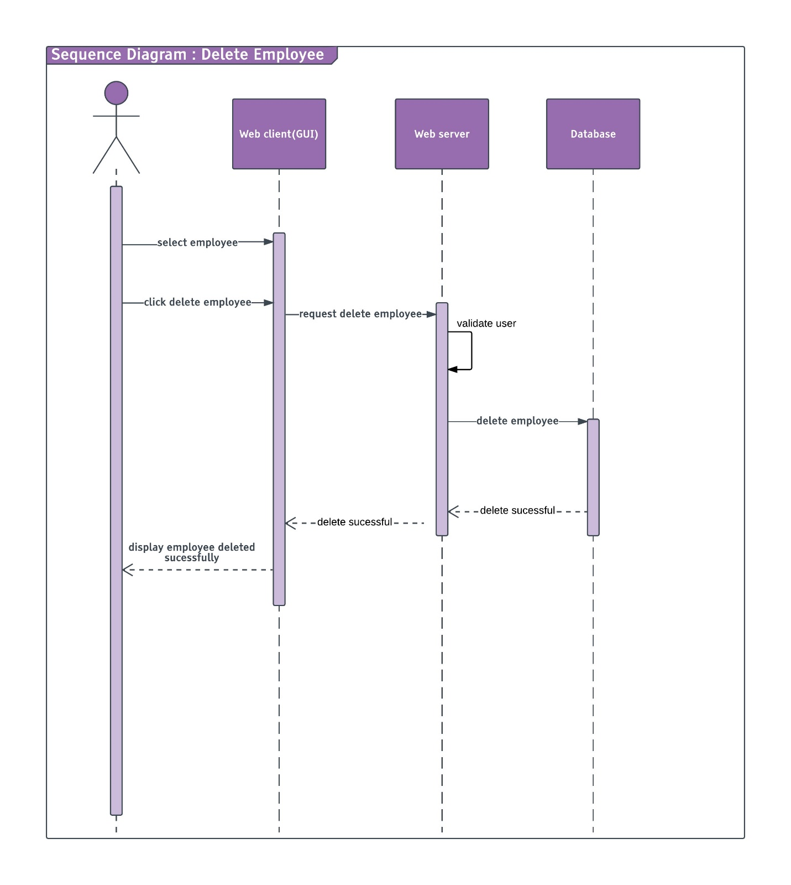

## SEQUENCE DIAGRAM FOR EDIT EMPLOYEE

## SEQUENCE DIAGRAM FOR VIEW EMPLOYEE

# EMPLOYEE AND CUSTOMER DATA

## Employee data

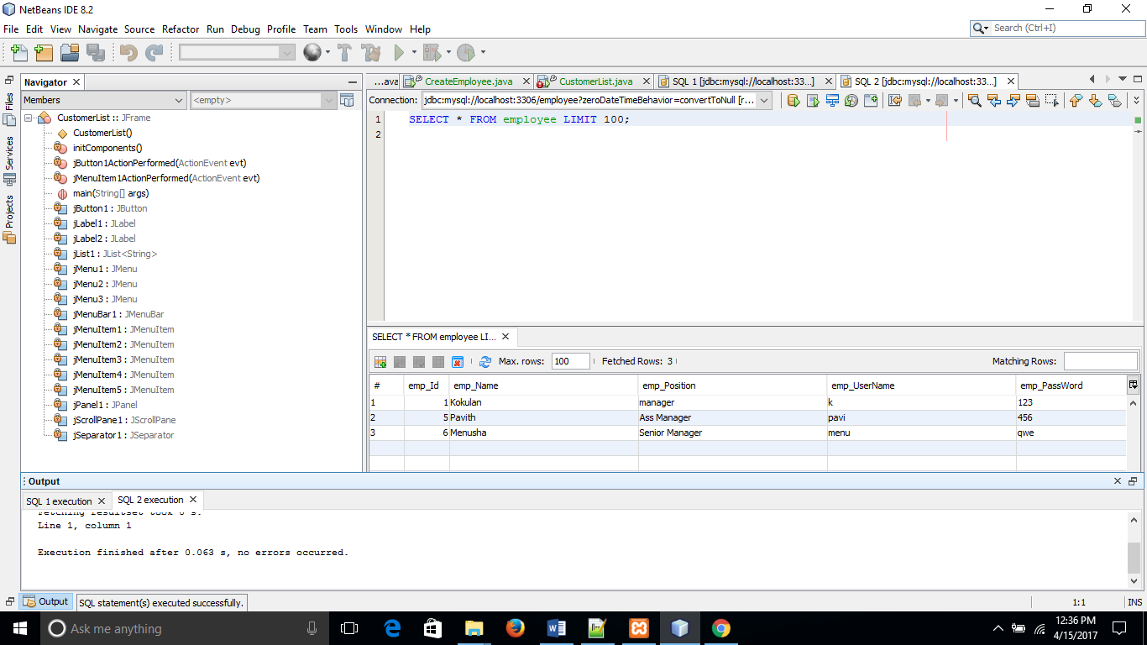

## Customer data

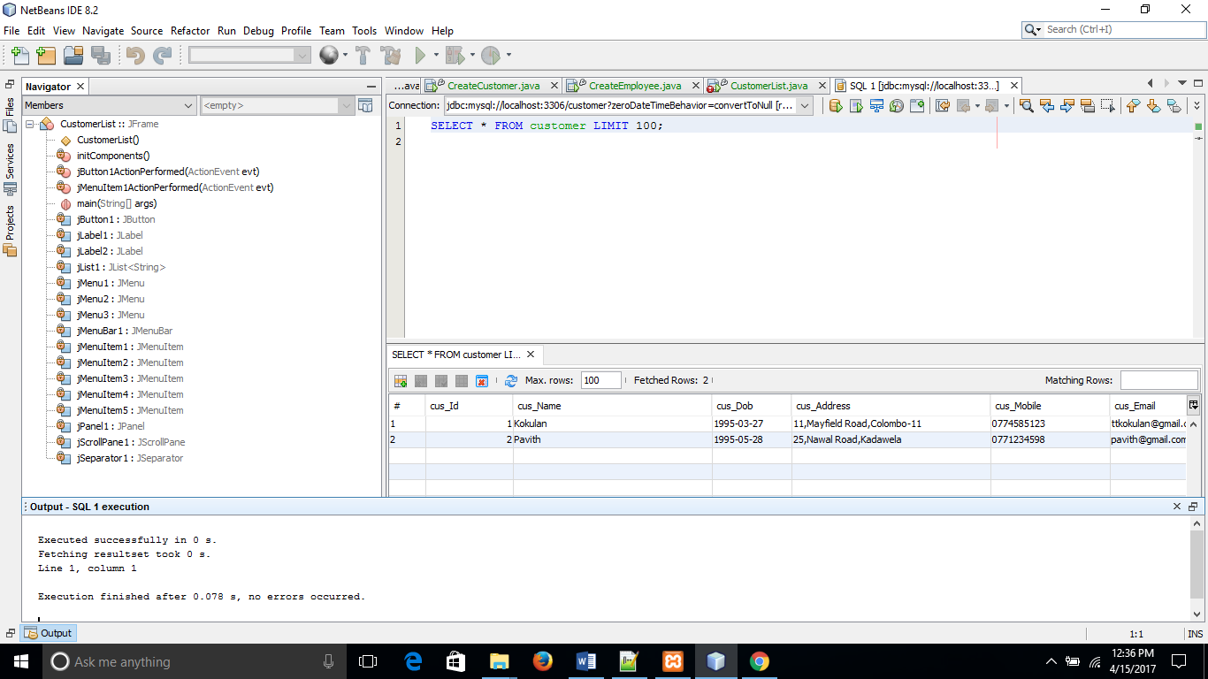

# WORK LOAD MATRIX

|  |  |  |  |
| --- | --- | --- | --- |
| Name | ID | UOW ID | Task |
| Thayanithi Kokulan | 2014287 | w1583044 | 1. Customer Web Service 2. Documentation(UML Diagrams) 3. Customer Manage GUIS |
| P.H. Menusha Prashan | 2015131 | w1582973 | 1. Customer list GUI 2. Customer Web Services 3. Documentation (UML Diagrams) |
| S.G.V.P.B. Gunasekara | 2015238 | w1608462 | 1. Login ,logout GUI 2. Employee Web Services 3. Documentation(UML Diagrams) |
| H.B.T.P. Gunarathna | 2015009 | w1583016 | 1. Employee Manage GUIS 2. Employee Web Services 3. Documentation (UML Diagrams) |
| P. Thevaki | 2015227 | w1608457 | 1. Employee list GUI 2. Employee Web Services 3. Documentation(UML Diagrams) |