

STUDENT NAME: M.Nandhini

REGISTER NO AND NMID:24132011802522065

asanm20124132011802522065

DEPARTMENT: Bachalor of computer science   
COLLEGE: Arignar Anna government arts and science college/   
Annamalai University

1



1.Java script

2.Css

3.Html

2



1.Problem Statement

2.Project Overview

3.End Users

4.Tools and Technologies   
5.Portfolio design and   
Layout

6.Features and

Functionality

7. Results and Screenshots

8. Conclusion

9. Github Link

3/21/2024 3



1. Building a UI component (e.g.,

navigation menu, carousel)?

2. Creating a interactive feature (e.g.,

quiz, game)?

3. Developing a responsive layout?

4. Implementing a specific

functionality (e.g., API integration,

animation)

4



1. \*Project Type \*: What kind of project   
are you building (e.g., personal

website, e-commerce site, blog,   
portfolio)

2. \*Features \*: What features do you   
want to include (e.g., user

authentication, payment gateway,   
responsive design)

3. \*Design \*: Do you have a specific

design or layout in mind

5



1. \*General Consumers \*: People browsing

the web, shopping online, or accessing

information?

2. \*Business Professionals \*: Users who

need specific tools, dashboards, or

applications for work?

3. \*Developers \*: Other developers who will

be using your project as a tool or

integrating it into their own work?

6



1. \*Code Editors \*: Visual Studio Code,

Sublime Text, Atom

2. \*Version Control \*: Git, GitHub,

GitLab

3. \*Debugging Tools \*: Chrome

DevTools, Firefox Developer Edition

4. \*Build Tools \*: Webpack, Gulp,

Grunt

7



1. \*Clear Navigation\*: Easy-to-use

navigation that allows visitors to find your

work quickly.

2. \*Project Showcase\*: A visually

appealing way to display your projects,

including images, descriptions, and links.   
3. \*About Section\*: A brief introduction to

who you are, what you do, and your skills.   
4. \*Contact Information\*: A way for

potential clients or employers to get in

touch with you.

8



1. \*Form Validation\*: Validate user input to

ensure it meets certain criteria.

2. \*Interactive Elements\*: Use JavaScript

to create interactive elements, such as

accordions, tabs, and modals.

3. \*Animations and Transitions\*: Use CSS

and JavaScript to create animations and

transitions that enhance the user

experience.

4. \*Drag-and-Drop Functionality\*: Allow

users to drag and drop elements on the

page.

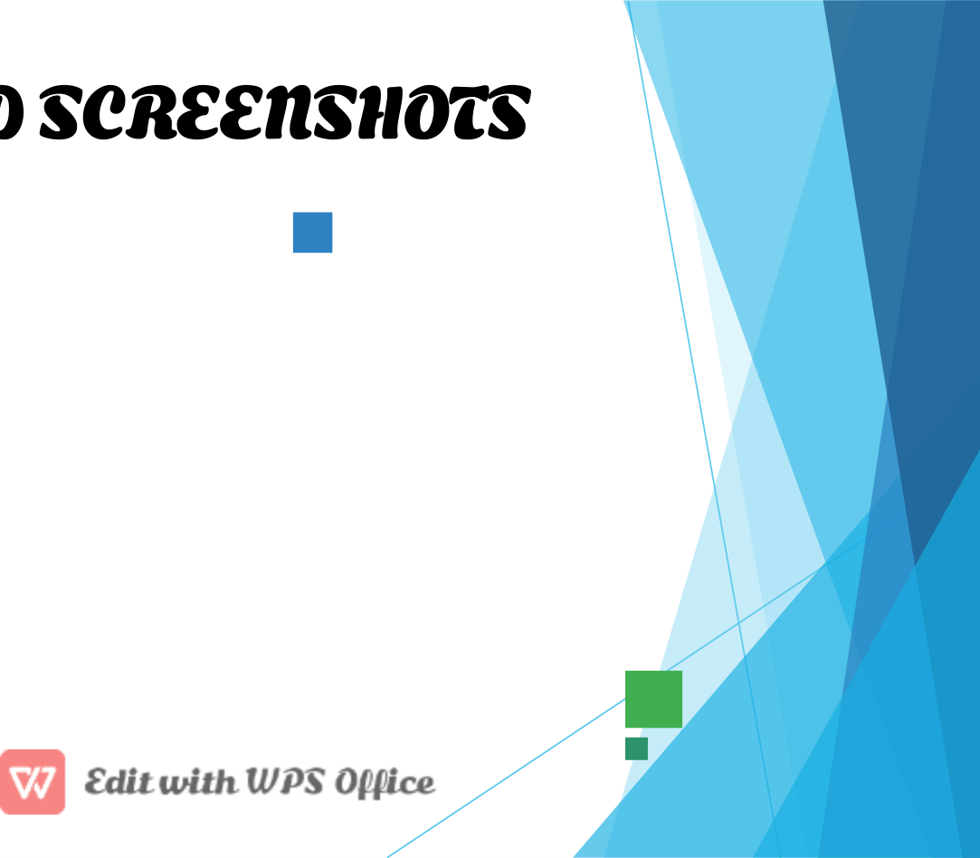

1. \*Create a functional web application\*: A

fully working web application that users can

interact with.

2. \*Design a visually appealing website\*: A

website with a stunning design that

showcases your skills.

1. \*Feature showcase\*: Screenshots

highlighting specific features or

functionality.

2. \*Responsive design\*: Screenshots

demonstrating how your design adapts to

different screen sizes.

3/21/2024 10



In conclusion, JavaScript, HTML, and

CSS are essential technologies for web

development. Understanding these

technologies is crucial for building

dynamic, interactive, and visually

appealing web applications. By

mastering these technologies,

developers can create a wide range of

web applications and enhance the user

experience.

11