ID ATTRIBUTE :

To define a specific style for one special element, add an id attribute to the element

<style>

#p01
{
color: blue;
}
</style>

<body>
<p>This is a paragraph.</p>
<p id="p01">I am different.</p>

</body>

CLASS ELEMENT :

To define a style for special types of elements, add a class attribute to the element

<style>

p.error {
color: red;
}
</style>

<body>
<p>This is a paragraph.</p>
<p class="error">I am different.</p>
<p>This is a paragraph.</p>
<p class="error">I am different too.</p>
</body>

LINK :

<link rel="stylesheet" href="https://www.w3schools.com/html/styles.css">

<link rel="stylesheet" href="/html/styles.css">

ATTRIBUTES OF LINK :

target :

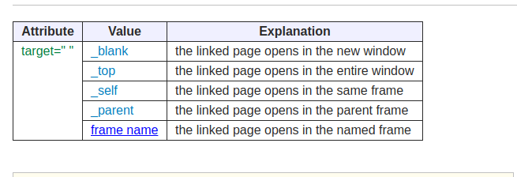

target="_top"

(The linked page opens in the entire window)
<p><a href="example_t01.html" target="_top">Entire window</a></p>

Output
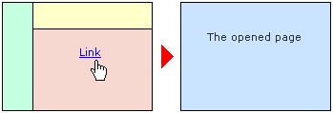

target="_self"
(The linked page opens in the same frame)
<p><a href="example_t02.html" target="_self">Same frame</a></p>

Output
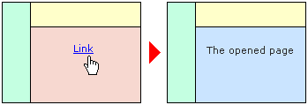

target="_parent"
(The linked page opens in the parent frame)
<p><a href="example_t03.html" target="_parent">Parent frame</a></p>

Output
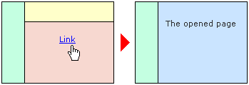

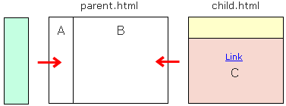
About the parent frame
When you load the "child.html" into the B frame, the parent frame of the C frame becomes the B frame.

target="FrameName"
(The linked page opens in the named frame)
<ul>
<li><a href="example_t04.html" target="top">B frame</a></li>
<li><a href="example_t04.html" target="main">C frame</a></li>
</ul>

Output
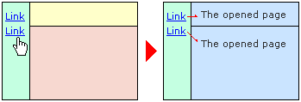

Link Titles :

The <title> attribute specifies extra information about an element. The information is most often shown as a tooltip text when the mouse moves over the element.
<a href="https://www.w3schools.com/html/" title="Go to W3Schools HTML section">Visit our HTML Tutorial</a>
image tag (preferred style) :
<p>The image below uses the style attribute, where the width is set to 128 pixels which overrides the stylesheet:</p>
<img src="html5.gif" alt="HTML5 Icon" style="width:128px;height:128px;">
1- src="/images/html5.gif" ==> folder
<p>
2- <img src="smiley.gif" alt="Smiley face" style="float:right;width:42px;height:42px;">
A paragraph with a floating image. A paragraph with a floating image. A paragraph with a floating image.
</p>
3-style="background-image:url('clouds.jpg')"

PICTURE TAG :

<picture>
<source media="(min-width: 650px)" srcset="img_pink_flowers.jpg">
<source media="(min-width: 465px)" srcset="img_white_flower.jpg">
<img src="img_orange_flowers.jpg" alt="Flowers" style="width:auto;">
</picture>

