TABLES-HTML ------QUICK-REF :

<!DOCTYPE html>
<html>
<head>
<style>
table, th, td {
border: 1px solid black;
padding: 5px;
}
table {
border-spacing: 15px;
}
</style>
</head>
<body>

<h2>Border Spacing</h2>
<p>Border spacing specifies the space between the cells.</p>

<table style="width:100%">
<tr>
<th>Firstname</th>
<th>Lastname</th>
<th>Age</th>
</tr>
<tr>
<td>Jill</td>
<td>Smith</td>
<td>50</td>
</tr>
<tr>
<td>Eve</td>
<td>Jackson</td>
<td>94</td>
</tr>
<tr>
<td>John</td>
<td>Doe</td>
<td>80</td>
</tr>
</table>

<p>Try to change the border-spacing to 5px.</p>

</body>
</html>

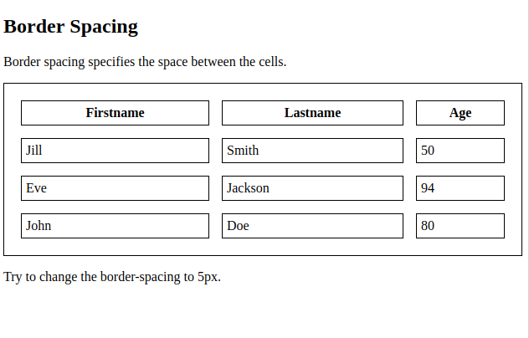

ROWSPAN :

<tr>
<th rowspan="2">Telephone:</th>
<td>55577854</td>
</tr>

COLSPAN :

<tr>
<th>Name</th>
<th colspan="2">Telephone</th>
</tr>

<!DOCTYPE html>
<html>
<head>
<style>
table
{
width:100%;
}
table, th, td
{
border: 1px solid black;
border-collapse: collapse;
}
th, td
{
padding: 15px;
text-align: left;
}
table#t01 tr:nth-child(even)
{
background-color: blue;
}
table#t01 tr:nth-child(odd)
{
background-color: green;
}
table#t01 th
{
background-color: black;
color: white; }

</style>
</head>
<body>

<h2>Styling Tables</h2>

<h2>Table Caption</h2>
<p>To add a caption to a table, use the caption tag.</p>
<table style="width:100%;">
<caption>Monthly savings</caption>
<tr>
<th>Firstname</th>
<th>Lastname</th>
<th>Age</th>
</tr>
<tr>
<td>Jill</td>
<td>Smith</td>
<td>50</td>
</tr>
<tr>
<td>Eve</td>
<td>Jackson</td>
<td>94</td>
</tr>
<tr>
<td>John</td>
<td>Doe</td>
<td>80</td>
</tr>
</table>
<br>

<table id="t01">
<tr>
<th>Firstname</th>
<th>Lastname</th>
<th>Age</th>
</tr>
<tr>
<td>Jill</td>
<td>Smith</td>
<td>50</td>
</tr>
<tr>
<td>Eve</td>
<td>Jackson</td>
<td>94</td>
</tr>
<tr>
<td>John</td>
<td>Doe</td>
<td>80</td>
</tr>
</table>
</body>
</html>

