Music Listener Segmentation
Data Analysis & EDA Report
Unsupervised Machine Learning Capstone Project
Team name
Team members
Role | Data Analysis & EDA Lead
Prepared by | Pavithra P.
Dataset | music_listeners.csv (30 listeners, 4 features)
Date | 21 September 2026

1. Purpose of this stage
This report documents the first stage of the Music Listener Segmentation project: understanding the dataset, checking and cleaning it, exploring the listening behaviour, and preparing the data so the next team members can train and deploy the clustering model. The project is unsupervised learning, so the dataset has no target column such as Casual, Explorer or Heavy. The model has to discover the listener groups by itself.

2. Understanding the dataset
The file music_listeners.csv contains 30 listeners and 4 numeric behaviour features. There is no ID column, no text column and no target column.
Feature | Meaning | Min | Max | Mean
listening hours per week | Total hours the listener spends on music in a week | 2 | 38 | 15.2
songs per day | Number of songs played per day | 10 | 145 | 60.4
skip rate | How often the listener skips a song (values 3 to 65, so it looks like a percentage) | 3 | 65 | 29.5
playlist count | Number of playlists the listener has | 2 | 40 | 15.0

The four features are on very different scales (songs per day goes up to 145 while playlist count goes up to 40). Distance-based clustering such as K-Means would be dominated by the largest numbers, so the features must be standardised before training.

3. Process followed
- Loaded music_listeners.csv and inspected its shape, data types, missing values and duplicates.
- Validated every column for impossible values and unusual points (outliers).
- Explored the distribution of each feature with histograms and boxplots.
- Studied the relationships between features using a correlation heatmap and scatter plots.
- Analysed the listening behaviour patterns.
- Prepared the data for clustering with StandardScaler.
- Checked how many clusters the data supports (PCA, elbow method, silhouette score).
- Ran a quick K-Means preview with 3 clusters to confirm the expected Casual, Explorer and Heavy groups.
- Wrote up the findings and the hand-over notes for the next team members.

4. Data cleaning and validation
Check | Result | Action
Missing values | 0 in all 4 columns | None needed
Duplicate rows | 0 | None needed
Data types | All columns are whole numbers (int64) | None needed
Impossible values | No negative values; skip rate stays within 3 to 65 | None needed
Outliers (IQR rule) | 0 in all 4 columns | No capping needed
Skewness | All features between 0.24 and 0.64 (mild) | No log transform needed
Feature scales | Very different (max 145 vs 40) | Standardise with StandardScaler

Conclusion: the dataset is already clean. All 30 rows were kept, so the cleaned file is identical to the original.

5. Exploratory data analysis

5.1 Distributions
Each feature has a mild right skew: most listeners have low to medium activity and a smaller group listens a lot. The shapes are not perfectly single-peaked, which already hints that there is more than one type of listener.
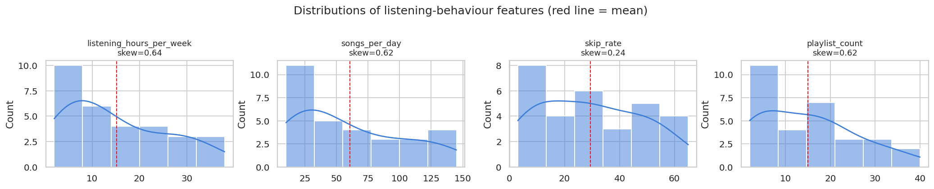
Figure 1. Distribution of each feature (red line = mean)

5.2 Outlier check
The boxplots show no points outside the whiskers, so no listener is an extreme outlier and no data had to be removed or capped.
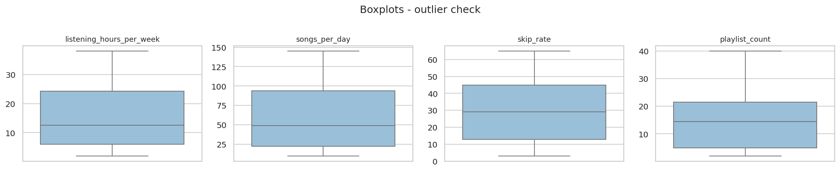
Figure 2. Boxplots of the four features

5.3 Relationships between features
 | hours / week | songs / day | skip rate | playlists
listening hours per week | 1.00 | 1.00 | -0.93 | 0.97
songs per day | 1.00 | 1.00 | -0.93 | 0.97
skip rate | -0.93 | -0.93 | 1.00 | -0.92
playlist count | 0.97 | 0.97 | -0.92 | 1.00

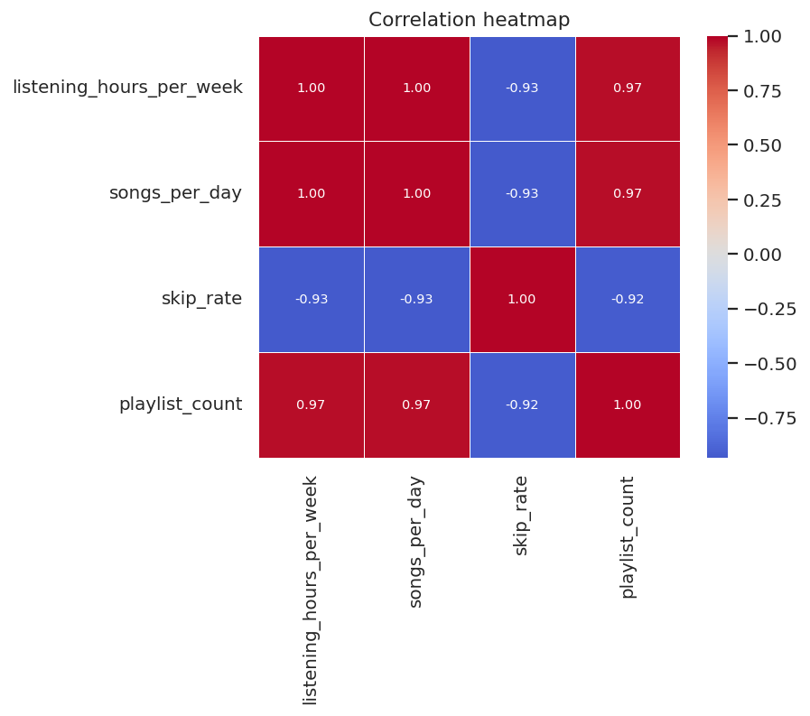
Figure 3. Correlation heatmap
The features are very strongly related:
- Listening hours and songs per day move almost perfectly together (r = 1.00).
- Playlist count also rises with listening (r = 0.97 with hours).
- Skip rate falls as activity rises (r = -0.93 with hours): heavy listeners skip far fewer songs.
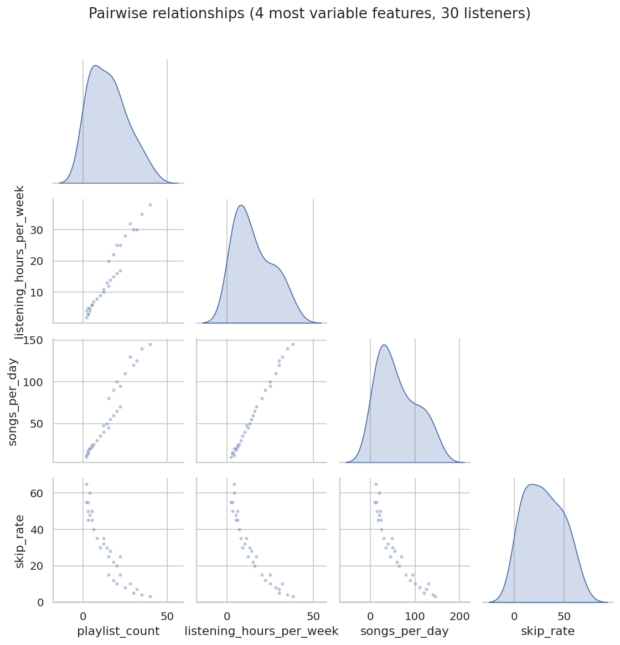
Figure 4. Pairwise scatter plots

6. Listening behaviour patterns
- Listeners who spend more hours per week also play more songs per day and keep more playlists.
- Low-activity listeners skip about half of their songs (skip rate near 50 to 65), while the most active listeners skip only 3 to 10.
- Because all features move together, the whole dataset behaves like one 'listening activity' axis running from casual to heavy. PCA confirms this: the first component alone explains 96.7% of the variation.
- The scatter plots show a gradual line of listeners rather than three far-apart blobs, so the groups will be neighbouring bands along this activity axis.

7. Preparing the data for clustering
- No outlier capping and no log transform were needed.
- Features are standardised with StandardScaler (mean 0, standard deviation 1) so that every feature has equal influence.
- Feature order to use everywhere: listening_hours_per_week, songs_per_day, skip_rate, playlist_count.
Important: train_model.py scales the data itself and saves scaler.pkl. It must therefore be given the cleaned, unscaled file (music_listeners_cleaned.csv). The already-scaled file is for reference only. Scaling twice would give wrong clusters.

8. How many clusters?
Three checks were run to see how many groups the data supports.
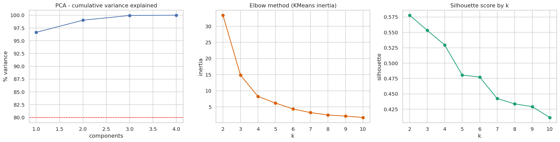
Figure 5. PCA variance, elbow method and silhouette score
k | 2 | 3 | 4 | 5 | 6
Silhouette | 0.578 | 0.553 | 0.529 | 0.481 | 0.477

- The elbow curve drops sharply until k = 3 and then flattens, so 3 is a natural choice.
- The silhouette score is highest for k = 2 (0.578), but k = 3 is almost as good (0.553). A score above 0.5 means well-separated clusters.
- Two groups would only split listeners into 'low' and 'high'. The project asks for three meaningful segments (Casual, Explorer, Heavy), which the elbow and silhouette results support.

9. Preview of the three listener groups
A quick K-Means preview (k = 3) on the standardised data confirms that the three expected groups exist. This is only a check; the official model is trained by the modelling teammate in train_model.py.
Group | Listeners | Share % | Hours / week | Songs / day | Skip rate | Playlists
Casual Listener | 11 | 36.7 | 4.82 | 19.09 | 49.82 | 4.09
Music Explorer | 11 | 36.7 | 14.45 | 58 | 24.91 | 15.64
Heavy Listener | 8 | 26.7 | 30.38 | 120.62 | 7.75 | 29

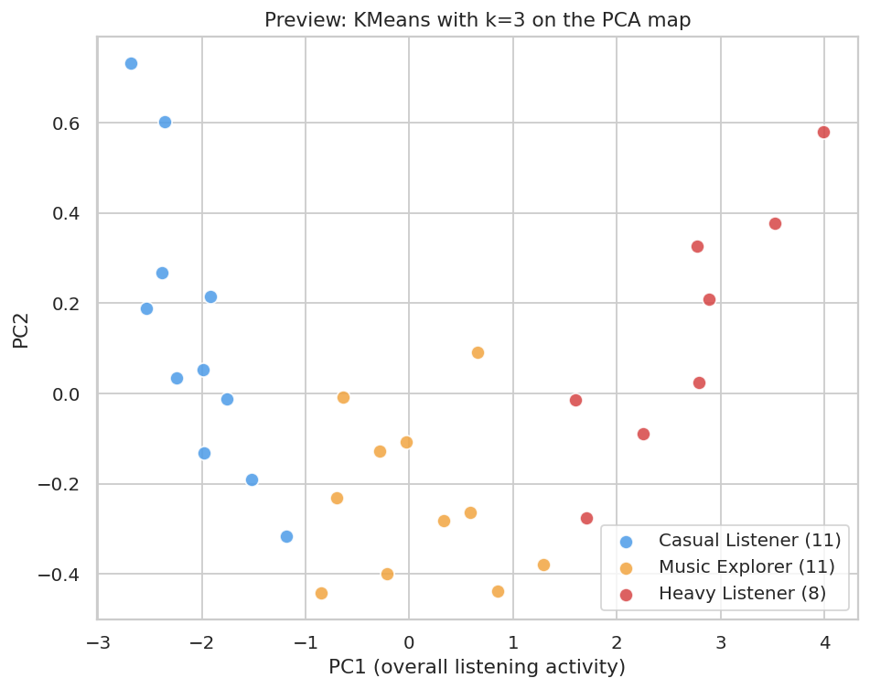
Figure 6. Preview clusters on the PCA map
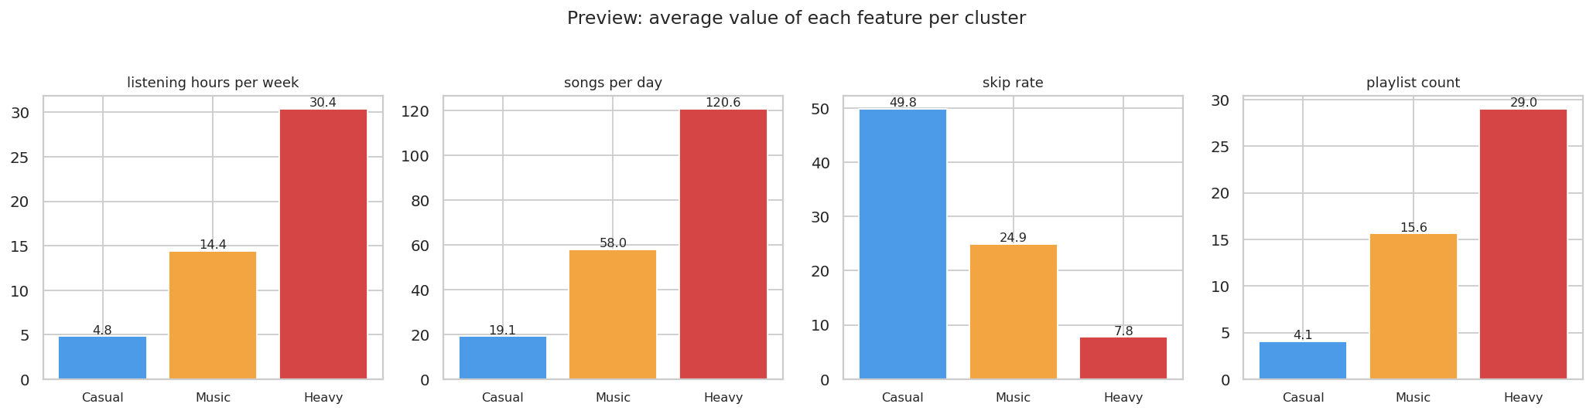
Figure 7. Average feature values per preview cluster
- Casual Listener: low hours, few songs, many skips, very few playlists.
- Music Explorer: medium activity, moderate skipping, a growing set of playlists.
- Heavy Listener: high hours and songs, very low skip rate, the most playlists.

10. Hand-over notes for the next team members

Modelling (train_model.py)
- Load music_listeners_cleaned.csv and select the four features in the order given above.
- Use StandardScaler with fit_transform() on the training data.
- Create K-Means with 3 clusters (for example n_clusters=3, n_init=10, random_state=42) and train it with fit().
- Inspect the cluster centres. Name the group with the lowest activity Casual Listener, the middle one Music Explorer and the highest Heavy Listener. K-Means only gives the numbers 0, 1 and 2.
- Save the model as model.pkl and the scaler as scaler.pkl with joblib.

Application (app.py)
- Load model.pkl and scaler.pkl.
- Take the four inputs in the same feature order.
- Use transform() only (never fit again), then model.predict(), then show the segment name.
A correct model should reproduce group sizes close to the preview (about 11, 11 and 8 listeners).

11. Limitations
- The dataset has only 30 listeners, so the results are indicative and not statistically strong.
- The four features are extremely correlated, so they carry almost the same information. Clustering is effectively splitting one activity scale into three bands.
- Group names come from interpreting the cluster centres; K-Means does not provide labels.

12. Files delivered
File | Purpose
music_listeners_cleaned.csv | Clean data for train_model.py (unscaled)
music_listeners_clustering_ready.csv | Standardised version, for reference only
cluster_preview_labels.csv | Data with the preview segment for each listener
findings.md, data_quality_report.txt, data_overview.txt | Text findings and quality report
charts/ (9 images) | All visualisations used in this report
eda.py | Script that reproduces every result (python eda.py)

13. Conclusion
The dataset is complete, clean and ready for modelling. The exploration shows that listeners differ mainly by overall activity, and that three groups (Casual, Music Explorer and Heavy) are supported by the elbow method, the silhouette score and a preview K-Means run. The next team members can now build the training script and the application using the cleaned data and the notes above.

