AI-BASED LOST AND FOUND SYSTEM
A PROJECT REPORT

Submitted by
NANDHAKUMAR D | 2303717610421102
PAVITHRA N | 2303717610422106

in partial fulfillment for the award of the degree

of
BACHELOR OF ENGINEERING

in
COMPUTER SCIENCE AND ENGINEERING

COIMBATORE INSTITUTE OF TECHNOLOGY
(Government Aided Autonomous Institution Affiliated to Anna University)
COIMBATORE-641014
ANNA UNIVERSITY: CHENNAI 600 025
October 2026

TABLE OF CONTENTS
S.No | Title | Page No
1. | INTRODUCTION | 1
2. | PROBLEM STATEMENT | 1
3. | OBJECTIVE | 2
4. | ARCHITECTURE | 3
5. | ALGORITHM | 7
6. | CODE | 11
7. | RESULTS | 14
8. | CONCLUSION | 17

1.INTRODUCTION

The AI-Based Lost and Found System is a web application developed using Python and Streamlit to help users report and recover lost belongings efficiently. The system uses multi-criteria weighted scoring, the Hill Climbing algorithm, and image similarity techniques to identify potential matches between lost and found items based on category, description, brand, color, location, date, and photographs. It also provides smart match explanations to highlight matching and differing attributes, allowing users to evaluate potential matches more easily. Additional features include image-based search, item claiming, duplicate report prevention, and a centralized dashboard for managing reports. The system aims to reduce manual effort, improve matching efficiency, and simplify the overall lost and found process.

2.PROBLEM STATEMENT

A lost and found system continuously receives reports of lost and found belongings from different users. Traditional manual methods can become difficult to manage when the number of reports increases.

The major challenges include:

Time-consuming manual searching for lost items.

Difficulty identifying matching lost and found reports.

Inconsistent or incomplete item descriptions.

Difficulty comparing item photographs.

Lack of clear explanations for potential matches.

Therefore, an AI-based Lost and Found System is proposed to efficiently manage reports, compare item details and images, identify potential matches, and simplify the recovery of lost belongings.

3.OBJECTIVE

To develop a user-friendly application that allows users to report lost and found items easily.

To identify potential matches between lost and found items using a weighted multi-criteria matching algorithm.

To compare item descriptions using fuzzy string matching to identify similar text with minor variations.

To compare item photographs using Average Hash and color signature techniques to improve visual matching.

To rank potential matches based on their matching scores and provide explanations to help users identify the correct item.

To manage item reports, track claim status, and reduce the manual effort required to recover lost belongings.

4. ARCHITECTURE

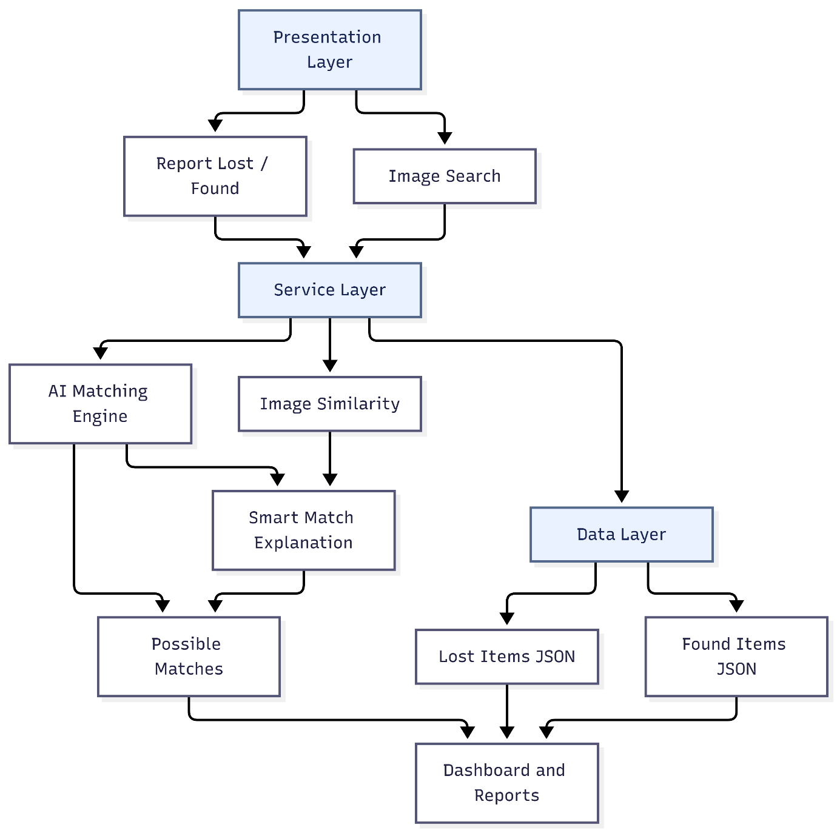

Fig 4.1 Architecture

1. Presentation Layer

The Presentation Layer provides the user interface developed using Python and Streamlit. It allows users to report lost and found items, search using images, and view possible matches. It also provides access to the dashboard and reports for easy interaction with the system.

2. Report Lost / Found

This module allows users to submit details about lost or found belongings. The information includes item category, description, color, brand, location, date, contact details, and an optional photograph. The submitted reports are validated and stored for further processing.

3. Image Search

The Image Search module allows users to upload an item photograph to find visually similar reports. It compares the uploaded image with stored images using Average Hash and color similarity techniques. The system displays potential results based on the calculated visual similarity.

4. Service Layer

The Service Layer coordinates the main operations of the application. It handles report processing, AI matching, image similarity, smart match explanations, and claim management. It connects the presentation interface with the processing modules and data storage.

5. AI Matching Engine

The AI Matching Engine compares lost and found reports using attributes such as category, description, brand, color, location, and date. It applies weighted scoring to calculate matching scores and uses the Hill Climbing algorithm to rank potential candidates. This helps users identify relevant found items efficiently.

6. Image Similarity

The Image Similarity module compares photographs of lost and found items. It uses Average Hash to compare image structure and color signatures to compare visual characteristics. These results provide additional evidence when identifying potentially matching items.

7. Smart Match Explanation

The Smart Match Explanation module describes why two item reports may match. It compares attributes such as category, description, brand, color, location, date, and photograph. The results highlight matching, partially matching, different, or unspecified attributes to help users evaluate candidates.

8. Data Layer

The Data Layer manages the application's persistent data and uploaded images. It uses JSON files to store lost and found item reports and a dedicated folder to store photographs. The stored information is retrieved by the matching engine, dashboard, and reports modules whenever required.

9. Lost Items JSON

The lost_items.json file stores information about items reported as lost. It contains the item details and other relevant information submitted through the Report Lost form. The AI Matching Engine uses these records to identify possible matches with found items.

10. Found Items JSON

The found_items.json file stores details of items reported as found. These records are compared against lost-item reports to identify potential matches. The file also maintains the item status so that claimed items can be excluded from future matching results.

11. Item Images

The Item Images module stores photographs uploaded through the Lost and Found forms. These images are used by the Image Similarity and Image Search modules for visual comparison. The stored image files support image-based matching alongside text and attribute comparison.

12. Possible Matches

The Possible Matches module displays found items that may correspond to a selected lost-item report. It presents matching scores, item details, and smart match explanations. Users can review the similarities and differences before deciding whether to claim an item.

13. Dashboard and Reports

The Dashboard and Reports module provides an overview of lost, found, matched, and claimed items. It displays summary statistics and stored reports to help users monitor system activity. It also provides an organized way to review item records and track the recovery process.

5.ALGORITHM
1.Hill Climbing Algorithm
Hill Climbing is a heuristic search algorithm that improves a solution by comparing the current state with neighboring states and selecting a better one. In the AI-Based Lost and Found System, it is used to help identify and rank potential matches between lost-item reports and found-item reports.
Working Procedure
- Initial State: Select the lost-item report for which a matching found item must be identified.
- Generate Neighbors: Identify compatible found-item reports while excluding incompatible item categories and items that have already been claimed.
- Calculate Matching Score: Calculate a weighted matching score for each eligible candidate using description similarity, category, brand, photo similarity, color, location, and date.
- Compare Candidates: Compare the matching scores of neighboring candidates to determine whether a better match is available.
- Select a Better Candidate: If a neighboring candidate has a higher matching score than the current candidate, select it as the new current state.
- Termination: Stop the search when no better neighboring candidate is available or the stopping condition is reached.
- Display Results: Display the highest-ranked candidate items along with their matching scores and explanations to help the user identify the potentially matching item.

Matching Score Formula
$\begin{aligned}S=&0.30D+0.25C+0.18B \\ &+0.10P+0.07Co+0.05L+0.05T\end{aligned}$
The weighted matching score is calculated using the following formula:
Where:
- (S) = Overall matching score
- (D) = Description similarity score
- (C) = Category matching score
- (B) = Brand matching score
- (P) = Photo similarity score
- (Co) = Color matching score
- (L) = Location matching score
- (T) = Date proximity score
The weights represent the relative importance assigned to each matching attribute. When each attribute score is normalized to a range of 0–100, the overall matching score also ranges from 0 to 100.
2. Weighted Multi-Criteria Matching Algorithm
The Weighted Multi-Criteria Matching Algorithm is the main matching approach used in the project. It compares lost and found items using description, category, brand, photo, color, location, and date. Each attribute is assigned a weight, and the individual scores are combined to calculate an overall matching score. Candidates with higher scores are ranked as better potential matches.

Formula:
[
S ={}& 0.30D + 0.25C + 0.18B\
&+ 0.10P + 0.07Co + 0.05L + 0.05T ]
Where (S) is the overall matching score, and (D), (C), (B), (P), (Co), (L), and (T) represent description, category, brand, photo, color, location, and date scores, respectively.
3. Fuzzy String Matching Algorithm
Fuzzy String Matching compares item descriptions that may contain different wording or minor spelling variations. The system uses Python's SequenceMatcher to calculate the similarity between two strings. This helps identify descriptions that may refer to similar items even when they are not exactly identical.
Formula:
[
R=\frac{2M}{|A|+|B|}
]
Where (R) is the similarity ratio, (M) is the number of matching characters in matching blocks, and (|A|) and (|B|) are the lengths of the two strings. The similarity ratio ranges from 0 to 1.

4.Image Similarity Algorithm
The Image Similarity Algorithm compares lost-item and found-item photographs using Average Hash (aHash) and color signature comparison. Average Hash compares the overall visual structure of images by generating binary hashes, while color signature comparison evaluates their dominant color characteristics.

Hamming Distance Formula:
[
d_H(H_1,H_2)=\sum_{i=1}^{n}[H_{1i}\ne H_{2i}]
]
Where (d_H) represents the Hamming distance, (H_1) and (H_2) are the binary hashes of the two images, and (n) is the number of bits in each hash. A smaller Hamming distance indicates greater similarity between the image hashes.
Color signature comparison provides additional information by comparing the dominant colors of the photographs. These visual comparisons help the system identify potential matches between lost and found items.

6.CODE
from datetime import datetime
def clean(value):
return str(value).strip().lower()
def check_date_proximity(lost_date, found_date):
try:
lost = datetime.strptime(
lost_date,
"%Y-%m-%d"
).date()
found = datetime.strptime(
found_date,
"%Y-%m-%d"
).date()
difference = abs(
(lost - found).days
)
if difference == 0:
return "Same date"
elif difference <= 2:
return "Dates are within 2 days"
elif difference <= 7:
return "Dates are within 1 week"
else:
return "Dates are more than 1 week apart"
except (ValueError, TypeError):
return None
def apply_rules(lost, found, score):
Parameters:
lost -> lost item dictionary
found -> found item dictionary
score -> overall similarity score
Returns:
result -> match category
reasons -> list of explanations
reasons = []
lost_type = clean(
lost.get("item_type", "") )
found_type = clean(
found.get("item_type", ""))
lost_color = clean(
lost.get("color", ""))
found_color = clean(
found.get("color", ""))
lost_brand = clean(
lost.get("brand", "") )
found_brand = clean(
found.get("brand", "") )
lost_location = clean(
lost.get("location", "") )
found_location = clean(
found.get("location", "") )
if lost_type and found_type:
if lost_type == found_type:
reasons.append(
"Same item type")
if lost_color and found_color:
if lost_color == found_color:
reasons.append(
"Same color"
)
if lost_brand and found_brand:
if lost_brand == found_brand:
reasons.append(
"Same brand" )
if lost_location and found_location:

if lost_location == found_location:
reasons.append(
"Same location" )
else:
reasons.append(
"Different reported locations" ) date_reason = check_date_proximity(
lost.get("date", ""),
found.get("date", "")
)
if date_reason:
reasons.append(
date_reason
)

if score >= 80:
reasons.append(
"High overall text similarity")

elif score >= 60:
reasons.append(
"Moderate overall text similarity" )
else:
reasons.append(
"Low overall similarity"
)
if score >= 80:
result = "Strong Match"
elif score >= 60:
result = "Possible Match"
elif score >= 40:
result = "Weak Match"
else:
result = "Unlikely Match"
return result, reasons

7.RESULTS
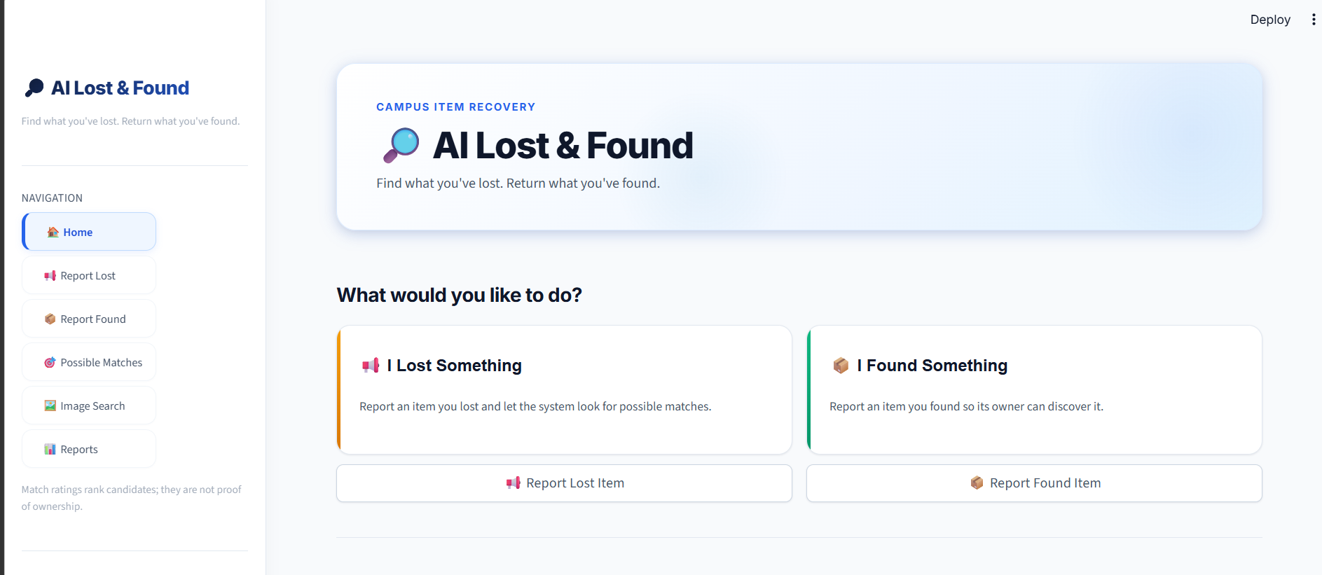
Fig 7.1 Home page
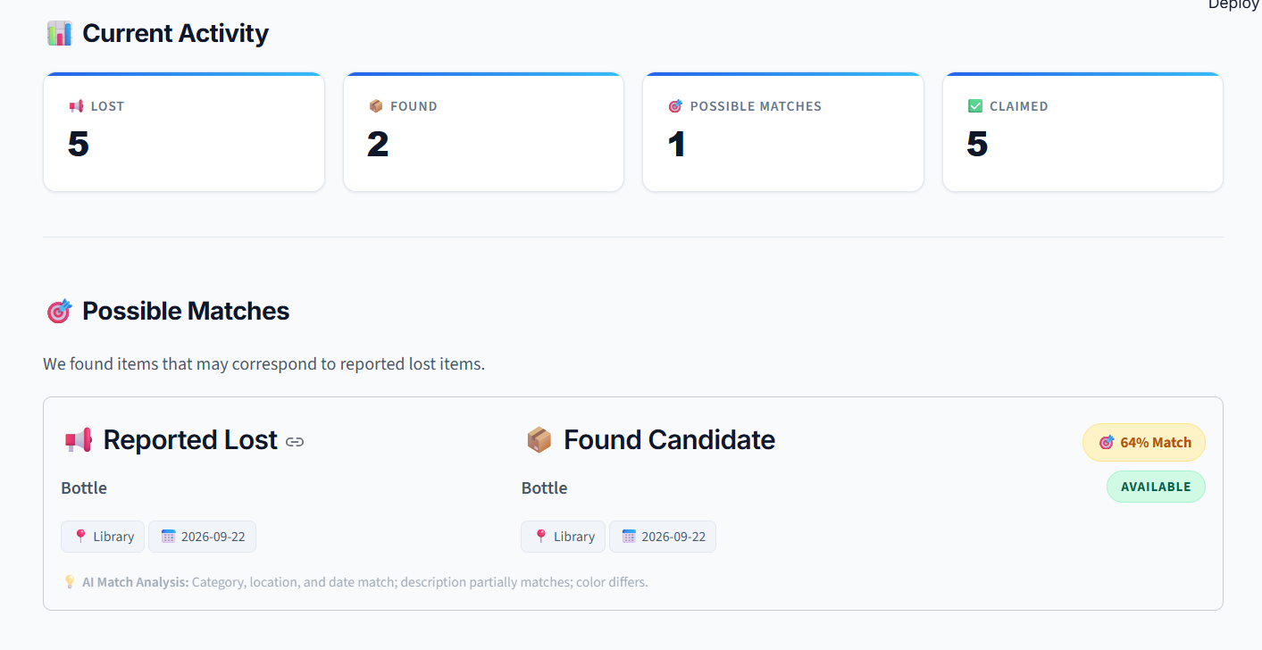
Fig 7.2 Current Activity and Possible Match
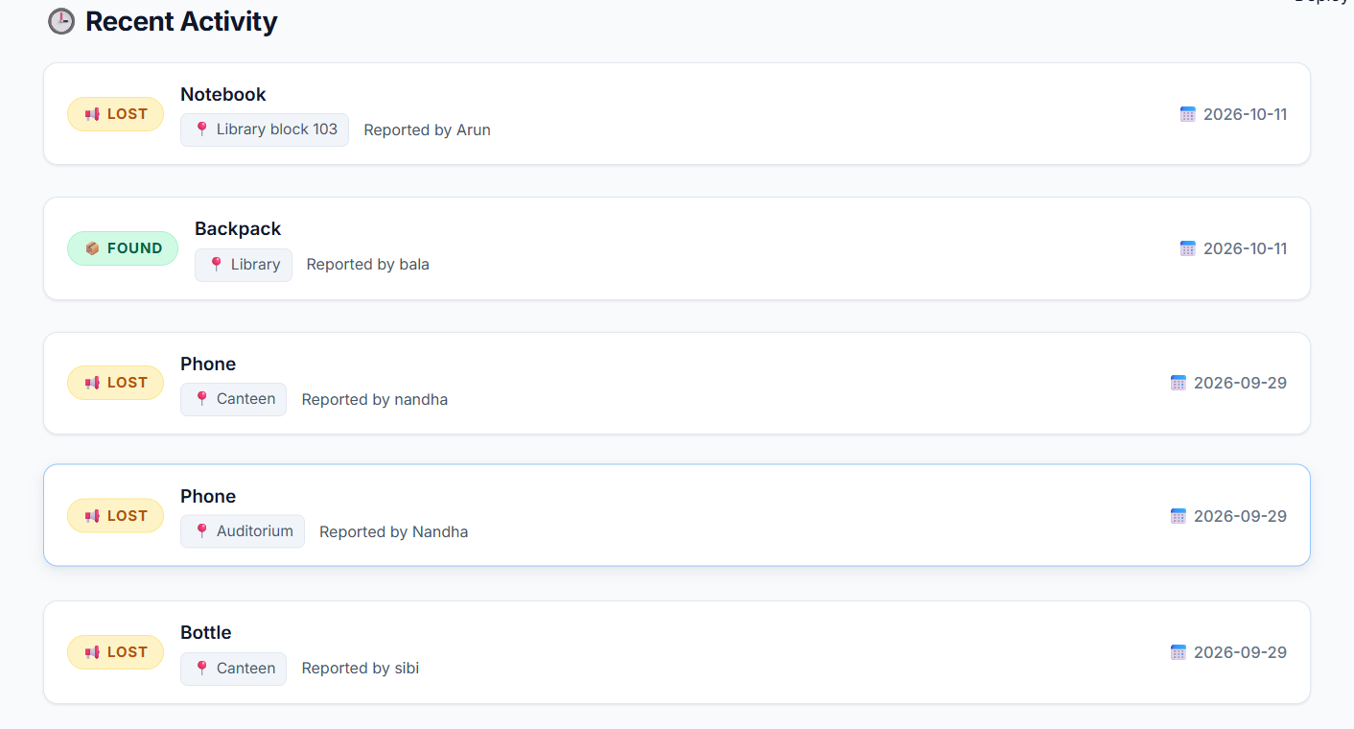
Fig 7.3 Recent Activity
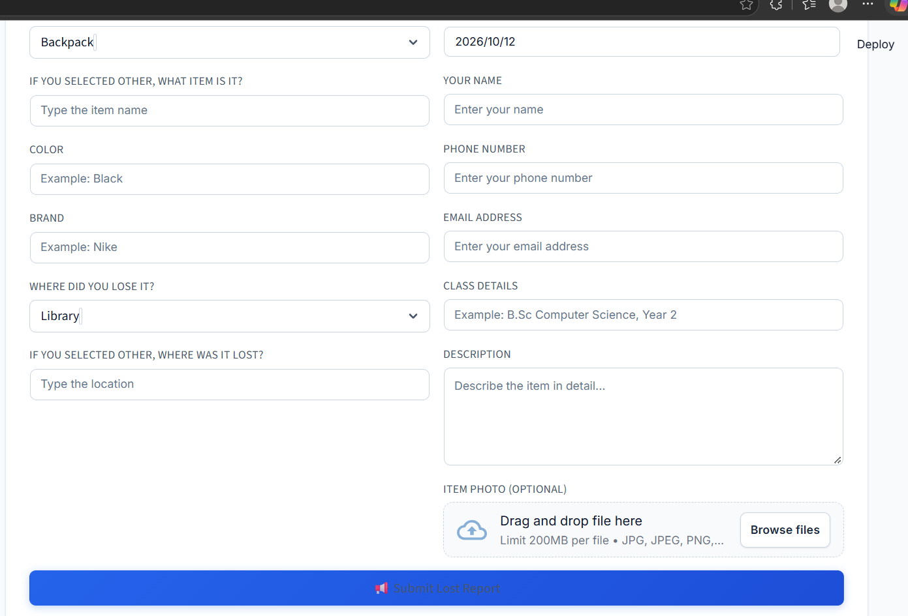
Fig 7.4 Lost Report
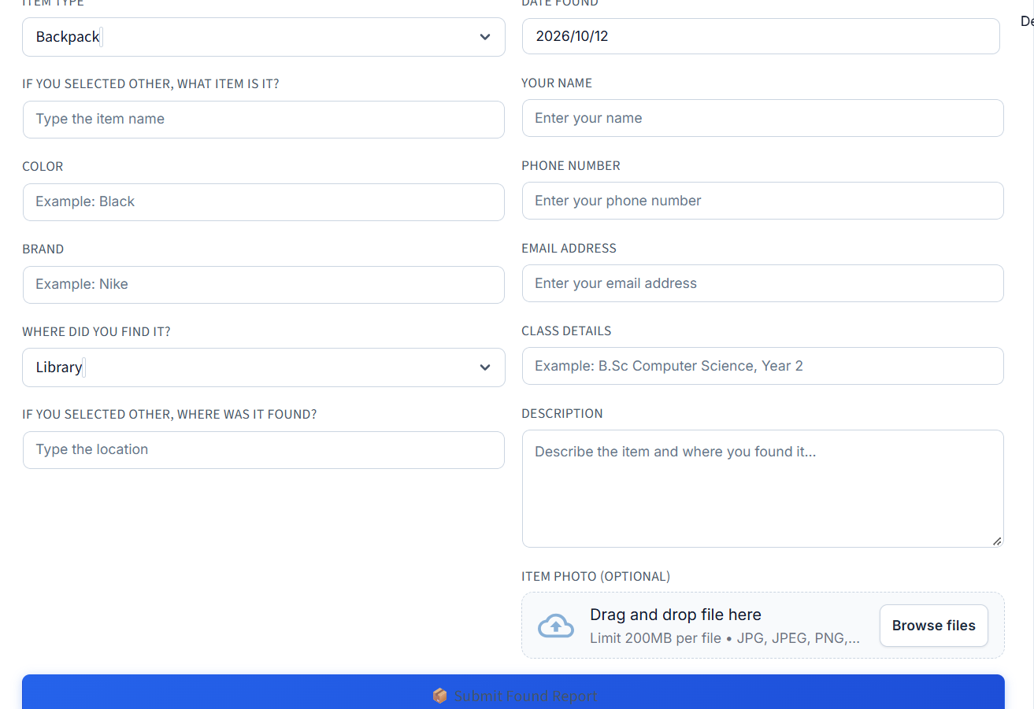
Fig 7.5 Found Report
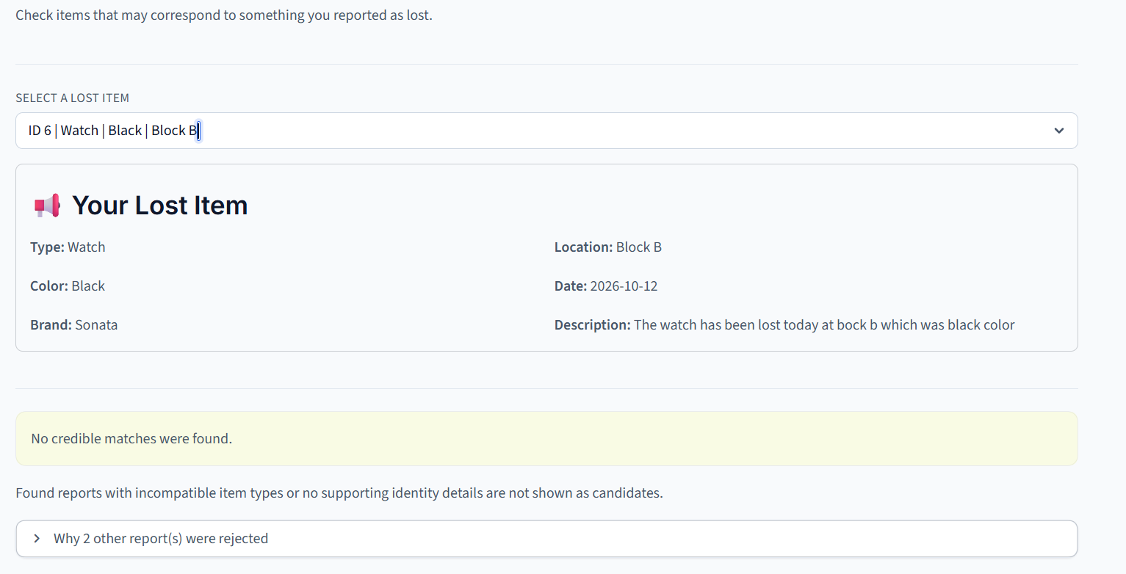
Fig 7.6 Matching items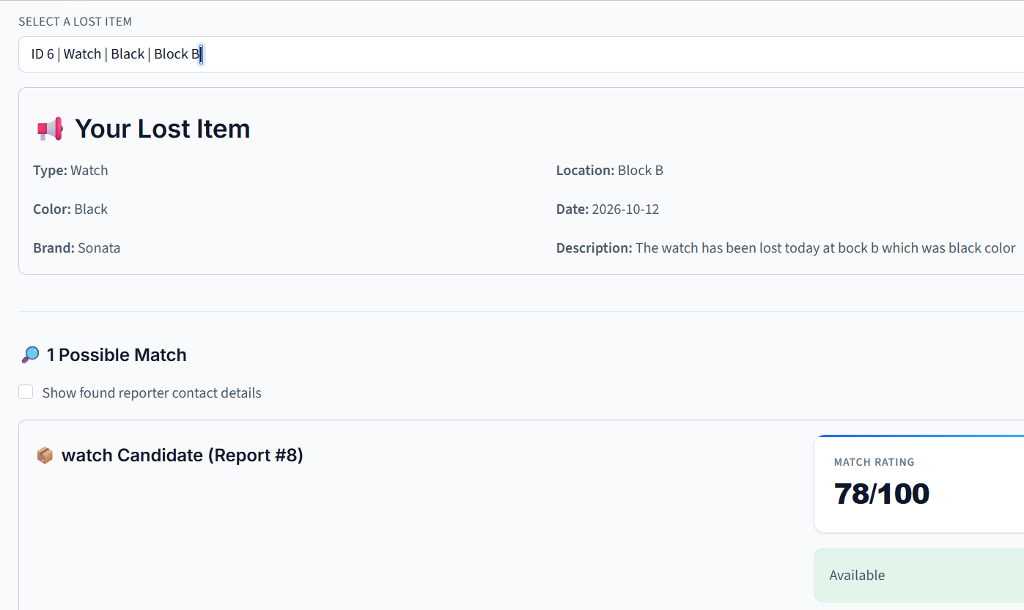
Fig 7.7 Match Score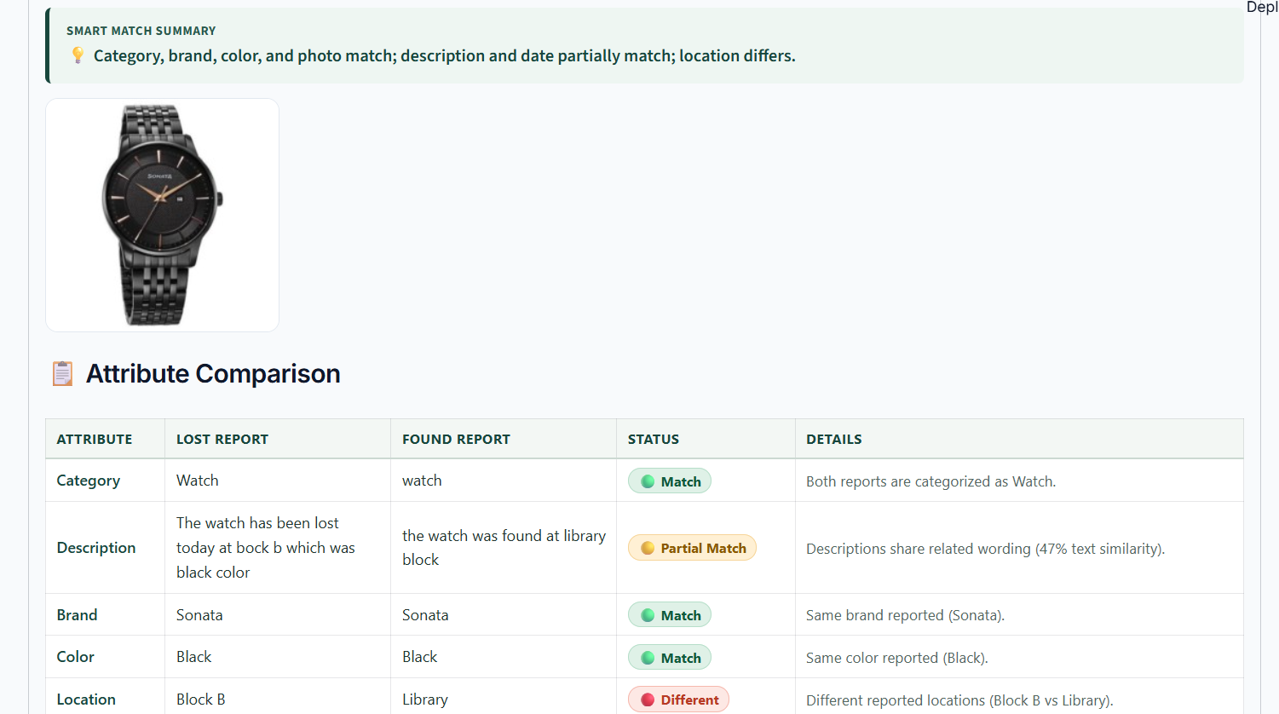
Fig 7.8 Comparison

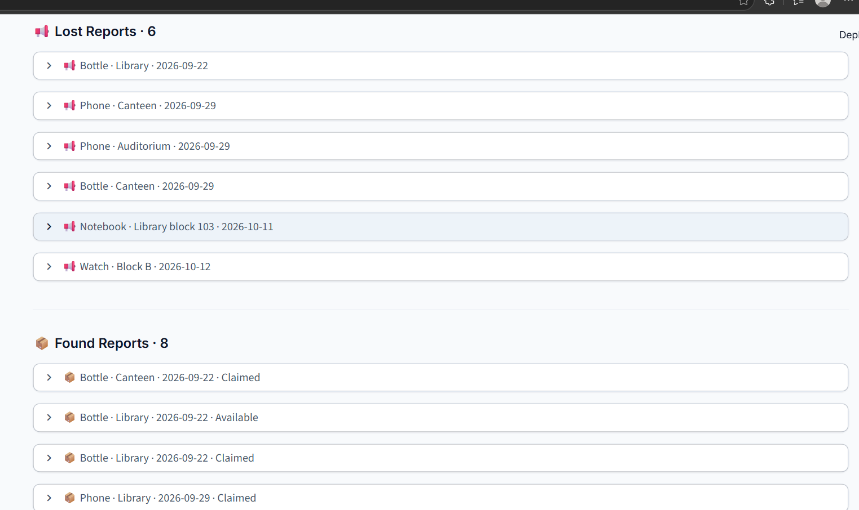
Fig 7.9 Report

8.CONCLUSION
The AI-Based Lost and Found System provides an efficient and user-friendly solution for managing lost and found items. It combines weighted multi-criteria matching, fuzzy string matching, and image similarity techniques to identify and rank potential matches based on item descriptions and visual characteristics. The system also provides matching explanations and supports item claim management, helping users identify their belongings more easily. By reducing manual searching and organizing item reports in a centralized application, the system improves the efficiency of the lost and found process. In the future, the system can be enhanced with advanced image recognition, improved matching techniques, and real-time notifications to provide a more effective user experience.

