**PHASE 1 PROJECT DOCUMENTATION**

**PROJECT AND DEVELOPER DETAILS:**

PROJECT NAME : LockedMe.com

PROJCET DETAILS :

It is file management system, which creates a root directory by creating a folder in the file application. It gives user yo files present in the directory and can add files to this directory ,it can delete files from directory and search any files present in the directory.

DEVELOPER NAME : PAVITHRA

SPRINT DETAILS:

NO.OF SPRINTS PLANNED : 3

DURATION OF SPRINTS : 2WEEKS

SPRINT 1 :

In the sprint basic structure of the application was developed, with first listing the welocme page in the console.developing the details of the user interface such as options displaying the user interactioninformation, and the featrures to accept the user input to select one of the option listed.

SPRINT 2:

* Firstly created the main menu with 3 options display ,sub menu, close from main application , where the first option Display will return the current files names which is available in the directory.
* The second option sub menu will display options for add the files ,delete the files and search for the file which is available in the directory.
* The add option will add a new file to the existing directory
* The delete option will delete a existing file in the directory and if the file is not found it will return a message “File not Found”.

SPRINT 3:

The search option for a user specified file from existing directory and retrieve the correct file and display the result as “file found” and if the file is not found in the directory it will return “file is not found in the directory”.

It has the option to navigate back to the main context. In the last there is an option to close the application.

IMPLEMENTATION :

The implementation of the project is by implementing the concepts of exceptions and sorting techniques for increased performance.Where the apllication will not close ,exit or throw an exception if the user specifies an invalid input.

**FLOWCHART OF THE APPLICATION :**

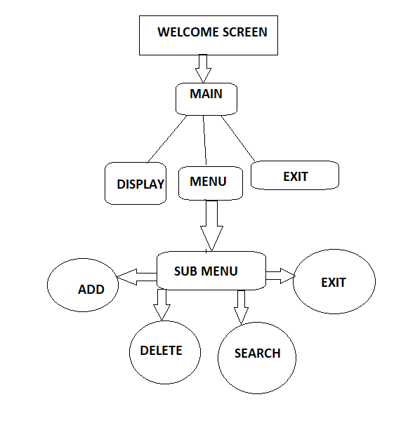

**CORE CONCEPTS USED IN THE PROJECT:**

1. Class
2. Inheritance
3. Arrays
4. Exception handling
5. File class
6. While loop
7. Switch class
8. Scanner class

LINK TO THE GITHUB REPOSITORY :

CONCLUSION :

The enhancement of the application is there is huge scope of improvement in the present project. user can easily navigate within the files and root directory

(Unique Selling Points) USP:

It can used by the user to update for the files