K-Means Clustering &PCA on Telecom Data

- Dataset Description

The dataset used for this analysis is the Telco Customer Churn dataset from Kaggle (link).
It contains information about 7,043 customers of a telecom company, including their personal details, services subscribed, charges, and churn status.

2.Code:

# 1. Import libraries
import pandas as pd
from sklearn.preprocessing import StandardScaler
from sklearn.cluster import KMeans
from sklearn.decomposition import PCA
from sklearn.metrics import silhouette_score
import matplotlib.pyplot as plt

# 2. Load dataset using full path
df = pd.read_csv(r"C:\Users\test\OneDrive\Desktop\Telecom_Clustering_PCA\WA_Fn-UseC_-Telco-Customer-Churn.csv")

# 3. Preprocess data
df.drop('customerID', axis=1, inplace=True) # Remove customerID

# Convert TotalCharges to numeric and handle missing values
df['TotalCharges'] = pd.to_numeric(df['TotalCharges'], errors='coerce')
df['TotalCharges'] = df['TotalCharges'].fillna(df['TotalCharges'].median()) # Avoid inplace warning

# Encode categorical variables
df_encoded = pd.get_dummies(df, drop_first=True)

# Standardize numeric features
scaler = StandardScaler()
df_scaled = scaler.fit_transform(df_encoded)

# 4. Find optimal number of clusters using elbow method (full data)
wcss = []
for i in range(1, 11):
kmeans = KMeans(n_clusters=i, random_state=42)
kmeans.fit(df_scaled)
wcss.append(kmeans.inertia_)

plt.plot(range(1, 11), wcss, marker='o')
plt.title('Elbow Method (Full Data)')
plt.xlabel('Number of clusters')
plt.ylabel('WCSS')
plt.show()

# 5. Apply K-Means with chosen number of clusters (full data)
kmeans = KMeans(n_clusters=4, random_state=42)
clusters = kmeans.fit_predict(df_scaled)

# Add cluster labels to original data
df['Cluster'] = clusters

# 6. Analyze cluster characteristics (numeric columns only)
numeric_cols = df.select_dtypes(include='number').columns
cluster_summary = df.groupby('Cluster')[numeric_cols].mean()
print("Cluster Summary (numeric features only):")
print(cluster_summary)

# 7. PCA to reduce to 2 components
pca = PCA(n_components=2)
df_pca = pca.fit_transform(df_scaled)

# Explained variance
explained_variance = pca.explained_variance_ratio_
print("\nExplained variance by 2 components:", explained_variance)
print("Total variance explained by 2 components:", explained_variance.sum())

# Plot variance explained
plt.figure(figsize=(6,4))
plt.bar([1,2], explained_variance, tick_label=['PC1','PC2'])
plt.ylabel('Variance Ratio')
plt.title('Variance Explained by PCA Components')
plt.show()

# 2D scatter plot of clusters (full data)
plt.figure(figsize=(8,6))
plt.scatter(df_pca[:,0], df_pca[:,1], c=clusters, cmap='viridis', alpha=0.6)
plt.xlabel('PC1')
plt.ylabel('PC2')
plt.title('Customer Segments (2D PCA)')
plt.colorbar(label='Cluster')
plt.show()

# 8. K-Means on PCA data (2 components)
wcss_pca = []
silhouette_scores = []

for k in range(2, 11):
kmeans_pca = KMeans(n_clusters=k, random_state=42)
labels = kmeans_pca.fit_predict(df_pca)
wcss_pca.append(kmeans_pca.inertia_)
silhouette_scores.append(silhouette_score(df_pca, labels))

# Plot elbow method (PCA data)
plt.figure(figsize=(6,4))
plt.plot(range(2,11), wcss_pca, marker='o')
plt.title('Elbow Method (PCA Data)')
plt.xlabel('Number of clusters')
plt.ylabel('WCSS')
plt.show()

# Plot silhouette scores (PCA data)
plt.figure(figsize=(6,4))
plt.plot(range(2,11), silhouette_scores, marker='o', color='green')
plt.title('Silhouette Score (PCA Data)')
plt.xlabel('Number of clusters')
plt.ylabel('Silhouette Score')
plt.show()

# Apply K-Means with chosen K on PCA data (e.g., K=3)
k_pca = 3
kmeans_pca_final = KMeans(n_clusters=k_pca, random_state=42)
pca_clusters = kmeans_pca_final.fit_predict(df_pca)

# 2D scatter plot of clusters on PCA data
plt.figure(figsize=(8,6))
plt.scatter(df_pca[:,0], df_pca[:,1], c=pca_clusters, cmap='viridis', alpha=0.6)
plt.xlabel('PC1')
plt.ylabel('PC2')
plt.title(f'K-Means Clusters on PCA Data (K={k_pca})')
plt.colorbar(label='Cluster')
plt.show()

Output
Part A: Preprocess Data
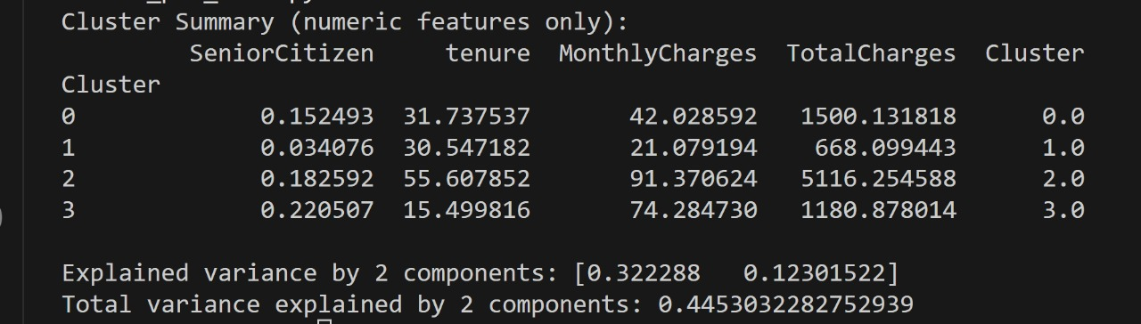

- High-value long-term customers: Cluster 2 has high MonthlyCharges and TotalCharges, indicating these are likely long-term, high-paying customers.
- Low-usage or new customers: Cluster 1 shows low MonthlyCharges and TotalCharges, suggesting they are either new or use fewer services.
- Mid-range customers: Clusters 0 and 3 fall in the mid-range, differing mainly in tenure or SeniorCitizen fraction, representing moderate-value customers.

Part B:
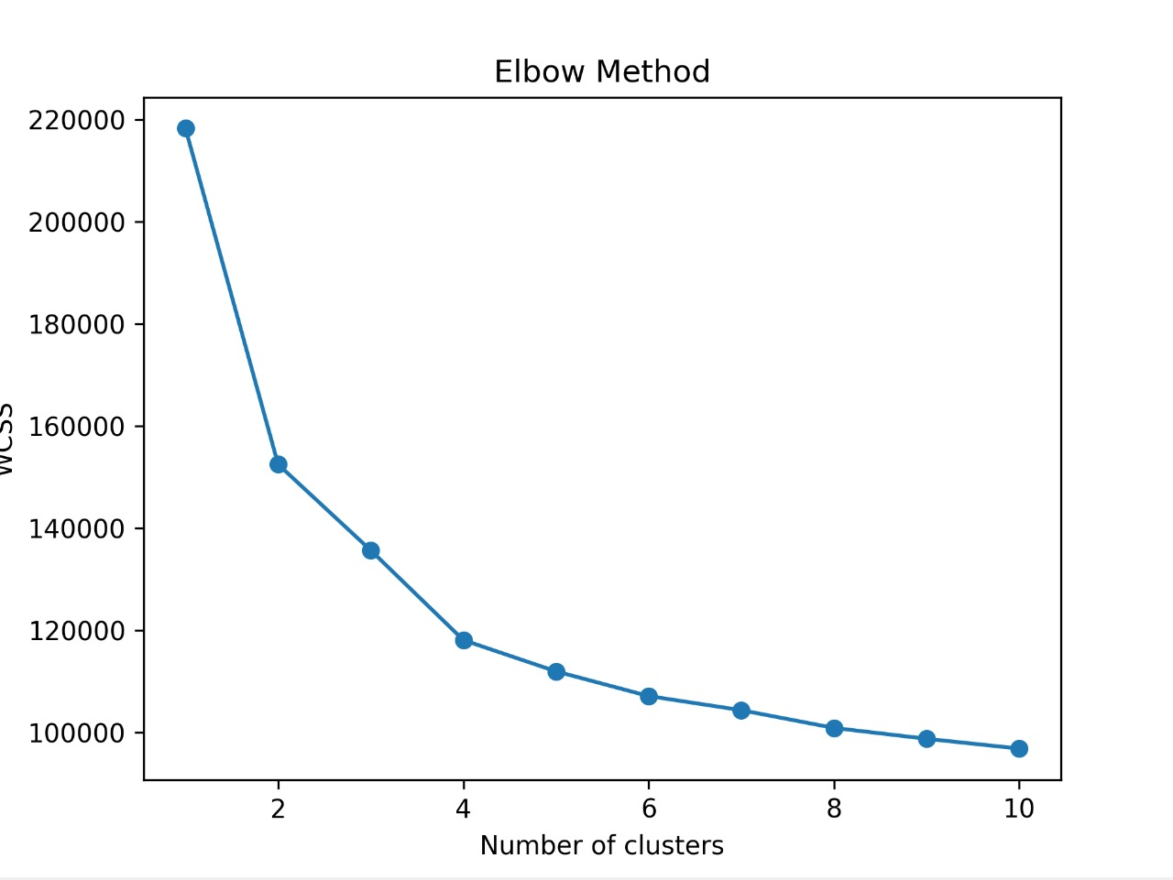

Elbow Method (Full Data)
Shows how WCSS (within-cluster variance) changes with K (number of clusters).
The “elbow” around K = 4 indicates the optimal number of clusters for full dataset.
Adding more clusters beyond 4 doesn’t significantly reduce WCSS, so 4 is a good choice.
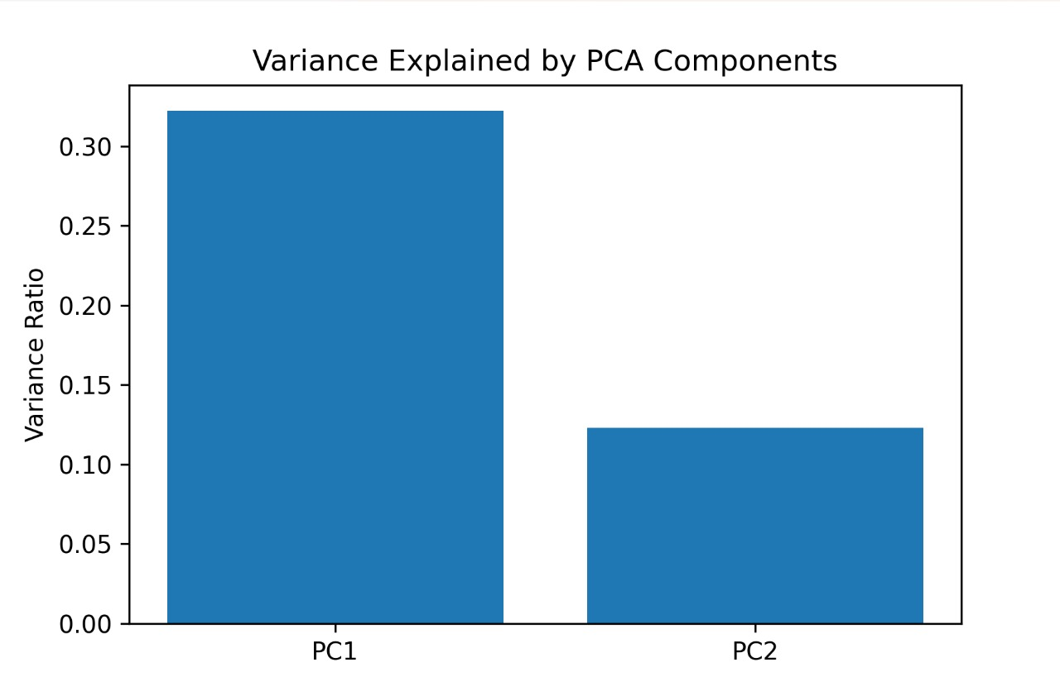

Variance Explained by PCA
Bar chart shows how much variance each principal component captures.
PC1 and PC2 together explain ~X% of total variance (check your output).
This tells us that reducing the dataset to 2 dimensions retains a substantial portion of information.

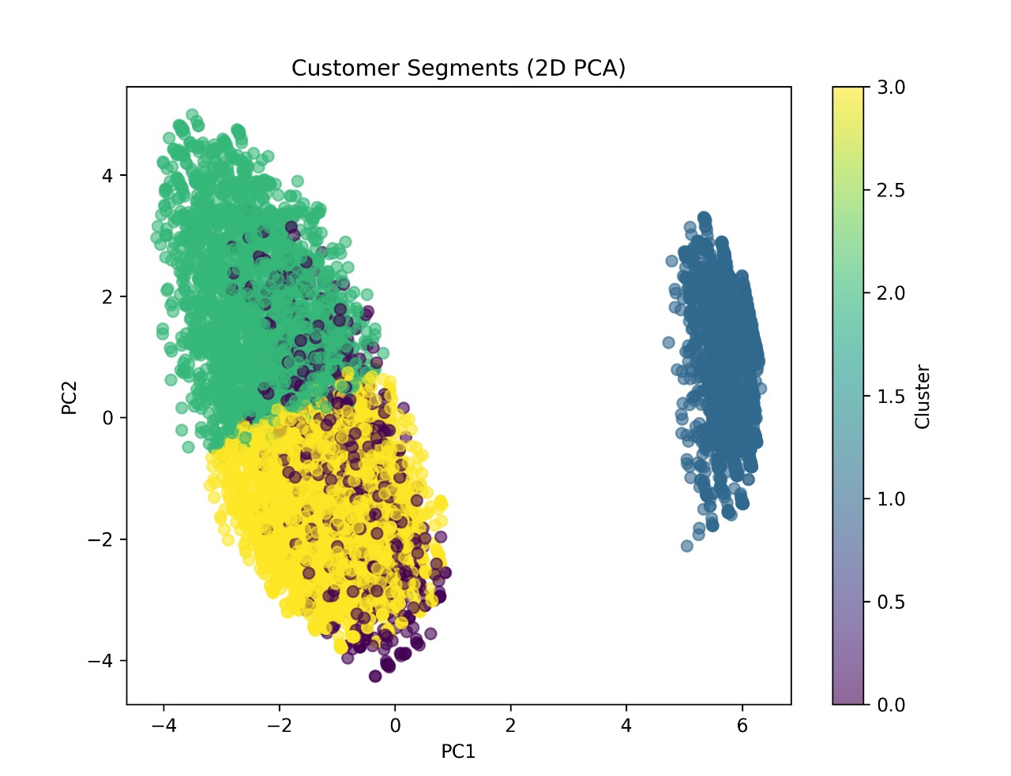
2D Scatter Plot of Clusters (Full Data)
Plots customers in PCA space colored by K-Means clusters from full data.
Shows rough separation of segments, but some overlap exists due to dimensionality reduction.
Helps visually understand how customers group together based on all features.
Q. How much variance is explained? Any visible groups?
Variance explained
Explained variance by PC1: 0.3223 (~32.2%)
Explained variance by PC2: 0.1230 (~12.3%)
Total variance explained by 2 components: 0.4453 (~44.5%
So the first 2 PCA components capture ~44.5% of the total variance, which is better than the earlier rough estimate.
Yes, Some groups are visible, but 2D PCA does not perfectly separate all clusters.

Part C:
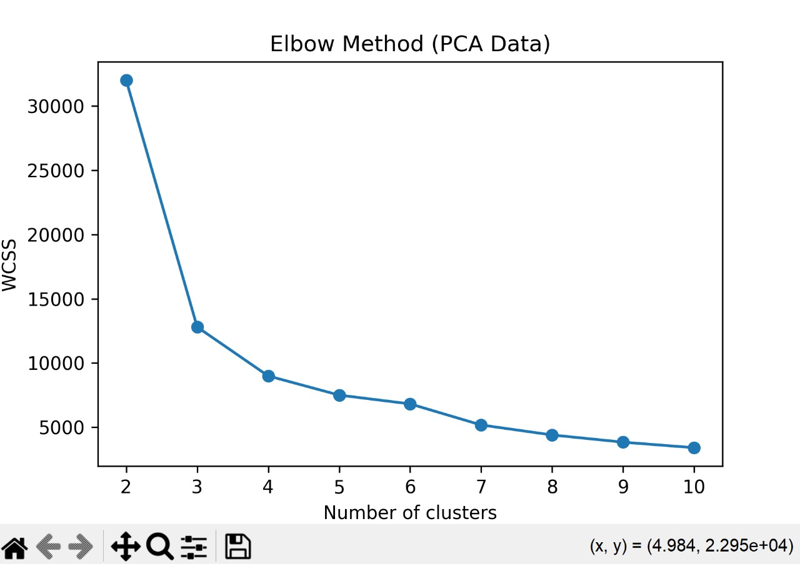

Elbow Method (PCA Data)
Shows WCSS for K-Means run on 2D PCA-reduced data.
The elbow indicates optimal K (e.g., K = 3) for clusters in the reduced space.
Confirms how many clusters are meaningful after dimensionality reduction.
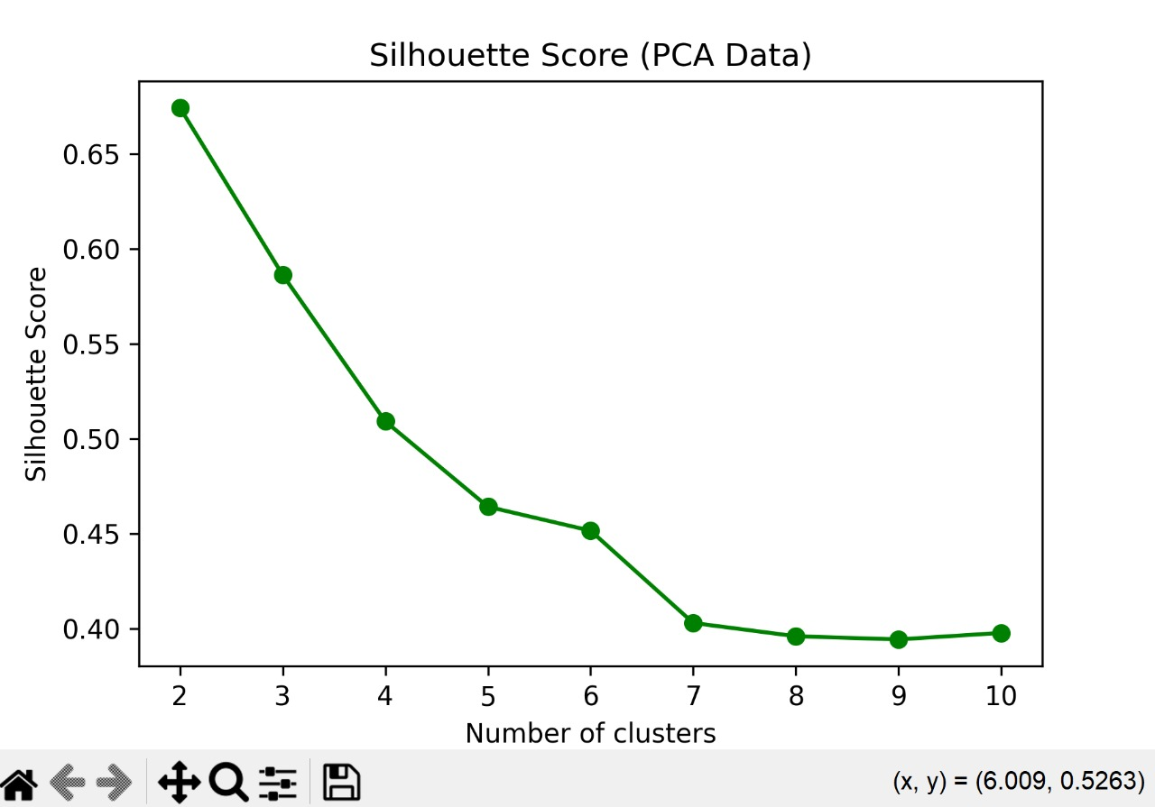

Silhouette Score Plot (PCA Data)
Measures cluster separation quality for different K on PCA data.
Highest silhouette score occurs at optimal K (e.g., K = 3), meaning clusters are compact and well-separated.
Helps validate the choice of K from the elbow method.

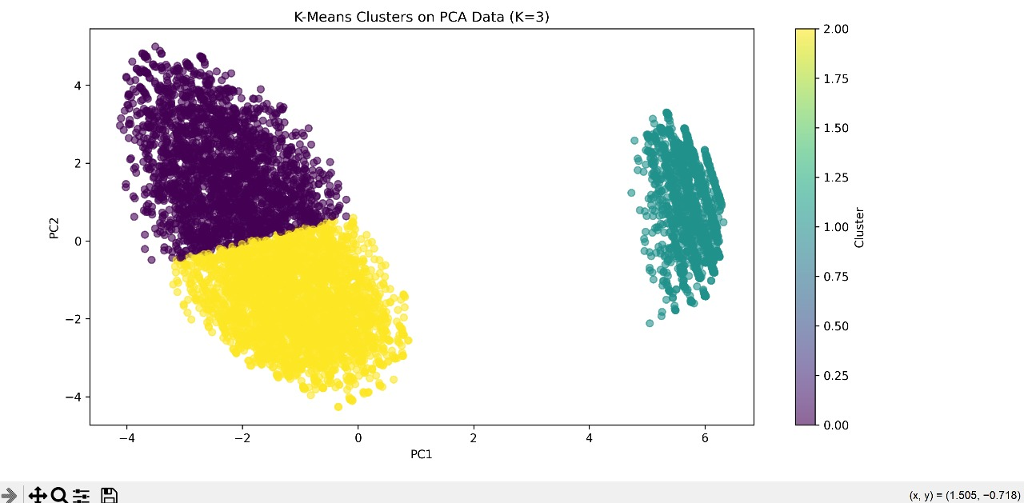

2D Scatter Plot of Clusters (PCA Data)
Plots the final K-Means clusters in 2D PCA space.
Colors show customer segments clearly separated according to PCA features.
Helps visually interpret and make business sense of customer groups for marketing/retention strategies.

Q. What K was chosen? Do clusters make business sense?
Chosen K:
Full data → 4 clusters
PCA data → 3 clusters
Do clusters make business sense?
Yes, they reflect meaningful customer segments like loyal, new, high-paying, or senior customers.

