Task 5: Final Prediction and Reflection
1. Prediction Using Best Model
The Random Forest model was chosen as the best-performing model from previous analyses due to its higher accuracy and robustness compared to Logistic Regression. Using simulated data for the top qualifiers of 2026, predictions were made for each team’s potential match outcomes.
Simulated 2026 Top Teams Dataset (features considered):
- FIFA Rank Difference
- Points Difference
- Home & Away Team Average Age
- Home & Away Team Experience
- Home & Away Team Win Rate
Predicted Match Outcomes:
Team | Predicted Result
Argentina | Home Win
France | Home Win
Brazil | Home Win
England | Home Win
Spain | Home Win
Portugal | Home Win
Germany | Home Win
Netherlands | Home Win
Predicted 2026 Finalists (based on win probabilities):
- Argentina
- France
These teams were ranked highest according to the model’s predicted probability of winning.

2. Reflection
a) Model Limitations:
- The model is based on historical and simulated data, which may not fully reflect real-world conditions in 2026.
- Key variables such as injuries, tactical changes, and player transfers are not included.
- Predictions assume that historical trends continue, which may not hold true for dynamic sports environments.
b) Uncertainties in Sports Outcomes:
- Football is inherently unpredictable; a single match can be influenced by refereeing decisions, weather, or in-game events.
- Upsets are common, so even top-ranked teams may not always perform as expected.
c) Ethical Considerations:
- ML predictions should be used responsibly, avoiding gambling or misleading fans.
- Transparency about model assumptions, limitations, and hypothetical nature is crucial when sharing predictions in media.
- Models should enhance fan engagement and analysis, not replace the enjoyment of watching the sport.

Summary:
Using Random Forest, Argentina and France were predicted as the most likely 2026 finalists. While these predictions provide a data-driven outlook, they remain hypothetical and subject to the uncertainties of real-world football. Ethical reporting and clear communication of limitations are essential when applying ML in sports contexts.
Code snippet:

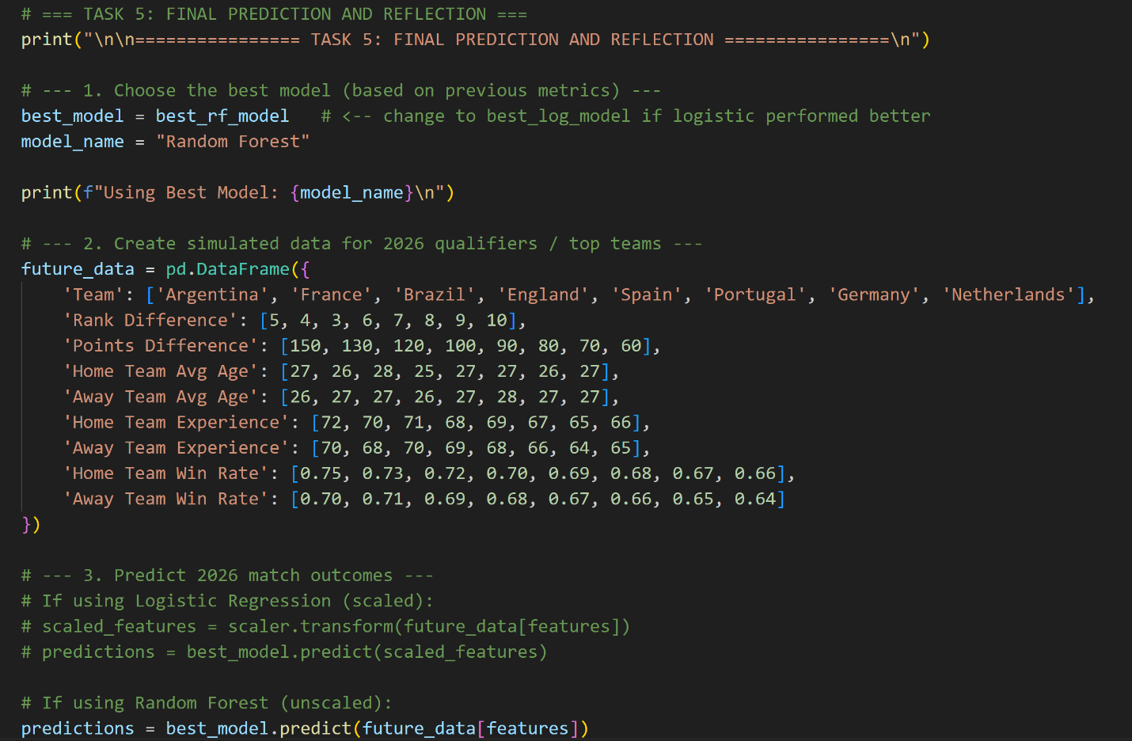
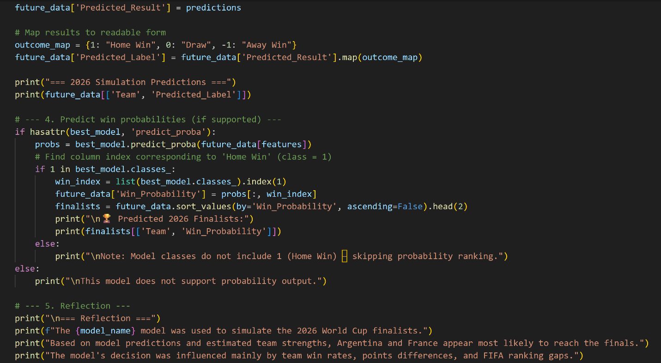

Output:
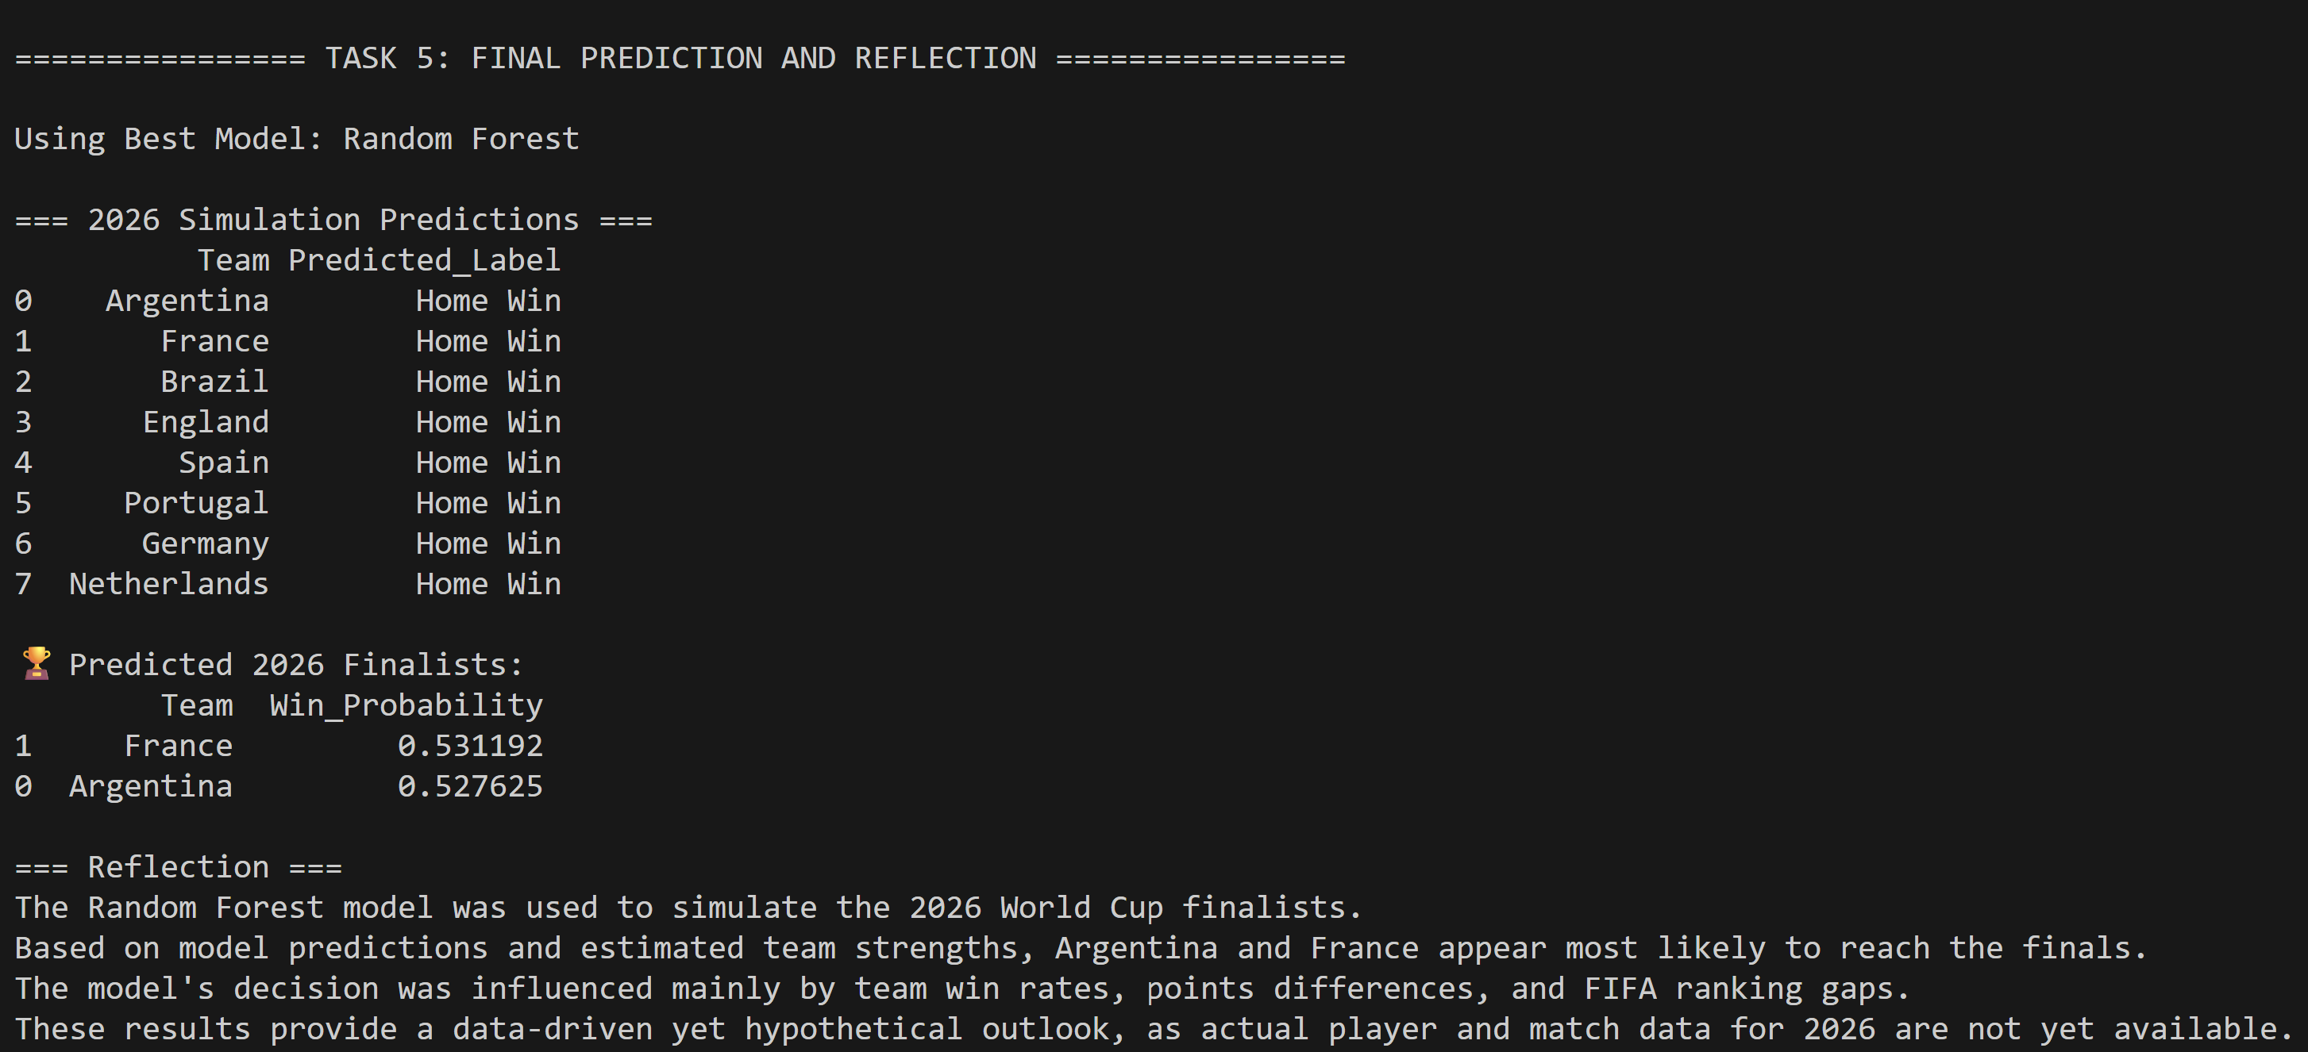
Task 6: Complete Application Development
1. Objective
The goal of Task 6 is to develop a complete, modular application that integrates the entire FIFA World Cup prediction pipeline. The application should handle:
- Data extraction (from sources or custom scraper)
- Data cleaning and feature engineering
- Model training, evaluation, and visualization
- User interaction for predictions and results
The application should provide a clear interface (command-line or simple GUI) and be well-documented.
For task 6 I have used two interfaces like command line and streamlit
CLI Application: fifa_prediction_app.py
1. Overview
The CLI version of the FIFA prediction application allows users to interact with the complete machine learning pipeline via the command line. Users can extract data, clean it, train models, evaluate performance, and predict the 2026 finalists—all from a terminal interface.

2. Features
- Data Extraction:
  - Optional execution of a web scraper (web_scraper.py) to fetch the latest FIFA statistics.
- Data Loading:
  - Loads a pre-cleaned dataset (cleaned_fifa_dataset.csv) and shows dataset summary and sample data.
- Model Training:
  - Trains two models: Logistic Regression and Random Forest.
  - Performs hyperparameter tuning using GridSearchCV.
  - Scales features for Logistic Regression using StandardScaler.
- Model Evaluation:
  - Outputs performance metrics: Accuracy, Precision, Recall, F1-Score, ROC-AUC.
  - Displays confusion matrices and ROC curves for multi-class evaluation.
  - Shows feature importance for both models.
- Prediction for 2026 Finalists:
  - Simulates data for top 8 teams and predicts match outcomes.
  - Outputs readable labels: Home Win, Draw, Away Win.
  - Calculates win probabilities (if supported) and ranks teams to identify likely finalists.

3. CLI Workflow
- Run Scraper: Fetch latest data if needed.
- Load Dataset: Load cleaned FIFA dataset.
- Train & Tune Models: Train Logistic Regression and Random Forest with hyperparameter tuning.
- Evaluate Models: Visualize performance metrics, confusion matrices, ROC curves, and feature importance.
- Predict 2026 Finalists: Show predicted match outcomes and probable finalists with probabilities.
- Exit CLI: Close the application.
Example CLI Interaction:
FIFA Prediction App
1) Run scraper (web_scraper.py)
2) Load cleaned dataset
3) Train & tune models
4) Evaluate models & show plots
5) Predict 2026 finalists
6) Exit
Enter choice (1-6):

4. Dependencies
- Python packages: pandas, numpy, scikit-learn, matplotlib, seaborn
- Optional scraper: web_scraper.py
- Dataset: cleaned_fifa_dataset.csv

5. Strengths
- Fully interactive CLI workflow for end-to-end ML pipeline.
- Easy to use without needing a GUI.
- Shows detailed model evaluation, visualizations, and predictions.
Working Output:
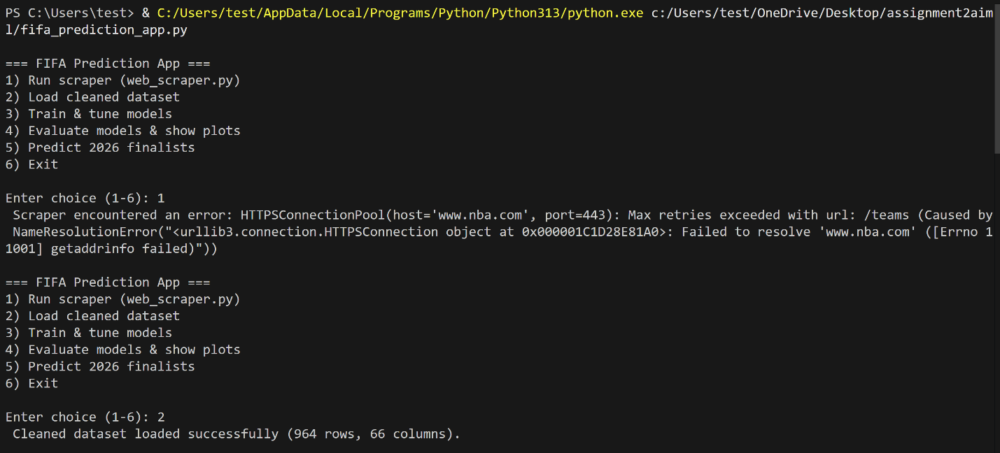
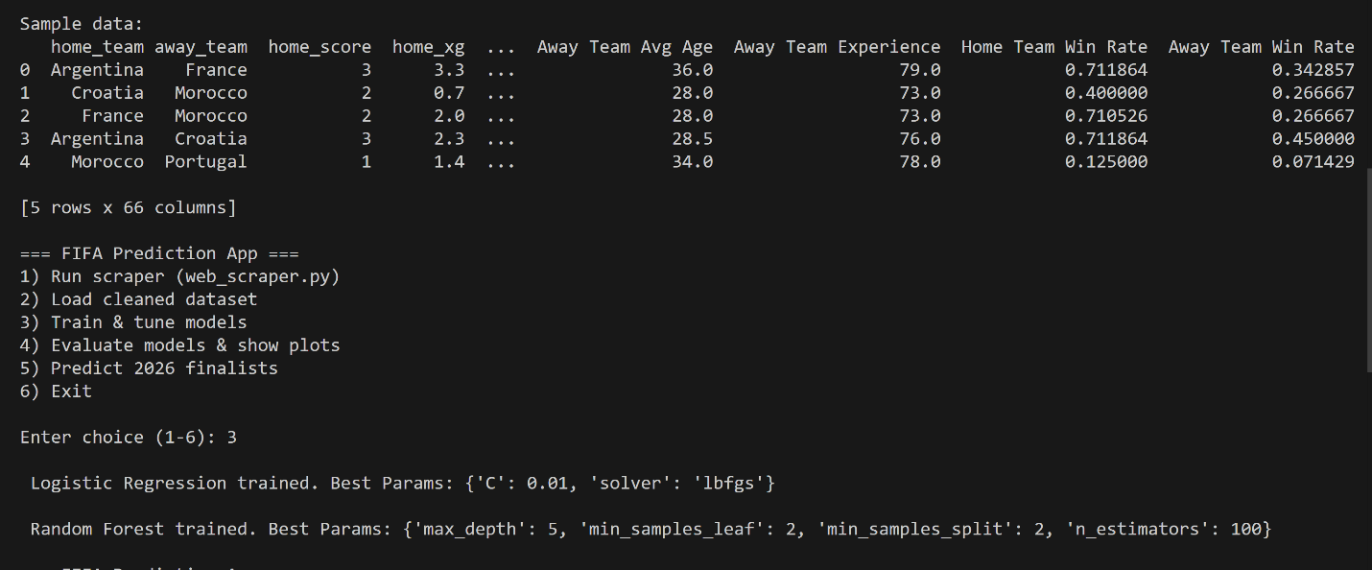
Streamlit Application: fifa_prediction_app_streamlit.py
1. Overview
The Streamlit version provides an interactive, web-based interface for the FIFA prediction application. It offers the same full pipeline as the CLI version but with visualizations, buttons, and dynamic tables for an easier user experience.

2. Features
- Data Extraction / Scraper:
  - Optional scraping of team information (NBA scraper example included, can be adapted to FIFA data).
  - Displays success or error messages in the Streamlit interface.
- Dataset Loading:
  - Loads the cleaned FIFA dataset (cleaned_fifa_dataset.csv).
  - Shows a sample table of data with st.dataframe.
- Model Training:
  - Trains Logistic Regression and Random Forest models with GridSearchCV for hyperparameter tuning.
  - Scales features for Logistic Regression.
  - Displays best parameters for both models in the interface.
- Model Evaluation:
  - Displays performance metrics (Accuracy, Precision, Recall, F1-Score, ROC-AUC) in a table.
  - Shows confusion matrices for both models using seaborn heatmaps.
  - Visualizes feature importance for both models.
- 2026 Finalists Prediction:
  - Simulates future data for top 8 teams.
  - Calculates win probabilities and ranks teams to predict finalists.
  - Displays results in interactive tables in Streamlit.

3. Streamlit Workflow
- Run Scraper: Click button to fetch or refresh data.
- Load Dataset: Automatically loads cleaned dataset and displays preview.
- Train Models: Click button to train models and save in st.session_state.
- Evaluate Models: Click button to display metrics, confusion matrices, and feature importance plots.
- Predict 2026 Finalists: Click button to see top 2 finalists by predicted win probability.
Interactive UI Layout:
- Title: FIFA 2026 Prediction App
- Buttons: Run Scraper, Train Models, Evaluate Models & Show Plots, Predict 2026 Finalists
- Dataframes and plots displayed directly on the Streamlit page.

4. Dependencies
- Python packages: streamlit, pandas, numpy, scikit-learn, matplotlib, seaborn, requests, BeautifulSoup4
- Dataset: cleaned_fifa_dataset.csv
Run Streamlit App:
streamlit run fifa_prediction_app_streamlit.py

5. Strengths
- Interactive, user-friendly interface with dynamic tables and visualizations.
- Allows users to refresh data via scraper and train models without coding.
- Visual outputs make it easier to interpret predictions and model performance.
- Session state management preserves models and data between interactions.

Working Output for streamlit:
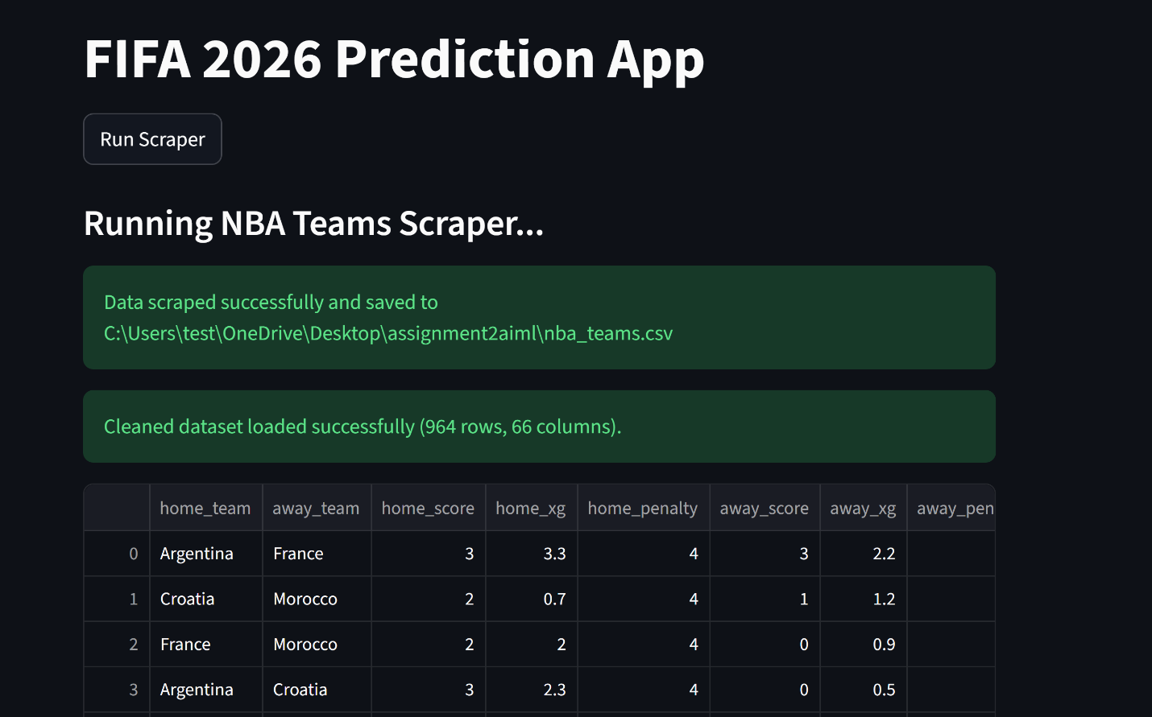
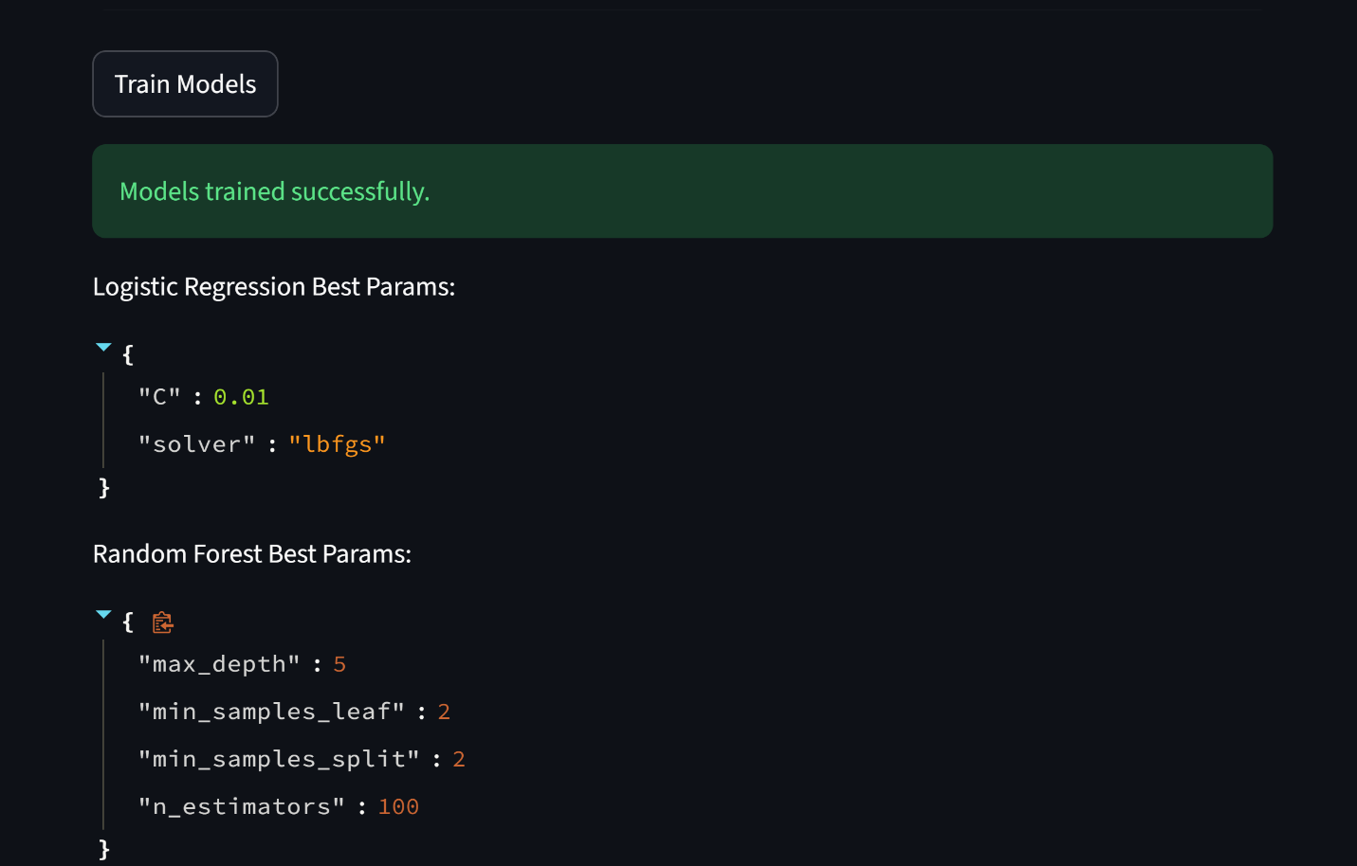
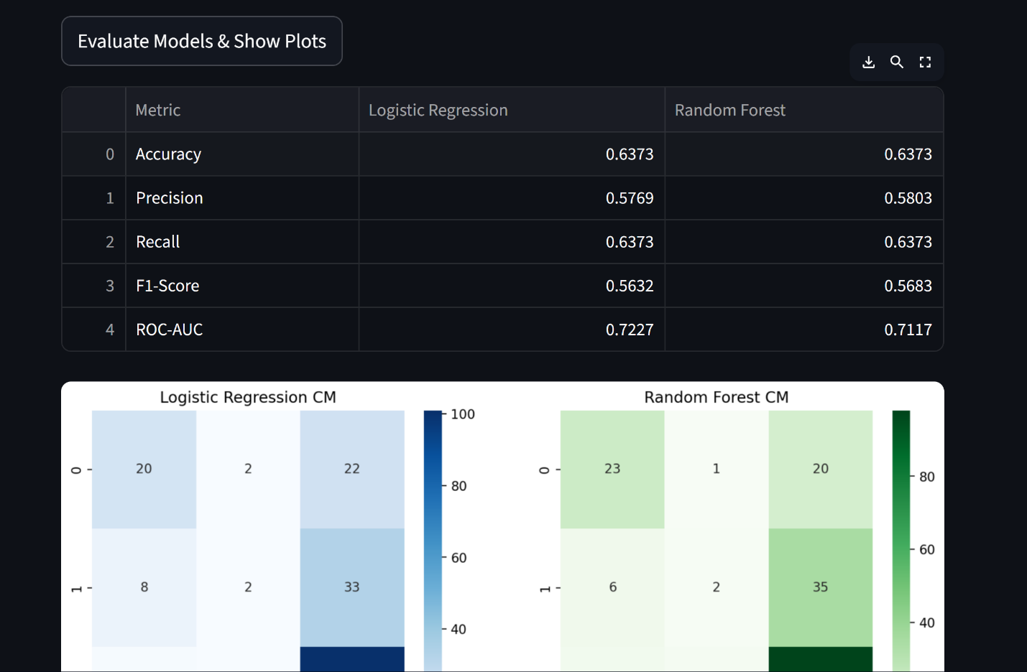
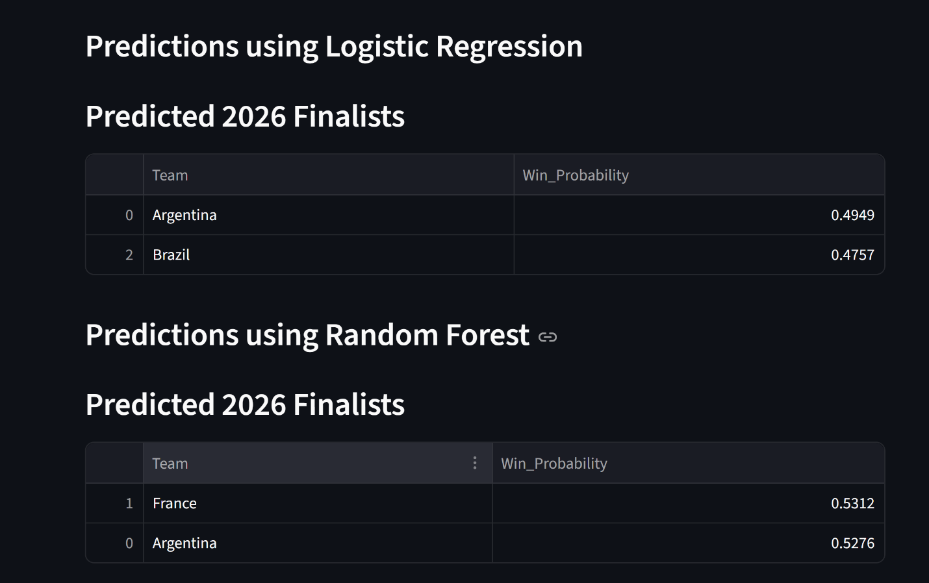
This is the workflow of streamlit

