Lab Exercise: Predicting House Price using Linear Regression

Aim
To build a Linear Regression model using Python to predict the price of a house based on its area, number of rooms, distance from city, and age.

Algorithm / Procedure
- Import the necessary Python libraries (pandas, sklearn.linear_model).
- Create a dataset with the following features:
  - Area (sqft)
  - Rooms
  - Distance (km)
  - Age (years)
  - Price (₹ Lacs)
- Convert the dataset into a DataFrame using pandas.
- Split the data into:
  - Independent variables (X): ['Area', 'Rooms', 'Distance', 'Age']
  - Dependent variable (y): 'Price'
- Create a Linear Regression model using LinearRegression().
- Fit the model using model.fit(X, y).
- Display:
  - Intercept
  - Coefficients
- Predict the house price for new data (e.g., 1600 sqft, 4 rooms, 5 km, 10 years).
- Display the predicted result.

Python Program
# Import libraries
import pandas as pd
from sklearn.linear_model import LinearRegression

# Create dataset
data = {
'Area': [1200, 1400, 1600, 1700, 1850],
'Rooms': [3, 4, 3, 5, 4],
'Distance': [5, 3, 8, 2, 4],
'Age': [10, 3, 20, 15, 7],
'Price': [120, 150, 130, 180, 170]
}

# Convert to DataFrame
df = pd.DataFrame(data)

# Independent (X) and dependent (y) variables
X = df[['Area', 'Rooms', 'Distance', 'Age']]
y = df['Price']

# Build Linear Regression model
model = LinearRegression()
model.fit(X, y)

# Display coefficients
print("Intercept:", model.intercept_)
print("Coefficients:", model.coef_)

# Predict for a new house
new_house = pd.DataFrame([[1600, 4, 5, 10]], columns=['Area', 'Rooms', 'Distance', 'Age'])
predicted_price = model.predict(new_house)
print("Predicted Price (₹ Lacs):", predicted_price[0])

input("\nPress Enter to exit...")
Output
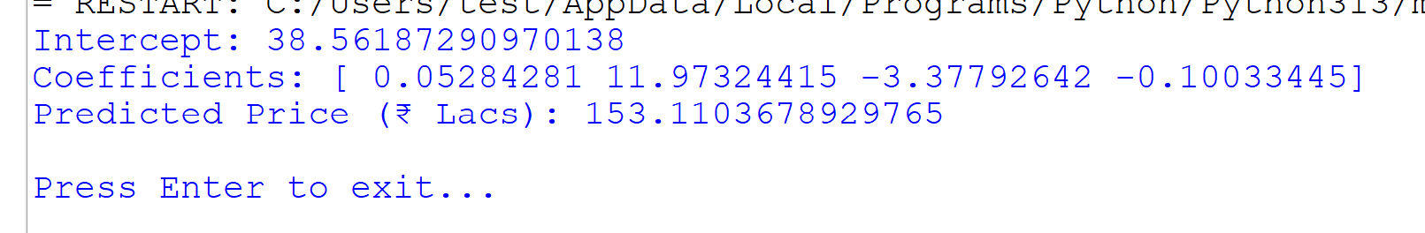
Result
The Linear Regression model was successfully built and used to predict house prices.
For a house with Area = 1600 sqft, Rooms = 4, Distance = 5 km, and Age = 10 years,
the Predicted Price = ₹153.11 Lacs.

