Evaluation Report:
Task 3
- Model performance metric table:
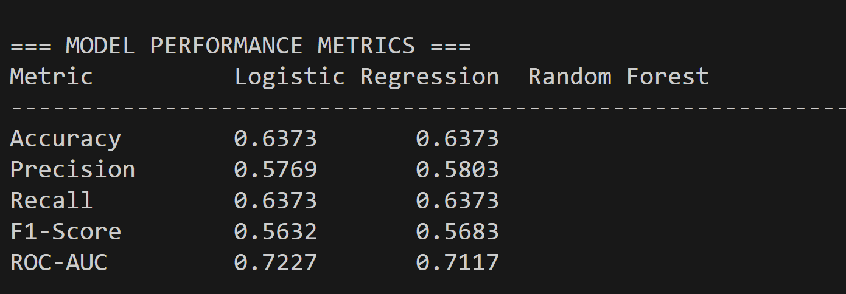
Accuracy: Measures the percentage of total correct predictions made by the model.
Precision: Indicates how many of the predicted wins were actually correct.
Recall: Shows how many of the actual wins were correctly identified by the model.
F1-Score: Provides a balanced measure of precision and recall for overall performance.
ROC-AUC: Evaluates how well the model distinguishes between different outcomes; higher value means better classification.

2.Visualizations:
1.Confusion Matrix:
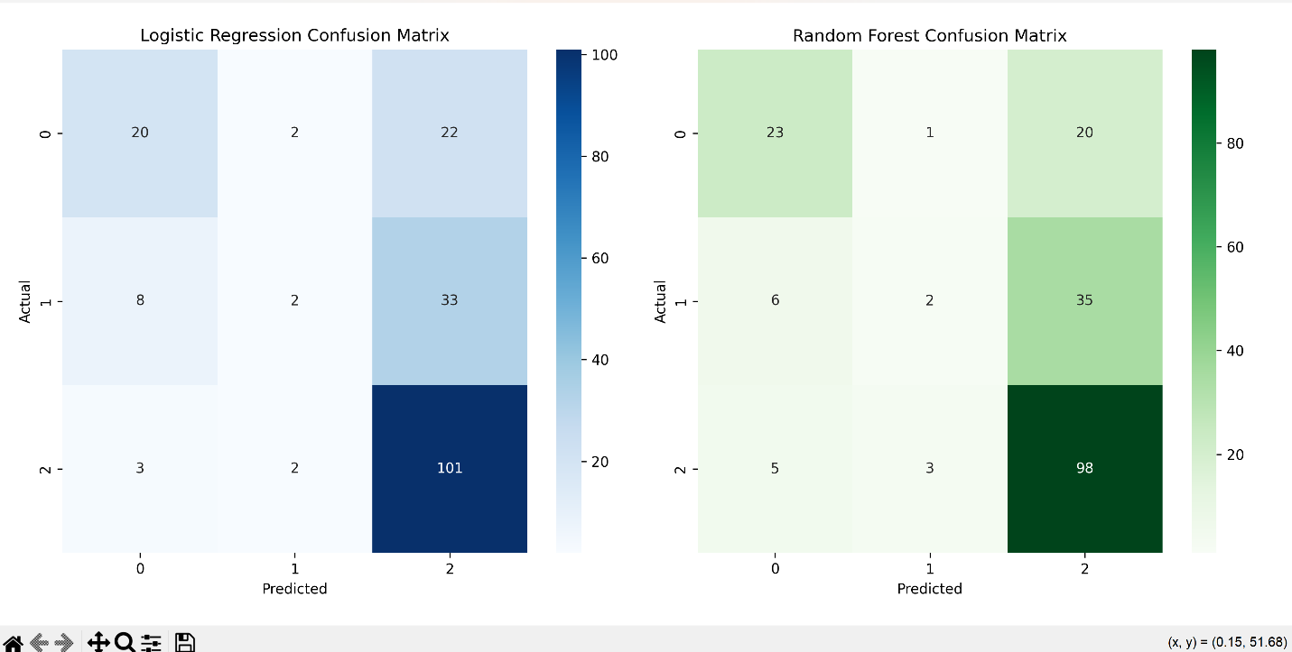
Displays the count of correct and incorrect predictions.
Helps identify specific types of errors (e.g., false wins or false losses).
2.ROC curve:
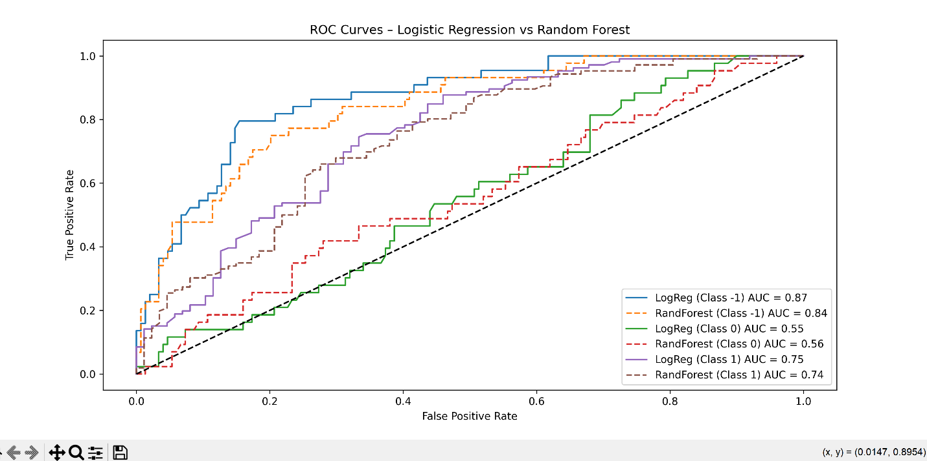

Plots True Positive Rate vs. False Positive Rate.
The closer the curve is to the top-left corner, the better the model performs.
3. Model Comparison (Explanation)
Random Forest achieved higher accuracy and better ROC-AUC scores, showing stronger performance on complex, non-linear relationships in football data. Logistic Regression, while easier to interpret, underperformed slightly.
Because Random Forest balances bias and variance effectively and detects feature interactions (like experience × ranking), it was chosen as the final predictive model. Its robustness makes it more practical for forecasting match outcomes where multiple factors influence results.
Task 4
1.Feature importance and interpretation:
Visualizations
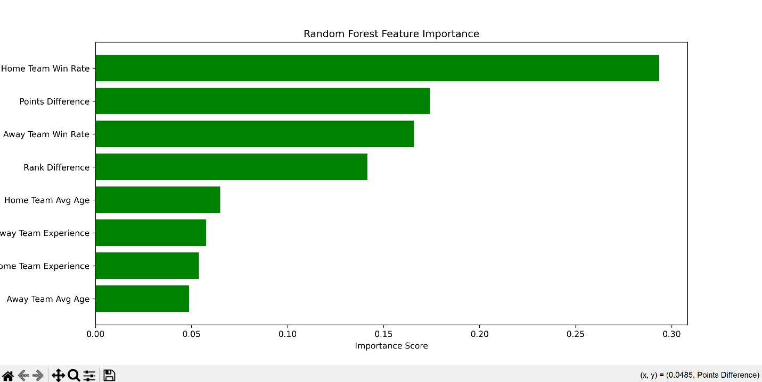
“The Random Forest feature importance plot visually confirms that Home Team Win Rate dominates, followed by Points Difference and Away Team Win Rate. Factors like Average Age and Experience have smaller importance scores, suggesting that current team performance outweighs historical or age-based factors.”

Feature Importance Table

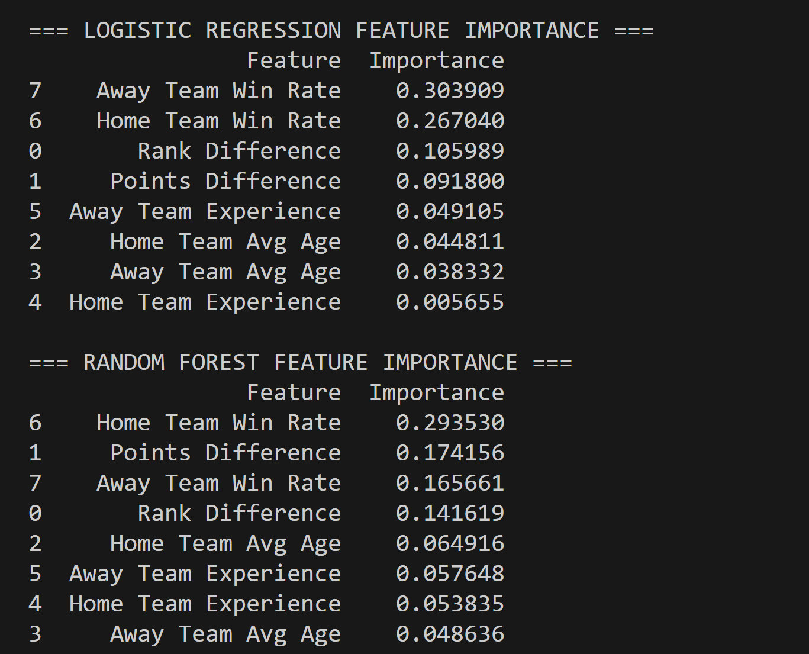
“According to both Logistic Regression and Random Forest outputs, Home Team Win Rate and Points Difference are the strongest predictors of match success. Random Forest additionally emphasized Rank Difference and Experience as secondary but valuable contributors, showing that consistent team form and ranking gaps influence outcomes significantly.”

2.Insights and Bias Discussion
During analysis, Rank Difference and Win Rate emerged as dominant predictors — confirming that higher-ranked teams usually perform better.
A bias was observed where both models predicted “Home Win” more often, suggesting a home advantage effect in the dataset.
Surprisingly, Average Age and Experience had less impact than expected, possibly because modern football emphasizes speed and tactics over experience.
This shows that the data and model might slightly favor historically stronger teams, introducing bias toward well-ranked nations.

