**1. Difference between linked list and array list?**

|  |  |
| --- | --- |
| Array List | List |
| **dynamic array** to store the elements. | **Doubly linked list** to store the elements. |
| An ArrayList class can **act as a list** only because it implements List only. | Linked List class can **act as a list and queue** both because it implements List and deque interfaces. |
| ArrayList is **better for storing and accessing** data. | Linked List is **better for manipulating** data. |
|  |
|  |  |

**2. What is Source File?**

A Java source file is a plain text file containing Java source code and having . java extension. The. java extension means that the file is the Java source file

**Example of SourceCode**

class College {

}

class Learning {

}

class Programming {

}

**3.What is Class file?**

A **Java class file** is a file containing Java bytecode and having **.class extension** that can be executed by JVM

.

Example for class

class DEMO

{

}

class Employee

{

}

class Testdemo

{

       public static void main(String[] args)

       {

           System.out.println(“Hello Everyone ");

       }

}

**4. What is jar file?**

A JAR file is a package file format typically used to aggregate many Java class files and associated metadata and resources into one file for distribution.

**Console application output**

**User Inserting**

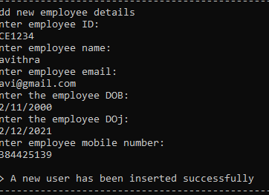

**User Details displaying**

