1.Find out the SELLING COST AVERAGE for the packages developed in PASCAL?

SELECT AVG (SCOST) FROM SOFTWARE WHERE DEV_IN LIKE 'PASCAL';

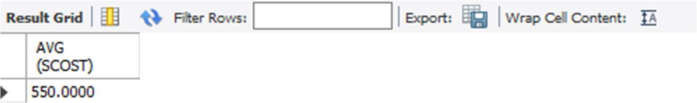

2.)What is the highest numbers of copies sold by a package?

SELECT MAX(scost) FROM SOFTWARE;

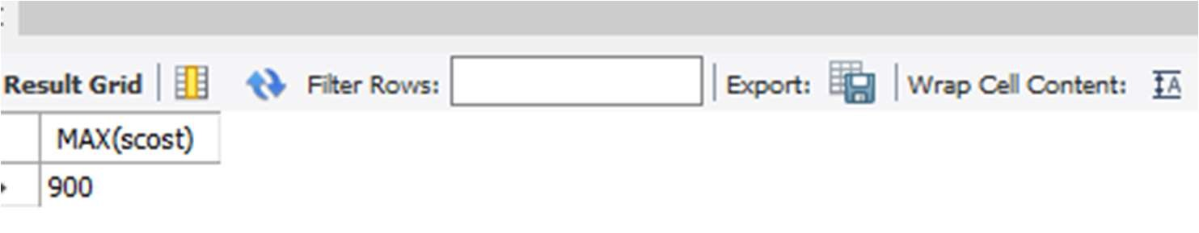

1. Display lowest course fee.

SELECT MIN(CCOST) FROM STUDIES;

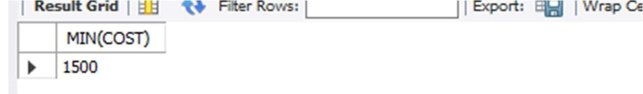

1. How many programmer has done PGDCA course.

SELECT COUNT (NAME) FROM STUDIES WHERE COURSE LIKE 'PGDCA';

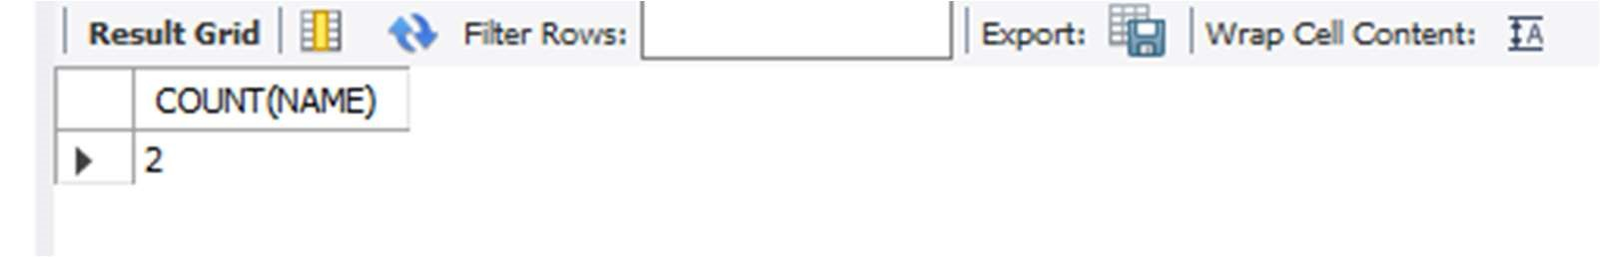

1. How much revenue has been earned through sales of packages in C.

SELECT SUM(SOLD*SCOST) FROM SOFTWARE WHERE DEV_IN LIKE 'C';

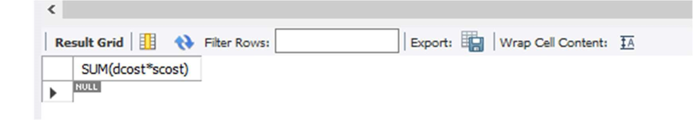 6)Display the details of software developed by Pavithra?

SELECT * FROM SOFTWARE WHERE NAME='Pavithra';

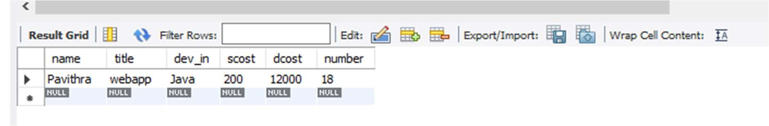

7)How many programmers studied at dcs.

SELECT COUNT(NAME) AS NOPROGRAMMERS FROM STUDIES WHERE SPLACE='dcs';

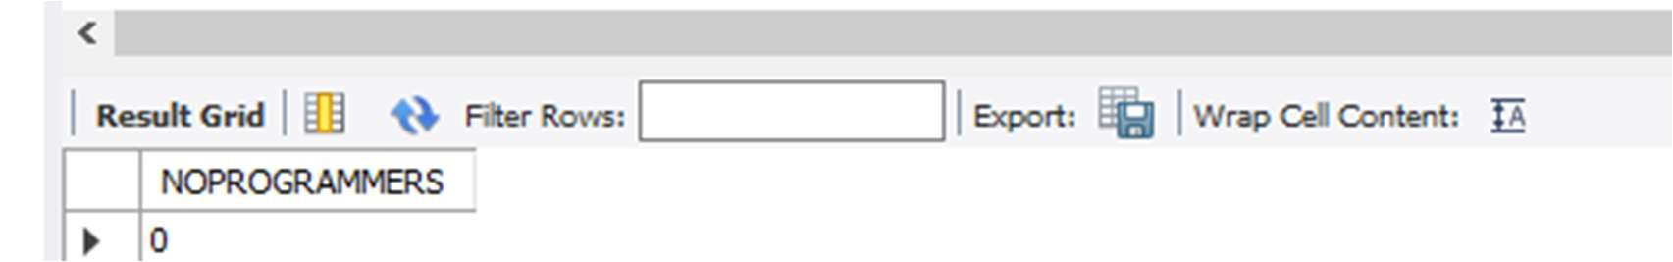

8) Display the details of PACKAGES whose sales crossed the 20000 mark.

SELECT * FROM SOFTWARE WHERE (SOLD*SCOST)>20000;

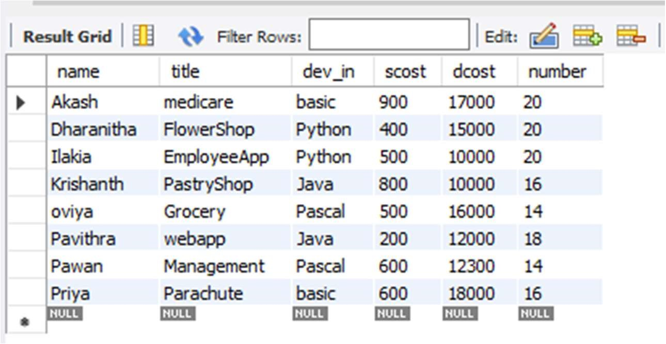

9)Find out the number of copies which should be sold in order to recover the development cost of each package.

SELECT ROUND(DCOST/SCOST) FROM SOFTWARE WHERE SCOST*SOLD<DCOST;

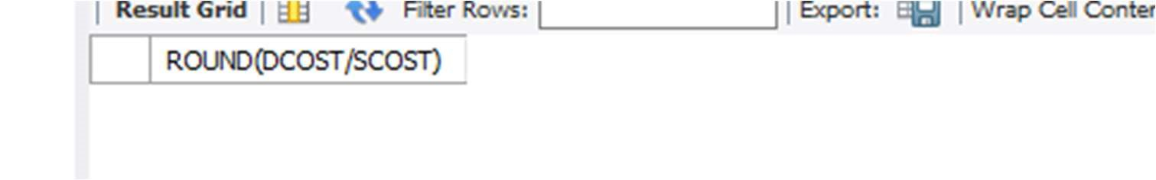

10)What is the price of the costliest software developed in BASIC?

SELECT MAX(SCOST) FROM SOFTWARE WHERE DEV_IN LIKE 'BASIC';

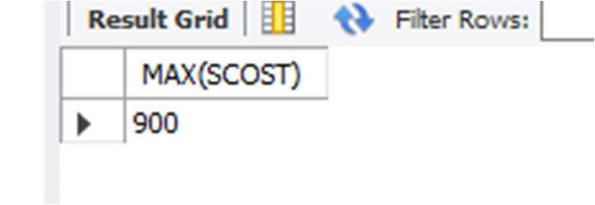

11)Display the details of packages for which development cost has been recovered.

SELECT * FROM SOFTWARE WHERE (*SCOST)>DCOST;

1. How many packages were developed in dbase?

SELECT COUNT (TITLE) AS TOTAL FROM SOFTWARE WHERE DEV_IN='DBASE'; SELECT * FROM SOFTWARE WHERE (number*SCOST)>DCOST;

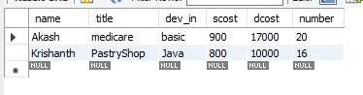

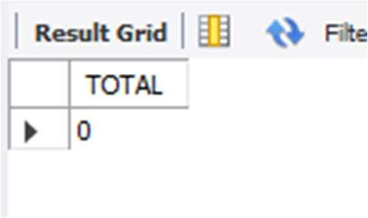

1. How many programmers studies at sabari?

SELECT COUNT(NAME) FROM STUDIES WHERE SPLACE='sabari';

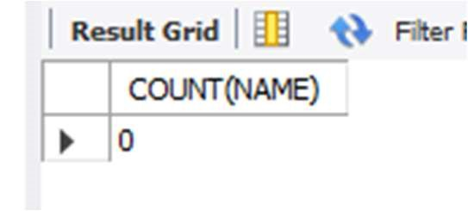

14)How many programmers paid 5000 to 10000 for their course?

SELECT COUNT(NAME) AS NO_OF_PROGRAMMERS FROM STUDIES WHERE CCOST>=5000 AND

CCOST<=10000;

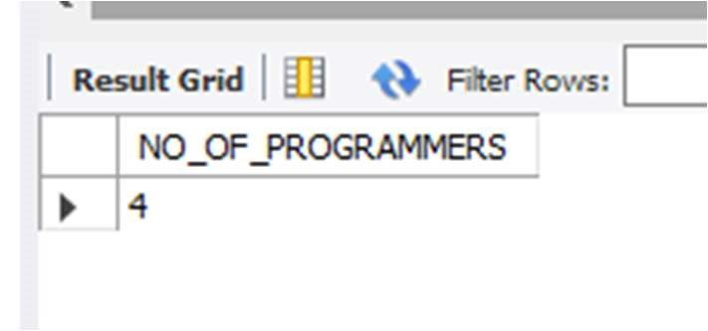

1. What is the average course fee?

SELECT AVG (COST) AS AVERAGECOST FROM STUDIES;

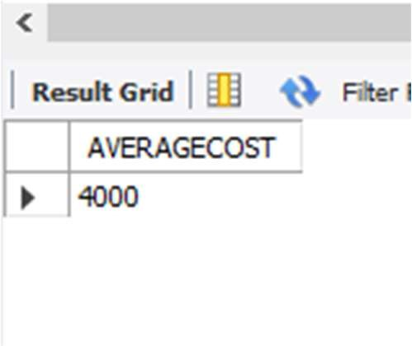

1. Display the details of programmers knowing c?

SELECT * FROM PROGRAMMER WHERE PROF1='C' OR PROF2='C';

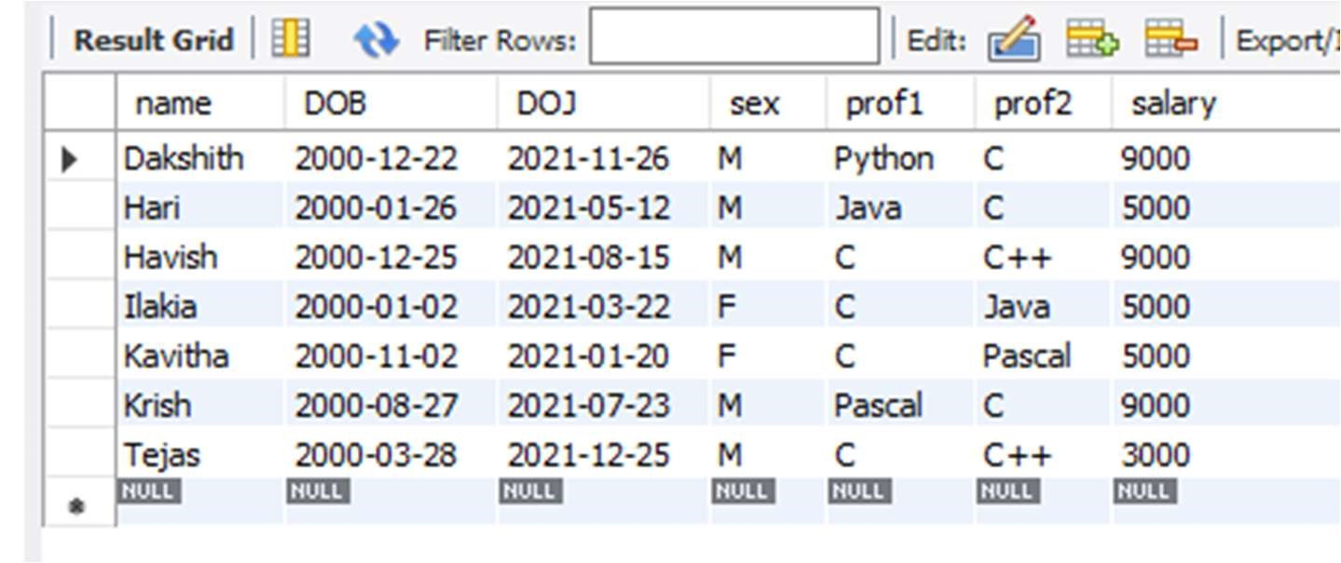

17)How many female programmers are there?

SELECT COUNT (NAME) FEMALE_PROG FROM PROGRAMMER WHERE SEX='F';

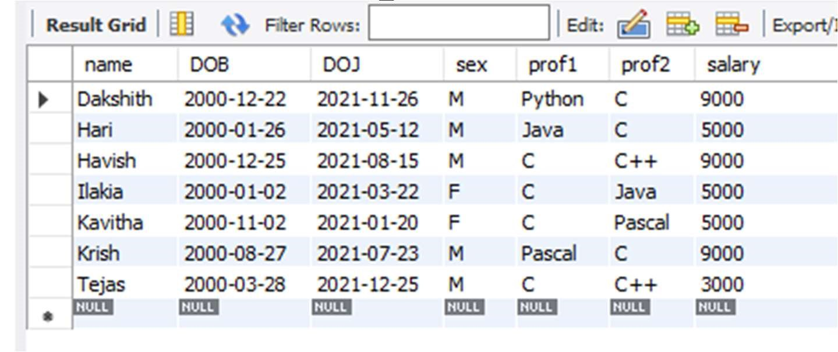

18)What is the Average salary?

SELECT AVG (SALARY) AS AVGSAL FROM PROGRAMMER;

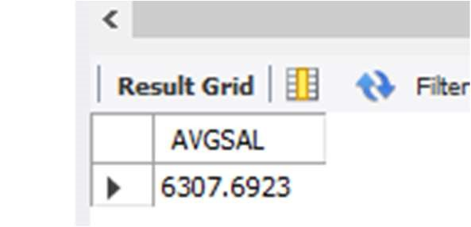

19)How many people draw 2000 to 4000?

SELECT NAME FROM PROGRAMMER WHERE SALARY BETWEEN 2000 AND 4000;

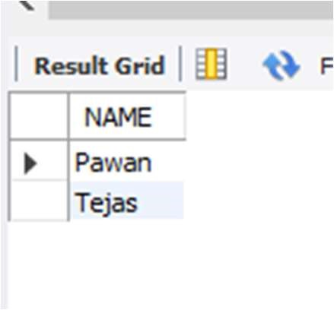

20)Display the title, scost, dcost and difference between scost and dcost in descending order of difference?

SELECT TITLE, SCOST, DCOST, DCOST -SCOST DIFF FROM SOFTWARE ORDER BY

4 DESC;

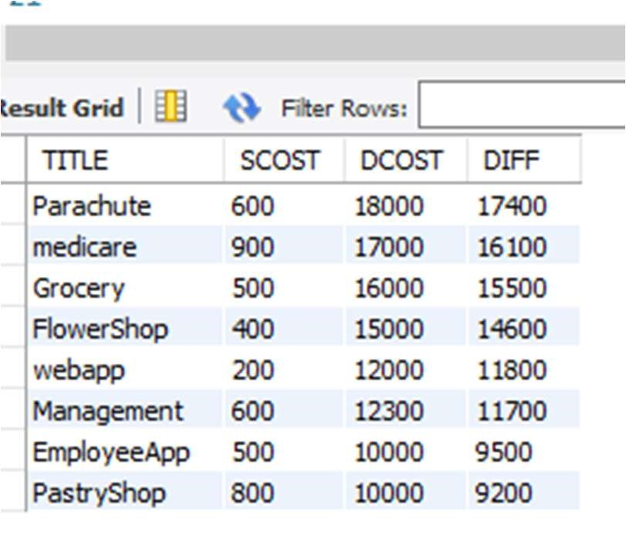

1. Who are the programmers who were born on the last day of the month?

SELECT NAME FROM PROGRAMMER WHERE LAST_DAY(DOB) = DOB;

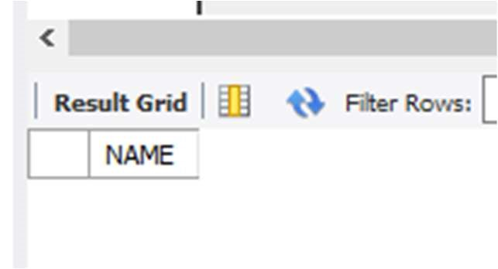

1. Display the name,sex,dob(DD/MM/YY format), doj for all the programmers without using conversion function?

SELECT NAME, SEX ,

SUBSTR(DOB,1,2)||'/'||SUBSTR(DOB,4,3)||'/'||SUBSTR(DOB,8,2) DOB,

SUBSTR(DOJ,1,2)||'/'||SUBSTR(DOJ,4,3)||'/'||SUBSTR(DOJ,8,2) DOJ FROM

PROGRAMMER;

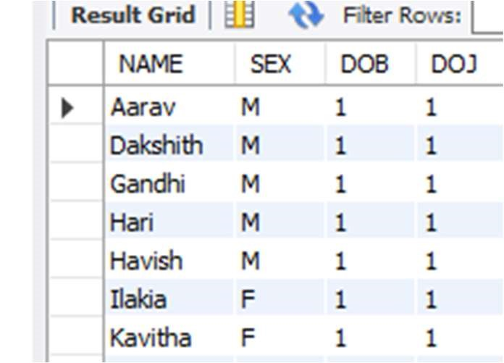

1. Display the names of the packages whose names contain more than 1 word?

SELECT TITLE FROM SOFTWARE WHERE TITLE LIKE '% %';

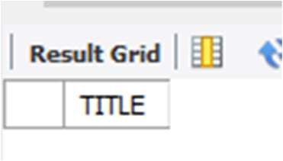

1. What is the length of the shortest name in the programmer table?

SELECT MIN(LENGTH(NAME)) FROM PROGRAMMER;

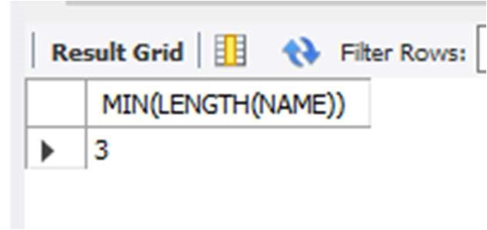

25)Display the names of programmers whose names contain upto 5 characters?

SELECT NAME FROM PROGRAMMER WHERE LENGTH(NAME)=5;

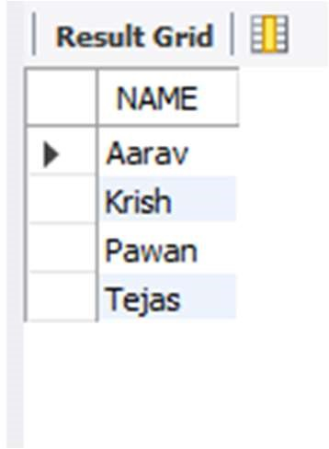

1. Display the names of the programmers whose names contain 2 occurrences of the letter A?

SELECT NAME FROM PROGRAMMER WHERE NAME LIKE '%A%A%';

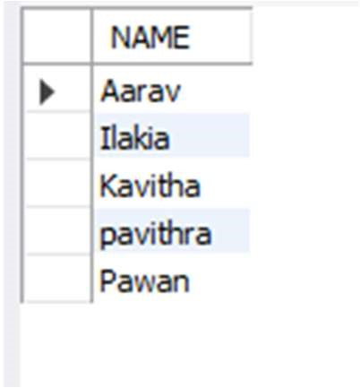

1. How many different courses are mentioned in the studies table?

SELECT DISTINCT COURSE FROM STUDIES;

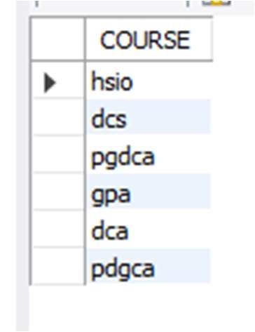

1. Display the institutes names from the studies table without duplicates?

SELECT DISTINCT SPLACE FROM STUDIES;

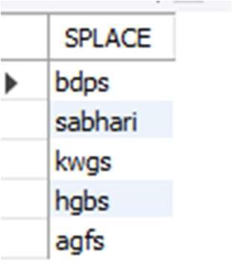

1. Display the details of those who don't know Clipper, Cobol or Pascal?

SELECT * FROM PROGRAMMER WHERE PROF1 NOT IN ('CLIPPER','COBOL','PASCAL') AND PROF2 NOT IN ('CLIPPER','COBOL','PASCAL');

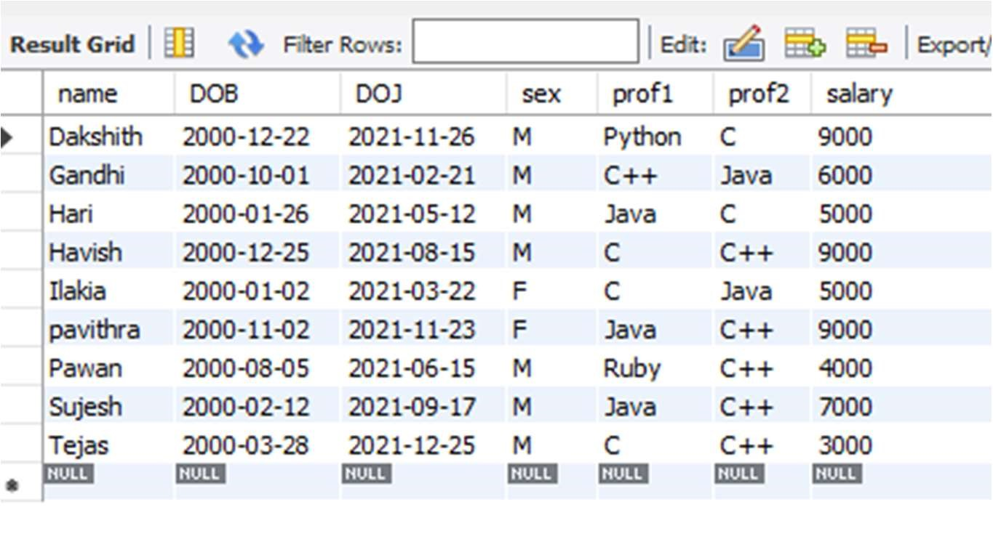

1. How many female programmers are there?

SELECT COUNT (NAME) FEMALE_PROG FROM PROGRAMMER WHERE SEX='F';

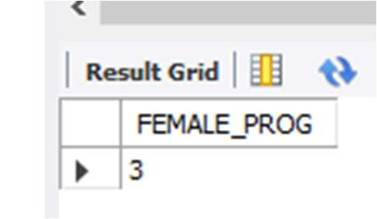

31)How many programmers don't know Pascal & C?

SELECT COUNT (NAME) AS PROGRAMMERS FROM PROGRAMMER WHERE PROF1 NOT IN

('C','PASCAL')

AND PROF2 NOT IN ('C','PASCAL');

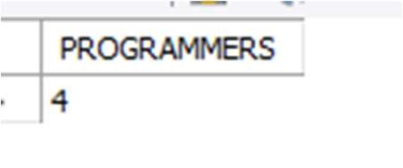

32)Who is the highest paid C programmer?

SELECT * FROM PROGRAMMER WHERE SALARY=(SELECT MAX(SALARY) FROM PROGRAMMER WHERE PROF1 LIKE 'C' OR PROF2 LIKE 'C');

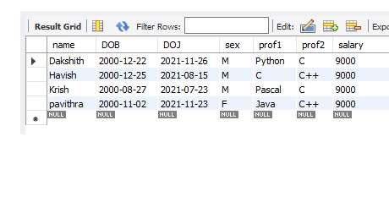

33)Who is the highest paid female cobol programmer?

SELECT * FROM PROGRAMMER WHERE SALARY=(SELECT MAX(SALARY) FROM PROGRAMMER

WHERE (PROF1 LIKE 'COBOL' OR PROF2 LIKE 'COBOL')) AND SEX LIKE 'F';

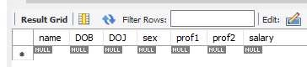

34)Display the name of the HIGEST paid programmer for EACH language (prof1)

SELECT DISTINCT NAME, SALARY, PROF1 FROM PROGRAMMER WHERE (SALARY,PROF1) IN

(SELECT MAX(SALARY),PROF1 FROM PROGRAMMER GROUP BY PROF1);

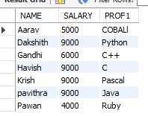

6) Which language is known by ONLY ONE programmer?

SELECT PROF1 FROM PROGRAMMER GROUP BY PROF1 HAVING PROF1 NOT IN (SELECT

PROF2 FROM PROGRAMMER) AND COUNT(PROF1)=1 UNION SELECT PROF2 FROM

PROGRAMMER GROUP BY PROF2 HAVING PROF2 NOT IN (SELECT PROF1 FROM

PROGRAMMER) AND COUNT(PROF2)=1;

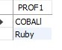

1. Which female programmer earns MORE than 3000/- but DOES NOT know C, C++, Oracle or Dbase?

SELECT * FROM PROGRAMMER WHERE SEX = 'F' AND SALARY >3000 AND (PROF1 NOT

IN('C','C++','ORACLE','DBASE') OR PROF2 NOT

IN('C','C++','ORACLE','DBASE'));

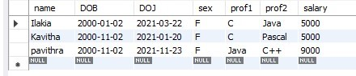

1. Which is the COSTLIEST course?

SELECT COURSE FROM STUDIES WHERE CCOST = (SELECT MAX(CCOST) FROM STUDIES);



1. Display name of the institute and course Which has below AVERAGE course fee?

SELECT SPLACE,COURSE FROM STUDIES WHERE CCOST < (SELECT AVG(CCOST) FROM

STUDIES);

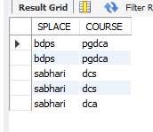

1. Which institute conducts COSTLIEST course?

SELECT SPLACE FROM STUDIES WHERE CCOST = (SELECT MAX(CCOST) FROM

STUDIES);

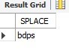

Who are the male programmers earning BELOW the AVERAGE salary of female programmers?

SELECT NAME FROM PROGRAMMER WHERE SEX = 'M' AND SALARY <

(SELECT(AVG(SALARY))FROM PROGRAMMER WHERE SEX = 'F');

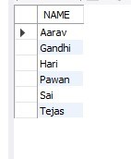

3) Display THE NUMBER OF male and female programmer.

SELECT SEX,COUNT(NAME) FROM PROGRAMMER GROUP BY SEX;

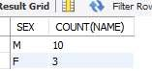

Display THE COSTLIEST packages and HIGEST selling developed in EACH language.

SELECT DEV_IN,MAX(SCOST),MAX(dcost) FROM SOFTWARE GROUP BY DEV_IN;

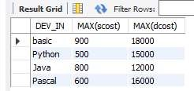

Display THE NUMBER OF people BORN in EACH YEAR.

SELECT TO_CHAR(DOB,'YY') AS YEAR,COUNT(NAME) FROM PROGRAMMER GROUP BY

TO_CHAR(DOB,'YY');

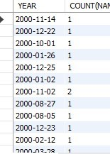

1. Display THE NUMBER OF people JOINED in EACH YEAR.

SELECT TO_CHAR(DOJ,'YY') AS YEAR,COUNT(NAME) FROM PROGRAMMER GROUP BY

TO_CHAR(DOJ,'YY');

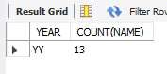

1. Display THE NUMBER OF people BORN in EACH MONTH.

SELECT SUBSTR(DOB,4,3),COUNT(NAME) FROM PROGRAMMER GROUP BY SUBSTR(DOB,4,3);

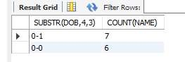

1. Display the language wise COUNTS of prof1.

SELECT PROF1, COUNT(PROF1) FROM PROGRAMMER GROUP BY PROF1;

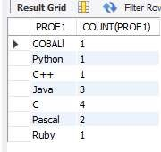

1. Display the language wise COUNTS of prof2.

SELECT PROF2, COUNT(PROF2) FROM PROGRAMMER GROUP BY PROF2;

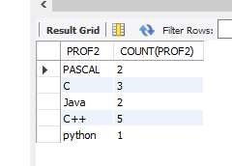

1. Display THE NUMBER OF people in EACH salary group.

SELECT SALARY,COUNT(NAME) FROM PROGRAMMER GROUP BY SALARY;

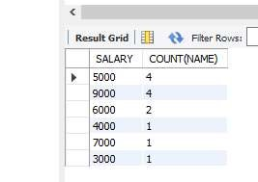

1. Display THE NUMBER OF people who studied in EACH institute.

SELECT SPLACE,COUNT(NAME) FROM STUDIES GROUP BY SPLACE;

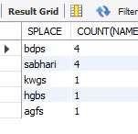

1. Display THE NUMBER OF people who studied in EACH course.

SELECT COURSE ,COUNT(NAME) FROM STUDIES GROUP BY COURSE;

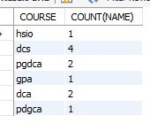

1. Display the TOTAL development COST of the packages developed in EACH language.

SELECT DEV_IN LANG,SUM(DCOST) TOTAL_COST FROM SOFTWARE GROUP BY

DEV_IN;

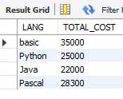

16) Display the cost of the package developed by EACH programmer.

SELECT NAME,SUM(DCOST) AS TOTAL_COST FROM SOFTWARE GROUP BY NAME;

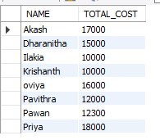

1. Display the NUMBER of packages developed by EACH programmer.

SELECT NAME,COUNT(TITLE) AS TOTAL_PACK FROM SOFTWARE GROUP BY NAME;

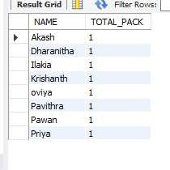

1. Display the sales COST of packages developed by EACH programmer language wise.

SELECT DEV_IN, SUM(SCOST) FROM SOFTWARE GROUP BY DEV_IN;

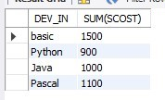

1. Display EACH programmers name,costliest package,cheapest packages developed by His/Her?

SELECT NAME,MIN(DCOST),MAX(DCOST) FROM SOFTWARE GROUP BY NAME;

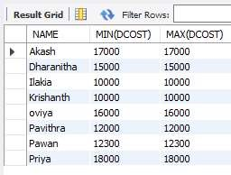

1. Display EACH language name with AVERAGE development cost, AVERAGE cost, selling cost and AVERAGE price per copy.

SELECT DEV_IN,AVG(DCOST),AVG(SCOST),AVG(SCOST) FROM SOFTWARE GROUP BY DEV_IN;

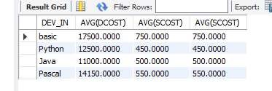

1. Display EACH institute name with NUMBER of courses, AVERAGE cost per course.

SELECT SPLACE,COUNT(COURSE), AVG(CCOST) FROM STUDIES GROUP BY SPLACE;

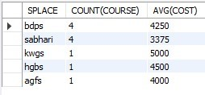

1. Display EACH institute name with NUMBER of students.

SELECT SPLACE,COUNT(NAME) FROM STUDIES GROUP BY SPLACE;

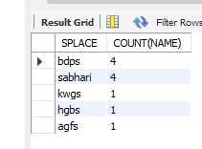

1. Display names of male and female programmers.

SELECT NAME,SEX FROM PROGRAMMER ORDER BY SEX;

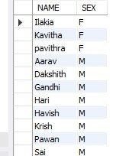

1. Display the programmer's name and their packages.

SELECT NAME,TITLE FROM SOFTWARE ORDER BY NAME;

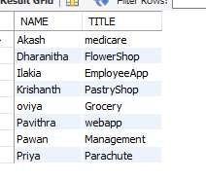

1. Display the NUMBER of packages in EACH language.

SELECT COUNT(TITLE),DEV_IN FROM SOFTWARE GROUP BY DEV_IN;

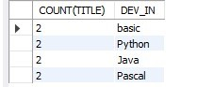

1. Display the NUMBER of packages in EACH language for which development cost is less than 1000.

SELECT COUNT(TITLE),DEV_IN FROM SOFTWARE WHERE DCOST<1000 GROUP BY DEV_IN;

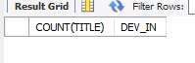

1. Display the AVERAGE difference BETWEEN scost and dcost for EACH language.

SELECT DEV_IN,AVG(DCOST - SCOST) FROM SOFTWARE GROUP BY DEV_IN;

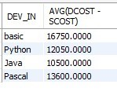

1. Display the TOTAL scost, dcsot and amount TOBE recovered for EACH programmer for whose dcost HAS NOT YET BEEN recovered.

SELECT SUM(SCOST), SUM(DCOST), SUM(DCOST-(SOLD*SCOST)) FROM SOFTWARE

GROUP BY NAME

HAVING SUM(DCOST)>SUM(SOLD*SCOST);



1. Display highest, lowest and average salaries for THOSE earning MORE than 2000.

SELECT MAX(SALARY), MIN(SALARY), AVG(SALARY) FROM PROGRAMMER WHERE

SALARY > 2000;

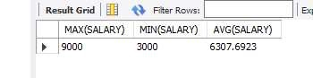

1) Who is the highest paid C programmer?

SELECT * FROM PROGRAMMER WHERE SALARY=(SELECT MAX(SALARY) FROM PROGRAMMER

WHERE PROF1 LIKE 'C' OR PROF2 LIKE 'C');

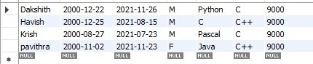

1. Display the name of the HIGEST paid programmer for EACH language (prof1) SELECT DISTINCT NAME, SALARY, PROF1 FROM PROGRAMMER WHERE (SALARY,PROF1) IN (SELECT MAX(SALARY),PROF1 FROM PROGRAMMER GROUP BY PROF1);

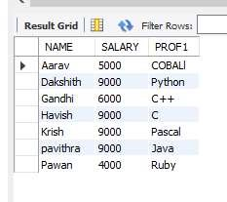

1. Who is the LEAST experienced programmer?

SELECT name FROM PROGRAMMER WHERE

FLOOR(DATEDIFF(CURRENT_TIMESTAMP,DOJ)/365)1;

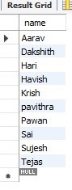

6) Which language is known by ONLY ONE programmer?

SELECT PROF1 FROM PROGRAMMER GROUP BY PROF1 HAVING PROF1 NOT IN (SELECT

PROF2 FROM PROGRAMMER) AND COUNT(PROF1)=1 UNION SELECT PROF2 FROM

PROGRAMMER GROUP BY PROF2 HAVING PROF2 NOT IN (SELECT PROF1 FROM

PROGRAMMER) AND COUNT(PROF2)=1;

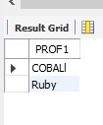

1. Which female programmer earns MORE than 3000/- but DOES NOT know C, C++, Oracle or Dbase?

SELECT * FROM PROGRAMMER WHERE SEX = 'F' AND SALARY >3000 AND (PROF1 NOT

IN('C','C++','ORACLE','DBASE') OR PROF2 NOT

IN('C','C++','ORACLE','DBASE'));

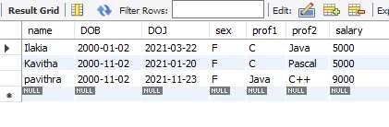

1. Which is the COSTLIEST course?

SELECT COURSE FROM STUDIES WHERE CCOST = (SELECT MAX(CCOST) FROM STUDIES);



1. Display name of the institute and course Which has below AVERAGE course fee?

SELECT SPLACE,COURSE FROM STUDIES WHERE CCOST < (SELECT AVG(CCOST) FROM

STUDIES); 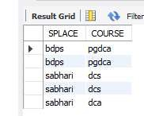

1. Which institute conducts COSTLIEST course?

SELECT SPLACE FROM STUDIES WHERE CCOST = (SELECT MAX(CCOST) FROM

STUDIES);

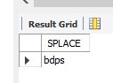

1. Display names of the course WHOSE fees are within 1000(+ or -) of the AVERAGE fee.

SELECT COURSE FROM STUDIES WHERE CCOST < (SELECT AVG(CCOST)+1000 FROM

STUDIES) AND CCOST > (SELECT AVG(CCOST)-1000 FROM STUDIES);

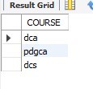

1. Which package has the HIGEST development cost?

SELECT TITLE,DCOST FROM SOFTWARE WHERE DCOST = (SELECT MAX(DCOST) FROM

SOFTWARE);



1. Which package has the LOWEST selling cost?

SELECT TITLE,SCOST FROM SOFTWARE WHERE SCOST = (SELECT MIN(SCOST) FROM

SOFTWARE);

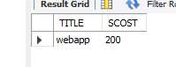

1. Who developed the package, which has sold the LEAST number of copies?

SELECT NAME,SOLD FROM SOFTWARE WHERE SOLD = (SELECT MIN(SOLD) FROM

SOFTWARE);

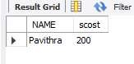

1. Which language was used to develop the package WHICH has the HIGEST sales amount?

SELECT DEV_IN,SCOST FROM SOFTWARE WHERE SCOST = (SELECT MAX(SCOST) FROM

SOFTWARE);

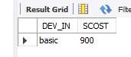

1. Which is the COSTLIEAST package developed in PASCAL?

SELECT TITLE FROM SOFTWARE WHERE DCOST = (SELECT MAX(DCOST) FROM SOFTWARE

WHERE DEV_IN LIKE 'PASCAL');

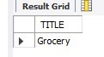

1. Which language was used to develop the MOST NUMBER of package?

SELECT DEV_IN FROM SOFTWARE GROUP BY DEV_IN HAVING MAX(DEV_IN) = (SELECT

MAX(DEV_IN) FROM SOFTWARE);

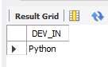

1. Which programmer has developed the HIGEST NUMBER of package?

SELECT NAME FROM SOFTWARE GROUP BY NAME HAVING MAX(NAME) = (SELECT

MAX(NAME) FROM SOFTWARE);



1. Who is the author of the COSTLIEST package?

SELECT NAME,DCOST FROM SOFTWARE WHERE DCOST = (SELECT MAX(DCOST)

FROM SOFTWARE);



1. Display names of packages WHICH have been sold LESS THAN the AVERAGE number of copies?

SELECT TITLE FROM SOFTWARE WHERE SOLD < (SELECT AVG(SOLD) FROM SOFTWARE);

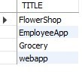

1. Which language has been stated as prof1 by MOST of the programmers?

SELECT PROF1 FROM PROGRAMMER GROUP BY PROF1 HAVING PROF1 = (SELECT

MAX(PROF1) FROM PROGRAMMER);

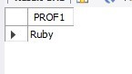

1. Who are the authors of packages, WHICH have recovered MORE THAN double the development cost?

SELECT NAME FROM SOFTWARE WHERE SOLD*SCOST > 2*DCOST;

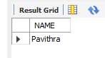

1. Display programmer names and CHEAPEST package developed by them in EACH language?

SELECT NAME,TITLE FROM SOFTWARE WHERE DCOST IN (SELECT MIN(DCOST) FROM

SOFTWARE GROUP BY DEV_IN);

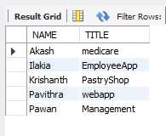

1. Display language used by EACH programmer to develop the HIGEST selling and LOWEST selling package.

SELECT NAME, DEV_IN FROM SOFTWARE WHERE SOLD IN (SELECT MAX(SOLD) FROM

SOFTWARE GROUP BY NAME) UNION SELECT NAME, DEV_IN FROM SOFTWARE WHERE SOLD

IN (SELECT MIN(SOLD) FROM SOFTWARE GROUP BY NAME);

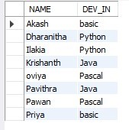

37) Who are the male programmers earning BELOW the AVERAGE salary of female programmers?

SELECT NAME FROM PROGRAMMER WHERE SEX = 'M' AND SALARY < (SELECT(AVG(SALARY))FROM PROGRAMMER WHERE SEX = 'F');

