1.Find out the SELLING COST AVERAGE for the packages developed in PASCAL?

SELECT AVG (SCOST) FROM SOFTWARE WHERE DEV_IN LIKE 'PASCAL';

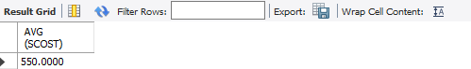

2.)What is the highest numbers of copies sold by a package?

SELECT MAX(scost) FROM SOFTWARE;

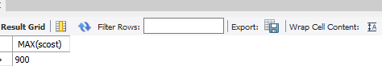

3) Display lowest course fee.

SELECT MIN(CCOST) FROM STUDIES;



4) How many programmer has done PGDCA course.

      SELECT COUNT (NAME) FROM STUDIES WHERE COURSE LIKE 'PGDCA';

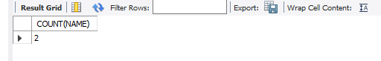

5) How much revenue has been earned through sales of packages in C.

      SELECT SUM(SOLD*SCOST) FROM SOFTWARE WHERE DEV_IN LIKE 'C';

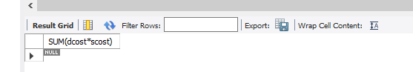

6)Display the details of software developed by Pavithra?

      SELECT * FROM SOFTWARE WHERE NAME='Pavithra';

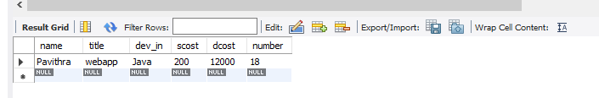

7)How many programmers studied at dcs.

      SELECT COUNT(NAME) AS NOPROGRAMMERS FROM STUDIES WHERE SPLACE='dcs';

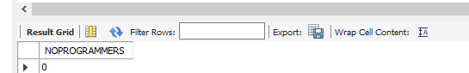

8) Display the details of PACKAGES whose sales crossed the 20000 mark.

      SELECT * FROM SOFTWARE WHERE (SOLD*SCOST)>20000;

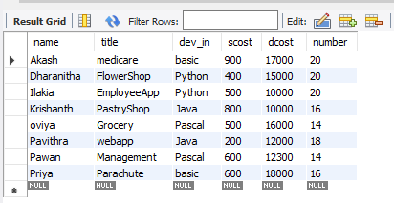

9)Find out the number of copies which should be sold in order to recover the development cost of each package.

      SELECT ROUND(DCOST/SCOST) FROM SOFTWARE WHERE SCOST*SOLD<DCOST;

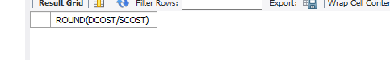

 10)What is the price of the costliest software developed in BASIC?

SELECT MAX(SCOST) FROM SOFTWARE WHERE DEV_IN LIKE 'BASIC';

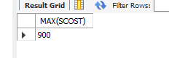

11)Display the details of packages for which development cost has been recovered.

 SELECT * FROM SOFTWARE WHERE (*SCOST)>DCOST;

12) How many packages were developed in dbase?

SELECT COUNT (TITLE) AS TOTAL FROM SOFTWARE WHERE DEV_IN='DBASE';

SELECT * FROM SOFTWARE WHERE (number*SCOST)>DCOST;

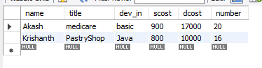

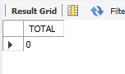

13) How many programmers studies at sabari?

      SELECT COUNT(NAME) FROM STUDIES WHERE SPLACE='sabari';

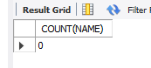

 14)How many programmers paid 5000 to 10000 for their course?

SELECT COUNT(NAME) AS NO_OF_PROGRAMMERS FROM STUDIES WHERE CCOST>=5000 AND CCOST<=10000;

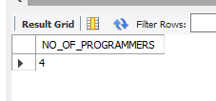

15) What is the average course fee?

SELECT AVG (COST) AS AVERAGECOST FROM STUDIES;

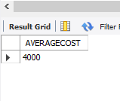

16) Display the details of programmers knowing c?

SELECT * FROM PROGRAMMER WHERE PROF1='C' OR PROF2='C';

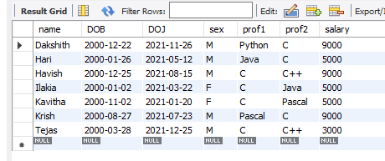

 17)How many female programmers are there?

SELECT COUNT (NAME) FEMALE_PROG FROM PROGRAMMER WHERE SEX='F';



 18)What is the Average salary?

      SELECT AVG (SALARY) AS AVGSAL FROM PROGRAMMER;

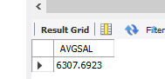

19)How many people draw 2000 to 4000?

      SELECT NAME FROM PROGRAMMER WHERE SALARY BETWEEN 2000 AND 4000;

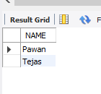

 20)Display the title, scost, dcost and difference between scost and dcost in descending order of

difference?

SELECT TITLE, SCOST, DCOST, DCOST -SCOST DIFF FROM SOFTWARE ORDER BY 4 DESC;

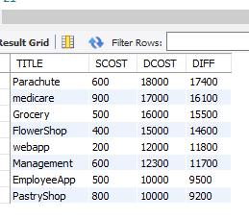

21) Who are the programmers who were born on the last day of the month?

      SELECT NAME FROM PROGRAMMER WHERE LAST_DAY(DOB) = DOB;

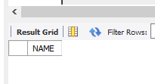

22) Display the name,sex,dob(DD/MM/YY format), doj for all the programmers without using

conversion function?

      SELECT NAME, SEX , SUBSTR(DOB,1,2)||'/'||SUBSTR(DOB,4,3)||'/'||SUBSTR(DOB,8,2) DOB, SUBSTR(DOJ,1,2)||'/'||SUBSTR(DOJ,4,3)||'/'||SUBSTR(DOJ,8,2) DOJ FROM PROGRAMMER;

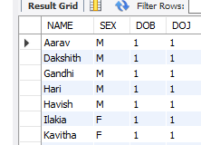

23) Display the names of the packages whose names contain more than 1 word?

      SELECT TITLE FROM SOFTWARE WHERE TITLE LIKE '% %';



24) What is the length of the shortest name in the programmer table?

      SELECT MIN(LENGTH(NAME)) FROM PROGRAMMER;

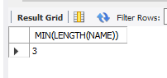

25)Display the names of programmers whose names contain upto 5 characters?

      SELECT NAME FROM PROGRAMMER WHERE LENGTH(NAME)=5;

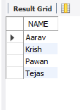

26) Display the names of the programmers whose names contain 2 occurrences of the letter A?

      SELECT NAME FROM PROGRAMMER WHERE NAME LIKE '%A%A%';

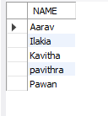

27) How many different courses are mentioned in the studies table?

      SELECT DISTINCT COURSE FROM STUDIES;

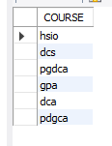

28) Display the institutes names from the studies table without duplicates?

      SELECT DISTINCT SPLACE FROM STUDIES;

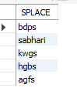

29)  Display the details of those who don't know Clipper, Cobol or Pascal?

SELECT * FROM PROGRAMMER WHERE PROF1 NOT IN ('CLIPPER','COBOL','PASCAL') AND PROF2 NOT IN ('CLIPPER','COBOL','PASCAL');

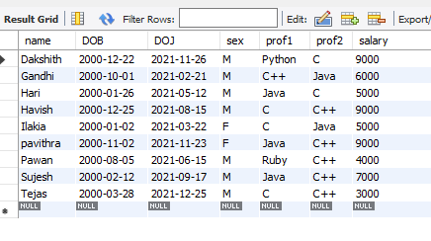

30) How many female programmers are there?

      SELECT COUNT (NAME) FEMALE_PROG FROM PROGRAMMER WHERE SEX='F';

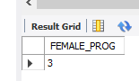

31)How many programmers don't know Pascal & C?

 SELECT COUNT (NAME) AS PROGRAMMERS FROM PROGRAMMER WHERE PROF1 NOT IN ('C','PASCAL')

AND PROF2 NOT IN ('C','PASCAL');



32)Who is the highest paid C programmer?

SELECT * FROM PROGRAMMER WHERE SALARY=(SELECT MAX(SALARY) FROM PROGRAMMER WHERE PROF1 LIKE 'C' OR PROF2 LIKE 'C');

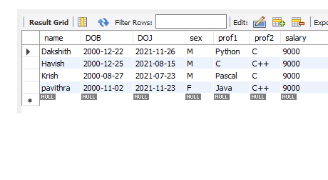

33)Who is the highest paid female cobol programmer?

SELECT * FROM PROGRAMMER WHERE SALARY=(SELECT MAX(SALARY) FROM PROGRAMMER WHERE (PROF1 LIKE 'COBOL' OR PROF2 LIKE 'COBOL')) AND SEX LIKE 'F';

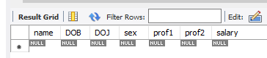

34)Display the name of the HIGEST paid programmer for EACH language (prof1)

SELECT DISTINCT NAME, SALARY, PROF1 FROM PROGRAMMER WHERE (SALARY,PROF1) IN (SELECT MAX(SALARY),PROF1 FROM PROGRAMMER GROUP BY PROF1);

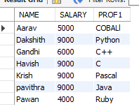

6) Which language is known by ONLY ONE programmer?

SELECT PROF1 FROM PROGRAMMER GROUP BY PROF1 HAVING PROF1 NOT IN (SELECT PROF2 FROM PROGRAMMER) AND COUNT(PROF1)=1 UNION SELECT PROF2 FROM PROGRAMMER GROUP BY PROF2 HAVING PROF2 NOT IN (SELECT PROF1 FROM PROGRAMMER) AND COUNT(PROF2)=1;

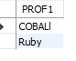

9) Which female programmer earns MORE than 3000/- but DOES NOT know C, C++, Oracle or Dbase?

SELECT * FROM PROGRAMMER WHERE SEX = 'F' AND SALARY >3000 AND (PROF1 NOT IN('C','C++','ORACLE','DBASE') OR PROF2 NOT IN('C','C++','ORACLE','DBASE'));

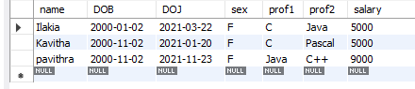

10) Which is the COSTLIEST course?

SELECT COURSE FROM STUDIES WHERE CCOST = (SELECT MAX(CCOST) FROM STUDIES);



12) Display name of the institute and course Which has below AVERAGE course fee?

SELECT SPLACE,COURSE FROM STUDIES WHERE CCOST < (SELECT AVG(CCOST) FROM STUDIES);

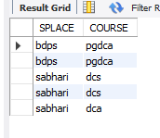

13) Which institute conducts COSTLIEST course?

      SELECT SPLACE FROM STUDIES WHERE CCOST = (SELECT MAX(CCOST) FROM STUDIES);

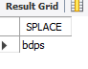

Who are the male programmers earning BELOW the AVERAGE salary of female

programmers?

SELECT NAME FROM PROGRAMMER WHERE SEX = 'M' AND SALARY < (SELECT(AVG(SALARY))FROM PROGRAMMER WHERE SEX = 'F');

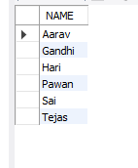

3) Display THE NUMBER OF male and female programmer.

      SELECT SEX,COUNT(NAME) FROM PROGRAMMER GROUP BY SEX;

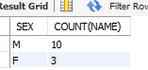

Display THE COSTLIEST packages and HIGEST selling developed in EACH language.

 SELECT DEV_IN,MAX(SCOST),MAX(dcost) FROM SOFTWARE GROUP BY DEV_IN;

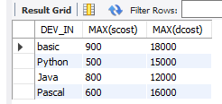

Display THE NUMBER OF people BORN in EACH YEAR.

SELECT TO_CHAR(DOB,'YY') AS YEAR,COUNT(NAME) FROM PROGRAMMER GROUP BY TO_CHAR(DOB,'YY');

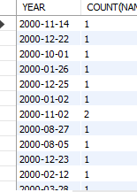

6) Display THE NUMBER OF people JOINED in EACH YEAR.

SELECT TO_CHAR(DOJ,'YY') AS YEAR,COUNT(NAME) FROM PROGRAMMER GROUP BY TO_CHAR(DOJ,'YY');

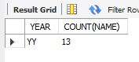

7) Display THE NUMBER OF people BORN in EACH MONTH.

      SELECT SUBSTR(DOB,4,3),COUNT(NAME) FROM PROGRAMMER GROUP BY SUBSTR(DOB,4,3);

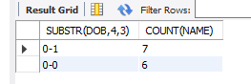

9) Display the language wise COUNTS of prof1.

      SELECT PROF1, COUNT(PROF1) FROM PROGRAMMER GROUP BY PROF1;

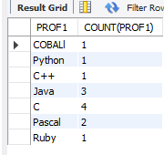

10) Display the language wise COUNTS of prof2.

      SELECT PROF2, COUNT(PROF2) FROM PROGRAMMER GROUP BY PROF2;

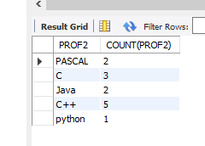

11) Display THE NUMBER OF people in EACH salary group.

      SELECT SALARY,COUNT(NAME) FROM PROGRAMMER GROUP BY SALARY;

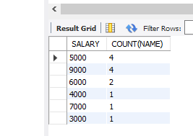

12) Display THE NUMBER OF people who studied in EACH institute.

      SELECT SPLACE,COUNT(NAME) FROM STUDIES GROUP BY SPLACE;

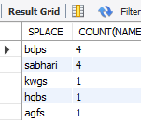

13) Display THE NUMBER OF people who studied in EACH course.

      SELECT COURSE ,COUNT(NAME) FROM STUDIES GROUP BY COURSE;

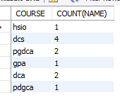

14) Display the TOTAL development COST of the packages developed in EACH language.

      SELECT DEV_IN LANG,SUM(DCOST) TOTAL_COST FROM SOFTWARE GROUP BY DEV_IN;

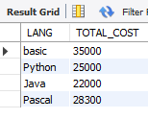

16) Display the cost of the package developed by EACH programmer.

      SELECT NAME,SUM(DCOST) AS TOTAL_COST FROM SOFTWARE GROUP BY NAME;

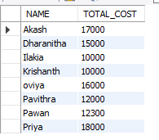

18) Display the NUMBER of packages developed by EACH programmer.

      SELECT NAME,COUNT(TITLE) AS TOTAL_PACK FROM SOFTWARE GROUP BY NAME;

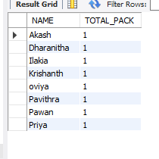

19) Display the sales COST of packages developed by EACH programmer language wise.

      SELECT DEV_IN, SUM(SCOST) FROM SOFTWARE GROUP BY DEV_IN;

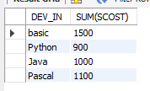

20) Display EACH programmers name,costliest package,cheapest packages developed by His/Her?

      SELECT NAME,MIN(DCOST),MAX(DCOST) FROM SOFTWARE GROUP BY NAME;

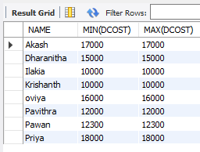

21) Display EACH language name with AVERAGE development cost, AVERAGE cost, selling

cost and AVERAGE price per copy.

      SELECT DEV_IN,AVG(DCOST),AVG(SCOST),AVG(SCOST) FROM SOFTWARE GROUP BY DEV_IN;

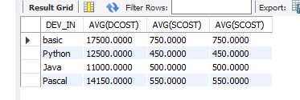

22) Display EACH institute name with NUMBER of courses, AVERAGE cost per course.

      SELECT SPLACE,COUNT(COURSE), AVG(CCOST) FROM STUDIES GROUP BY SPLACE;

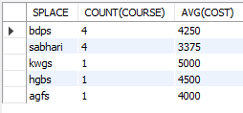

23) Display EACH institute name with NUMBER of students.

      SELECT SPLACE,COUNT(NAME) FROM STUDIES GROUP BY SPLACE;

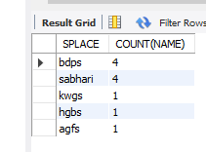

24) Display names of male and female programmers.

      SELECT NAME,SEX FROM PROGRAMMER ORDER BY SEX;

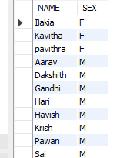

25) Display the programmer's name and their packages.

      SELECT NAME,TITLE FROM SOFTWARE ORDER BY NAME;

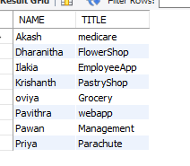

26) Display the NUMBER of packages in EACH language.

      SELECT COUNT(TITLE),DEV_IN FROM SOFTWARE GROUP BY DEV_IN;

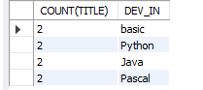

27) Display the NUMBER of packages in EACH language for which development cost is less than

1000.

      SELECT COUNT(TITLE),DEV_IN FROM SOFTWARE WHERE DCOST<1000 GROUP BY DEV_IN;

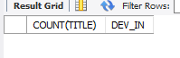

28) Display the AVERAGE difference BETWEEN scost and dcost for EACH language.

      SELECT DEV_IN,AVG(DCOST - SCOST) FROM SOFTWARE GROUP BY DEV_IN;

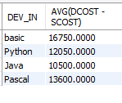

29) Display the TOTAL scost, dcsot and amount TOBE recovered for EACH programmer for

whose dcost HAS NOT YET BEEN recovered.

      SELECT SUM(SCOST), SUM(DCOST), SUM(DCOST-(SOLD*SCOST)) FROM SOFTWARE GROUP BY NAME

HAVING SUM(DCOST)>SUM(SOLD*SCOST);



30) Display highest, lowest and average salaries for THOSE earning MORE than 2000.

      SELECT MAX(SALARY), MIN(SALARY), AVG(SALARY) FROM PROGRAMMER WHERE SALARY > 2000;

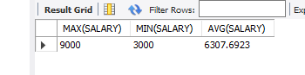

1) Who is the highest paid C programmer?

SELECT * FROM PROGRAMMER WHERE SALARY=(SELECT MAX(SALARY) FROM PROGRAMMER WHERE PROF1 LIKE 'C' OR PROF2 LIKE 'C');

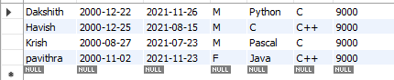

3) Display the name of the HIGEST paid programmer for EACH language (prof1)

SELECT DISTINCT NAME, SALARY, PROF1 FROM PROGRAMMER WHERE (SALARY,PROF1) IN (SELECT MAX(SALARY),PROF1 FROM PROGRAMMER GROUP BY PROF1);

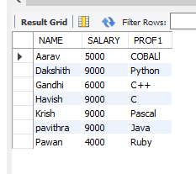

4) Who is the LEAST experienced programmer?

SELECT name FROM PROGRAMMER WHERE FLOOR(DATEDIFF(CURRENT_TIMESTAMP,DOJ)/365)1;

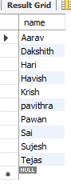

6) Which language is known by ONLY ONE programmer?

SELECT PROF1 FROM PROGRAMMER GROUP BY PROF1 HAVING PROF1 NOT IN (SELECT PROF2 FROM PROGRAMMER) AND COUNT(PROF1)=1 UNION SELECT PROF2 FROM PROGRAMMER GROUP BY PROF2 HAVING PROF2 NOT IN (SELECT PROF1 FROM PROGRAMMER) AND COUNT(PROF2)=1;

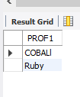

9) Which female programmer earns MORE than 3000/- but DOES NOT know C, C++, Oracle or Dbase?

SELECT * FROM PROGRAMMER WHERE SEX = 'F' AND SALARY >3000 AND (PROF1 NOT IN('C','C++','ORACLE','DBASE') OR PROF2 NOT IN('C','C++','ORACLE','DBASE'));

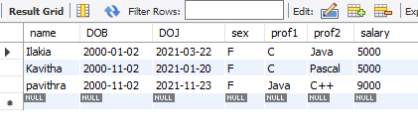

10) Which is the COSTLIEST course?

SELECT COURSE FROM STUDIES WHERE CCOST = (SELECT MAX(CCOST) FROM STUDIES);



12) Display name of the institute and course Which has below AVERAGE course fee?

SELECT SPLACE,COURSE FROM STUDIES WHERE CCOST < (SELECT AVG(CCOST) FROM STUDIES); 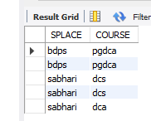

13) Which institute conducts COSTLIEST course?

      SELECT SPLACE FROM STUDIES WHERE CCOST = (SELECT MAX(CCOST) FROM STUDIES);

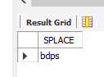

16) Display names of the course WHOSE fees are within 1000(+ or -) of the AVERAGE fee.

SELECT COURSE FROM STUDIES WHERE CCOST < (SELECT AVG(CCOST)+1000 FROM STUDIES) AND CCOST > (SELECT AVG(CCOST)-1000 FROM STUDIES);

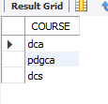

17) Which package has the HIGEST development cost?

SELECT TITLE,DCOST FROM SOFTWARE WHERE DCOST = (SELECT MAX(DCOST) FROM SOFTWARE);



18) Which package has the LOWEST selling cost?

SELECT TITLE,SCOST FROM SOFTWARE WHERE SCOST = (SELECT MIN(SCOST) FROM SOFTWARE);

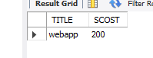

19) Who developed the package, which has sold the LEAST number of copies?

SELECT NAME,SOLD FROM SOFTWARE WHERE SOLD = (SELECT MIN(SOLD) FROM SOFTWARE);

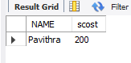

20) Which language was used to develop the package WHICH has the HIGEST sales amount?

SELECT DEV_IN,SCOST FROM SOFTWARE WHERE SCOST = (SELECT MAX(SCOST) FROM SOFTWARE);

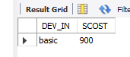

22) Which is the COSTLIEAST package developed in PASCAL?

SELECT TITLE FROM SOFTWARE WHERE DCOST = (SELECT MAX(DCOST) FROM SOFTWARE WHERE DEV_IN LIKE 'PASCAL');

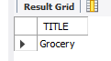

23) Which language was used to develop the MOST NUMBER of package?

SELECT DEV_IN FROM SOFTWARE GROUP BY DEV_IN HAVING MAX(DEV_IN) = (SELECT MAX(DEV_IN) FROM SOFTWARE);

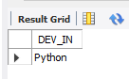

24) Which programmer has developed the HIGEST NUMBER of package?

SELECT NAME FROM SOFTWARE GROUP BY NAME HAVING MAX(NAME) = (SELECT MAX(NAME) FROM SOFTWARE);



25) Who is the author of the COSTLIEST package?

      SELECT NAME,DCOST FROM SOFTWARE WHERE DCOST = (SELECT MAX(DCOST) FROM   SOFTWARE);



26) Display names of packages WHICH have been sold LESS THAN the AVERAGE number of copies?

SELECT TITLE FROM SOFTWARE WHERE SOLD < (SELECT AVG(SOLD) FROM SOFTWARE);

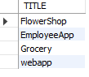

28) Which language has been stated as prof1 by MOST of the programmers?

SELECT PROF1 FROM PROGRAMMER GROUP BY PROF1 HAVING PROF1 = (SELECT MAX(PROF1) FROM PROGRAMMER);

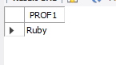

29) Who are the authors of packages, WHICH have recovered MORE THAN double the development cost?

      SELECT NAME FROM SOFTWARE WHERE SOLD*SCOST > 2*DCOST;

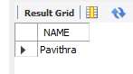

30) Display programmer names and CHEAPEST package developed by them in EACH

language?

SELECT NAME,TITLE FROM SOFTWARE WHERE DCOST IN (SELECT MIN(DCOST) FROM SOFTWARE GROUP BY DEV_IN);

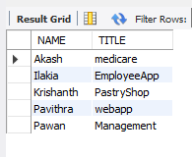

31) Who is the YOUNGEST male programmer born in 1965?

SELECT NAME FROM PROGRAMMER WHERE DOB=(SELECT (MAX(DOB)) FROM PROGRAMMER WHERE TO_CHAR(DOB,'YYYY') LIKE '1965');

32) Display language used by EACH programmer to develop the HIGEST selling and LOWEST selling package.

SELECT NAME, DEV_IN FROM SOFTWARE WHERE SOLD IN (SELECT MAX(SOLD) FROM SOFTWARE GROUP BY NAME) UNION SELECT NAME, DEV_IN FROM SOFTWARE WHERE SOLD IN (SELECT MIN(SOLD) FROM SOFTWARE GROUP BY NAME);

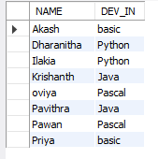

33) Who is the OLDEST female programmer WHO joined in 1992?

SELECT NAME FROM PROGRAMMER WHERE DOJ=(SELECT (MIN(DOJ)) FROM PROGRAMMER WHERE TO_CHAR(DOJ,'YYYY') LIKE '1992');

34) In WHICH year where the MOST NUMBER of programmer born?

SELECT DISTINCT TO_CHAR(DOB,'YYYY') FROM PROGRAMMER WHERE TO_CHAR(DOJ,'YYYY') = (SELECT MIN(TO_CHAR(DOJ,'YYYY')) FROM PROGRAMMER);

37) Who are the male programmers earning BELOW the AVERAGE salary of female

programmers?

SELECT NAME FROM PROGRAMMER WHERE SEX = 'M' AND SALARY < (SELECT(AVG(SALARY))FROM PROGRAMMER WHERE SEX = 'F');

