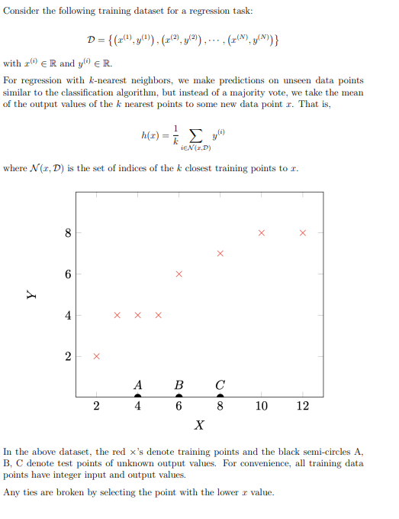
When k = 2, what is the predicted value at A?

You have just enrolled into your favourite course Introduction to Machine Learning, but you have not yet decided if you want to take it for a grade or as pass/fail. You want to use your performance in HW1 and HW2 to make this decision. You follow a general rule that if you can get at least a B in the course, you will take it for a grade, and if not, you will take it as pass/fail.
You have just learnt the new classification technique, k-NN, and wish to employ it to make your decision. You start by collecting data on prior student performance in HW1 and HW2, along with their final letter grades. You then create a binary label (1/0) based on the final grades such that you assign a label of 1 if the final grade is at least a B and 0 otherwise. Next, you train the model on this data set and calculate the training error. The distance measure you use is Euclidean distance.

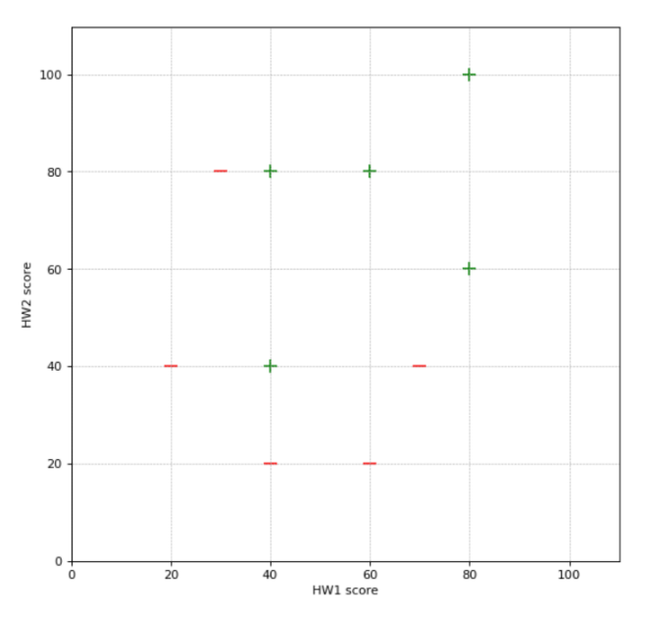
What will be the training error if you choose k = 3?

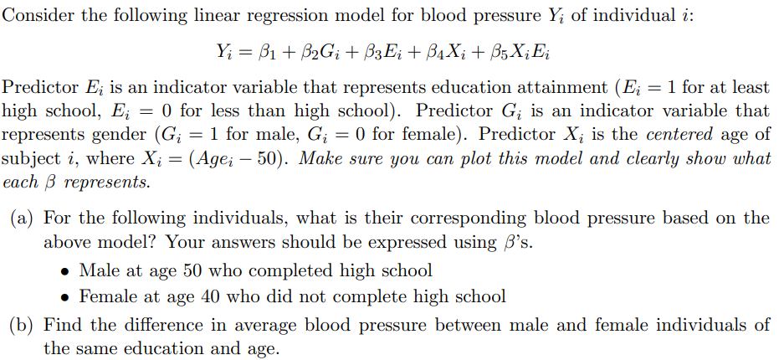
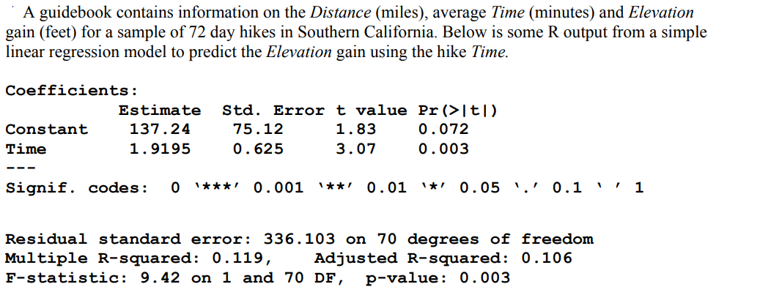

Write a sentence that interprets the value of the estimated slope of the model in the context of this data situation.
Write a sentence that interprets the value of R2 (not adjusted) in the context of this data situation.

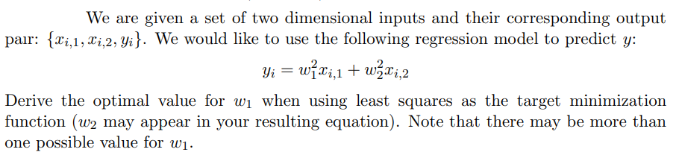
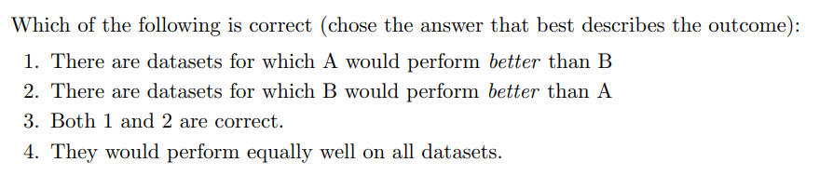
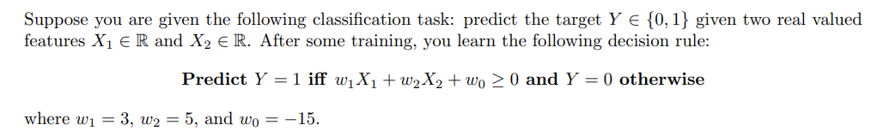
Plot the decision boundary and label the region where we would predict Y = 1 and Y = 0.
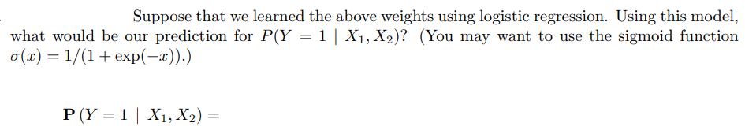
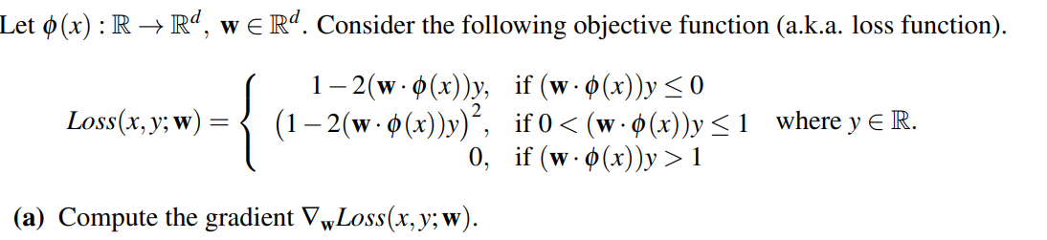

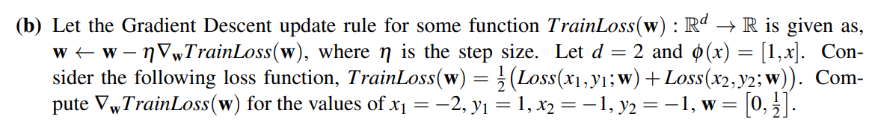

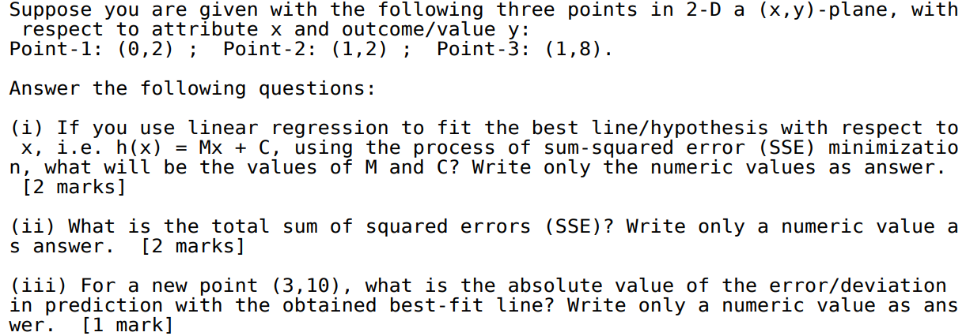
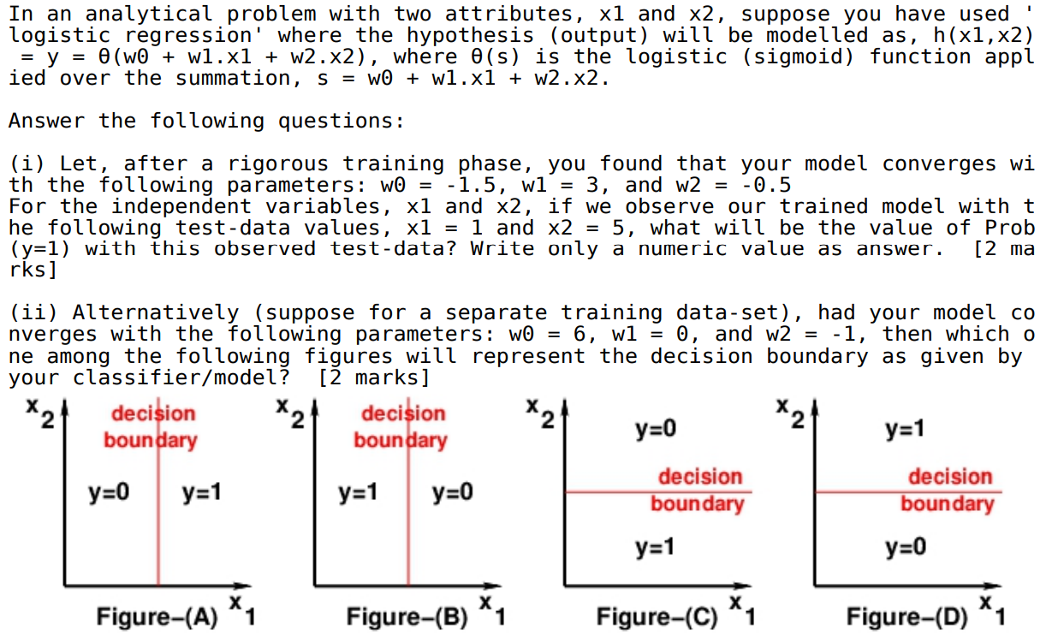
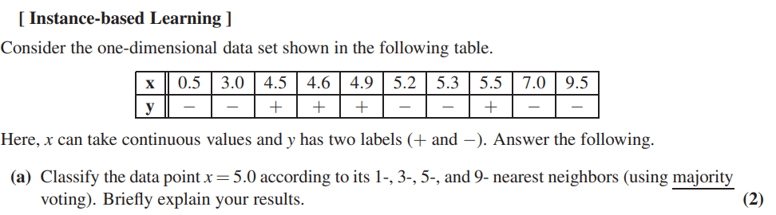
(b)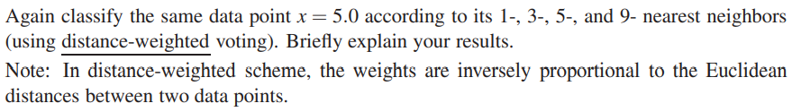
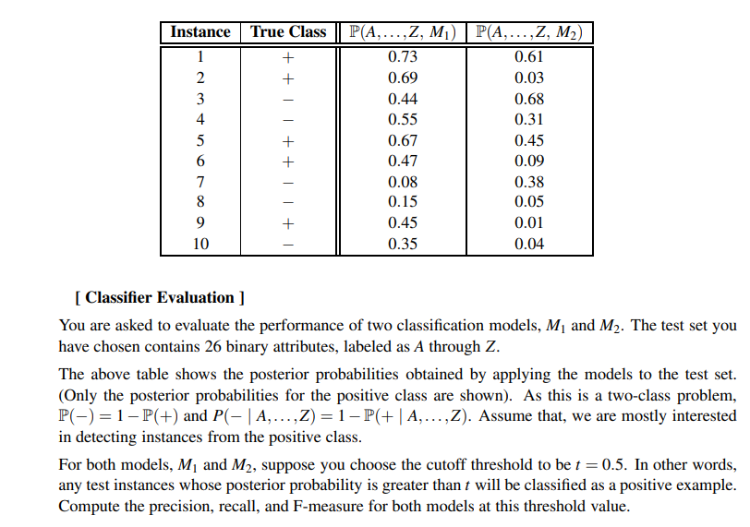
__----------------------------------------------------------------------------------------------------------------------------
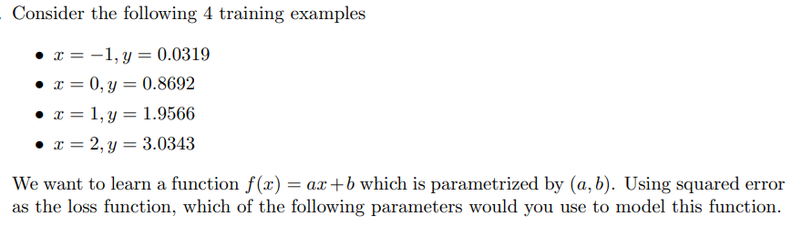
(a) (1, 1) 2 (b) (1, 2) (c) (2, 1) (d) (2, 2)
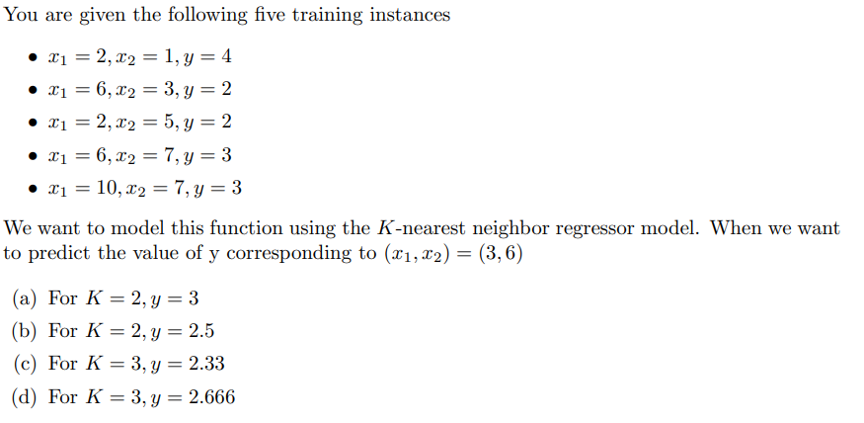
__________________________________________________________________________________
Suppose you are only allowed to use binary logistic classifiers to solve a multi-class classification problem. Given a training set with 2 classes, this classifier can learn a model, which can then be used to classify a new test point to one of the 2 classes in the training set. You are now given a 6 class problem along with its training set, and have to use more than one binary logistic classifier to solve the problem, as mentioned before. You propose the following scheme (also known as one vs one approach in ML terminology) - you will first train a binary logistic classifier for every pair of classes. Now, for a new test point, you will run it through each of these models, and the class which wins the maximum number of pairwise contests, is the predicted label for the test point. How many binary logistic classifiers will you need to solve the problem using your proposed scheme?
