Data Visualization and Insight Communication using R
Week 2 Task – Retail Sales Dataset
Prepared using R (ggplot2, corrplot)

1. Introduction
This report continues the analysis of the retail sales dataset introduced in Week 1. Having already cleaned, imputed, and encoded the data, this week's focus shifts from preparation to communication: designing a set of visualizations that make the dataset's key trends, comparisons, and anomalies immediately understandable to a non-technical audience. Seven visualizations are presented, spanning line charts, bar charts, a grouped bar chart, a histogram, a scatter plot, a boxplot, and a correlation heatmap, each chosen because it is the clearest way to answer a specific business question about the data.

2. Data Overview
The dataset (retail_sales_cleaned.csv) contains 1,000 retail orders placed between January 2023 and December 2024, each described by: Sales and Profit (dollar values), Quantity and Discount (order-level numeric fields), and several categorical fields — Region, Segment (Consumer / Corporate / Home Office), Category (Furniture / Office Supplies / Technology), and Ship_Mode (shipping method). Sales_capped and Profit_capped, produced during Week 1's outlier treatment, are used throughout this report's visualizations so that the small number of extreme orders does not distort chart scales; the original, uncapped Sales and Profit columns are used specifically in Section 4.5 to identify and highlight those anomalous orders.

3. Visualization Design
Each visualization below was chosen to match the type of question being asked: trends over time call for a line chart, comparisons across categories call for bar charts, distributions call for a histogram, relationships between two numeric variables call for a scatter plot, comparisons of a distribution across groups call for a boxplot, and the overall pattern of relationships between numeric variables calls for a correlation heatmap.

3.1 Monthly Sales and Profit Trend
Why this chart: a line chart is the standard way to show how a value changes over time, making it easy to spot seasonality, growth, or decline at a glance.
R Code
monthly <- sales %>%
mutate(Month = floor_date(Order_Date, "month")) %>%
group_by(Month) %>%
summarise(Total_Sales = sum(Sales_capped), Total_Profit = sum(Profit_capped))

ggplot(monthly, aes(x = Month)) +
geom_line(aes(y = Total_Sales, color = "Total Sales"), linewidth = 1) +
geom_point(aes(y = Total_Sales, color = "Total Sales")) +
geom_line(aes(y = Total_Profit * scale_factor, color = "Total Profit"), linewidth = 1) +
geom_point(aes(y = Total_Profit * scale_factor, color = "Total Profit")) +
scale_y_continuous(name = "Total Sales ($)", labels = dollar_format(),
sec.axis = sec_axis(~ . / scale_factor, name = "Total Profit ($)", labels = dollar_format())) +
labs(title = "Monthly Sales and Profit Trend (Jan 2023 - Dec 2024)") +
theme_minimal()
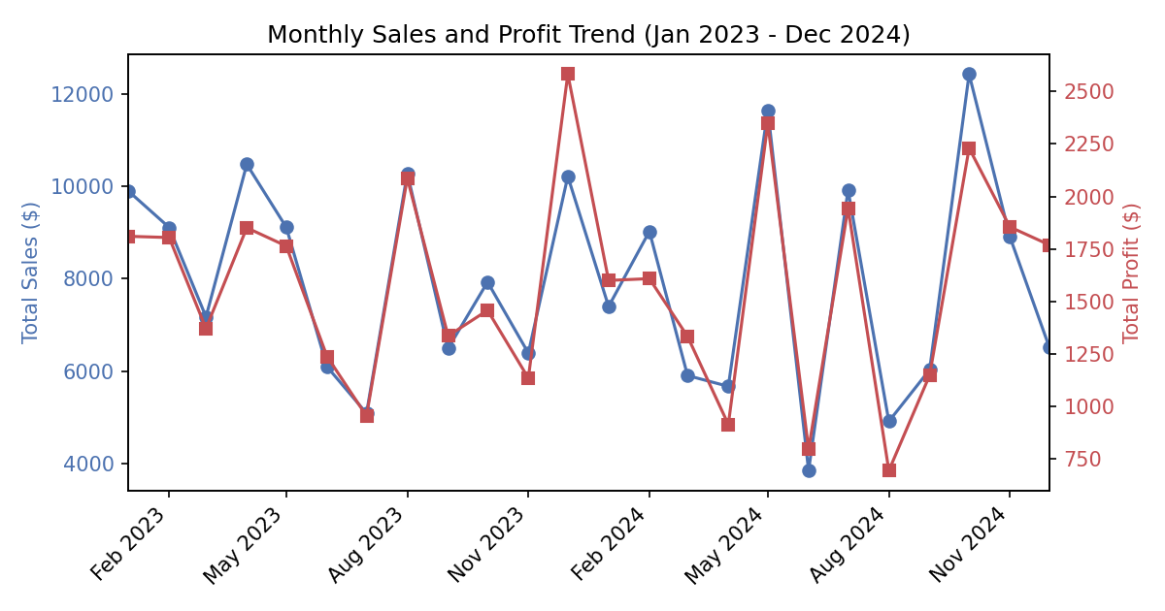
Figure 1. Total monthly sales (blue) and total monthly profit (red), January 2023 through December 2024.
Interpretation: Sales and Profit move almost in lockstep month to month, which is expected since profit is derived from sales. There is no steady upward or downward trend across the two years — instead the business shows sharp month-to-month swings, with a strong peak in December 2023 and October 2024 (both exceeding $10,000 in monthly sales) and a noticeable trough in June and August 2024 (both dipping under $5,000). For a non-technical reader, the takeaway is that revenue is volatile month-to-month rather than steadily growing, which may warrant investigating what drove the high and low months specifically.

3.2 Total Sales by Region
Why this chart: a simple bar chart is the clearest way to rank a small number of categories by a single total.
R Code
sales %>%
group_by(Region) %>%
summarise(Total_Sales = sum(Sales_capped)) %>%
arrange(desc(Total_Sales)) %>%
ggplot(aes(x = reorder(Region, -Total_Sales), y = Total_Sales)) +
geom_col(fill = "#55A868") +
geom_text(aes(label = dollar(round(Total_Sales))), vjust = -0.5) +
labs(title = "Total Sales by Region", x = "Region", y = "Total Sales ($)") +
theme_minimal()
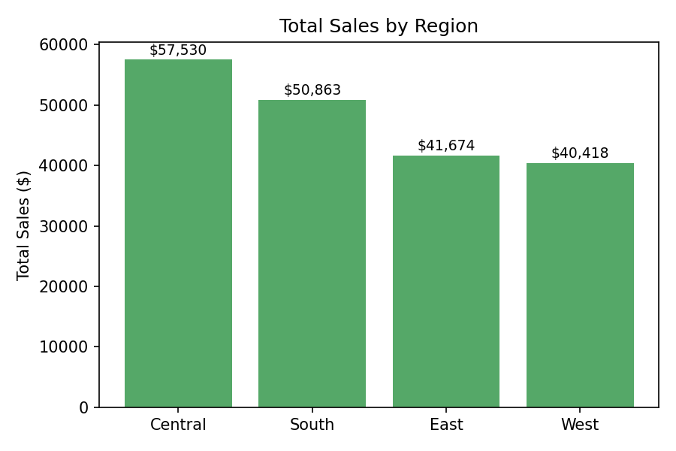
Figure 2. Total sales aggregated by region.
Interpretation: the Central region leads with $57,530 in total sales, roughly 42% higher than the West region's $40,418, the lowest of the four. South ($50,863) and East ($41,674) fall in between. Since the data was generated with region assigned independently of other variables, this ranking should be read as this dataset's regional split rather than a universal retail pattern — but it illustrates exactly the kind of comparison this chart type is built to surface.

3.3 Average Profit by Category and Customer Segment
Why this chart: a grouped (dodged) bar chart lets a reader compare two categorical dimensions — Category and Segment — at once, without needing a separate chart for each segment.
R Code
sales %>%
group_by(Category, Segment) %>%
summarise(Avg_Profit = mean(Profit_capped), .groups = "drop") %>%
ggplot(aes(x = Category, y = Avg_Profit, fill = Segment)) +
geom_col(position = "dodge") +
labs(title = "Average Profit by Category and Customer Segment",
x = "Category", y = "Average Profit ($)") +
theme_minimal()
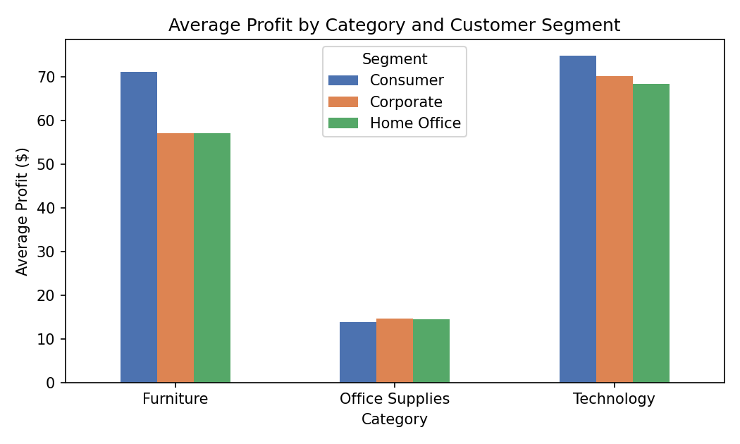
Figure 3. Average profit per order, broken down by product category and customer segment.
Interpretation: Technology ($68–$75 average profit per order) and Furniture ($57–$71) are markedly more profitable per order than Office Supplies ($14–$15) across every customer segment. Within each category, the Consumer segment is the most profitable, though the gap between segments is small compared to the gap between categories. The clear message for a non-technical reader: which product category an order belongs to matters far more to profitability than which type of customer placed it.

3.4 Distribution of Order Sales Value
Why this chart: a histogram is the standard tool for showing the shape of a single numeric variable's distribution — whether it's symmetric, skewed, or has unusual spikes.
R Code
ggplot(sales, aes(x = Sales_capped)) +
geom_histogram(bins = 30, fill = "#8172B2", color = "white") +
geom_vline(xintercept = median(sales$Sales_capped), linetype = "dashed") +
labs(title = "Distribution of Order Sales Value", x = "Sales ($)", y = "Number of Orders") +
theme_minimal()
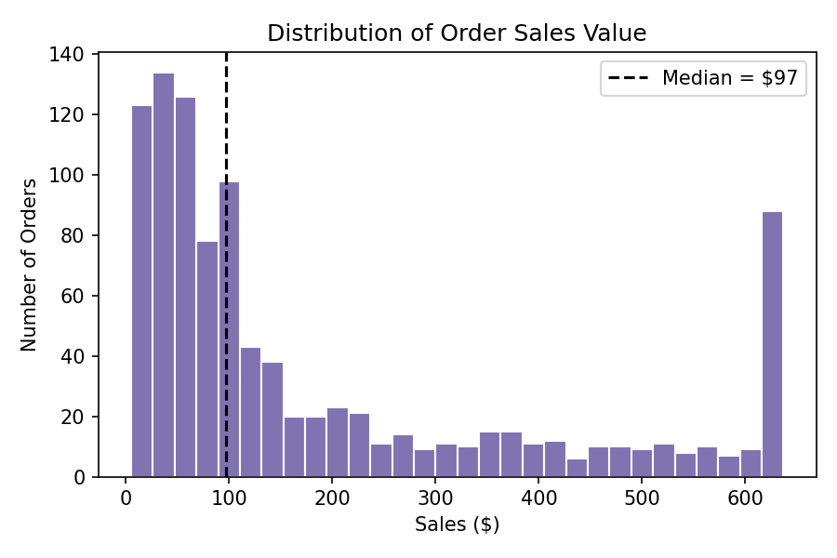
Figure 4. Distribution of order sales values after outlier capping; the dashed line marks the median ($97).
Interpretation: order sizes are strongly right-skewed — most orders are small (the median order is just $97), and the distribution tapers off with a long tail toward higher values. The tall bar at the right edge (around $625–$640) is not a natural cluster of orders; it is an artifact of Week 1's outlier capping, which pushed every order above the IQR upper bound down to that ceiling. This is worth calling out explicitly to a reader, since without that context the spike could be misread as a genuine group of similarly priced orders.

3.5 Sales vs Profit, with Anomalies Highlighted
Why this chart: a scatter plot is the natural choice for examining the relationship between two numeric variables, and color/shape can be layered on to flag which points are statistical anomalies — directly addressing the task's request to surface trends, patterns, and anomalies in one view.
R Code
detect_outliers <- function(x) {
q1 <- quantile(x, 0.25); q3 <- quantile(x, 0.75); iqr <- q3 - q1
x < (q1 - 1.5 * iqr) | x > (q3 + 1.5 * iqr)
}
sales$is_outlier <- detect_outliers(sales$Sales) | detect_outliers(sales$Profit)

ggplot(sales, aes(x = Sales, y = Profit, color = is_outlier, shape = is_outlier)) +
geom_point(alpha = 0.6) +
scale_color_manual(values = c("FALSE" = "#4C72B0", "TRUE" = "#C44E52"),
labels = c("Typical orders", "Anomalous orders (IQR outliers)")) +
labs(title = "Sales vs Profit, with Anomalies Highlighted",
x = "Sales ($)", y = "Profit ($)") +
theme_minimal()
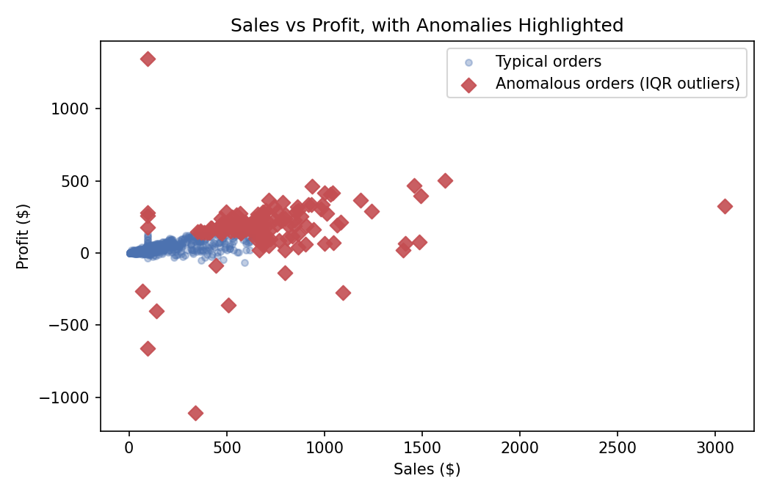
Figure 5. Sales against profit for all 1,000 orders (pre-capping values), with the 134 orders flagged as IQR outliers on either variable shown as red diamonds.
Interpretation: for typical orders (blue), profit rises gently with sales, forming a tight cluster near the origin. The flagged anomalies (red) include both unusually large orders — one order near $3,050 in sales — and orders with unusually large losses, such as one order that lost over $1,100 on only about $340 in sales. Flagging these points visually makes it easy for a reviewer to see that the anomalies aren't randomly scattered: almost all of them sit at either the high-sales end or the high-loss end of the chart, which is exactly the pattern Week 1's IQR-based outlier treatment was designed to catch.

3.6 Profit Distribution by Shipping Mode
Why this chart: a boxplot summarizes an entire distribution (median, spread, and outliers) for each group side by side, which is more informative than a single average when comparing variability across groups.
R Code
ship_order <- sales %>% group_by(Ship_Mode) %>%
summarise(med = median(Profit_capped)) %>% arrange(desc(med)) %>% pull(Ship_Mode)
sales$Ship_Mode <- factor(sales$Ship_Mode, levels = ship_order)

ggplot(sales, aes(x = Ship_Mode, y = Profit_capped)) +
geom_boxplot() +
labs(title = "Profit Distribution by Shipping Mode", x = NULL, y = "Profit ($)") +
theme_minimal()
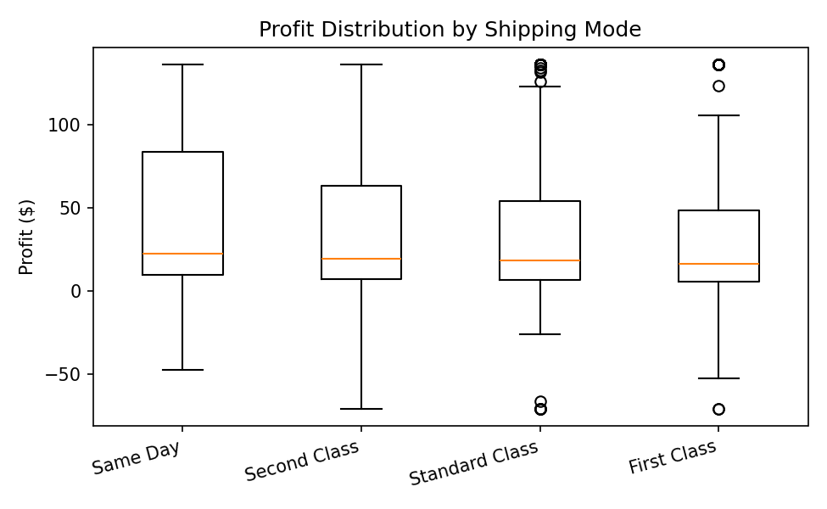
Figure 6. Profit distribution (capped) for each shipping mode, ordered by median profit.
Interpretation: median profit is highest for Same Day shipping ($22.45) and lowest for First Class ($16.28), though the difference between modes is modest compared to the spread within each mode. Same Day orders also show the widest interquartile range, meaning profit outcomes for that shipping method are the least predictable of the four.

3.7 Correlation Matrix of Numeric Variables
Why this chart: a heatmap condenses a full correlation matrix into a single, color-coded view, letting a reader spot the strongest relationships in the data without reading a table of numbers.
R Code
num_vars <- sales[, c("Sales_capped", "Quantity", "Discount", "Profit_capped")]
corr_matrix <- cor(num_vars)
corrplot(corr_matrix, method = "color", addCoef.col = "black",
title = "Correlation Matrix", mar = c(0,0,1,0))
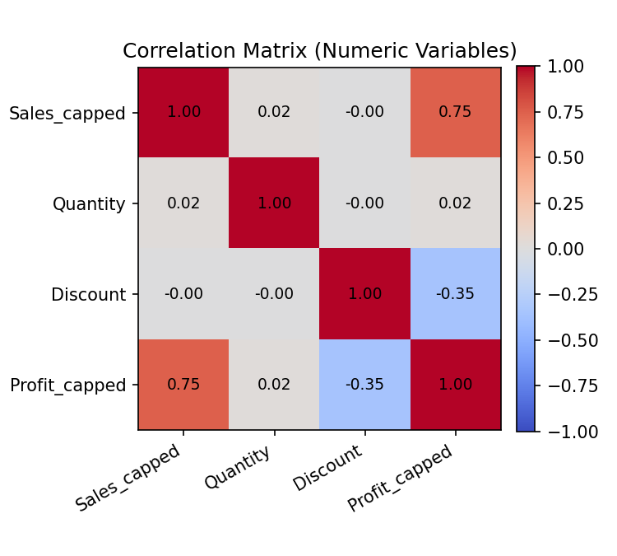
Figure 7. Correlation heatmap of Sales, Quantity, Discount, and Profit (capped values).
Interpretation: the strongest relationship in the dataset is between Sales and Profit (r ≈ 0.75, dark red), confirming that bigger orders tend to be more profitable in absolute terms. Discount and Profit are moderately negatively correlated (r ≈ -0.35, blue), meaning heavier discounting erodes profit. Quantity has almost no linear relationship with any other variable (all correlations near 0), indicating that the number of units in an order says little about its dollar value or profitability.

4. Summary of Key Insights
- Revenue is volatile rather than steadily trending: monthly sales swing between roughly $4,000 and $12,500 with no consistent upward or downward trajectory over the two-year window.
- Region matters for total volume (Central leads South, East, and West), but Category matters far more for profitability, with Technology and Furniture far outperforming Office Supplies regardless of customer segment.
- Order sizes are right-skewed, with a typical order around $97 and a long tail of larger orders.
- 134 orders (13.4%) are flagged as statistical anomalies on Sales or Profit, concentrated at the high-sales and high-loss extremes — exactly the records Week 1's outlier-capping step was designed to control for.
- Sales and Profit are strongly positively correlated (r ≈ 0.75); Discount and Profit are moderately negatively correlated (r ≈ -0.35); Quantity is essentially unrelated to either.
Together, these seven visualizations move from a broad view of the business (trend, regional totals) to specific, actionable detail (which category drives profit, which orders are anomalies, which numeric relationships are strongest) — giving a non-technical reader a complete, evidence-based picture of how sales and profit behave in this dataset.

Appendix: Full R Script
The complete R script used to produce every figure in this report (week2_report.R) accompanies this submission and is also included in the linked GitHub repository.

