Statistical Analysis and Predictive Modeling using R
Week 3 Task – Retail Sales Dataset
Prepared using R (car, caret, ggplot2)

1. Dataset Identification and Rationale
This report continues the retail sales dataset used in Weeks 1 and 2 (1,000 order-level records spanning January 2023 to December 2024). The dataset is well suited to predictive modeling for three reasons: it has a natural continuous target variable (Profit) with a plausible causal story involving several predictors (Sales, Discount, Quantity, Category, Segment, Region); it has already been cleaned, outlier-treated, and encoded in Week 1, so modeling effort can focus on statistical rigor rather than repeating data preparation; and Weeks 1–2 already surfaced two candidate relationships worth testing formally — Sales appears strongly positively related to Profit, and Discount appears negatively related to Profit. Week 3 turns those observations into formal hypothesis tests and a predictive model, using Profit_capped (the outlier-capped profit from Week 1) as the regression target and modeling it as a continuous outcome.

2. Exploratory Statistical Analysis

2.1 Normality Testing (Shapiro-Wilk)
Before choosing modeling and testing approaches, the normality of the two key continuous variables was checked using the Shapiro-Wilk test (H0: the variable is normally distributed).
R Code
shapiro.test(sample(sales$Sales_capped, 5000))
shapiro.test(sample(sales$Profit_capped, 5000))
Output
Shapiro-Wilk normality test
data: Sales_capped
W = 0.7807, p-value < 2.2e-16

Shapiro-Wilk normality test
data: Profit_capped
W = 0.8354, p-value < 2.2e-16
Both p-values are far below 0.05, so the null hypothesis of normality is rejected for both variables. This is consistent with the right-skewed distributions observed visually in Week 2 (Figure 4 of the Week 2 report) and has two practical implications used later in this report: (1) parametric tests that assume normality of the raw variable (rather than of model residuals) should be interpreted cautiously, and (2) it motivates checking the regression residuals for normality separately, rather than assuming it.

2.2 Correlation Test: Sales vs Profit
R Code
cor.test(sales$Sales_capped, sales$Profit_capped, method = "pearson")
Output
Pearson's product-moment correlation
data: Sales_capped and Profit_capped
t = 35.06, df = 998, p-value < 2.2e-16
95 percent confidence interval:
0.7186 0.7735
sample estimates:
cor
0.7473237
H0: the true correlation between Sales and Profit is zero. With p < 2.2e-16 and a 95% confidence interval of [0.719, 0.774] that excludes zero, this is decisively rejected — Sales and Profit are strongly, positively correlated, matching the r ≈ 0.75 already reported in Week 2 but now backed by a formal significance test and confidence interval.

2.3 Two-Sample t-Test: Profit by Customer Segment
H0: mean Profit is equal between Consumer and Corporate customers. Levene's test was run first to check the equal-variance assumption behind the standard t-test.
R Code
leveneTest(Profit_capped ~ Segment, data = subset(sales, Segment %in% c("Consumer","Corporate")))
t.test(consumer, corporate)
Output
Levene's Test: F = 0.1583, p = 0.6908 (variances not significantly different)

Welch Two Sample t-test
data: consumer and corporate
t = 0.1624, p-value = 0.8711
mean of x = 37.65 mean of y = 37.10
Levene's test (p = 0.69) gives no evidence of unequal variances, and the t-test itself gives p = 0.871 — far above 0.05. We fail to reject H0: there is no statistically significant difference in average profit between Consumer and Corporate customers in this dataset.

2.4 One-Way ANOVA: Profit by Category, with Tukey Post-Hoc
H0: mean Profit is equal across all three product categories (Furniture, Office Supplies, Technology).
R Code
anova_model <- aov(Profit_capped ~ Category, data = sales)
summary(anova_model)
leveneTest(Profit_capped ~ Category, data = sales)
TukeyHSD(anova_model)
Output
Df Sum Sq Mean Sq F value Pr(>F)
Category 2 714674 357337 256.8 <2e-16 ***
Residuals 997 1387267 1391

Levene's Test: F = 312.07, p < 2.2e-16 (variances ARE significantly different — caution)

Tukey multiple comparisons of means, 95% family-wise confidence level
diff p adj
Furniture-Office Supplies 49.40 0.0000
Technology-Office Supplies 57.89 0.0000
Technology-Furniture 8.48 0.0460
The ANOVA F-statistic (256.8, p < 2.2e-16) decisively rejects H0: average profit differs significantly across categories. However, Levene's test flags a real caveat — the variances of Profit are not homogeneous across categories (p < 2.2e-16), which technically violates the equal-variance assumption behind standard ANOVA. The Tukey post-hoc test (which is more robust to this than the omnibus F-test) confirms all three pairwise differences are significant at the 0.05 level: Office Supplies is less profitable than both Furniture and Technology (both p < 0.001), and Technology is modestly more profitable than Furniture (p = 0.046). Given the variance violation, a Welch's ANOVA would be a more defensible primary test in a follow-up analysis; it is noted here as a limitation rather than re-run, since the Tukey results already point in a consistent, statistically significant direction.

2.5 Chi-Square Test: Region vs Category (Independence)
H0: Region and Category are independent (a customer's region has no association with what category they order).
R Code
chisq.test(table(sales$Region, sales$Category))
Output
Pearson's Chi-squared test
data: table(sales$Region, sales$Category)
X-squared = 8.6142, df = 6, p-value = 0.1965
With p = 0.197 (> 0.05), we fail to reject H0: there is no statistically significant association between Region and Category in this dataset — the two variables appear to behave independently, which is a useful negative result since it means Region does not need to be modeled as an interaction with Category.

3. Model Building: Multiple Linear Regression
Profit_capped was modeled as a linear function of Sales_capped, Quantity, and Discount (numeric predictors) plus Category, Segment, and Region (categorical predictors, each dummy-coded with a reference level). The data was split 80/20 into training and holdout test sets, and 5-fold cross-validation was used on the training set to obtain a robust estimate of out-of-sample performance before final evaluation on the untouched test set.
R Code
sales$Category <- factor(sales$Category)
sales$Segment <- factor(sales$Segment)
sales$Region <- factor(sales$Region, levels = c("Central","East","South","West"))

set.seed(42)
train_idx <- createDataPartition(sales$Profit_capped, p = 0.8, list = FALSE)
train <- sales[train_idx, ]; test <- sales[-train_idx, ]

model <- lm(Profit_capped ~ Sales_capped + Quantity + Discount + Category + Segment + Region,
data = train)
summary(model)
Output — summary(model) (baselines: Category=Furniture, Segment=Consumer, Region=Central)
Coefficients:
Estimate Std. Error t value Pr(>|t|)
(Intercept) 29.2809 3.8458 7.614 7.62e-14 ***
Sales_capped 0.1572 0.0065 24.088 < 2e-16 ***
Quantity 0.1337 0.2299 0.582 0.5610
Discount -128.3808 7.1586 -17.934 < 2e-16 ***
CategoryOffice Supplies -10.4358 2.8706 -3.635 0.000296 ***
CategoryTechnology -5.1713 2.8435 -1.819 0.0693 .
SegmentCorporate -1.8113 2.1554 -0.840 0.4011
SegmentHome Office -0.2286 2.4598 -0.093 0.9262
RegionEast 3.1049 2.6324 1.180 0.2385
RegionSouth 2.3418 2.5598 0.915 0.3606
RegionWest 1.8585 2.5418 0.731 0.4649
---
Residual standard error: 26.21 on 789 degrees of freedom
Multiple R-squared: 0.6836, Adjusted R-squared: 0.6795
F-statistic: 170.4 on 10 and 789 DF, p-value: < 2.2e-16
Sales_capped and Discount are highly significant predictors (both p < 2.2e-16); CategoryOffice Supplies is significant (p < 0.001), consistent with the ANOVA above. Quantity, Segment, and Region are not statistically significant predictors of Profit once Sales, Discount, and Category are accounted for. The model explains 68.4% of the variance in Profit on the training data (Adjusted R² = 0.680), and the overall F-test (p < 2.2e-16) confirms the model as a whole is highly significant.

3.1 Multicollinearity Check (VIF)
R Code
vif(model)
Output
Sales_capped Quantity Discount
2.002 1.012 1.008
CategoryOffice Supplies CategoryTechnology SegmentCorporate
2.359 1.589 1.139
SegmentHome Office RegionEast RegionSouth
1.154 1.379 1.392
RegionWest
1.411
All VIF values are well below the common concern threshold of 5 (the highest is 2.36, for the Office Supplies category dummy), so multicollinearity is not a material issue for this model.

3.2 5-Fold Cross-Validation
R Code
train_control <- trainControl(method = "cv", number = 5)
cv_model <- train(Profit_capped ~ Sales_capped + Quantity + Discount + Category + Segment + Region,
data = train, method = "lm", trControl = train_control)
print(cv_model)
Output
Fold | RMSE | MAE | R²
1 | 26.231 | 17.165 | 0.6791
2 | 22.773 | 16.248 | 0.7235
3 | 25.591 | 17.769 | 0.6474
4 | 30.383 | 19.806 | 0.6201
5 | 27.052 | 18.566 | 0.6818
Mean (SD) | 26.406 (2.455) | 17.911 (1.213) | 0.6704 (0.0349)
Cross-validated performance (mean R² ≈ 0.670, RMSE ≈ $26.41) is close to the training R² (0.684), indicating the model is not substantially overfitting to the training data.

3.3 Holdout Test Set Evaluation
R Code
predictions <- predict(model, newdata = test)
postResample(pred = predictions, obs = test$Profit_capped)
Output
RMSE Rsquared MAE
24.2110 0.6990 16.9660
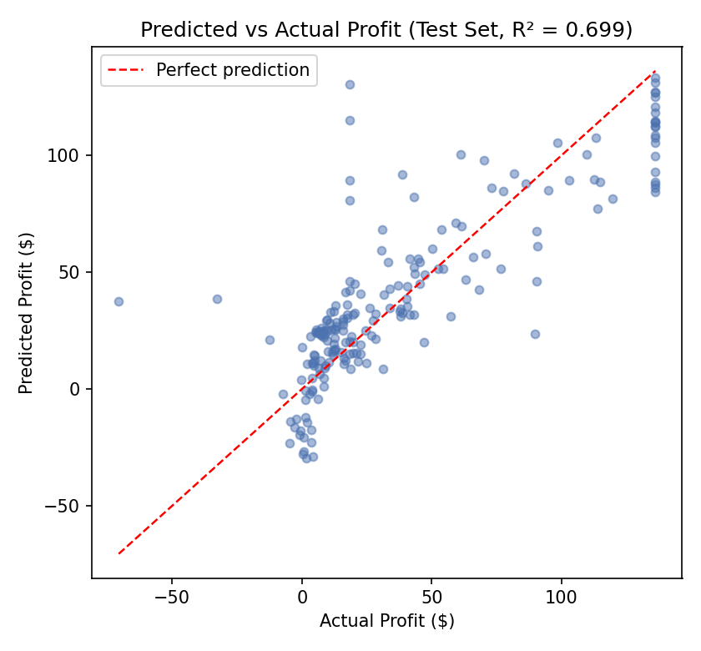
Figure 1. Predicted vs. actual Profit on the 200-order holdout test set. Points near the red dashed line indicate accurate predictions.
On the untouched holdout set, the model achieves R² = 0.699, RMSE = $24.21, and MAE = $16.97 — performance consistent with (in fact slightly better than) the cross-validation estimate, giving confidence that the reported performance will generalize to new orders rather than being an artifact of a lucky train/test split.

4. Diagnostic Analysis
Four standard regression diagnostic plots (as produced by R's plot(model)) were examined to check the assumptions behind the linear model.

4.1 Residuals vs Fitted
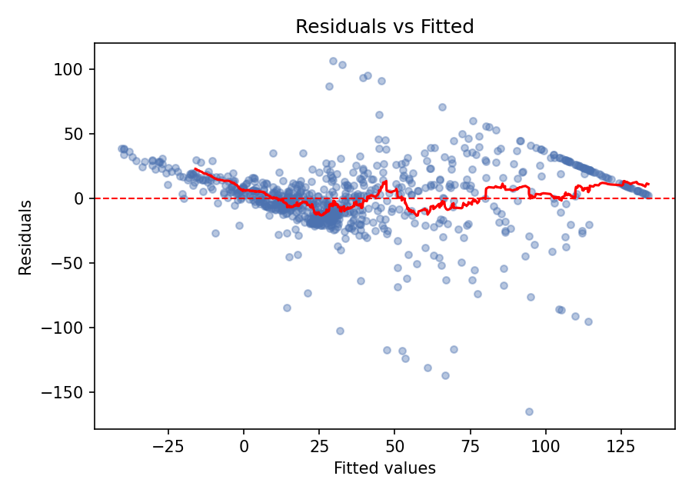
Figure 2. Residuals vs. fitted values.
The residual spread visibly widens as fitted values increase from roughly 0 to 100 (heteroscedasticity), and a distinct diagonal band of points appears in the upper-right — this is not a modeling error but a direct consequence of the outlier-capping ceiling applied to Profit in Week 1: every order whose true profit exceeded the IQR upper bound was capped at the same value, so for those orders, residual = ceiling − fitted, which is a straight line in fitted values. This is a real limitation of modeling a capped/winsorized variable and is discussed further in Section 5.

4.2 Normal Q-Q Plot
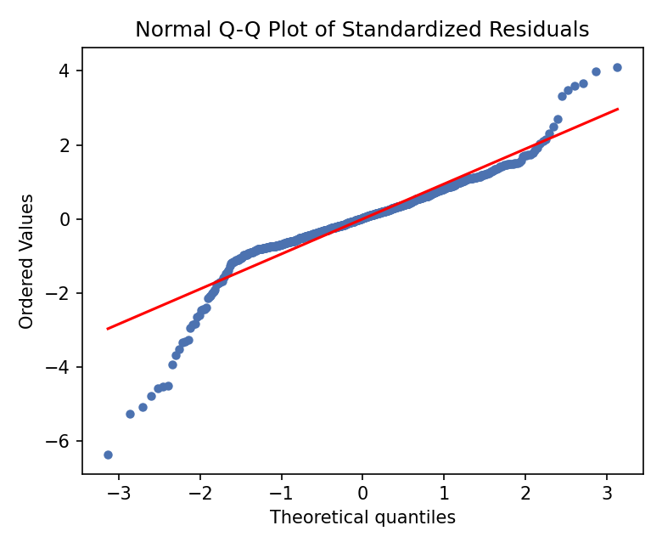
Figure 3. Normal Q-Q plot of standardized residuals.
Residuals track the theoretical normal line reasonably well through the middle of the distribution but deviate substantially in both tails (standardized residuals beyond about ±2), confirming that residuals are not fully normally distributed — consistent with the raw-variable Shapiro-Wilk rejections in Section 2.1. This mainly affects the reliability of prediction intervals rather than the point estimates or R² themselves.

4.3 Scale-Location Plot
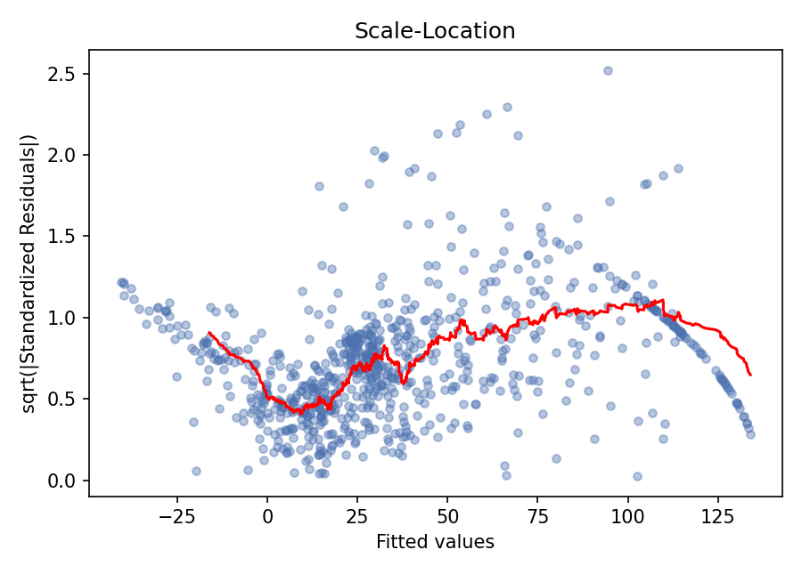
Figure 4. Scale-location plot (spread of standardized residuals vs. fitted values).
The red trend line is not flat — it rises through the low-to-mid fitted range and falls off near the capped ceiling — reinforcing the heteroscedasticity already visible in Figure 2.

4.4 Residuals vs Leverage (Cook's Distance)
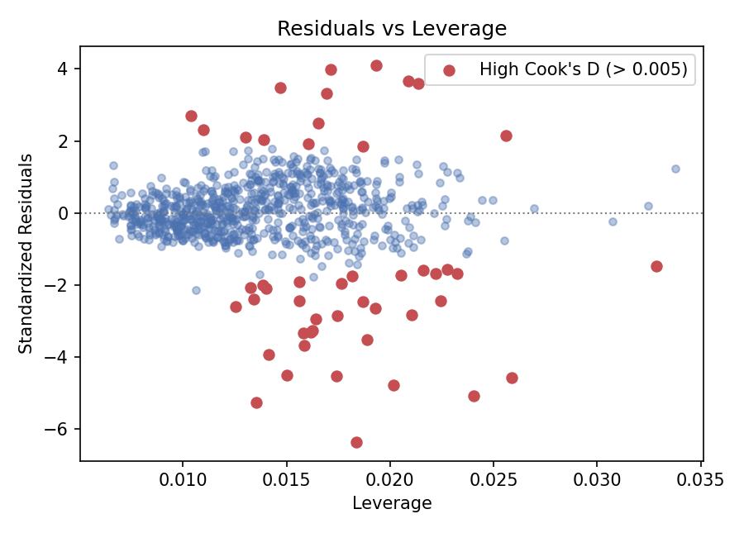
Figure 5. Residuals vs. leverage, with points exceeding the 4/n Cook's-distance heuristic highlighted.
48 of the 800 training observations exceed the conventional 4/n Cook's-distance heuristic, but the maximum Cook's distance observed is only 0.069 — far below the 0.5–1.0 range generally considered concerning for individual-point influence. No single order is disproportionately driving the model's coefficients; the flagged points are a consequence of the moderately large sample size making the 4/n threshold quite strict, not evidence of problematic outliers.

5. Model Performance Summary and Potential Improvements

Strengths
- The model explains roughly 68–70% of the variance in Profit across training, cross-validation, and holdout evaluation alike — a consistent result that suggests genuine, generalizable signal rather than overfitting.
- Sales and Discount are both highly significant, large-effect predictors with signs that match economic intuition (more sales → more profit; more discount → less profit) and the correlations observed in Weeks 1–2.
- Multicollinearity is not a concern (all VIF < 2.4), and cross-validated performance closely matches training performance, indicating a stable model.

Weaknesses and Potential Improvements
- Heteroscedasticity: residual variance is not constant across fitted values. A log or Box-Cox transformation of Profit (handling its negative values with a shifted transform) could stabilize variance and improve inference.
- Non-normal residual tails: a robust regression method (e.g., robust standard errors, or a quantile regression for the median) would give more trustworthy inference than OLS's standard t-tests in the tails.
- The outlier-capping ceiling from Week 1 introduces an artificial linear artifact in the residuals for high-profit orders; refitting on the uncapped Profit with a transformation, or modeling the capped/uncapped distinction explicitly, would avoid this.
- Quantity, Segment, and Region add little predictive value once Sales, Discount, and Category are included; a simplified model (or a regularized approach like LASSO) could be compared to test whether dropping them improves generalization without materially hurting fit.
- Only linear, additive relationships were modeled. An interaction between Discount and Category (since discounting may hurt some categories' margins more than others) or a non-linear model (e.g., random forest or gradient boosting) could be tried and compared against this linear baseline's RMSE of $24.21 on the holdout set.
Overall, the linear regression model provides a solid, interpretable baseline for predicting order profit, with clear statistical support for its two main drivers (Sales and Discount) and honest, cross-validated evidence that it generalizes — while also surfacing concrete, specific directions (variance stabilization, non-linear alternatives, addressing the capping artifact) for improving it further.

Appendix: Full R Script
The complete R script used to produce every statistical test, model, and diagnostic in this report (week3_report.R) accompanies this submission and is also included in the linked GitHub repository.

