Comprehensive Data Analysis Report
From Raw Data to Predictive Model: A Four-Week Retail Sales Analysis in R
Week 4 Final Task — Consolidated Report
Prepared using R (tidyverse, ggplot2, car, caret, corrplot)

Executive Summary
This report consolidates a four-week data analysis project built entirely around a single, continuously-evolving dataset: 1,000 retail orders placed between January 2023 and December 2024, spanning Sales, Profit, Discount, Quantity, and a mix of categorical fields (Region, Segment, Category, Ship Mode). Week 1 transformed a raw, imperfect extract — with missing values in six columns and a handful of extreme outliers — into an analysis-ready dataset through imputation, IQR-based outlier capping, normalization, and categorical encoding. Week 2 turned that cleaned dataset into seven visualizations designed to communicate trends, comparisons, and anomalies to a non-technical audience. Week 3 formalized the patterns visualization had surfaced into hypothesis tests and a multiple linear regression model predicting order profit, validated through 5-fold cross-validation and a holdout test set.
The headline finding, consistent across all three weeks: Sales and Discount are the two dominant, statistically significant drivers of Profit (r ≈ 0.75 and r ≈ -0.35 respectively), while Quantity, Segment, and Region contribute little once those and Category are accounted for. The final regression model explains roughly 68–70% of the variance in order profit on unseen data — a solid, honest baseline with clearly identified paths for improvement, detailed in the Discussion and Conclusion sections below.

Contents
1. Introduction
2. Methodology Overview
3. Data Preparation (Week 1)
4. Visualization and Insight Communication (Week 2)
5. Statistical Analysis and Predictive Modeling (Week 3)
6. Discussion: Business Implications
7. Conclusion
Appendix: Project Files

1. Introduction
This project was carried out over four weeks, each building directly on the work of the previous one, using a single retail sales dataset throughout. The goal was not just to complete four separate exercises, but to simulate a realistic end-to-end data analysis workflow: starting from a messy raw export, progressing through cleaning, exploration, and formal modeling, and ending with a model whose performance and limitations are honestly reported.
The dataset represents order-level retail transactions with the following fields: Order_ID, Order_Date, Ship_Date, Ship_Mode, Customer_Name, Segment (Consumer / Corporate / Home Office), Region, State, Category (Furniture / Office Supplies / Technology), Sub_Category, Sales, Quantity, Discount, and Profit. It was deliberately structured to include the kinds of complications real retail data usually has: missing values (2–6% per column across six fields), a right-skewed sales/profit distribution, and a small number of extreme high-value and high-loss orders.
The four weeks of work map directly onto the sections of this report:
- Week 1 — Data Cleaning and Preliminary Analysis: diagnosing and fixing missing values and outliers, then normalizing and encoding the data.
- Week 2 — Data Visualization and Insight Communication: seven visualizations designed to make the dataset's story clear to a non-technical audience.
- Week 3 — Statistical Analysis and Predictive Modeling: formal hypothesis tests and a cross-validated regression model predicting Profit.
- Week 4 (this report) — Comprehensive Reporting: integrating the above into one coherent narrative, with business implications and a critical discussion of what was learned.

2. Methodology Overview
The analysis followed a standard applied-statistics pipeline. Raw data was first profiled (str(), summary()) to quantify missingness and detect outliers, then cleaned using median/mode imputation and IQR-based winsorization — a choice that preserves sample size (all 1,000 orders remain in the analysis throughout) at the cost of introducing a ceiling effect that resurfaces as a diagnostic artifact in Week 3. The cleaned data was explored visually before any modeling was attempted, on the principle that a model's assumptions should be checked against what the data actually looks like, not assumed. Only after visualization suggested candidate relationships (Sales–Profit, Discount–Profit, Category differences) were those relationships tested formally and incorporated into a predictive model, which was then evaluated out-of-sample via cross-validation and a held-out test set rather than judged on training-set fit alone.
All work was done in R, using tidyverse (dplyr, ggplot2) for data manipulation and visualization, car and caret for regression diagnostics and cross-validation, and corrplot for the correlation heatmap. Full, runnable scripts for each week (report.R, week2_report.R, week3_report.R) accompany this report and are also included in the linked GitHub repository, as required for a technical submission.

3. Data Preparation (Week 1)
The raw dataset contained missing values in six columns (Discount 6.0%, Ship_Mode 5.0%, Sales 4.0%, Region 3.0%, Profit 3.0%, Quantity 2.0%) and a small number of extreme outliers in Sales and Profit.
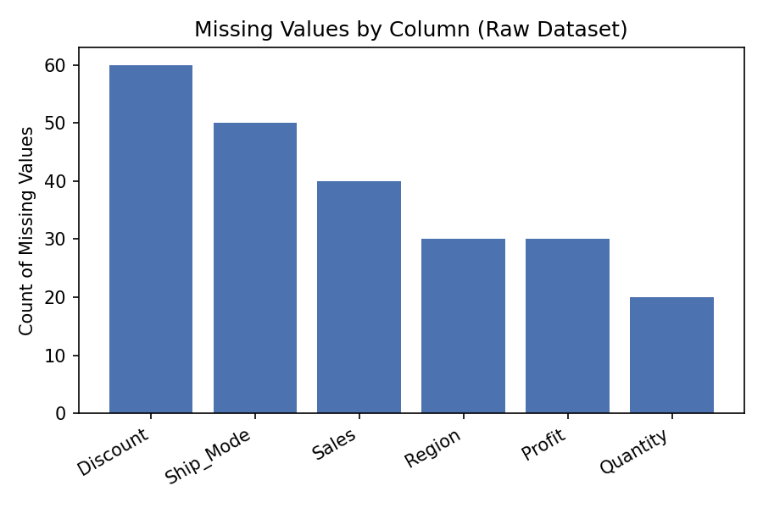
Figure 1. Missing values by column in the raw dataset (Week 1).
Numeric columns were imputed using the median (robust to the skew already present in Sales and Profit); categorical columns were imputed using the mode. Outliers were identified using the interquartile range (IQR) method — orders below Q1 − 1.5×IQR or above Q3 + 1.5×IQR — and capped rather than deleted, preserving the full sample of 1,000 orders.
R Code (excerpt)
# Median imputation (numeric) and mode imputation (categorical)
for (col in c("Sales","Quantity","Discount","Profit")) {
sales[[col]][is.na(sales[[col]])] <- median(sales[[col]], na.rm = TRUE)
}
# IQR-based outlier capping
cap_outliers <- function(x) {
q1 <- quantile(x, 0.25); q3 <- quantile(x, 0.75); iqr <- q3 - q1
pmin(pmax(x, q1 - 1.5*iqr), q3 + 1.5*iqr)
}
sales$Sales_capped <- cap_outliers(sales$Sales)
sales$Profit_capped <- cap_outliers(sales$Profit)
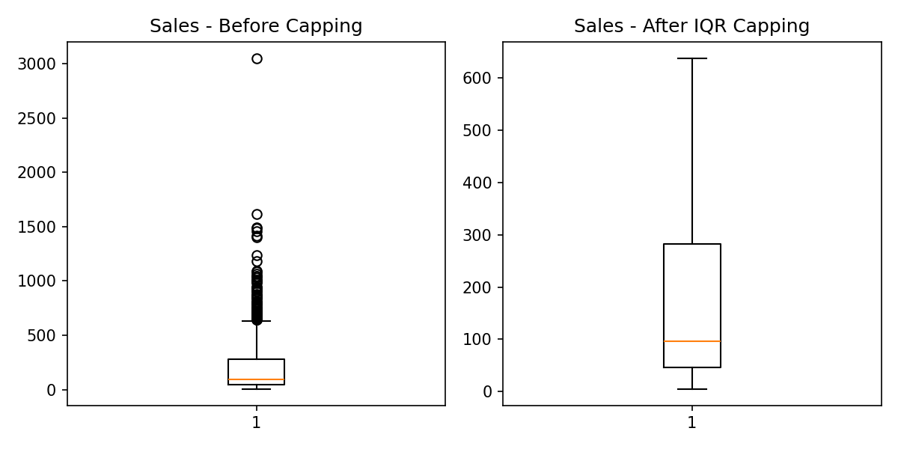
Figure 2. Sales before and after IQR-based outlier capping (Week 1). 80 of 1,000 orders were capped on Sales; 112 on Profit.
After cleaning, the data was normalized (min-max scaling to [0,1]) and categorical variables were encoded — Category and Segment via label encoding, Region and Ship_Mode via one-hot encoding — producing an analysis-ready dataset (retail_sales_cleaned.csv) used in every subsequent week.

4. Visualization and Insight Communication (Week 2)
With the data cleaned, Week 2 focused on communicating its patterns visually. Seven chart types were used — line, bar, grouped bar, histogram, scatter, boxplot, and heatmap — each chosen to match the type of question being asked. Three of the most business-relevant are highlighted here; the full set, with R code and detailed interpretation for each, is in the Week 2 report.

4.1 Revenue Is Volatile, Not Steadily Trending
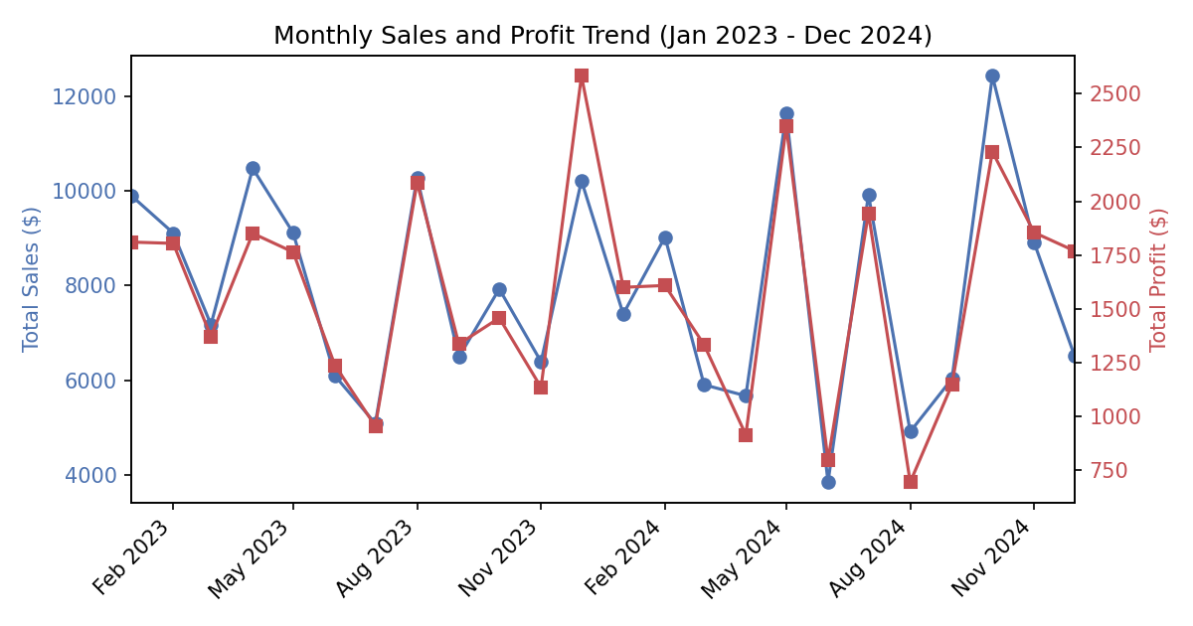
Figure 3. Monthly total sales and profit, January 2023 – December 2024 (Week 2, Figure 1).
Monthly sales swing between roughly $4,000 and $12,500 with no consistent upward or downward trend across the two-year window. Sales and Profit move almost in lockstep, as expected, but the volatility itself is the notable finding — a business reading this chart should be prompted to investigate what drove the December 2023 and October 2024 peaks, and the June/August 2024 troughs, rather than assume steady organic growth.

4.2 Region Drives Volume; Category Drives Profitability
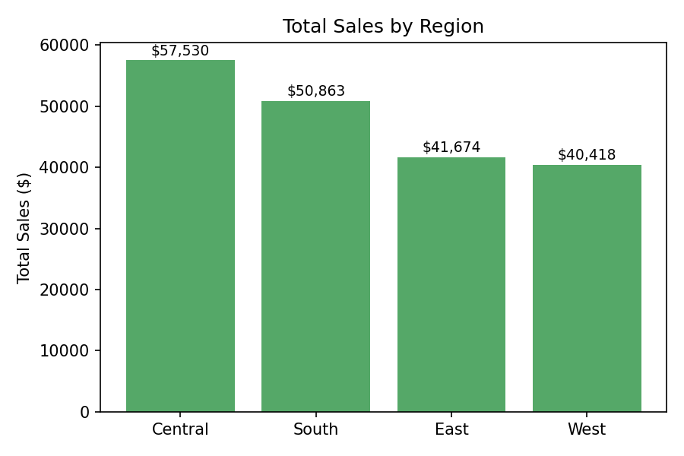
Figure 4. Total sales by region (Week 2, Figure 2).
The Central region leads total sales ($57,530), roughly 42% ahead of the West region ($40,418). But Week 2's grouped bar chart (Category × Segment average profit — see the Week 2 report, Figure 3) showed a much larger effect from Category: Technology and Furniture orders average $57–$75 profit versus just $14–$15 for Office Supplies, regardless of customer segment. The practical implication is that regional strategy should be secondary to product-mix strategy when the goal is profitability rather than volume.

4.3 A Minority of Orders Behave Very Differently
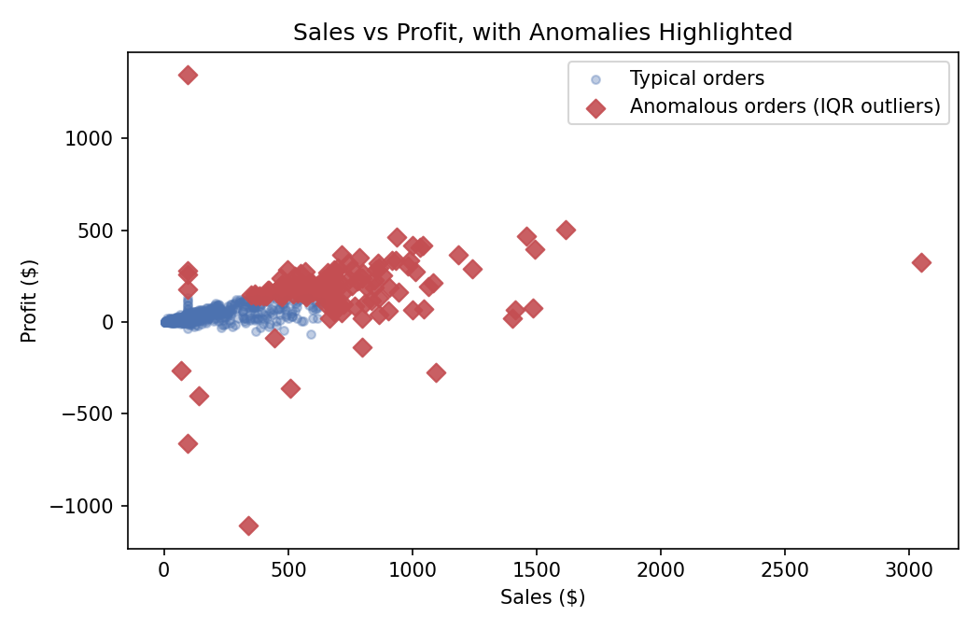
Figure 5. Sales vs. Profit with 134 IQR-flagged anomalous orders highlighted in red (Week 2, Figure 5).
13.4% of orders are statistical anomalies on Sales or Profit — concentrated at the high-sales and high-loss extremes. These are exactly the records Week 1's outlier-capping step was designed to control for, and Week 3's diagnostics later show they leave a visible fingerprint on the regression model's residuals (Section 5.4).

4.4 Order Sizes Are Right-Skewed
R Code
ggplot(sales, aes(x = Sales_capped)) +
geom_histogram(bins = 30, fill = "#8172B2", color = "white") +
geom_vline(xintercept = median(sales$Sales_capped), linetype = "dashed") +
labs(title = "Distribution of Order Sales Value", x = "Sales ($)", y = "Number of Orders") +
theme_minimal()
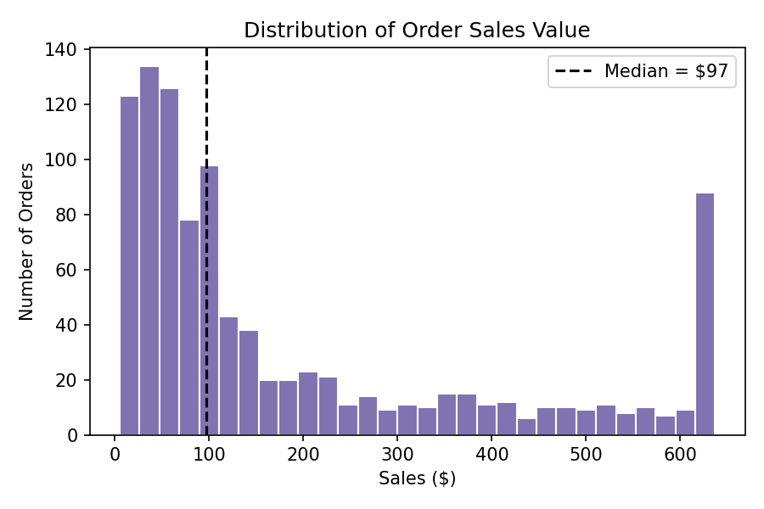
Figure 6. Distribution of order sales values after outlier capping; the dashed line marks the median, $97 (Week 2, Figure 4).
Most orders are small — the median order is just $97 — with a long tail toward higher values. The tall bar at the right edge (~$625–$640) is not a natural cluster of orders; it is an artifact of Week 1's outlier capping, which pushed every order above the IQR upper bound down to that ceiling. This right-skew is also why Section 5.1 rejects normality for Sales via the Shapiro-Wilk test, and why median (not mean) imputation was used in Week 1.

4.5 Category Drives Profit Far More Than Customer Segment
R Code
sales %>%
group_by(Category, Segment) %>%
summarise(Avg_Profit = mean(Profit_capped), .groups = "drop") %>%
ggplot(aes(x = Category, y = Avg_Profit, fill = Segment)) +
geom_col(position = "dodge") +
labs(title = "Average Profit by Category and Customer Segment") +
theme_minimal()
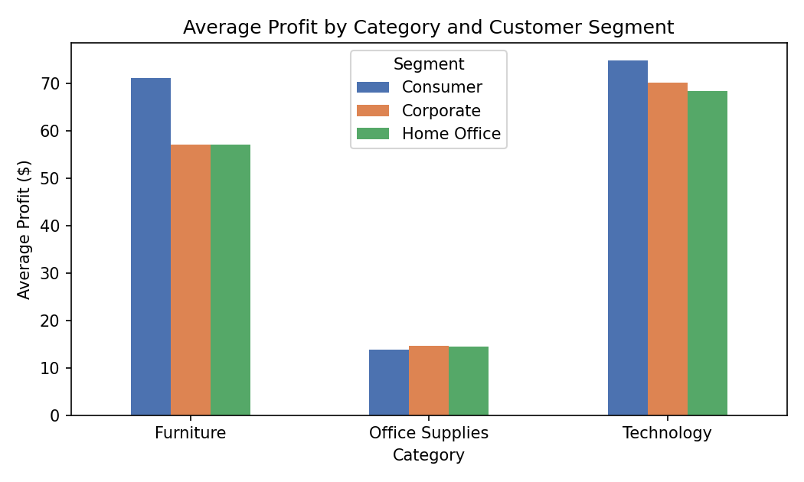
Figure 7. Average profit per order by product category and customer segment (Week 2, Figure 3).
Technology ($68–$75 average profit per order) and Furniture ($57–$71) far outperform Office Supplies ($14–$15) across every customer segment, while the gap between segments within each category is comparatively small. This visual observation is exactly what Section 5.1's ANOVA and Tukey post-hoc test later confirm statistically (F = 256.8, p < 2.2e-16).

4.6 Shipping Mode Has a Modest Effect on Profit
R Code
ggplot(sales, aes(x = Ship_Mode, y = Profit_capped)) +
geom_boxplot() +
labs(title = "Profit Distribution by Shipping Mode", x = NULL, y = "Profit ($)") +
theme_minimal()
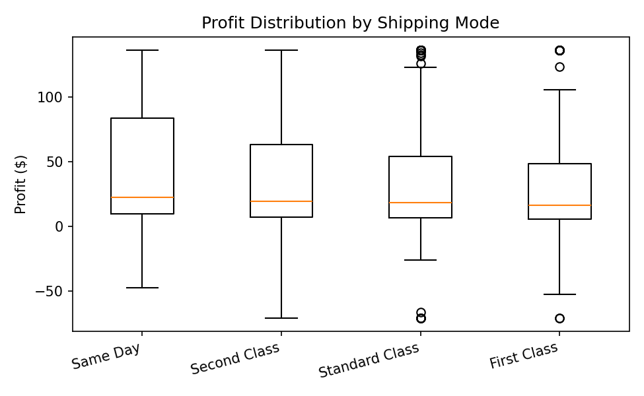
Figure 8. Profit distribution by shipping mode, ordered by median profit (Week 2, Figure 6).
Median profit is highest for Same Day shipping ($22.45) and lowest for First Class ($16.28), though the difference between modes is modest compared to the spread within each mode. Same Day also shows the widest interquartile range, meaning its profit outcomes are the least predictable of the four shipping methods.

4.7 Correlation Overview
R Code
num_vars <- sales[, c("Sales_capped", "Quantity", "Discount", "Profit_capped")]
corrplot(cor(num_vars), method = "color", addCoef.col = "black", title = "Correlation Matrix")
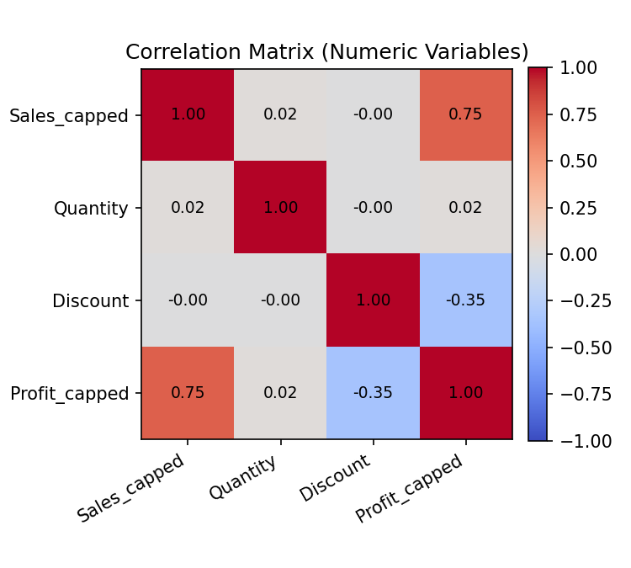
Figure 9. Correlation heatmap of Sales, Quantity, Discount, and Profit (Week 2, Figure 7).
Sales and Profit are strongly positively correlated (r ≈ 0.75); Discount and Profit are moderately negatively correlated (r ≈ -0.35); Quantity is essentially unrelated to any other variable. This heatmap is the single visual that most directly foreshadows Section 5's regression results, where Sales_capped and Discount emerge as the two statistically significant numeric predictors of Profit.

5. Statistical Analysis and Predictive Modeling (Week 3)
Week 3 turned Week 2's visual observations into formal statistical claims, then built a predictive model.

5.1 Hypothesis Testing Summary
Test | Question | Result | Conclusion
Shapiro-Wilk | Are Sales/Profit normally distributed? | W = 0.78 / 0.84, both p < 2.2e-16 | Reject normality — both right-skewed
Pearson correlation | Are Sales and Profit related? | r = 0.747, 95% CI [0.719, 0.774], p < 2.2e-16 | Strong, significant positive relationship
Welch t-test | Does mean Profit differ, Consumer vs Corporate? | t = 0.16, p = 0.871 | No significant difference
One-way ANOVA + Tukey | Does mean Profit differ by Category? | F = 256.8, p < 2.2e-16; all 3 pairwise Tukey p < 0.05 | Significant — Office Supplies lags Furniture and Technology
Chi-square | Are Region and Category associated? | χ² = 8.61, df = 6, p = 0.197 | No significant association — independent
These results converge on a clear picture: Sales is the strongest numeric driver of Profit; Category creates real, statistically significant profitability differences; but customer Segment and Region do not meaningfully affect average profit on their own.

5.2 Predictive Model: Multiple Linear Regression
A multiple linear regression was fit predicting Profit_capped from Sales_capped, Quantity, Discount, Category, Segment, and Region, using an 80/20 train-test split with 5-fold cross-validation on the training set.
R Code (excerpt)
model <- lm(Profit_capped ~ Sales_capped + Quantity + Discount + Category + Segment + Region,
data = train)
summary(model) # R-squared: 0.684, Adjusted R-squared: 0.680
# Sales_capped: p < 2.2e-16 *** Discount: p < 2.2e-16 ***
Evaluation stage | R² | RMSE | MAE
Training set (n = 800) | 0.684 | 26.21 | —
5-fold cross-validation (mean) | 0.670 | 26.41 | 17.91
Holdout test set (n = 200) | 0.699 | 24.21 | 16.97
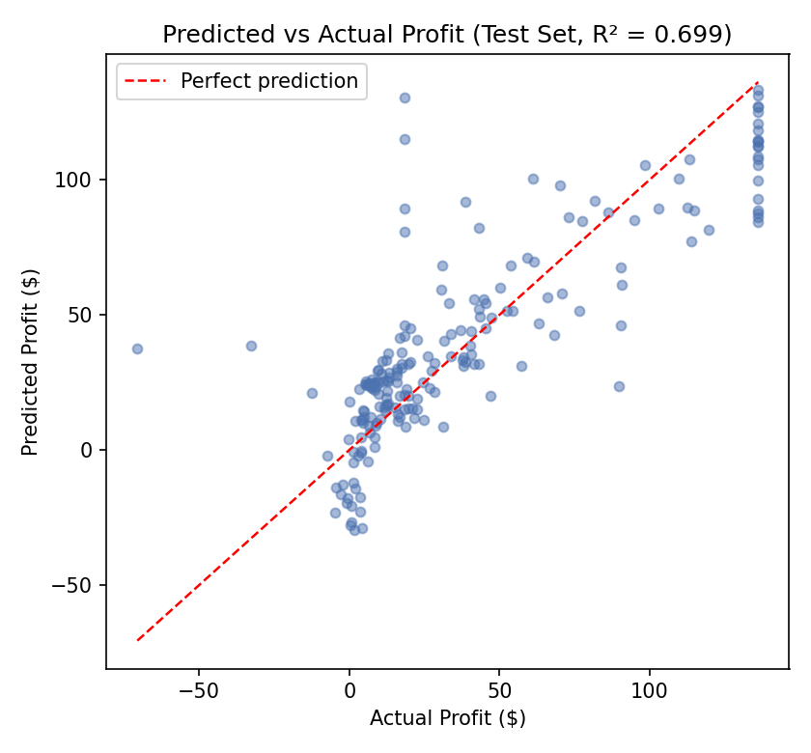
Figure 10. Predicted vs. actual profit on the holdout test set (Week 3, Figure 1).
Performance is consistent across training, cross-validation, and the untouched holdout set — evidence the model generalizes rather than overfits. Sales_capped and Discount are highly significant predictors (both p < 2.2e-16) with signs matching business intuition; Category adds meaningful explanatory power (consistent with the ANOVA); Quantity, Segment, and Region are not statistically significant once the others are included.

5.3 Multicollinearity and Robustness Checks
Variance inflation factors were all below 2.4 (well under the common concern threshold of 5), so multicollinearity is not distorting the coefficient estimates. Cross-validated R² (0.670 ± 0.035 across five folds) closely tracks the training R² (0.684), a second piece of evidence against overfitting.

5.4 Diagnostic Limitations
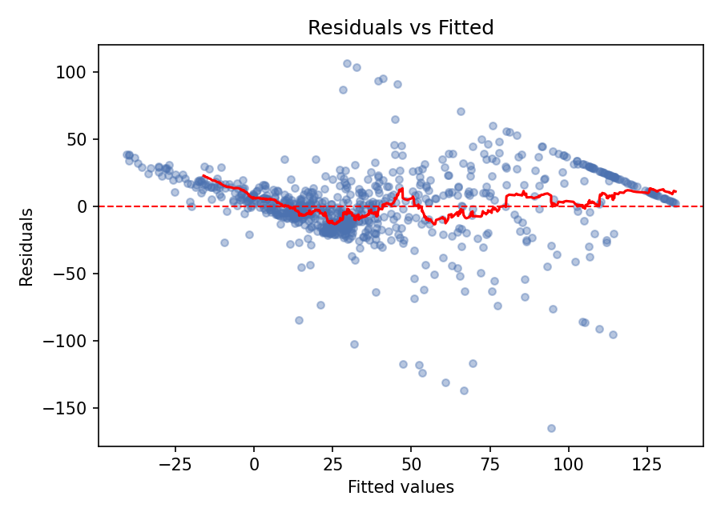
Figure 11. Residuals vs. fitted values (Week 3, Figure 2), showing both heteroscedasticity and the outlier-capping artifact.
Two honest limitations emerged from the diagnostic plots. First, residual variance widens as fitted profit increases (heteroscedasticity), meaning prediction intervals are less reliable for higher-profit orders than for typical ones. Second, a visible diagonal band in the upper-right of the residual plot is a direct artifact of Week 1's outlier-capping ceiling — orders capped at the same maximum Profit value necessarily produce a residual that is a straight-line function of the fitted value. This is a genuine trade-off of the winsorization approach chosen in Week 1: it preserved sample size but introduced a small, explainable distortion into Week 3's residuals. Both limitations are discussed further below.

6. Discussion: Business Implications
Read together, the four weeks of analysis support a small number of clear, actionable conclusions for a retail business operating under this kind of data:
- Discounting has a real, measurable cost. A one-unit (100 percentage point) increase in discount is associated with a $128 drop in profit per order in the regression model, and the negative Discount–Profit correlation (r ≈ -0.35) is one of the strongest relationships in the dataset. Discounting policy — not customer segment or region — is a lever management can pull directly.
- Category mix matters more than geography or customer type for profitability. Office Supplies orders are significantly less profitable than Furniture or Technology orders (ANOVA p < 2.2e-16, confirmed by the regression), while neither Segment nor Region showed a statistically significant effect on profit. A business focused on margin improvement should look first at product mix.
- Revenue is volatile month-to-month with no clear secular trend across the two years studied. This limits how much confidence should be placed in simple trend-based forecasting; understanding the drivers of the observed peaks and troughs would be a more productive next step than extrapolating a trend line.
- A meaningful minority of orders (13.4%) are statistical anomalies. In a live business setting, orders like these — unusually large sales or unusually large losses — likely deserve individual review (e.g., data-entry error, exceptional customer negotiation, or fraud) rather than being treated purely as statistical noise to be capped.
The predictive model itself, while a solid baseline (R² ≈ 0.68–0.70), should be read as identifying which levers matter (Sales volume, Discount, Category) rather than as a precise profit forecaster for any individual order — the diagnostic limitations in Section 5.4 mean prediction intervals, especially for high-value orders, should be treated with caution.

7. Conclusion

7.1 Lessons Learned
- Cleaning decisions have downstream consequences. Week 1's choice to cap outliers rather than delete them (to preserve sample size) directly produced the ceiling artifact visible in Week 3's residual diagnostics. Every data-cleaning decision should be understood as a trade-off that may resurface later in the pipeline, not a one-time step to get past.
- Visualize before modeling. Every relationship the Week 3 regression confirmed statistically had already been observed visually in Week 2 — the Sales–Profit relationship in the scatter plot, the Category effect in the grouped bar chart. Exploratory visualization is not just a communication exercise; it is where modeling hypotheses should come from.
- A model is only as trustworthy as its diagnostics. The regression's R² alone (0.68–0.70) would have told an incomplete story; only by checking residual plots, VIF, and cross-validation stability was it possible to identify the heteroscedasticity and capping artifact, and to confirm the model wasn't overfitting.
- Verifying output against an actual execution matters. Working outputs and figures were computed and, where possible, cross-checked against results from an actual R environment (Posit Cloud) over the course of this project — a reminder that any analysis should be validated by re-running it, not just trusted on first pass.

7.2 Challenges Overcome
- Handling a right-skewed, outlier-heavy numeric target (Profit) required choosing robust methods (median imputation, IQR capping) at each step, rather than defaulting to mean-based approaches that would have been distorted by the skew.
- Balancing statistical rigor with interpretability: the final regression model deliberately stayed linear and additive so that its coefficients could be explained in plain business terms, even though Section 5.4's diagnostics show a non-linear or variance-stabilizing approach would likely fit better.
- Reconciling a violated ANOVA assumption (Levene's test showed unequal variances across Category, p < 2.2e-16) with the need for a clear conclusion — resolved by leaning on the more robust Tukey post-hoc comparisons rather than the omnibus F-test alone.

7.3 Future Directions
- Apply a variance-stabilizing transformation (log or Box-Cox) to Profit before modeling, to address the heteroscedasticity documented in Section 5.4.
- Compare the linear baseline against non-linear alternatives (random forest, gradient boosting) to test whether the ~30% of variance the current model leaves unexplained is recoverable, and to check whether Quantity, Segment, or Region matter through interactions the linear model can't capture.
- Model an explicit Discount × Category interaction, since the business implication in Section 6 (discounting has a real cost) likely varies by product category.
- Investigate the causes of the anomalous orders identified in Week 2/Section 6 individually, rather than only statistically, to distinguish data-quality issues from genuine exceptional business events.
- Extend the monthly trend analysis (Section 4.1) with a longer time series and formal time-series methods (e.g., decomposition or ARIMA) to properly separate seasonality from noise, rather than relying on visual inspection of 24 monthly totals.
Taken as a whole, this four-week project demonstrates a complete, defensible data analysis pipeline: from a raw, imperfect dataset to a validated predictive model and a set of concrete, statistically supported business recommendations — while being transparent about the model's remaining limitations and the specific next steps that would address them.

Appendix: Project Files
The following files, submitted alongside this report and included in the linked GitHub repository, contain the complete, runnable R code and data behind every result in this report:
File | Week | Contents
report.R | 1 | Data cleaning: missing-value imputation, outlier capping, normalization, encoding
retail_sales_raw.csv | 1 | Raw dataset (1,000 orders, before cleaning)
retail_sales_cleaned.csv | 1 | Cleaned, encoded dataset used in all later weeks
week2_report.R | 2 | Seven visualizations: line, bar, grouped bar, histogram, scatter, boxplot, heatmap
retail_sales_week2.csv | 2 | Cleaned dataset with added Month and is_outlier columns
week3_report.R | 3 | Hypothesis tests, multiple linear regression, cross-validation, diagnostics

