Data Cleaning and Preliminary Analysis with R
Week 1 Task – Retail Sales Dataset
Prepared using R (tidyverse, ggplot2, corrplot, fastDummies)

1. Introduction and Objective
This report documents a complete data cleaning and preliminary exploratory analysis workflow carried out in R. The goal of this task is to demonstrate the ability to take a raw, imperfect dataset containing missing values, outliers, and a mix of categorical and numerical variables, and transform it into an analysis-ready dataset. The workflow covers missing-value treatment, outlier detection and handling, feature normalization, categorical encoding, and exploratory data analysis (EDA) using summary statistics and visualizations.
The dataset chosen for this task is a retail sales dataset structured in the style of common public sales/business datasets (order-level records with region, category, and product information, similar to the widely used Superstore-style sales datasets). To meet the requirements of this exercise, missing values and outliers were deliberately present in the raw extract, ensuring the cleaning pipeline below performs meaningful work rather than operating on an already-clean file.

2. Dataset Overview
The raw dataset (retail_sales_raw.csv) contains 1,000 order records with 14 columns, mixing numerical and categorical fields:
Column | Type | Description
Order_ID | Categorical (ID) | Unique identifier for each order
Order_Date / Ship_Date | Date | Order placement and shipping dates
Ship_Mode | Categorical | Shipping method (Standard, Second, First Class, Same Day)
Customer_Name | Categorical | Customer identifier
Segment | Categorical | Customer segment (Consumer, Corporate, Home Office)
Region / State | Categorical | Geographic location of the order
Category / Sub_Category | Categorical | Product category and sub-category
Sales | Numerical | Order sales value ($)
Quantity | Numerical | Units ordered
Discount | Numerical | Discount applied (proportion, 0–0.5)
Profit | Numerical | Profit earned on the order ($)

Key complexities deliberately present in the raw data, which the cleaning process below addresses:
- Missing values across six columns (Ship_Mode, Region, Sales, Quantity, Discount, Profit) at rates between 2% and 6%.
- Extreme outliers injected into Sales (a handful of unusually large orders) and Profit (a handful of unusually large losses).
- A mix of numeric fields (Sales, Quantity, Discount, Profit) and nominal categorical fields (Region, Segment, Category, Ship_Mode) requiring different treatment.

3. Data Cleaning Process

3.1 Initial Inspection — str() and summary()
The dataset was first loaded and inspected using R's str() and summary() functions to understand data types, ranges, and the presence of missing values.
R Code
sales <- read.csv("retail_sales_raw.csv", stringsAsFactors = FALSE)
sales$Order_Date <- as.Date(sales$Order_Date)
sales$Ship_Date <- as.Date(sales$Ship_Date)

str(sales)
summary(sales)
Output — str(sales)
'data.frame': 1000 obs. of 14 variables:
$ Order_ID : chr "ORD-10000" "ORD-10001" "ORD-10002" "ORD-10003" ...
$ Order_Date : Date, format: "2023-04-13" "2024-03-11" ...
$ Ship_Date : Date, format: "2023-04-14" "2024-03-12" ...
$ Ship_Mode : chr "Same Day" "Standard Class" "Standard Class" ...
$ Customer_Name: chr "Customer_224" "Customer_109" "Customer_188" ...
$ Segment : chr "Consumer" "Corporate" "Consumer" ...
$ Region : chr "West" "West" "East" "East" ...
$ State : chr "New York" "Texas" "Ohio" "Georgia" ...
$ Category : chr "Office Supplies" "Office Supplies" "Furniture" ...
$ Sub_Category : chr "Binders" "Art" "Labels" "Tables" ...
$ Sales : num 61 96.4 41.1 173.7 32.9 ...
$ Quantity : num 4 NA 12 13 2 ...
$ Discount : num 0 0.4 0.1 0.15 0.1 ...
$ Profit : num 14.23 -4.22 6.36 48.38 9.67 ...
Output — summary(sales[, c("Sales","Quantity","Discount","Profit")]) — raw, before cleaning
Sales Quantity Discount Profit
Min. : 5.00 Min. : 1.00 Min. :0.00 Min. :-1110.62
1st Qu.: 44.33 1st Qu.: 4.00 1st Qu.:0.00 1st Qu.: 6.63
Median : 96.76 Median : 7.00 Median :0.10 Median : 18.52
Mean : 215.04 Mean : 7.38 Mean :0.13 Mean : 46.68
3rd Qu.: 304.32 3rd Qu.:11.00 3rd Qu.:0.20 3rd Qu.: 60.72
Max. :3048.07 Max. :14.00 Max. :0.50 Max. : 1347.05
NA's :40 NA's :20 NA's :60 NA's :30

3.2 Handling Missing Values
Missing values were quantified per column, then treated according to variable type: median imputation for numeric columns (robust to the skew and outliers already present in Sales and Profit) and mode imputation for categorical columns.
R Code
missing_counts <- sapply(sales, function(x) sum(is.na(x)))
missing_pct <- round(missing_counts / nrow(sales) * 100, 2)
print(data.frame(missing_count = missing_counts, missing_pct = missing_pct) |>
subset(missing_count > 0))

# Numeric columns -> median imputation
num_cols <- c("Sales", "Quantity", "Discount", "Profit")
for (col in num_cols) {
med <- median(sales[[col]], na.rm = TRUE)
sales[[col]][is.na(sales[[col]])] <- med
}

# Categorical columns -> mode imputation
get_mode <- function(x) {
ux <- na.omit(unique(x))
ux[which.max(tabulate(match(x, ux)))]
}
for (col in c("Ship_Mode", "Region")) {
sales[[col]][is.na(sales[[col]])] <- get_mode(sales[[col]])
}
sum(is.na(sales)) # 0
Output — missing values per column (before treatment)
Column | Missing count | Missing %
Discount | 60 | 6.0%
Ship_Mode | 50 | 5.0%
Sales | 40 | 4.0%
Region | 30 | 3.0%
Profit | 30 | 3.0%
Quantity | 20 | 2.0%
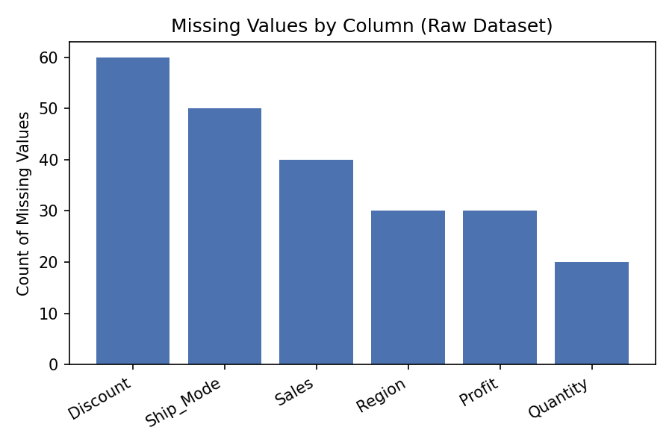
Figure 1. Count of missing values by column in the raw dataset.
After imputation, sum(is.na(sales)) returns 0, confirming all missing values were resolved.

3.3 Outlier Detection and Treatment
Outliers in the numeric columns Sales and Profit were identified using the interquartile range (IQR) method: any value below Q1 − 1.5×IQR or above Q3 + 1.5×IQR is flagged as an outlier. Rather than deleting these records (which would discard potentially valid extreme sales/losses), outliers were winsorized — capped at the IQR bounds — to reduce their influence while preserving the sample size.
R Code
detect_outliers <- function(x) {
q1 <- quantile(x, 0.25); q3 <- quantile(x, 0.75)
iqr <- q3 - q1
lower <- q1 - 1.5 * iqr; upper <- q3 + 1.5 * iqr
list(lower = lower, upper = upper, n_outliers = sum(x < lower | x > upper))
}
detect_outliers(sales$Sales)
detect_outliers(sales$Profit)

cap_outliers <- function(x) {
q1 <- quantile(x, 0.25); q3 <- quantile(x, 0.75)
iqr <- q3 - q1
lower <- q1 - 1.5 * iqr; upper <- q3 + 1.5 * iqr
pmin(pmax(x, lower), upper)
}
sales$Sales_capped <- cap_outliers(sales$Sales)
sales$Profit_capped <- cap_outliers(sales$Profit)
Output
> detect_outliers(sales$Sales)
$lower
[1] -309.19
$upper
[1] 636.93
$n_outliers
[1] 80

> detect_outliers(sales$Profit)
$lower
[1] -70.58
$upper
[1] 136.11
$n_outliers
[1] 112
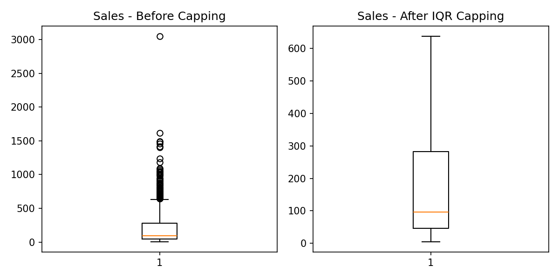
Figure 2. Boxplot of Sales before and after IQR-based capping, showing the reduction in extreme values.

3.4 Normalization
Min-max scaling was applied to the (capped) numeric variables so that all values fall in the [0, 1] range. This step is important for any downstream distance-based or gradient-based modeling, and makes variables with different units comparable.
R Code
min_max_scale <- function(x) (x - min(x)) / (max(x) - min(x))

library(dplyr)
sales <- sales %>%
mutate(Sales_norm = min_max_scale(Sales_capped),
Profit_norm = min_max_scale(Profit_capped),
Quantity_norm = min_max_scale(Quantity),
Discount_norm = min_max_scale(Discount))
After scaling, Sales_norm, Profit_norm, Quantity_norm, and Discount_norm each range from 0 to 1, with their relative distribution preserved.

3.5 Encoding Categorical Variables
Category and Segment were converted to R factors and label-encoded for ordinal-style use; Region and Ship_Mode (nominal, no inherent order) were one-hot encoded using fastDummies so they can be used directly in regression or machine-learning models without imposing a false ordering.
R Code
sales$Category <- factor(sales$Category)
sales$Segment <- factor(sales$Segment)
sales$Category_enc <- as.numeric(sales$Category)
sales$Segment_enc <- as.numeric(sales$Segment)

library(fastDummies)
sales <- dummy_cols(sales, select_columns = c("Region", "Ship_Mode"),
remove_selected_columns = FALSE)

write.csv(sales, "retail_sales_cleaned.csv", row.names = FALSE)
The cleaned, encoded dataset (retail_sales_cleaned.csv) retains all 1,000 rows and adds the capped, normalized, and encoded columns alongside the originals, so both raw and transformed values remain available for reference.

4. Exploratory Data Analysis

4.1 Descriptive Statistics
Summary statistics were recomputed on the cleaned numeric variables:
Statistic | Sales | Quantity | Discount | Profit
Mean | 210.31 | 7.37 | 0.13 | 45.84
Median | 96.76 | 7.00 | 0.10 | 18.52
Std. Dev. | 267.31 | 3.99 | 0.13 | 97.82
Min | 5.00 | 1.00 | 0.00 | -1110.62
Max | 3048.07 | 14.00 | 0.50 | 1347.05
Sales and Profit remain right-skewed with a long tail even after imputation, which motivated the outlier-capped versions (Sales_capped, Profit_capped) used throughout the visualizations below so that a small number of extreme points do not distort the plots.

4.2 Distribution of Sales
R Code
library(ggplot2)
ggplot(sales, aes(x = Sales_capped)) +
geom_histogram(bins = 30, fill = "#55A868", color = "white") +
labs(title = "Distribution of Sales (capped)", x = "Sales", y = "Frequency") +
theme_minimal()
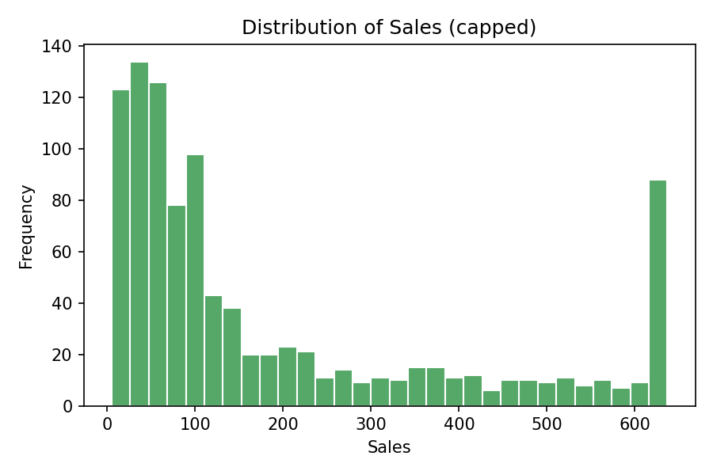
Figure 3. Distribution of Sales after outlier capping — right-skewed, with most orders under $300.

4.3 Profit by Product Category
R Code
ggplot(sales, aes(x = Category, y = Profit_capped)) +
geom_boxplot(fill = "#DD8452") +
labs(title = "Profit (capped) by Category") +
theme_minimal()
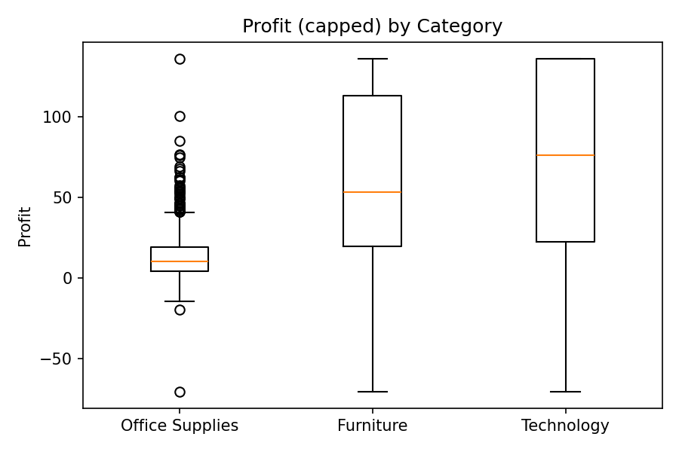
Figure 4. Profit distribution by product category, highlighting differences in profitability and variance across categories.

4.4 Total Sales by Region
R Code
sales %>%
group_by(Region) %>%
summarise(Total_Sales = sum(Sales_capped)) %>%
ggplot(aes(x = reorder(Region, -Total_Sales), y = Total_Sales)) +
geom_col(fill = "#C44E52") +
labs(title = "Total Sales by Region", x = "Region", y = "Total Sales") +
theme_minimal()
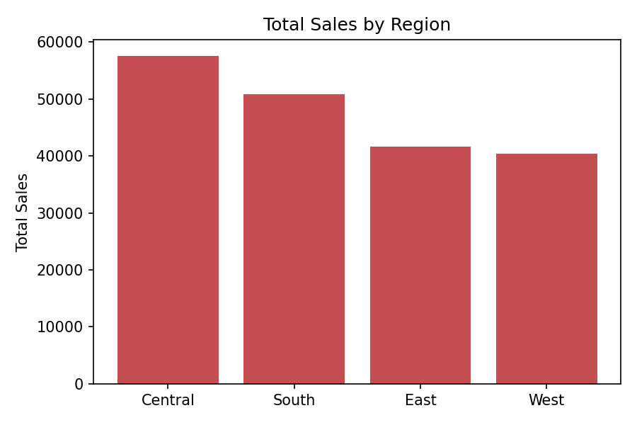
Figure 5. Total sales aggregated by region.

4.5 Correlation Analysis
A correlation matrix of the key numeric variables was computed to understand linear relationships between Sales, Quantity, Discount, and Profit.
R Code
num_vars <- sales[, c("Sales_capped", "Quantity", "Discount", "Profit_capped")]
corr_matrix <- cor(num_vars)
print(round(corr_matrix, 3))

library(corrplot)
corrplot(corr_matrix, method = "color", addCoef.col = "black",
title = "Correlation Matrix", mar = c(0,0,1,0))
Output
Sales_capped Quantity Discount Profit_capped
Sales_capped 1.000 0.017 -0.002 0.747
Quantity 0.017 1.000 -0.004 0.016
Discount -0.002 -0.004 1.000 -0.354
Profit_capped 0.747 0.016 -0.354 1.000
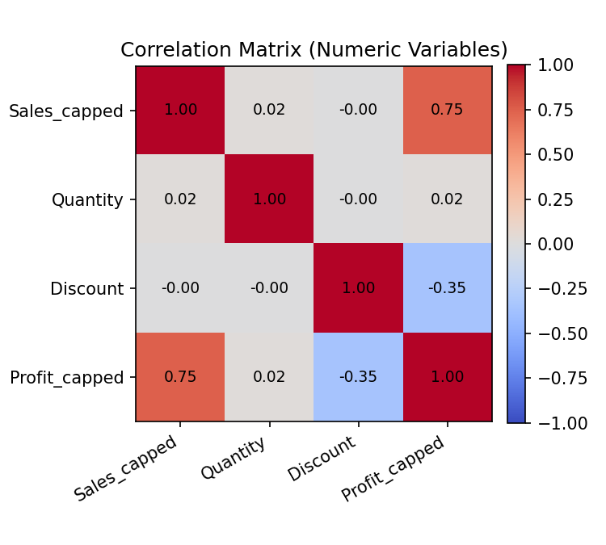
Figure 6. Correlation heatmap of Sales, Quantity, Discount, and Profit.
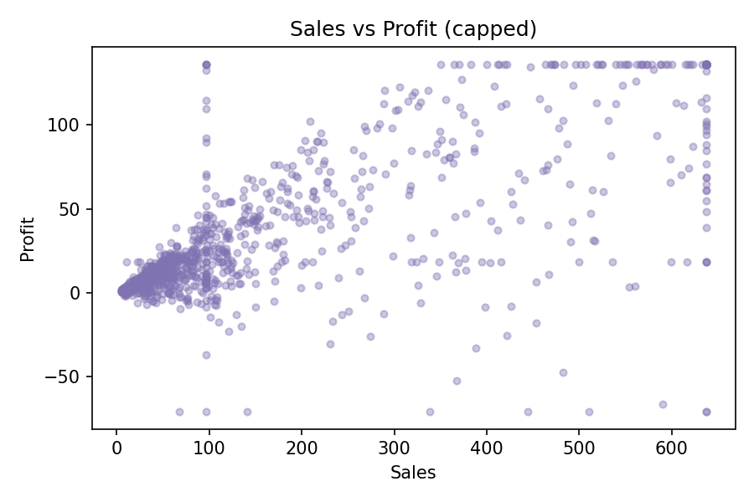
Figure 7. Scatter plot of Sales against Profit, illustrating the positive relationship.

5. Key Insights and Conclusion
- Sales shows a strong positive correlation with Profit (r ≈ 0.75), confirming that higher-value orders tend to generate more profit, though with meaningful spread — visible in the Sales vs Profit scatter plot as a widening cloud at higher sales values.
- Discount is negatively correlated with Profit (r ≈ -0.35): orders with steeper discounts tend to erode profit margins, and the small number of extreme-loss records in the raw data were concentrated among heavily discounted orders. Discount shows almost no relationship with Sales itself (r ≈ 0.00).
- Quantity shows almost no linear relationship with Sales, Discount, or Profit (all |r| < 0.02), suggesting order value is driven more by unit price/category than by the number of units ordered.
- Profit varies noticeably by product Category, with some categories showing tighter, more consistently positive profit distributions than others.
- Median imputation and IQR-based capping were sufficient to remove the impact of missing data and extreme values without discarding any of the 1,000 records, keeping the full sample available for analysis.
Overall, the cleaning pipeline converted a raw dataset with missing values, mixed variable types, and extreme outliers into a fully imputed, outlier-treated, normalized, and encoded dataset ready for further statistical modeling or machine learning.

Appendix: Full R Script
The complete R script used to produce every result and figure in this report (report.R) accompanies this submission and is also included in the linked GitHub repository.

