GENERATE HIGH-QUALITY BLOG CONTENT USING AI
-AI BlogNest API

CONTENTGEN - GENERATE HIGH-QUALITY BLOG CONTENT USING AI

DESCRIPTION:
ContentGen is a modern AI-powered Content Management System designed to simplify blog creation, content organization, and intelligent writing assistance. The application is developed using Node.js and Express.js, while MongoDB serves as the primary database. Mongoose ODM is used to manage database schemas, perform validation, and provide efficient communication between the application and the database.
The system incorporates Google Gemini AI to enhance the content creation process through intelligent features such as AI-based blog generation, FAQ assistance, AI WeatherWise insights, and AI FitTrack recommendations. These features help users generate relevant and personalized content quickly while reducing the effort required for manual content creation.
Security and access management are important components of the system. JWT (JSON Web Token) technology is implemented for secure and stateless user authentication, while role-based access control provides different levels of permissions for Admin, Editor, Author, and Reader users. Passwords are securely protected using bcrypt.js hashing. The application also provides features for managing blogs, categories, tags, comments, and media information, along with advanced search functionality and centralized error handling.
To improve reliability and protect the application from common security threats, the system incorporates request validation, input sanitization, rate limiting, and structured logging. These mechanisms help maintain data integrity, improve system performance, and provide a more secure user experience.
With its modular and scalable architecture, ContentGen combines conventional blogging and content management features with the capabilities of Generative AI. The platform aims to provide a faster, smarter, and more personalized environment for creating, managing, and discovering digital content.
SCENARIO-BASED CASE STUDY
Background
Priya is a content creator who manages multiple blogs but struggles to organize posts, schedule publications, manage categories/tags, and track reader engagement efficiently.
Problem
- Difficulty managing multiple drafts, categories, and tags.
- Limited visibility into post performance and engagement analytics.
- Time-consuming processes for content approval and comment moderation.
- No streamlined system for handling media uploads or metadata.
- Lack of collaborative permission tiers for editors, authors, and administrators.
Solution
The BlogNest backend delivers a centralized, secure API wrapper that decouples application business logic from frontend delivery systems. It introduces an internal permission matrix controlling specialized services for content scheduling, category taxonomy, media path registration, and granular user roles.
Usage
- Author Usage: Creates blog posts, uploads media pathways, organizes content drafts, and reviews their distinct post-performance data.
- Editor/Admin Usage: Accesses protected endpoints to review content queues, change publishing statuses, moderate visitor comments, and orchestrate user privilege upgrades.
- Reader Usage: Queries public list routes to consume posts and invokes comment creation endpoints.
OUTCOME
By offloading workflow controls to a robust backend, content execution delays are minimized. Data structural integrity is strictly maintained through schema validation, security filters guarantee that only authorized roles perform administrative shifts, and persistent tracking provides raw analytics to measure post optimization metrics accurately.
1. Software Requirements
- Operating System: Windows 10/11, macOS, or Linux (supports cross-platform operations).
- Node.js (v16 or above): Runtime ecosystem running server logic and routing infrastructure.
- npm (v8 or above): Node package manager to control operational dependencies.
- Express.js: Lightweight routing web framework to construct backend RESTful entry points.
- MongoDB: Document NoSQL engine storing users, posts, categories, comments, and analytics metrics.
- Postman: API verification toolkit to assert schema validation responses across administrative route shields.
- Code Editor: Visual Studio Code or similar IDE environment.
2. Hardware Requirements
- Processor: Intel Core i5 (8th Gen or above) / AMD Ryzen 5 or equivalent.
- RAM: 8 GB minimum (16 GB recommended for concurrent instances of MongoDB, processing layers, and execution nodes).
- Storage: 1 GB of available disk workspace.
Epic:-1 PROJECT ARCHITECTURE
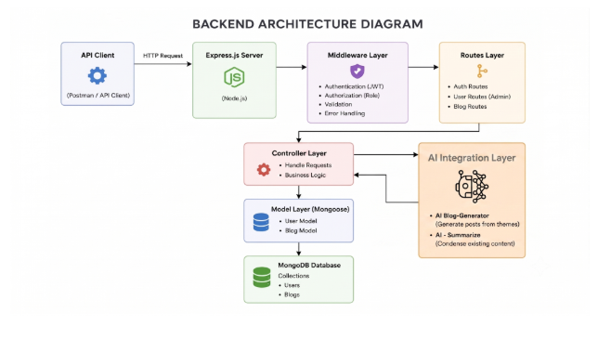
COMPONENTS DEFINITION
- API Interface: Tools such as Postman are used to interact with the application through specific API endpoints and retrieve or submit data in JSON format.
- Express Server Gateway: The Express.js server acts as the main entry point for client requests. It manages network communication, handles HTTP methods such as GET, POST, PUT, and DELETE, processes JSON request bodies, and manages CORS configurations.
- Authentication and Role-Based Middleware: This middleware extracts authentication tokens from request headers, verifies the user's identity, and checks their assigned role before providing access to protected resources. It ensures that permissions are enforced according to roles such as Admin, Editor, Author, and Reader.
- Modular Service Layer: The service layer contains independent modules responsible for implementing the application's core business logic. It manages blog workflows such as Draft, Pending Approval, Scheduled, and Published, along with comment processing and system-level reporting functions.
- Database Access Layer: Mongoose ODM provides an interface between the application and MongoDB. It manages data schemas, validation, and database operations while converting application requests into efficient MongoDB queries.
- AI Integration Service: The AI service provides intelligent content-related functionality, including automated blog generation and content summarization. It communicates with external AI models through dedicated API endpoints such as /api/ai/generate-blog and /api/ai/summarize. This allows the application to perform advanced text-processing tasks and improve the overall content creation workflow.
- AI Blog Generator: The BlogGenerator is a dedicated service responsible for automatically creating blog content with the a

Entity-Relationship (ER) Diagram Description

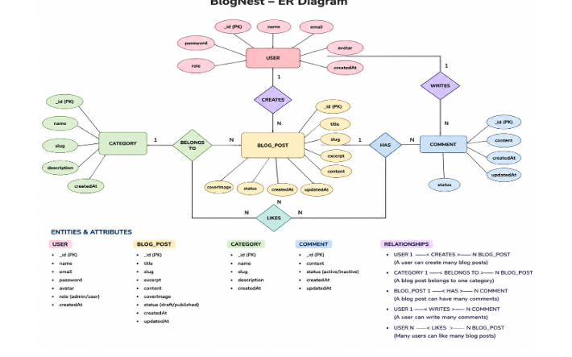
1. User Entity
- _id (Primary Key - ObjectId)
- name (String, Required)
- email (String, Required, Unique)
- password (String, Hashed, Required)
- role (String, Default: "reader")
2. Post Entity
- _id (Primary Key - ObjectId)
- userID (Foreign Key referencing User Collection)
- name (String, Required - represents Title)
- photo (Object/String pathway link)
- message (String - Core content body)
- likes (Number, Default: 0)
- timestamps (True)
KEY STRUCTURAL MAPPINGS
- User to Post (One-to-Many): An author can submit multiple blog documents.
- User to Comment (One-to-Many): Readers/Users can append multiple response comments across independent post nodes.
- Post to Comment (One-to-Many): A single blog document stores individual referenced comment submissions.
KEY FEATURES
- Role-Based Access Control: Secure authentication and authorization mechanisms ensure that users can access or modify resources only according to their assigned roles and permissions.
- Blog CRUD Management: Provides complete Create, Read, Update, and Delete (CRUD) functionality for managing blog posts, including content details, publication status, and associated media assets.
- Category and Tag Management: Organizes blog content using categories and tags, making it easier to filter, search, classify, and discover relevant posts.
- Comment Moderation: Provides controlled access for managing user comments through moderation states such as Approved, Pending, and Spam, helping administrators maintain content quality.
- Input Sanitization and Security: Validates and sanitizes incoming request data to reduce security risks such as Cross-Site Scripting (XSS) and malicious NoSQL query manipulation.
- AI-Powered Blog Generation: Integrates external Large Language Model (LLM) services with structured prompts and contextual inputs to automatically generate complete and well-organized blog posts from user-provided topics.
- Intelligent Content Summarization: Uses AI-based text processing to analyze lengthy articles and generate concise summaries, abstracts, and relevant metadata, making large amounts of content easier to understand.
ROLES AND RESPONSIBILITIES
- Admin: Has the highest level of system access. The Admin can manage user accounts, assign or modify user roles, moderate or remove inappropriate comments, manage system settings, and review application logs.
- Editor: Responsible for managing the editorial workflow. The Editor can review submitted drafts, approve content for publication, update blog information, and maintain categories and tags.
- Author: Has limited content management privileges. Authors can create and manage blog posts associated with their own accounts, subject to the application's approval and publishing workflow.
- Reader: Represents the general user or content-consumer role. Readers can view published blog posts and, after authentication.

MVC ARCHITECTURE PATTERN
The system architecture structures its source configuration layers around the Model-View-Controller design pattern to completely decouple components:
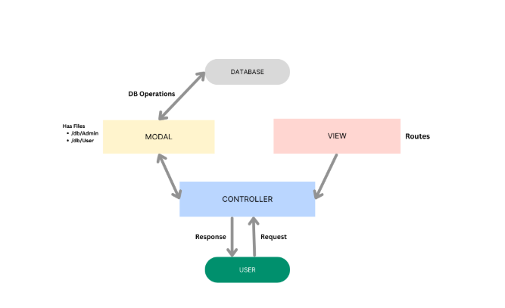

Model Layer (Data Blueprint)
Defines structure blueprints via strongly enforced Mongoose schemas mapping explicit fields into raw collection items inside MongoDB. It sets default states, indexing rules, and transformation parameters before validation persistence occurs.
Controller Layer (Execution Matrix)
The intermediary brain of the ecosystem. It captures request vectors from the execution routes, checks structural request constraints, delegates processing workflows directly to models, and packages the resultant output into standard JSON return arrays.
View Layer (Routing Network Interface)
In this pure headless backend service context, standard user-interface template views do not exist. Instead, the interface layer lives as an API Routing Layer. It links network requests on specified paths directly to their associated controller handler logic maps.

EPIC2: PROJECT SETUP AND CONFIGURATION
Creating project folder
1. Create a new folder with your <project name>.
2. Inside that folder create one new folders.
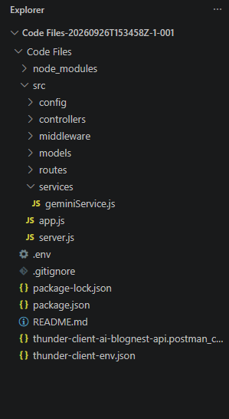

3. Name another one as Server.
4. Now open that folder in VS Code.
Server setup (npm init)
- Open Server folder in terminal of VScode.
  - npm init -y
- Create files:
  - server.js
- Create folders:
  - models
- controllers
- routes
Epic 3: Backend Development
Server.js
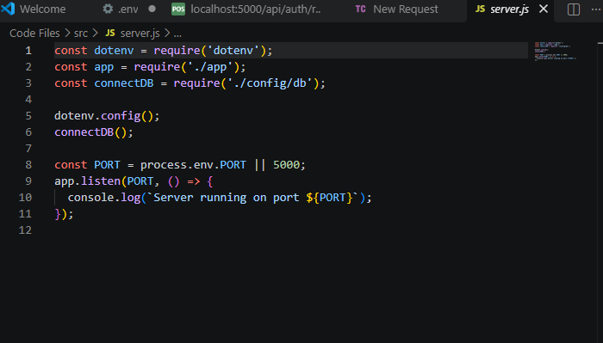

App.js
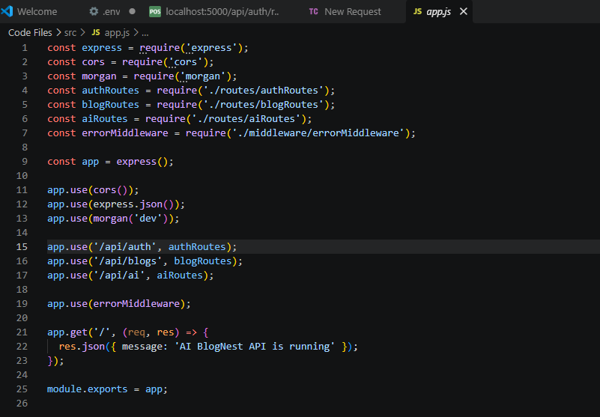
EPIC4: DATABASE CONFIGURATION
DB CONNECTION:-

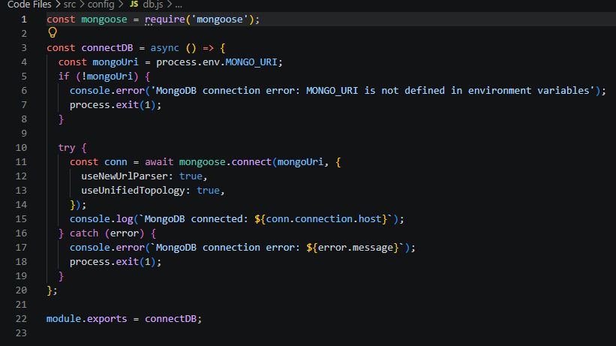

1. Configure MongoDB:
Install Mongoose.
In your Node.js project directory, run:
npm install mongoose
- Create database connection.
- Create Schemas & Models.
Create Database connection:
Now, make sure the database is connected before performing any of the actions through the backend. The connection code looks similar to the one provided below
EPIC 5: PROJECT EXECUTIONS:
· Install Postman or ThunderClient (VS Code extension).
· Start the backend server:
“npm start”

Request:
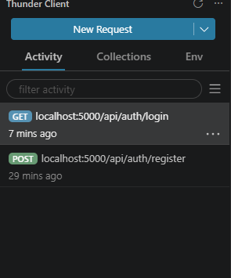

API TESTING
USER REGISTRATION :
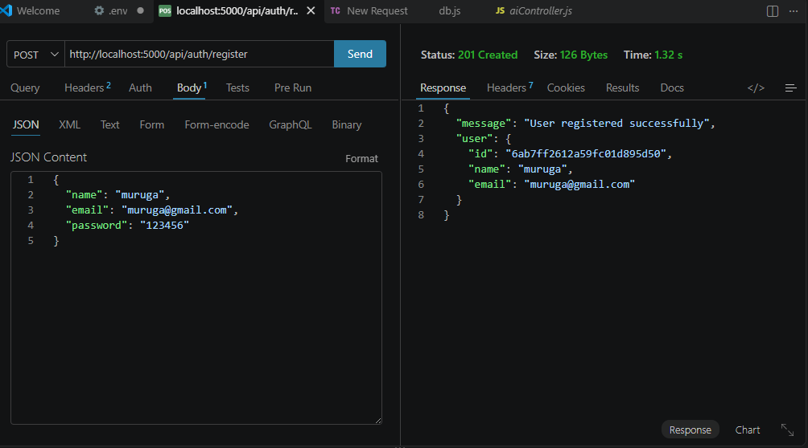USER LOGIN:
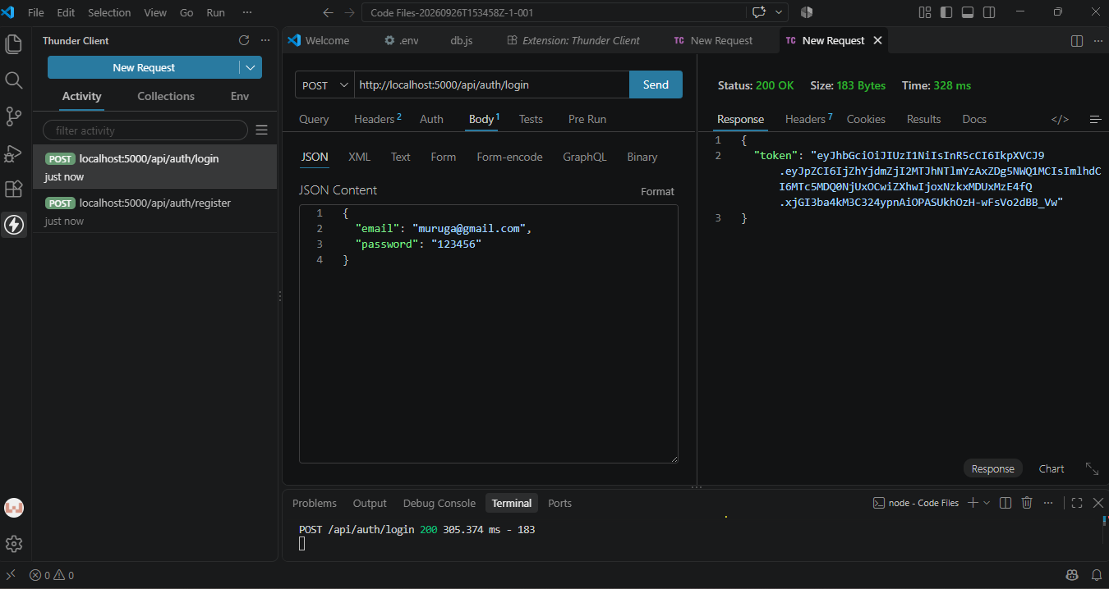

CREATE BLOGS :
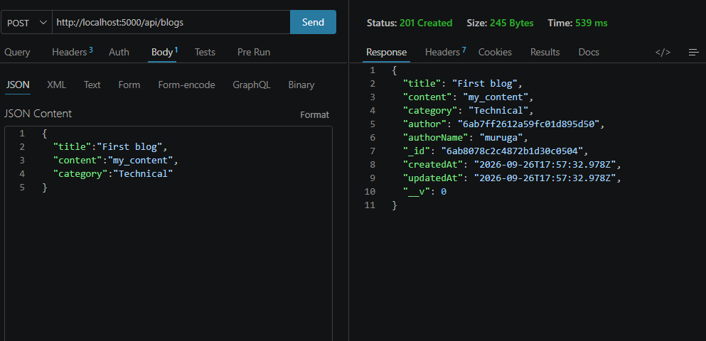
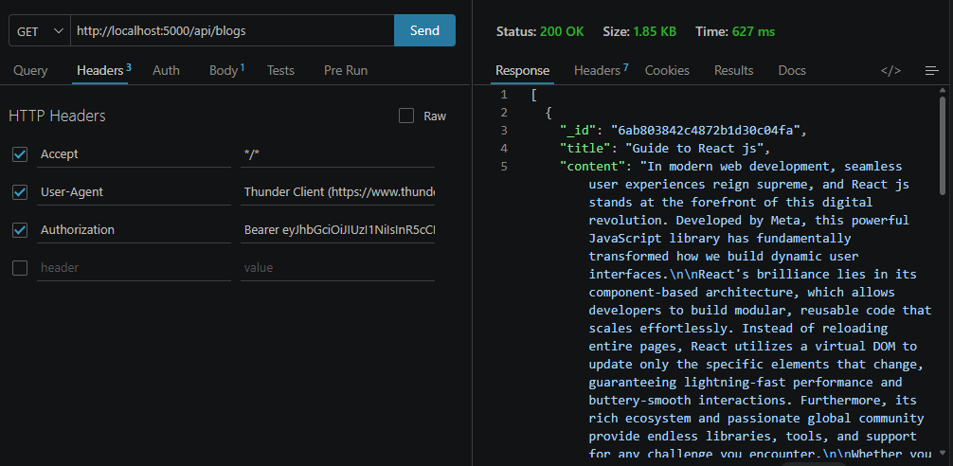

FETCH BLOGS :

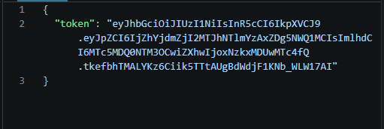
GENERATE AI BLOGS :
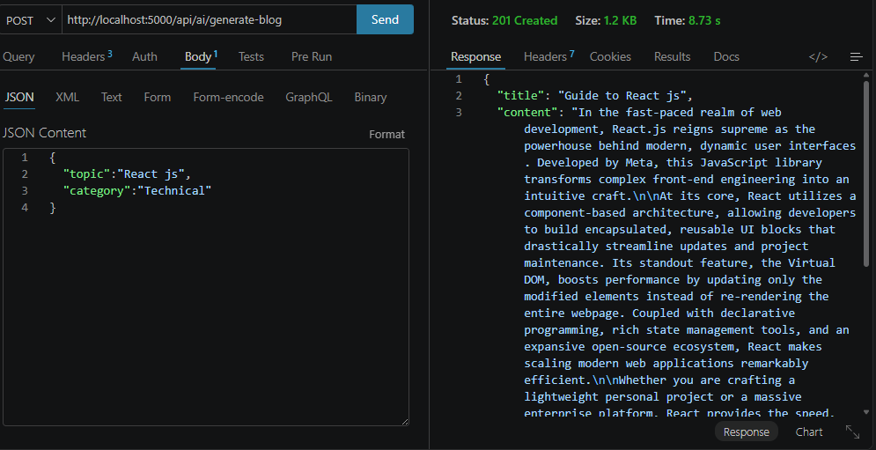
SUMMARIZE BLOGS :
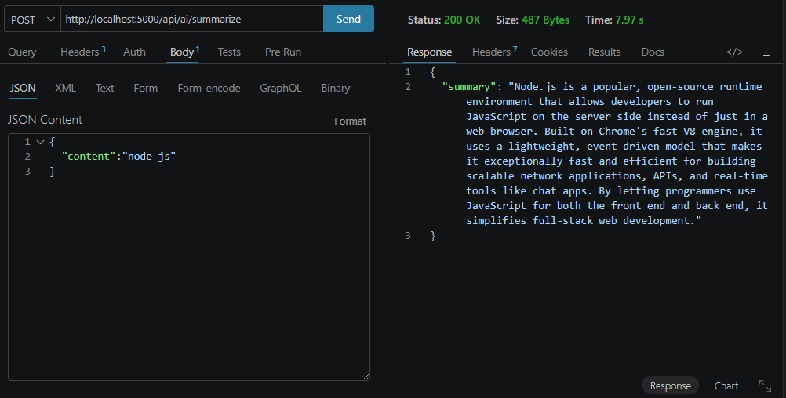

Code link: https://drive.google.com/drive/folders/1WysDpcb9WjjhKBju1kNL5OrPe-R0_NpT?usp=drive_link
Demo video: https://drive.google.com/file/d/1ccWKNtnBTcGD-wMXlmGeVofUsYxDs092/view?usp=drivesdkS

