Automatic Speech Recognition (ASR)

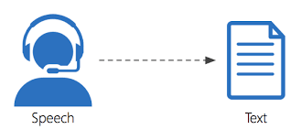

Group 10

- Abstract:
The document provides a comprehensive guide to building Automatic Speech Recognition (ASR) systems using the Kaldi toolkit. It covers various aspects of ASR system development, including data preparation, acoustic modelling, language modelling, decoding, and evaluation.

Table of Contents:
- Introduction to ASR and Kaldi
- Setting up the Environment
- Data Preparation
- Feature Extraction
- Acoustic Modeling
- Language Modeling
- Decoding and Evaluation
- Real-world Applications
- Conclusion and Future Directions
- References

1. Introduction to ASR and Kaldi:

Automatic Speech Recognition (ASR) models use Artificial Intelligence (AI) to process human speech into readable text. ASR models can transcribe audio and video files asynchronously, meaning after the file has been recorded, or synchronously with the aid of real-time transcription models.
Automatic Speech Recognition (ASR) is a technology that enables computers to understand and transcribe spoken language into text format. It is an interdisciplinary field that draws upon various disciplines such as linguistics, signal processing, machine learning, and artificial intelligence. It's a crucial component of many modern applications, including virtual assistants (e.g., Siri, Google Assistant), dictation software, voice search, and interactive voice response systems.
Automatic Speech recognition is one of the best speech processing areas, allowing the machine to understand the user’s speech and convert it to a series of words through a computer program, creating a kind of communication between man and machine. It has greatly contributed to the development of artificial intelligence, which seeks to create very flexible ways to handle a machine. This allows the user to communicate with the machine without using the known input/output modules such as the keyboard. Voice-based input/output techniques are very useful in various areas such as the care of disabled people, the use of cars particularly when driving.

Kaldi is a speech recognition tool written in C++, available on Github . The homepage of the project can be found here.
Kaldi is a tool user for many speech-related tasks, such as:
- Automatic Speech Recogniton (ASR)
- Speaker Verification (SV)
- Speaker Diarization
It implements low-level efficient algorithms and makes them available to the end-user through bash and Python scripts. Kaldi is developed by Johns Hopkins University, and Idiap is a large contributor. The project started in 2009. Many ASR or speech-related companies rely today on Kaldi.
2. Setting up the Environment:
Installation and configuration of Kaldi on Ubuntu/Linux environment.
Setting up the necessary dependencies and tools.
  - Basic dependencies:
Git: To clone the Kaldi repository.
Subversion: Sometimes required by Kaldi for specific data.
wget: For downloading additional resources.
Python: Necessary for some of Kaldi's scripts and tools.
  - Install Kaldi: git clone https://github.com/kaldi-asr/kaldi.git Kaldi --origin upstream

3. Data Preparation:
Collection and preprocessing of speech data for training and testing.
  - Need of speech and its corresponding text to train the model. Used GMM-HMM based acoustic model.

- Collect and Preprocess Data: Gather a large dataset of audio recordings and their corresponding transcriptions. Preprocess the audio data by converting it into a suitable format (e.g., WAV files) and ensuring consistent sampling rates.
- Create Transcriptions: Manually transcribe the audio recordings to create a text corpus that corresponds to the spoken words.

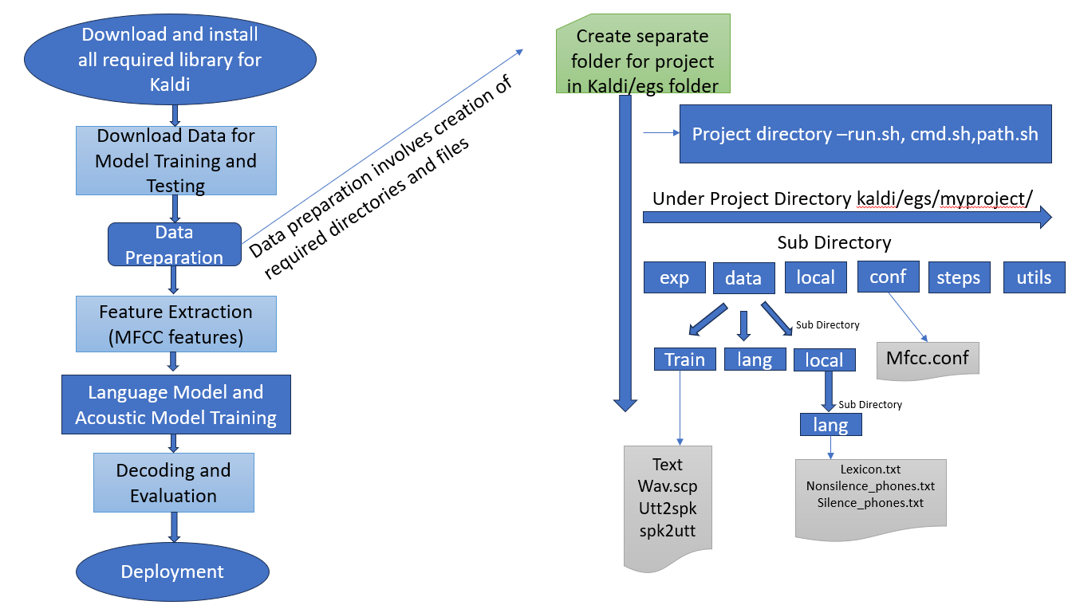

Data Splitting:Training, Validation, and Test Sets: Split the dataset into training, validation, and test sets. This is crucial for evaluating the performance of your ASR system.

Prepare directories: Create the following directories in mycorpus: exp, conf, data. Within data, create the following directories: train, lang, local and local/lang

Create files for data/train: The files in data/train contain information regarding the specifics of the audio files, transcripts, and speakers. Specifically, it will contain the following files:
- wav.scp - file_id path/file
- utt2spk - utt_id spkr
- spk2utt - spkr utt_id1 utt_id2 utt_id3
- text - utt_id WORD1 WORD2 WORD3 WORD4 …

Create files for data/local/lang: data/local/lang is the directory that contains language data specific to our corpus. For example, the lexicon only contains words and their pronunciations that are present in the corpus. This directory will contain the following:
- lexicon.txt
- nonsilence_phones.txt
- optional_silence.txt
- silence_phones.txt
- extra_questions.txt (optional)

Create files for data/lang: The new files located in data/lang are L.fst, L_disambig.fst, oov.int, oov.txt, phones.txt, topo,words.txt, and phones

Set the parallelization wrapper

Create files for conf : create mfcc.conf file which contains --sample-frequency=16000

4. Feature Extraction:
Extraction of acoustic features from speech signals.
Mel Frequency Cepstral Coefficients (MFCCs), filterbanks, and other feature representations.
Feature normalization and processing.
5. Acoustic Modeling:
Introduction to acoustic modeling techniques (e.g., Gaussian Mixture Models, Deep Neural Networks) supported by Kaldi.
Training acoustic models using Kaldi recipes and scripts.
Speaker adaptation and model optimization strategies.

Monophone training and alignment
- Take subset of data for monophone training
- Train monophones
- Align monophones

Triphone training and alignment
- Train delta-based triphones
- Align delta-based triphones
- Train delta + delta-delta triphones
- Align delta + delta-delta triphones
- Train LDA-MLLT triphones
- Align LDA-MLLT triphones with FMLLR
- Train SAT triphones
- Align SAT triphones with FMLLR
6. Language Modelling:
Building language models using Kaldi's tools and utilities.
N-gram models, neural network-based language models, and lattice rescoring techniques.
Handling out-of-vocabulary words and domain-specific language modelling.
7. Decoding and Evaluation:
Decoding process in Kaldi using various decoding algorithms (e.g., Viterbi decoding, lattice generation).
Evaluation metrics for assessing ASR system performance (e.g., Word Error Rate, Sentence Error Rate).
Techniques for analysing and interpreting decoding results.
8. Real-world Applications:
Automatic Speech Recognition (ASR) technology has found diverse applications across various industries, revolutionizing the way we interact with machines and enabling new forms of human-computer interaction. Here's an overview of the applications and use cases of ASR technology across different sectors:
Applications:
1)Voice Assistants:
Siri, Google Assistant, Amazon Alexa.
2)Transcription Services:
Legal, medical, media transcription.
3)Accessibility:
Enabling individuals with disabilities to interact with devices.
4)Call Centers:
Automated voice response systems, call routing.
5)Language Translation:
Real-time language translation services.
6)Healthcare:
Medical dictation and transcription.
7)Education:
Lecture transcription, language learning support.
8)Market Research:
Analyzing customer feedback from recorded calls.
9)Smart Homes:
Voice-controlled smart home systems, Natural language communication between humans and robots.
10)Speech-to-Speech Translation:
Real-time translation of spoken language.
11)Voice-Enabled Search and Information Retrieval:
Voice-enabled search engines.
12)Automated Voice Response (IVR) Systems:
Automated telephony services.

9. Challenges in ASR:
1) Noise and Variability:
ASR systems struggle with background noise, accents, speech rates, and various speaking styles.
2)Out-of-Vocabulary Words:
Difficulty in recognizing words not present in the training data, especially names, technical terms, or slang.
3)Speaker Diarization:
Identifying and distinguishing between different speakers in an audio stream.
4)Resource-Intensive Training:
Training accurate ASR models requires large amounts of labeled data and significant computational resources.
5)Low-Resource Languages:
Developing ASR models for languages with limited training data.
6)Emotional Speech Recognition:
Recognizing emotions from speech accurately.
7)Code-Switching:
Recognizing and transcribing speech involving switching between multiple languages.
8)Low-Resource Accents:
ASR models may struggle with accents with limited training data.

10. References:

1) ExKaldi-RT: A Real-Time Automatic Speech Recognition Extension Toolkit of Kaldi -3 Apr 2021- https://paperswithcode.com/paper/exkaldi-rt-a-real-time-automatic-speech

2) PyKaldi2: Yet another speech toolkit based on Kaldi and PyTorch - 12 Jul 2019 - https://paperswithcode.com/paper/pykaldi2-yet-another-speech-toolkit-based-on

3)https://maelfabien.github.io/machinelearning/speech_reco/#

4) https://huggingface.co/tasks/automatic-speech-recognition

5) https://www.gladia.io/blog/an-introduction-to-asr-speaker-recognition-identification-verification-and-diarization

