Automatic Speech Recognition (ASR)
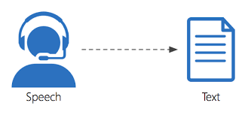

GROUP 10

International Institute of Information Technology,
Hyderabad
in association with Talent Sprint

ABSTRACT

Automatic speech recognition, which was considered to be a concept of science fiction and which has been hit by number of performance degrading factors, is now an important part of information and communication technology.
The main task of automatic speech recognition (ASR) is to convert voice signals to text transcriptions. It is one of the most important research fields in natural language processing (NLP). With more than a half century of endeavour, the word error rate (WER), which is a metric unit for transcription performance, has significantly been reduced. Particularly in recent years, due to the increase of computational power, large quantity of collected data, and efficient neural learning algorithms, the dominant power of deep learning technology further enhanced the performance of ASR systems to a practical level. However, there are still many issues that need to be further investigated for these systems to be adapted to a wide range of applications. In this chapter, we will introduce the main stream and pipeline of ASR frameworks, particularly the two dominant frameworks, i.e., Hidden Markov Model (HMM) with Gaussian Mixture model (GMM)-based ASR which dominated the field in the early decades, and deep learning model-based ASR which dominates the techniques used now. In addition, noisy robustness, which is one of the most important challenges for ASR in real applications, will also be introduced.

Title of study | Automatic Speech Recognition (ASR)
Created by | Pavithra Rajendrababu
Framework | Kaldi- GMM-HMM Model
API and Frontend | FASTAPI-Swagger UI, Gradio for frontend
Operating Systems | Windows-installed Ubuntu 22.04.3 LTS
Date of the report | 09-02-2024
NOTE | Install all required libraries for Kaldi framework for which system specifications should reach the expectations to install all required libraries and run the huge set of data which will be for more than 30 hrs.  Minimum 8 GB of RAM is recommended for basic processing tasks  Ubuntu LTS installed on Windows using WSL  Ensure that you have the necessary dependencies and libraries installed on your Ubuntu LTS system for running Kaldi.

INTRODUCTION

Automatic Speech Recognition (ASR) is a technology that enables computers to understand and transcribe spoken language into text format. It is an interdisciplinary field that draws upon various disciplines such as linguistics, signal processing, machine learning, and artificial intelligence. It's a crucial component of many modern applications, including virtual assistants (e.g., Siri, Google Assistant), dictation software, voice search, and interactive voice response systems.
Automatic Speech recognition is one of the best speech processing areas, allowing the machine to understand the user’s speech and convert it to a series of words through a computer program, creating a kind of communication between man and machine. It has greatly contributed to the development of artificial intelligence, which seeks to create very flexible ways to handle a machine. This allows the user to communicate with the machine without using the known input/output modules such as the keyboard. Voice-based input/output techniques are very useful in various areas such as the care of disabled people, the use of cars particularly when driving.

Some of the speech-related tasks involve:
- speaker diarization: which speaker spoke when?
- speaker recognition: who spoke?
- spoken language understanding: what’s the meaning?
- sentiment analysis: how does the speaker feel?
The classical pipeline in an ASR-powered application involves the Speech-to-text, Natural Language Processing and Text-to-speech.
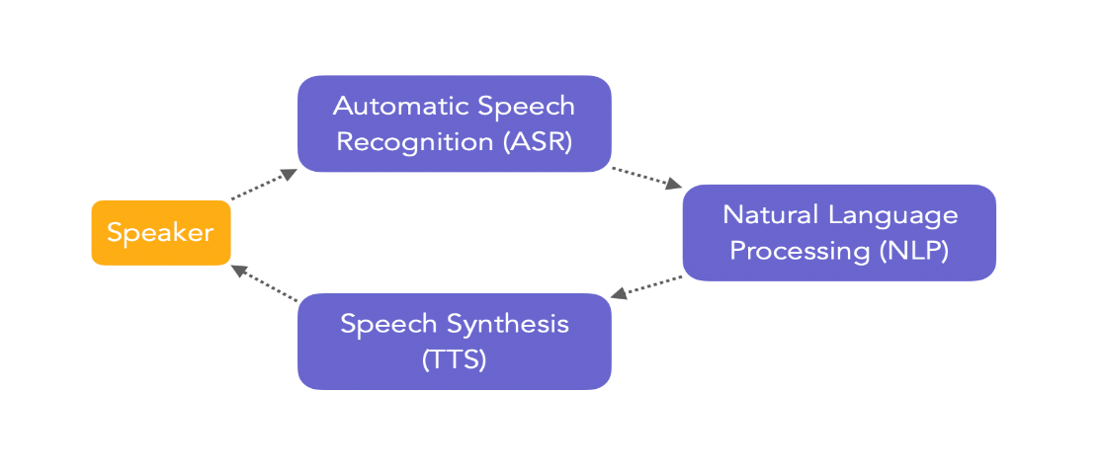
ASR is not easy since there are lots of variabilities:
- acoustics:
  - variability between speakers (inter-speaker)
  - variability for the same speaker (intra-speaker)
  - noise, reverberation in the room, environment…
- phonetics:
  - articulation
  - elisions (grouping some words, not pronouncing them)
  - words with similar pronunciation
- linguistics:
  - size of vocabulary
  - word variations
From a Machine Learning perspective, ASR is also really hard:
- very high dimensional output space, and a complex sequence to sequence problem
- few annotated training data
- data is noisy

Literature Review:

Automatic Speech Recognition (ASR)
Automatic Speech Recognition is defined as the graphical representation of frequencies emitted as a function of time. It is the process of deriving the speech transcription which is the Word Sequence in which the focus is on the shape of the speech wave. Voice recognition can have several applications such as:
- Inquiry systems
- Automatic call handling
- Disabled assistance, vocal dictation
- Voice services: weather reports, speaking clock, etc.

Characteristics of Speech Recognition:

Speech can be categorized as following:
- Isolated Words: This requires a quite (silence space) between utterances so that the user’s voice is more easily recognized.
- Connected Words: Similar to isolated words, the difference between them is to allow separate words to run-together having minimum pause between the words.
- Continues Speech: The users talk normally but the computer selects the content. It is one the most difficult systems.
- Spontaneous Speech: The user’s speech sounds more natural not rehearsed.
- Vocabulary Size

Architecture of ASR
Signal Analysis
Decoder
Language Model
Pronunciation Model
Acoustic Model
Text

Speech

Speech signal analysis is the beginning of processing the signal by breaking it down to small frame size, to segment the input signal which is intended to make analysis on speech segments. There are methods to perform speech analysis:
- Segmentation Analysis : The objective of this step is to extract speaker’s information of frame size 10 to 30ms(APPROX.).
- Sub-Segmentation Analysis : This step is used to extract and analyze the characteristics of the excitation state of the signal of frame size 3 to 5ms(APPROX.).
- Supra-Segmentation Analysis : In this step analyze the characteristics of the speaker's behavior.
- Decoder: Speech to Text : it is the combination of Language Model, Pronunciation Model and Acoustic Model to provide the most likely text transcription from the input speech.
- Language Model : Language Model can be divided into 2 groups :
- Deterministic Model: also called a grammatical model which is determined by experts.
- Stochastic Model : also called a statistical model which are the results of an unsupervised language model which is estimated on learning corpus.
- Pronunciation Model : Building a language model as to how to write a word
- Acoustic Model : This model allows us to predict the phonemes from the audio input.

Speech Recognition Algorithms
The vagaries of human tone make it quite challenging for the development of speech recognition systems. The accuracy of speech recognition is determined by Word Error Rate(WER) and Speed. There are a number of factors that affect the word error rate(WER) such as; pronunciation, accent, pitch, volume and background noise etc; Various algorithms and computation techniques are used to improve the accuracy of the text transcription from speech inputs. Some of the algorithms used are :
- Natural Language Processing(NLP): it is the area of artificial intelligence which focuses on the interaction between humans and machines through language through speech and text. Many mobile devices incorporate speech recognition into their systems to conduct voice search to provide more accessibility around texting.
- Hidden Markov Model(HMM): Hidden Markov Models build on the Markov chain model, which stipulates that the probability of a given state hinges on the current state, not its prior states.The Markov chain model is useful for observable events, such as text inputs, hidden markov models allow us to incorporate hidden events, such as part-of-speech tags, into a probabilistic model. They are utilized as sequence models within speech recognition, assigning labels to each unit—i.e. words, syllables, sentences, etc.—in the sequence. These labels create a mapping with the provided input, allowing it to determine the most appropriate label sequence.
- N-grams: This one of the simplest Language Models.which assigns probabilities to sentences or phrases.N-grams are sequence of words like Bigrams, Trigrams,etc; Grammar and probability are used to attain good accuracy and recognition.
- Speaker Diarization(SD): Speaker Diarization algorithms identify speech by speaker identity. This helps programs to better distinguish the speakers in a conversation. The SD algorithms are applied in call-centers to better differentiate between sales agent and customers.

Methodology and Components of ASR:

Automatic Speech Recognition System using KALDI from scratch


Automatic Speech Recognition (ASR) using Kaldi and Python involves several steps. Kaldi is a powerful open-source toolkit for speech recognition that provides tools for building ASR systems.
It also contains recipes for training your own acoustic models on commonly used speech corpora such as the Wall Street Journal Corpus, TIMIT, and more. These recipes can also serve as a template for training acoustic models on your own speech data.
Data Preparation:
Collect and Preprocess Data: Gather a large dataset of audio recordings and their corresponding transcriptions. Preprocess the audio data by converting it into a suitable format (e.g., WAV files) and ensuring consistent sampling rates.
Create Transcriptions: Manually transcribe the audio recordings to create a text corpus that corresponds to the spoken words.

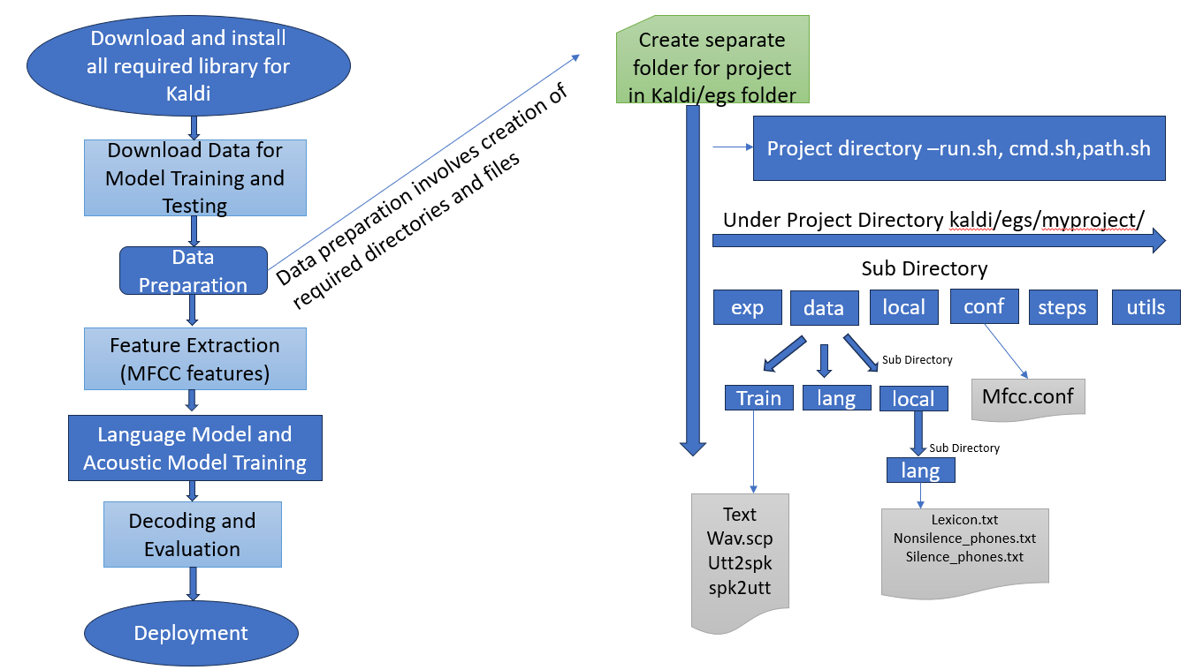

Feature Extraction:MFCC (Mel-Frequency Cepstral Coefficients): Extract MFCC features from the audio data. Kaldi provides tools for feature extraction, and you can use Python to script the process. This step involves converting the audio signal into a sequence of feature vectors.
Data Splitting:Training, Validation, and Test Sets: Split the dataset into training, validation, and test sets. This is crucial for evaluating the performance of your ASR system.
Language Model:Create Language Model: Build a language model using the transcriptions. You can use tools like SRILM (SRI Language Modeling toolkit) or other language modeling libraries. The language model helps the ASR system understand the likelihood of word sequences.
Acoustic Model:
Training: Train the acoustic model using the training set. Kaldi provides tools for training Hidden Markov Models (HMMs) and Gaussian Mixture Models (GMMs).
Feature Alignment: Align the extracted features with the transcriptions to create training alignments.
Decoding:Decoding with the Language Model: Use the trained acoustic model and the language model to perform decoding on the test set. Kaldi's decoding tools allow you to recognize spoken words based on the input audio.
Evaluation:WER (Word Error Rate): Evaluate the performance of your ASR system using metrics like Word Error Rate. Compare the recognized transcriptions with the ground truth.
Integration with Python:System Integration: Develop a Python script to integrate the different steps of ASR, from data preparation to evaluation. You can use Python to automate the process, manage data, and invoke Kaldi tools.
Optimization:Fine-tuning: Based on the evaluation results, fine-tune your ASR system. This may involve adjusting model parameters, retraining the model with more data, or refining the language model.
Deployment:Integration with Applications: If you plan to deploy your ASR system in real-world applications, integrate it with your desired applications using Python. This may involve using frameworks like Flask for creating APIs or integrating with other services.

Working of ASR:

There are two main approaches to Automatic Speech Recognition: a traditional hybrid approach and an end-to-end Deep Learning approach.
Traditional Hybrid Approach
The traditional hybrid approach is the legacy approach to Speech Recognition and has dominated the field for the past fifteen years. Many companies still rely on this traditional hybrid approach simply because it’s the way it has always been done--there is more knowledge around how to build a robust model because of the extensive research and training data available, despite plateaus in accuracy.
Here’s how it works:
Traditional HMM and GMM systems
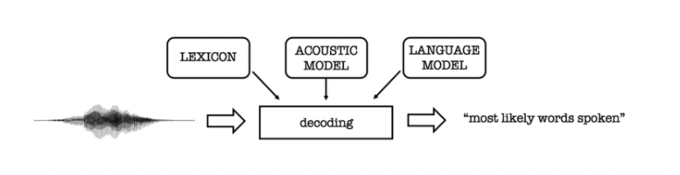
Traditional HMM (Hidden Markov Models) and GMM (Gaussian Mixture Models) require forced aligned data. Force alignment is the process of taking the text transcription of an audio speech segment and determining where in time particular words occur in the speech segment.
As you can see in the above illustration, this approach combines a lexicon model + an acoustic model + a language model to make transcription predictions.
Each step is defined in more detail below:
Lexicon Model
The lexicon model describes how words are pronounced phonetically. You usually need a custom phoneme set for each language, handcrafted by expert phoneticians.
Acoustic Model
The acoustic model (AM), models the acoustic patterns of speech. The job of the acoustic model is to predict which sound or phoneme is being spoken at each speech segment from the forced aligned data. The acoustic model is usually of an HMM or GMM variant.
Language Model
The language model (LM) models the statistics of language. It learns which sequences of words are most likely to be spoken, and its job is to predict which words will follow on from the current words and with what probability.
Decoding
Decoding is a process of utilizing the lexicon, acoustic, and language model to produce a transcript.
Downsides of Using the Traditional Hybrid Approach
Though still widely used, the traditional hybrid approach to Speech Recognition does have a few drawbacks. Lower accuracy, as discussed previously, is the biggest. In addition, each model must be trained independently, making them time and labor intensive. Forced aligned data is also difficult to come by and a significant amount of human labor is needed, making them less accessible. Finally, experts are needed to build a custom phonetic set in order to boost the model’s accuracy.

Steps in process:

- Required Library and tools:

  - Basic dependencies:
Git: To clone the Kaldi repository.
Subversion: Sometimes required by Kaldi for specific data.
wget: For downloading additional resources.
Python: Necessary for some of Kaldi's scripts and tools.
  - Install Kaldi: git clone https://github.com/kaldi-asr/kaldi.git Kaldi --origin upstream

- Data preparations and Download data.
- Divide data for training and testing.
- Create directories and files required for acoustic and language model training for train and test data.
- GMM-HMM based acoustic model to train and fine tune the model to reduce the WER.
- Installed fastapi, gradio.
- Using FASTAPI and swagger UI – upload the audio and get the corresponding text.
- For demo purpose deploy the model using Gradio for frontend.

FastAPI :
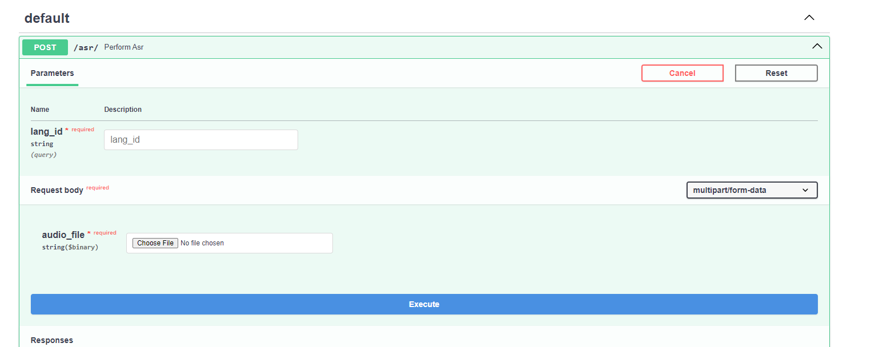
FASTAPI Response:

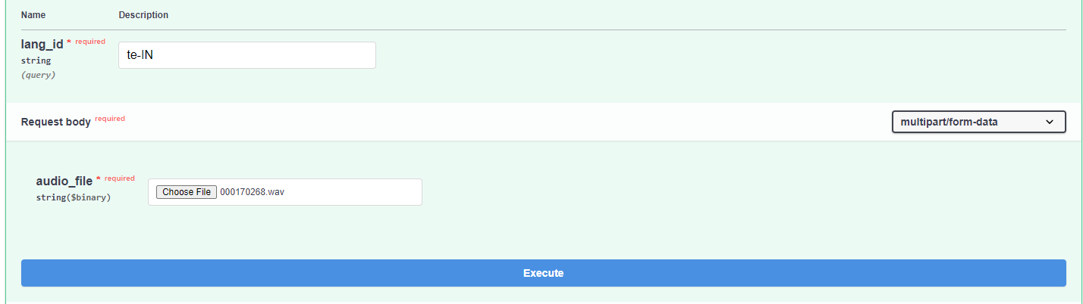

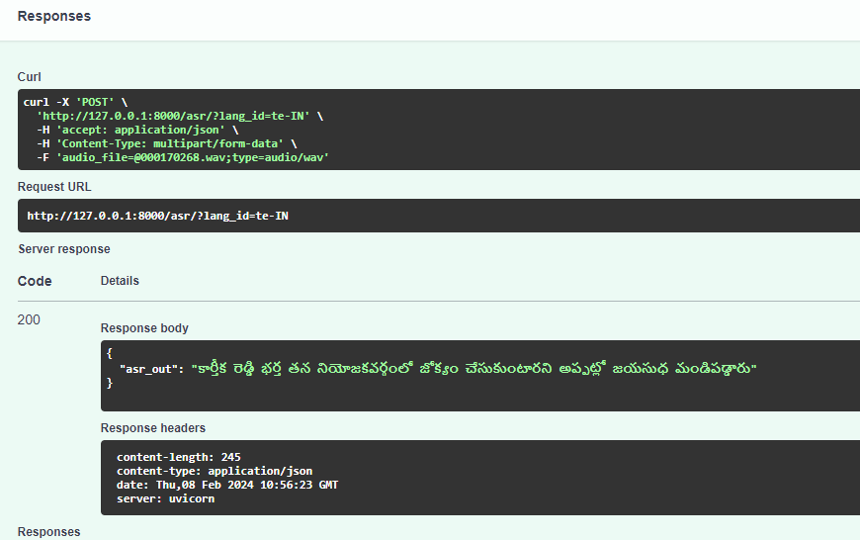
Gradio Response:

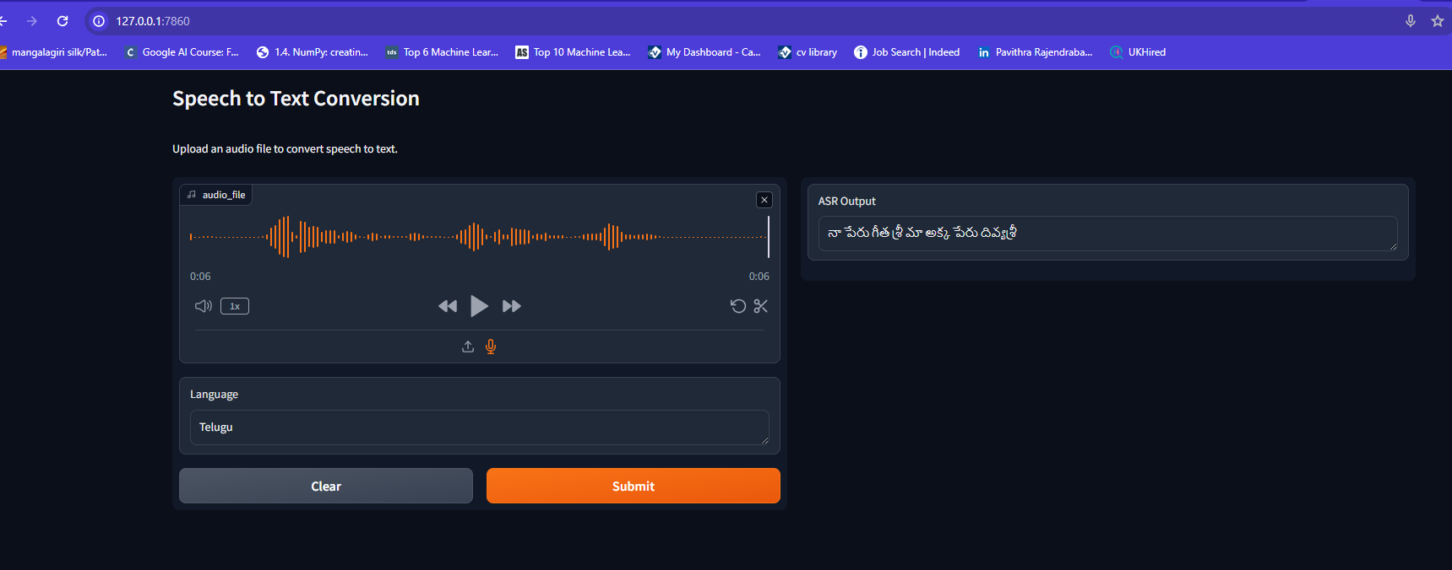

Challenges faced:

    - During installation of Kaldi faced issues in requirement of installation of various libraries.
    - struck at Align monophones in executing command: steps/align_si.sh --boost-silence 1.25 --nj 16 --cmd "$train_cmd" \
data/train data/lang exp/mono_10k exp/mono_ali || exit 1; which was exiting for no of parallel process was 16 and later decreased to 4 based on system requirements.
    - .wav file was not read properly since there was wave.py file saved in the same folder where the project python file which reads the audio file runs, so faced multiple issues which later got resolved on removing wave.py file from that folder.

Challenges in ASR:
1) Noise and Variability:
ASR systems struggle with background noise, accents, speech rates, and various speaking styles.
2)Out-of-Vocabulary Words:
Difficulty in recognizing words not present in the training data, especially names, technical terms, or slang.
3)Speaker Diarization:
Identifying and distinguishing between different speakers in an audio stream.
4)Resource-Intensive Training:
Training accurate ASR models requires large amounts of labeled data and significant computational resources.
5)Low-Resource Languages:
Developing ASR models for languages with limited training data.
6)Emotional Speech Recognition:
Recognizing emotions from speech accurately.
7)Code-Switching:
Recognizing and transcribing speech involving switching between multiple languages.
8)Low-Resource Accents:
ASR models may struggle with accents with limited training data.

Applications and Use Cases:

Automatic Speech Recognition (ASR) technology has found diverse applications across various industries, revolutionizing the way we interact with machines and enabling new forms of human-computer interaction. Here's an overview of the applications and use cases of ASR technology across different sectors:

1) Healthcare
2) Telecommunication
3) Education
4) Entertainment
5) Finance
6) Automotive

References:

1) ExKaldi-RT: A Real-Time Automatic Speech Recognition Extension Toolkit of Kaldi -3 Apr 2021- https://paperswithcode.com/paper/exkaldi-rt-a-real-time-automatic-speech

2) PyKaldi2: Yet another speech toolkit based on Kaldi and PyTorch - 12 Jul 2019 - https://paperswithcode.com/paper/pykaldi2-yet-another-speech-toolkit-based-on

3)https://maelfabien.github.io/machinelearning/speech_reco/#

4) https://huggingface.co/tasks/automatic-speech-recognition

5) https://www.gladia.io/blog/an-introduction-to-asr-speaker-recognition-identification-verification-and-diarization

Git Hub Repo: https://github.com/pavithra4u/My-Projects-in-AIML

